Settings

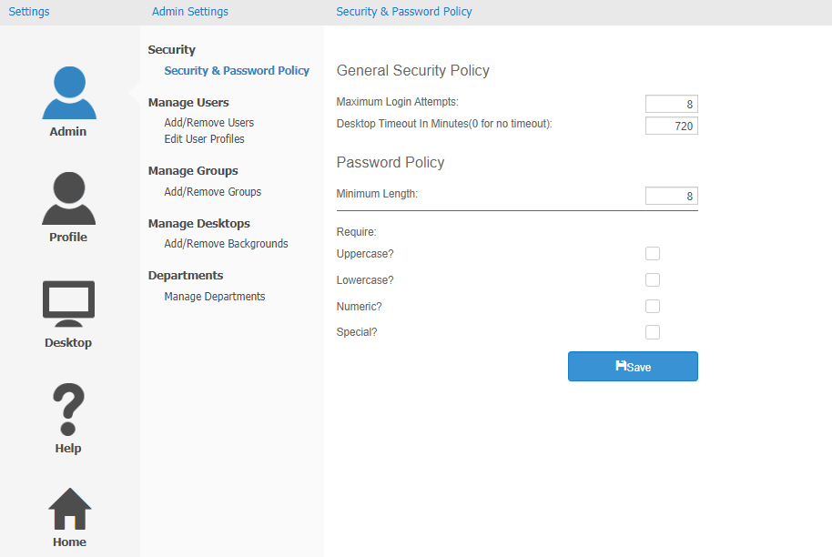

The Settings option is located on the far right of the Toolbar, and is used to adjust the settings of your ActiveDesktop.  Open it by clicking on Settings.  You will be brought to a new page with 3 panels.  The panel on the left, which is the smallest of the 3, shows the main Settings menu and its 5 black category icons:

* **Admin**
* **Profile**
* **Desktop**
* **Help**
* **Home**