**TaxJar Configuration (TJC):**

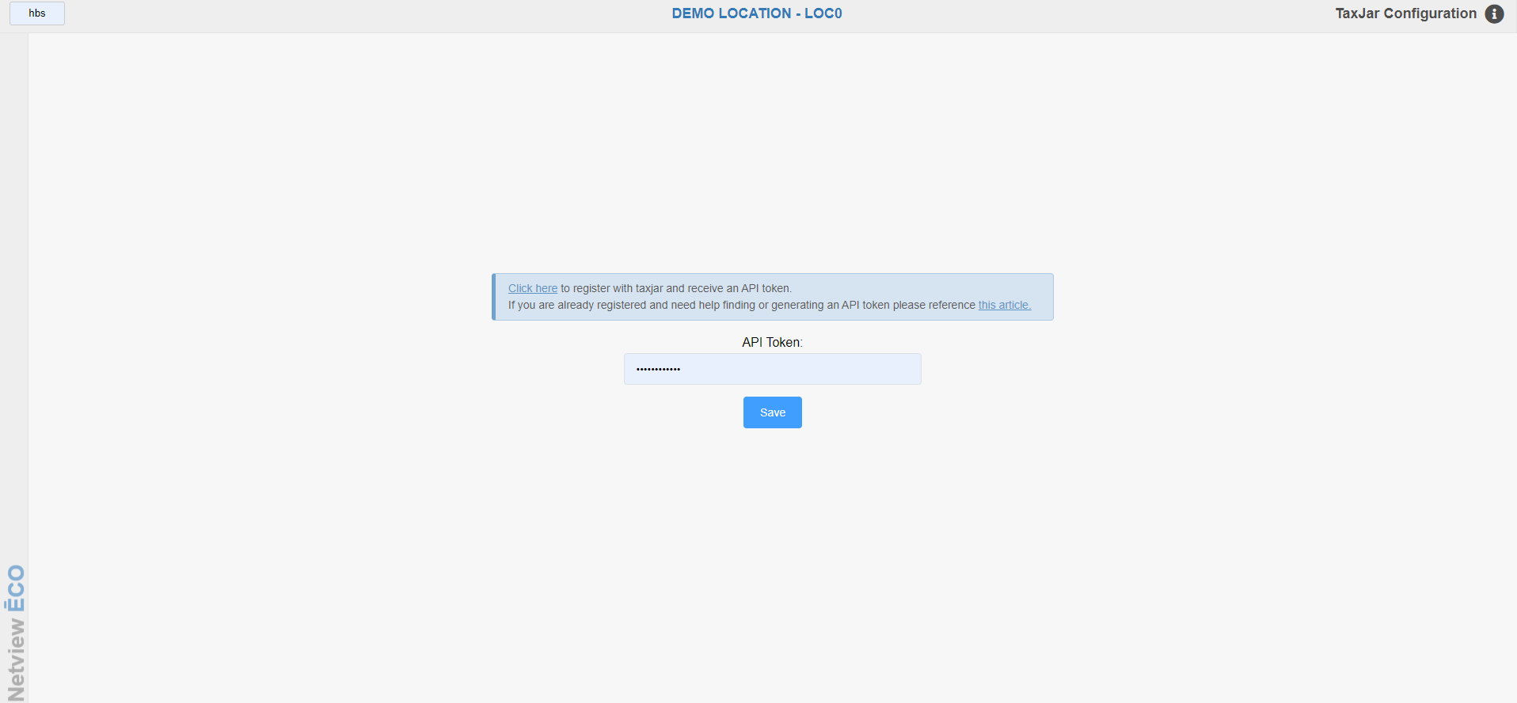

TaxJar Configuration (TJC) is the setup program for utilizing TaxJar to process tax in NetView in connection with using the E-Commerce Portal (ECOM) to process orders. Performing setup in this program is a **required** part of the overall ECOM setup in Netview.

To **access this program**, type “TJC” in the Shortcuts Bar.

**Initial Setup:** The first time you open the program, it will look like the screen above. Enter your TaxJar API Token and click **Save** in order to validate it. Once validated, it will allow you to access the normal TaxJar program from that point forward.

If you have **not registered** with TaxJar yet when you first open the program, use the link provided to register with TaxJar and receive your token. If you need **help** finding or generating your token **after** registering, there is also a link provided to TaxJar’s own Help documentation that can assist you in getting the token. Both links are reproduced here for your convenience:

**TaxJar Registration:** <https://app.taxjar.com/api_sign_up>

**TaxJar Token Help:** <https://support.taxjar.com/article/160-how-do-i-get-a-taxjar-sales-tax-api-token>

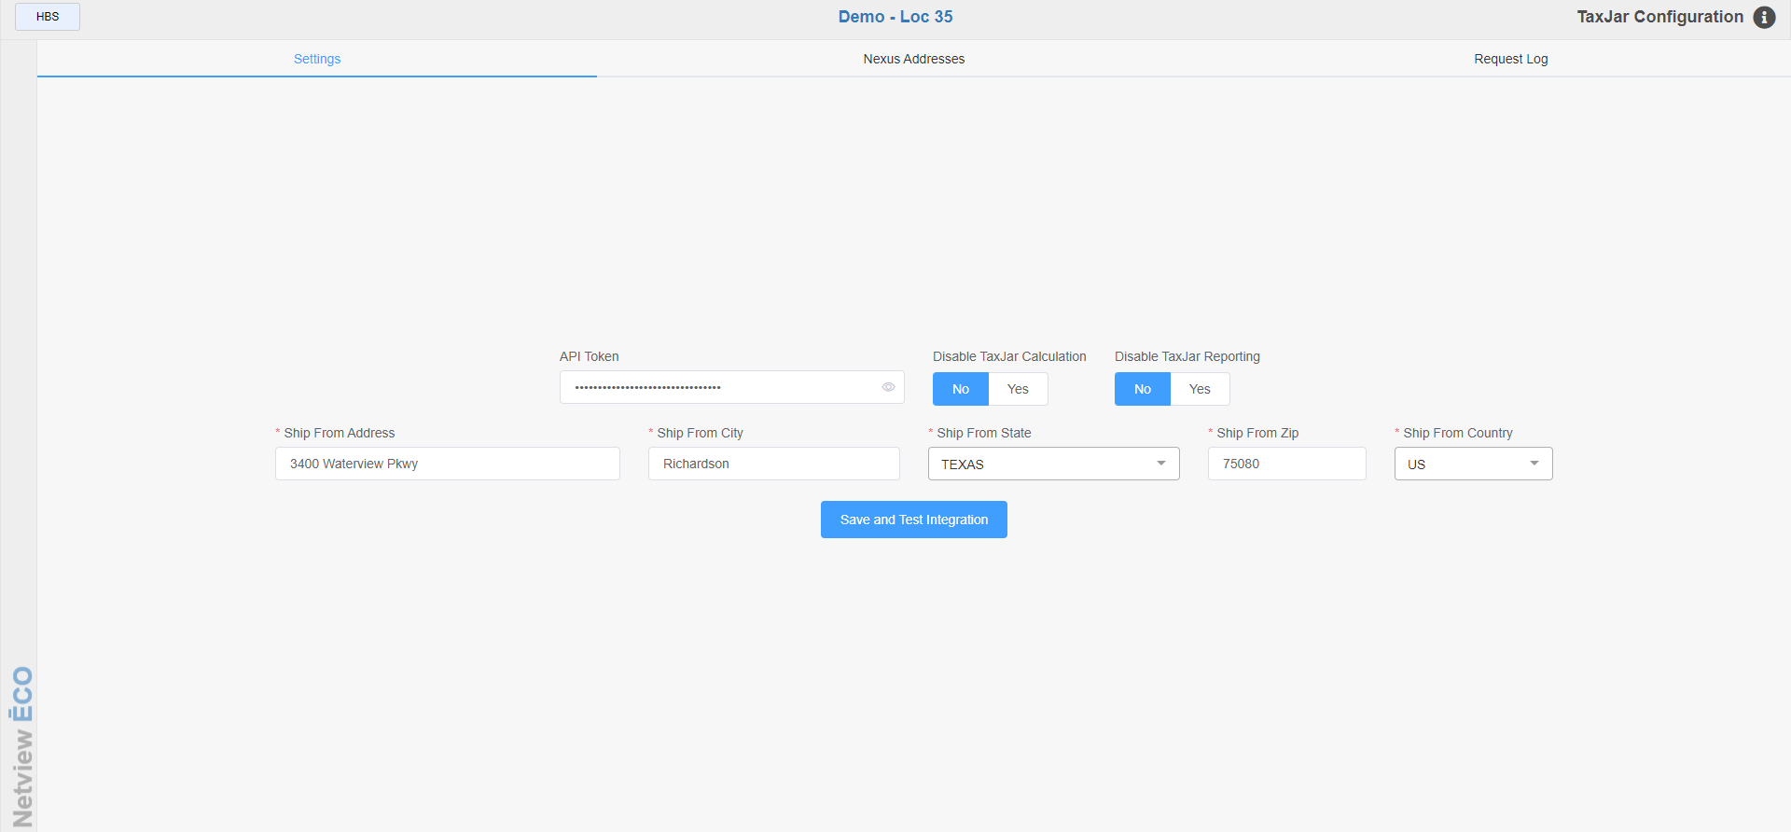

**Settings Screen:** After you initially enter your TaxJar API token, this screen will be the new default screen when you open the program. Here is where you need to enter the remaining required information to set up your TaxJar communications.

Disable TaxJar Calculation: Leave this option set to **No**.

Disable TaxJar Reporting: Leave this option set to **No**.

Ship From Address: Enter your desired shipping address for tax purposes here.

Ship From City: Enter the city for the address here.

Ship From State/Province: Select the state or province for the address here. The dropdown includes both US states and Canadian provinces.

Ship From Zip/Postal: Enter the zip or postal code for the address here.

Ship From Country: Select the address’s country here (options will be US or CA).

After entering your address information, click **Save and Test Integration** to store your settings and make sure the integration is working.

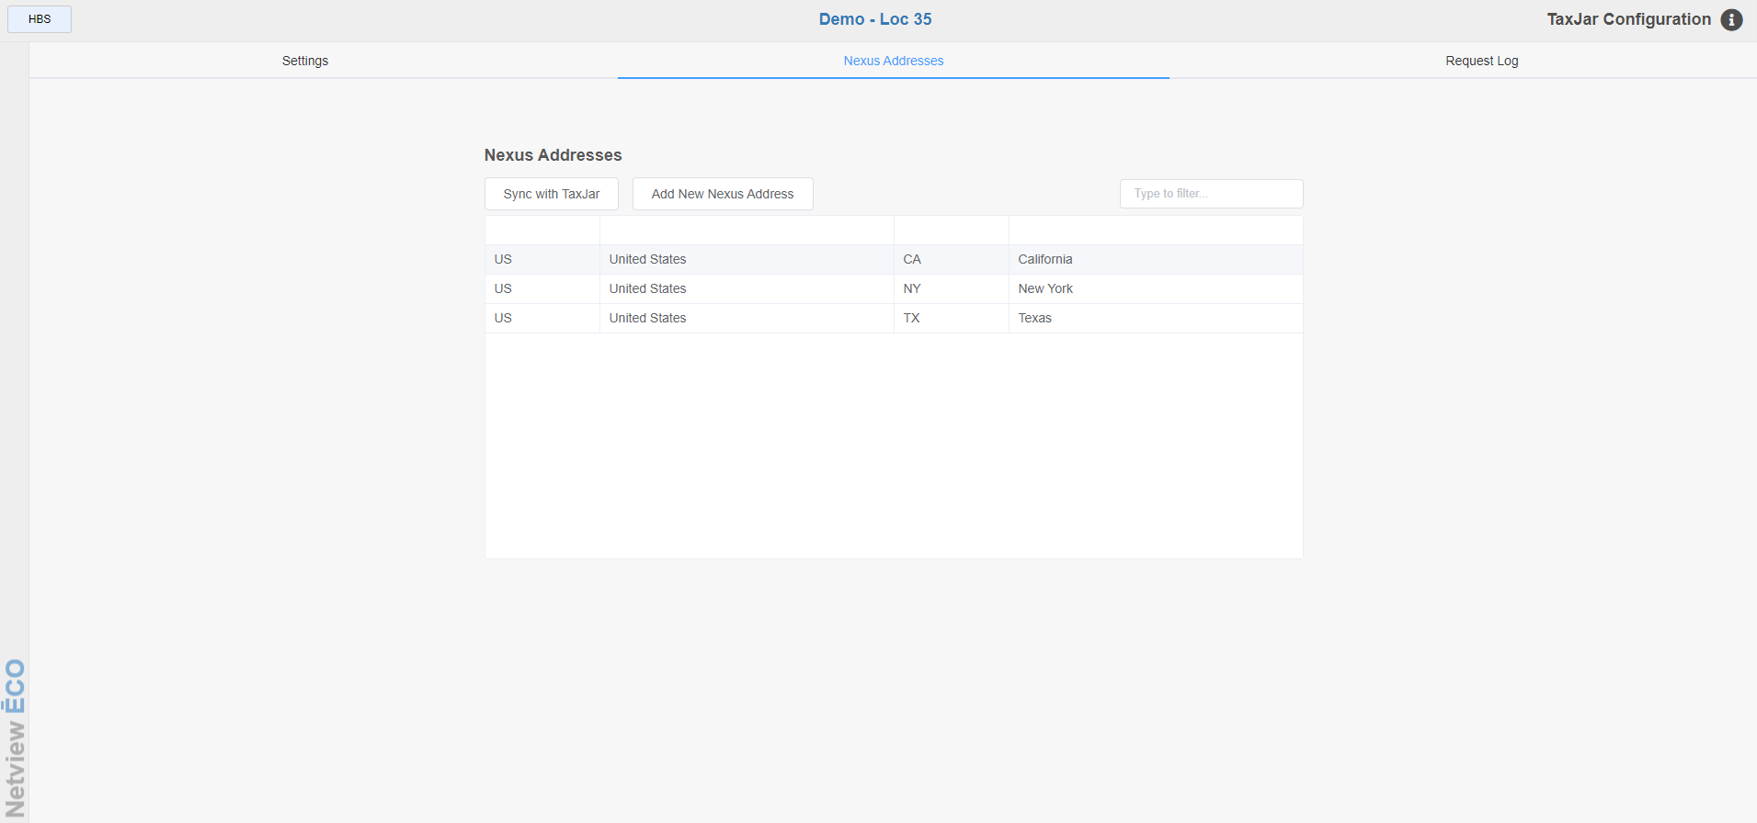

**Nexus Addresses:** This screen shows and maintains all of your nexus addresses.

Add New Nexus Address: If you receive a notification that you need to add a new nexus address, go into this TJC screen and click this button. You will be redirected to TaxJar’s website in a new tab, where you can add the address.

Sync with TaxJar: After you add a new nexus address, be sure to click this button to update your list of addresses in TJC. You can click this button at any time to sync this screen with the list of addresses you have in TaxJar so it displays the most current list.

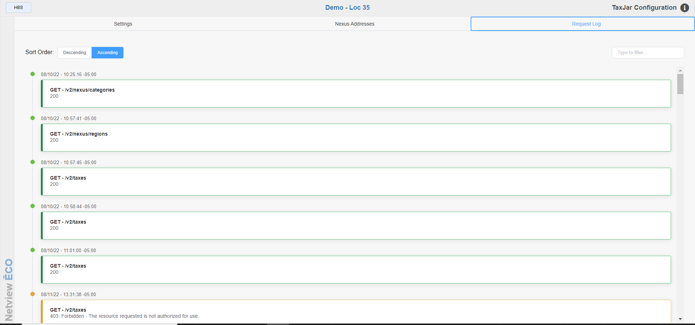

**Request Log:** This screen lists all communication between your server and TaxJar. Each request is **color-coded** to indicate what it represents:

* **Green** means a **successful** charge was made.
* **Yellow** means a **warning** message.
* **Red** means an error occurred and the communication did not go through.

Sort Order: You can use the sorting options to change how the requests are displayed. It displays in **Ascending** order by default, meaning the **oldest** request is at the top. If you switch it to **Descending**, then the most **recent** request will show at the top.

Filter Requests: You can use the Filter field on the top right of the screen to look for specific requests. Type in information you may know about the request, like its date or time stamp, to narrow down the displayed results.