**NetView Transport (TRNS)**

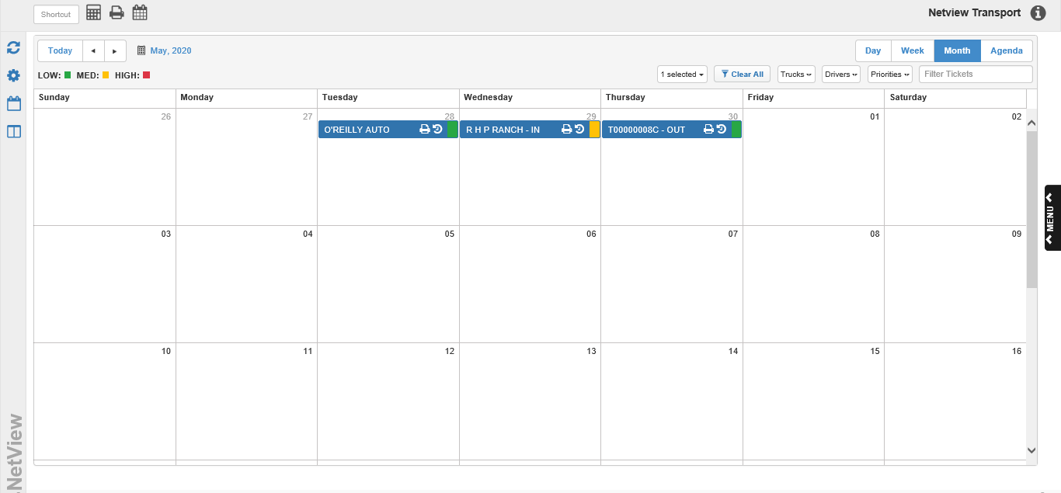

NetView Transport (TRNS) allows users to create and manage a delivery schedule for their dealership using various schedule views. Each delivery event is generated based on a ticket, which holds basic information about the delivery and can be printed out for the assigned driver.

**Sidebar Icons:** On the left-hand side of the program screen, you will see these four icons:



Use these Sidebar icons to update and move between the program screens.

Refresh: Click the  icon to refresh the program. The program will update to reflect all changes made to Transport since you opening the program or your last refresh, whichever occurred last.

Transport Assets: Click the  icon to open the **Transport Assets** screen. See the **“Transport Assets”** section below for more details.

Switch to Calendar View: Click the  icon to open the dealership’s delivery schedule in **Calendar View**. The **Month** Calendar view is the **default** screen when you open TRNS. See the **“Calendar View”** section below for more details.

Switch to Swimlanes View: Click the  icon to open the dealership’s delivery schedule in **Swimlanes View**, which displays the three different types of tickets—Inbound, Outbound, and Relocate—in separate columns. See the **“Swimlanes View”** section below for more details.

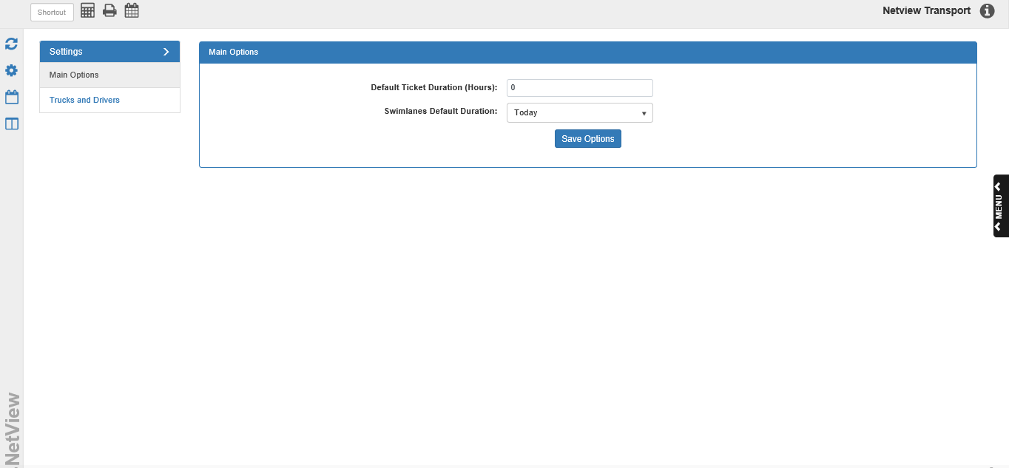

**Transport Assets Settings:** The Transport Assets screen lets you manage the program settings and add new assets to the program, such as trucks and drivers. It is divided into settings for general users and setting that only system administrators can modify.

Main Options Tab: The Main Options tab (see above image) lets you set **user-specific** default preferences.

**Default Ticket Duration (Hours):** When you create a ticket, you assign start and end times, letting the driver know how long they have to make the delivery; this is the Ticket Duration. This field allows you to set a default Ticket Duration period in hours, so when you enter the start time for the ticket, the program will automatically assign an end time based on this default duration. For example, if you set the duration at 4 hours, the end time will automatically set to 4 hours after your entered start time.

**Swimlanes Default Duration:** Each column in the Swimlanes view can be filtered to show the tickets within a pre-set period of time (starting on the current date and moving forward in time). This field lets you set which time period you want the columns to display by default. Your options are:

* Today
* 3 Days
* 1 Week
* 2 Weeks
* 3 Weeks
* 4 Weeks

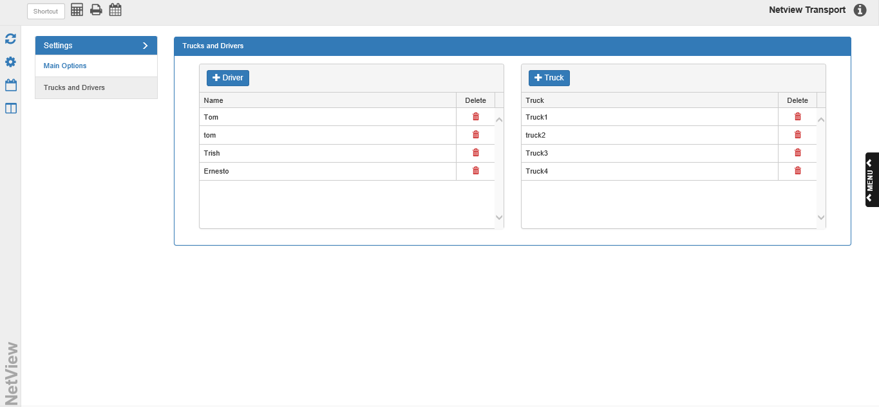

Trucks and Drivers Tab: The Trucks and Drivers tab lets you add resources—in this case, trucks and drivers—to TRNS so you can assign them to delivery tickets. **Only the system administrator can access this tab.**

**Drivers Grid:** This grid lists all drivers currently available in TRNS.

* **Add a Driver:** To add a new driver, click the  button. The following window will appear:

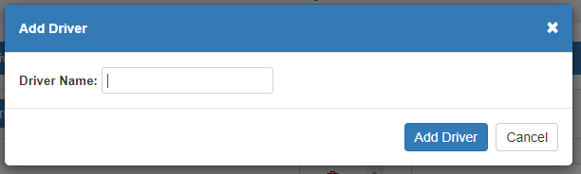

Enter a name or designation for the driver in this field, then click **Add Driver**. The window will close and the driver’s name will appear on the grid list.

* **Delete a Driver:** To delete a driver, click the  icon in the Delete column next to the driver’s name.

**Trucks Grid:** This grid lists all trucks currently available in TRNS.

* **Add a Truck:** To add a new truck, click the  button. The following window will appear:

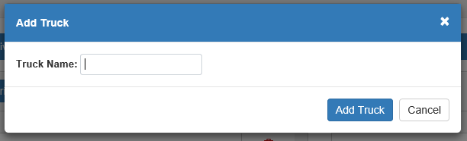

Enter a name or designation for the truck in this field, then click **Add Truck**. The window will close and the truck’s name will appear on the grid list.

* **Delete a Truck:** To delete a truck, click the  icon in the Delete column next to the truck’s name.



**Calendar View:** This is the **default** and primary view of the program. The Calendar View allows you to see your entire dealership’s delivery schedule, with multiple sub-view options and filters so you can see exactly what you need to see at any time. These views are also where you will create your tickets and continue to manage them.

Creating A Delivery Ticket: To create a ticket, use the **Day, Week,** or **Month** Calendar View (see below sections on Sub-Views for details). Locate the date and/or time you would like to schedule the ticket on and double-click that spot on the screen. For example, in **Month** view you would double-click on the desired date, while in **Day** view you would pick the time since you’ve already picked the date.

The following window will open:

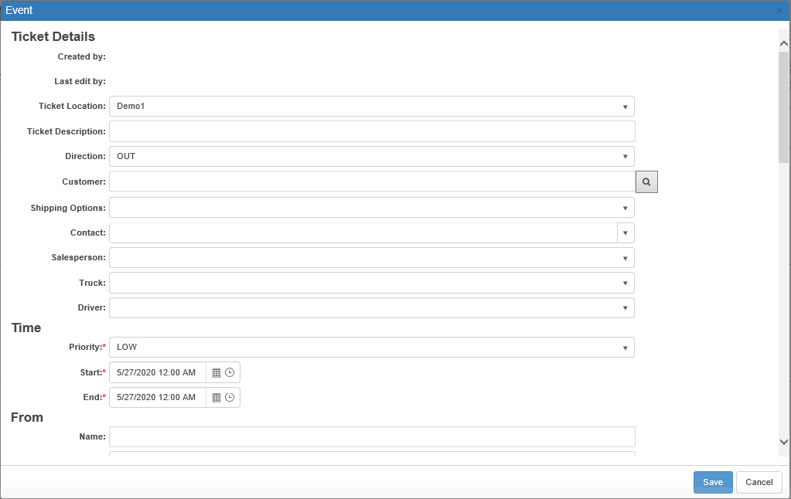

Fill the fields displayed with your ticket details. The descriptions below will note which fields are required to make the ticket.

**Ticket Details Section:** Fill in the basic ticket details here.

* **Created by:** This field will show the ID of the user who created the ticket. It will remain **blank** until the ticket is actually created.
* **Last edit by:** This field will show the ID of the user who last edited the ticket. It will remain **blank** until the ticket is first **edited** after creation.
* **Ticket Location:** Select the dealer location for the ticket. This field will default to the **current** location.
* **Ticket Description:** Enter a description for the ticket here.
* **Direction:** Set the delivery direction, i.e. whether it is moving from the dealership to a customer (Outbound/OUT), vice versa (Inbound/IN), or between two non-dealership locations (Relocate/REL). The field defaults to **OUT (Outbound)**.
* **Customer:** Enter the ticket customer in this field, or use the field’s search function to look a customer up.
* **Shipping Options:** If the customer you selected for the ticket has any Shipping Addresses recorded in NetView, this field will activate. If that includes the customer address you want to use for the ticket, select it from the dropdown menu to have it pre-fill in the ticket.
* **Contact:** If the customer you selected for the ticket has any contacts recorded in NetView, this field will activate. Select a customer contact from the dropdown to record them as a contact for the ticket.
* **Salesperson:** Put the Salesperson ID for the ticket salesperson here. If you have a salesperson database set up in NetView, the field will provide a dropdown menu listing all available salesperson IDs. If you do not, simply enter your own designation here or leave the field blank (as it is optional).
* **Truck:** Use this field to assign a truck to the delivery.
* **Driver:** Use this field to assign a driver to the delivery.

**Time Section:** This section holds the fields that set the ticket’s priority and duration. These fields are **required** to create the ticket.

* **Priority:** This **required** field sets the ticket priority (Low/Medium/High) to indicate how important the delivery is. The default priority is **Low**.
* **Start:** This **required** field sets the start date and time for the delivery.
  + On the **Day** and **Week** views, it will pre-fill with the date and time period you selected when opening the ticket.
  + **Month** view will pre-fill the date, but default to 12 AM since Month view doesn’t let you select specific times on the calendar. You will have to adjust the time to match what you want.
* **End:** This **required** field sets the end date and time for the delivery.
  + If you have a **default duration** set in the Transport Assets screen, this field will pre-set the End Time based on that duration. For example, if your set duration is 4 hours, this field will automatically set the End Time for 4 hours after the Start Time.
  + If you have **no default**, the field will set the End Time to exactly the same time as the Start Time. You will have to change the field manually to set your desired duration.

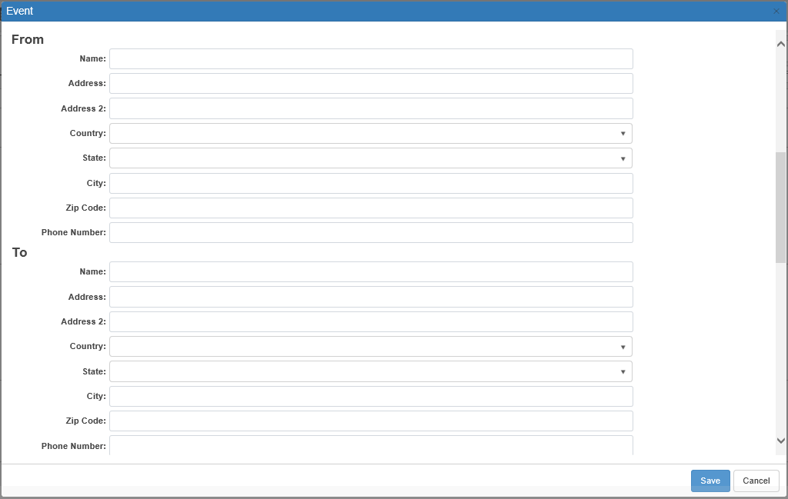

**From Address Section:** This section holds the address fields for the **starting** address of the delivery. If the delivery direction is **Outbound (OUT)**, it will pre-fill with the **ticket dealership location’s** address. If the delivery direction is **Inbound (IN)**, it will prefill with the **ticket customer’s** address, either their main one recorded in the system or the Shipping Address selected in the Ticket Details section. If the delivery direction is **Relocate (REL)**, the fields will not pre-fill and will have to be entered manually.

* **Name:** Can hold the name of either the dealership (OUT) or a customer (IN/REL).
* **Address:** Enter the first line of the address here.
* **Address 2:** If the address requires a second line (apartment #, office #, etc.), enter that information here.
* **Country:** Set the country for the address here (United States or Canada, depending).
* **State:** Set the state/province for the address (options will depend on the chosen country).
* **City:** Set the city for the address.
* **Zip Code:** Set the zip code for the address.
* **Phone Number:** Enter a contact phone number for the address.

**To Address Section:** This section holds the address fields for the **ending** address of the delivery. If the delivery direction is **Outbound (OUT)**, it will pre-fill with the **ticket customer’s** address, either their main one recorded in the system or the Shipping Address selected in the Ticket Details section. If the delivery direction is **Inbound (IN)**, it will prefill with the **ticket dealership location’s** address. If the delivery direction is **Relocate (REL)**, the fields will not pre-fill and will have to be entered manually.

* **Name:** Can hold the name of either the dealership (IN) or a customer (OUT/REL).
* **Address:** Enter the first line of the address here.
* **Address 2:** If the address requires a second line (apartment #, office #, etc.), enter that information here.
* **Country:** Set the country for the address here (United States or Canada, depending).
* **State:** Set the state/province for the address (options will depend on the chosen country).
* **City:** Set the city for the address.
* **Zip Code:** Set the zip code for the address.
* **Phone Number:** Enter a contact phone number for the address.

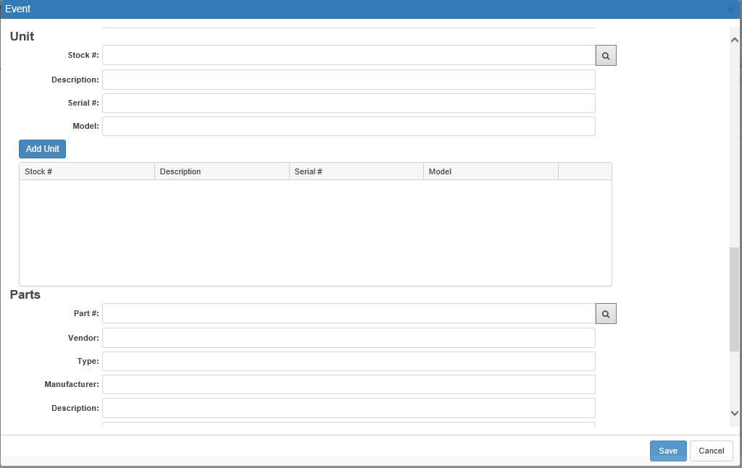

**Unit Section:** If the delivery includes one or more **units**, enter that information in this section.

* **Stock #:** Enter the unit stock number in this field or use the search to look it up if it is recorded in NetView. If the selected unit is recorded in the system, the remaining fields will **pre-fill** with the unit’s information.
* **Description:** This field holds the unit’s description.
* **Serial #:** This field holds the unit’s serial number.
* **Model:** This field holds the unit’s model.
* **Add Unit:** Click this button to add the unit to the ticket. The unit’s information will save to the grid below the section, and the fields will clear so you can add more units, if necessary.

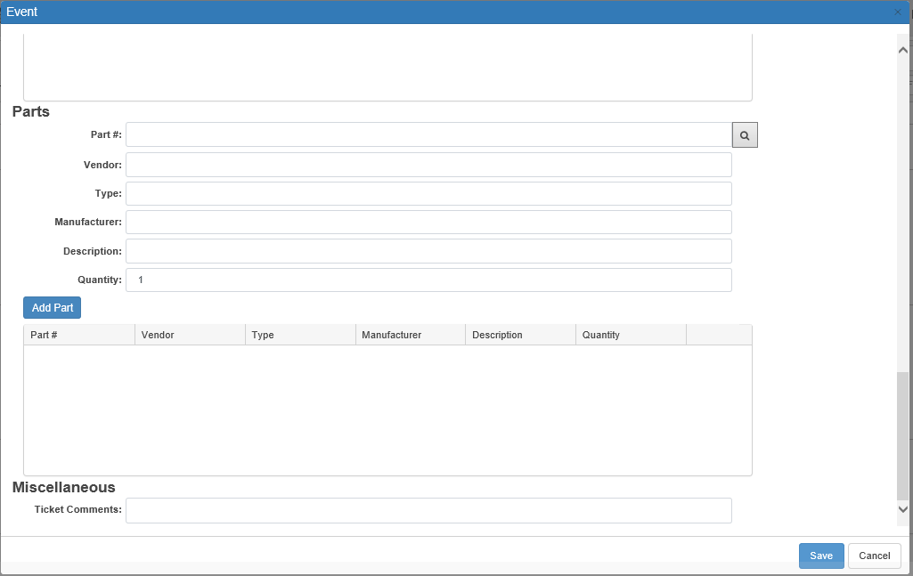

**Parts Section:** If the delivery includes one or more **parts**, enter that information in this section.

* **Part #:** Enter the part number in this field or use the search to look it up. If the selected part is recorded in the system, some of the fields will **pre-fill** with part information.
* **Vendor:** This field will **pre-fill** if the part number is in the system. It will show the part’s vendor number.
* **Type:** This field will **pre-fill** if the part number is in the system. It will show the part’s type code.
* **Manufacturer:** Enter the part’s manufacturer in this field. It will **not** pre-fill and must be entered **manually**.
* **Description:** Enter the part’s description in this field. It will **not** pre-fill and must be entered **manually**.
* **Quantity:** This field **defaults** to “1” if you add a part number. Change it to match the part quantity getting delivered (if larger than 1).
* **Add Part:** Click this button to add the part to the ticket. The part’s information will save to the grid below the section, and the fields will clear so you can add more parts, if necessary.

**Miscellaneous Section:** This section holds any other fields that might provide useful information about the delivery.

* **Ticket Comments:** Enter any desired comments about the delivery in this field.

**Save:** Click this button to save the ticket. The window will close and the ticket will appear in its determined spot on the schedule.

**Cancel:** Click this button to close the window without saving any of the ticket details.



**Delete:** This button only appears if you **re-open** the ticket to edit it after saving. Click it to delete the ticket.



**Sign Ticket:** This button only appears if you **re-open** the ticket to edit it after saving. You can use it to add any necessary signature to the ticket. Click the button to open the signature capture window:

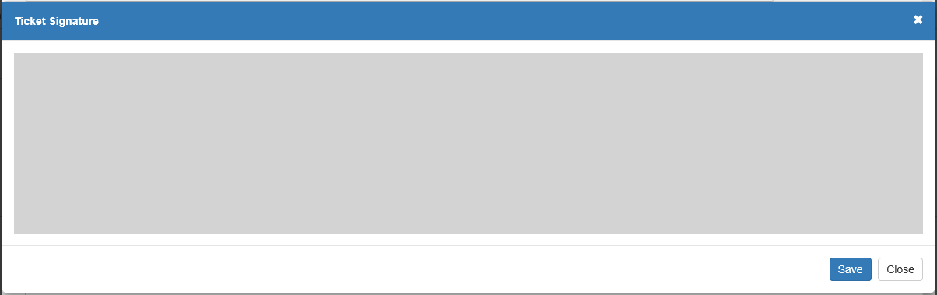

Use either your mouse (if operating on a computer) or your finger (if operating on mobile touch-screen device like a cell phone) to make the signature, then click **Save** to add it. An  button will appear once you start signing, which will allow you to correct the signature as needed while making it. This signature, along with the date you added it to the ticket, will appear at the bottom of the ticket printout.



Calendar Sub-Views: Once you have created your tickets, you can use the Calendar View to view and organize your schedule. This screen has four different sub-views: Day, Week, Month (the **default** sub-view), and Agenda. Use the view selection in the top right-hand corner of the Calendar screen to switch between them.

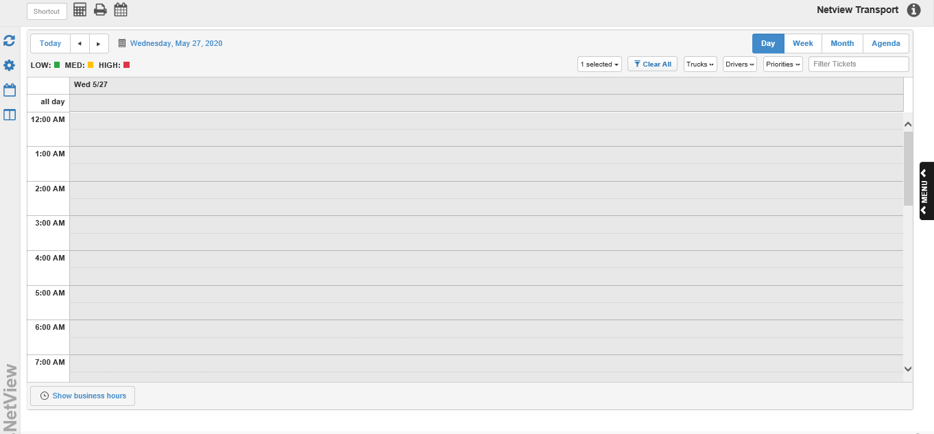

**Day View:** The Day view shows the delivery schedule for the current 24-hour date, divided into hour blocks which are split into two half-hours. See below for how to perform Calendar functions in Day View:

* **Ticket Detail Displays:** Each ticket entry shows the delivery direction and either the customer number (if a customer is assigned) or the ticket number (if a customer is not assigned). It also provides a color-coded priority indicator, which you can interpret using the **Priority Legend** (see that section for details).

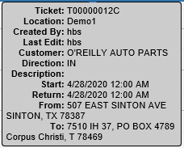

Hovering your mouse over the ticket entry activates a display showing additional information:

* + Ticket Number
  + Dealer Location (if assigned)
  + User Created By
  + User Last Edited By (if edited since creation)
  + Customer Number (if assigned)
  + Delivery Direction
  + Ticket Description (if provided)
  + Start Date/Time
  + Return Date/Time
  + Starting (From) Location (if assigned)
  + Ending (To) Location (if assigned)
* **Viewing All Day Tickets:** At the top of the Day View schedule, just above the 12:00 AM time slot, there is a line that says “all day.” If you create a ticket whose time duration is **24 hours,** and **any** part of that time falls on this particular date, it will appear on the date’s “all day” slot. This is to conserve space for other tickets with shorter durations.
* **Edit Ticket:** To edit a ticket in Day View, double-click on the ticket entry. The following window will open:

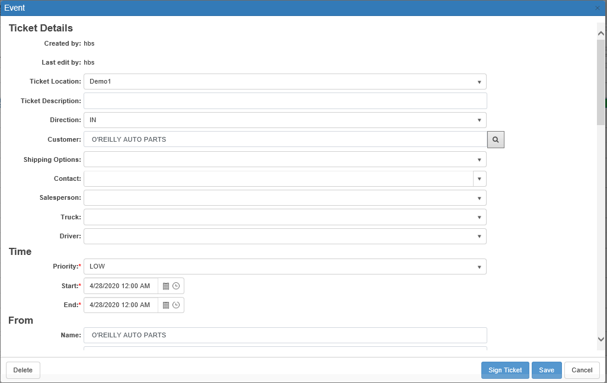

Make the desired changes and click **Save**.

* **Move Ticket:** You can manually adjust the ticket’s scheduled Start and End Times in Day View by clicking on the entry, then dragging it to a new time slot while holding down on the mouse key. Dropping it in the new slot will automatically update the ticket information with the new Start and End times.
* **Expand/Contract Ticket:** When you hover your mouse over a ticket entry in Day View, you will see faint white lines appear at the top and bottom of the ticket entry. These lines allow you to lengthen or shorten the ticket’s delivery duration by making the entry itself longer or shorter. Simply click on a line and, while holding down the mouse key, drag the top or bottom of the entry up or down. Once you release the mouse, the ticket will automatically update to reflect its new duration. For example, if you have a ticket that starts at 12:30 PM, dragging the top of the entry upward to 11 AM will change the ticket’s start time to 11 AM, lengthening the original duration.
* **View Ticket History:** To view the ticket’s edit history in Day View, click the  icon in the ticket’s entry. The following window will appear:

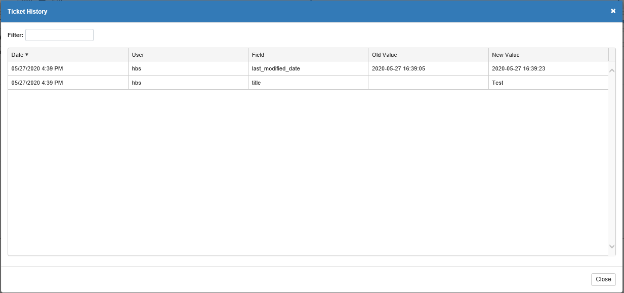

You will see a list of all changes made to the ticket, with the most recent listed at the top by default. You will also be able to see who made the change and what exactly was changed. Additionally, you can resort the list by clicking on any of the column headers, and you can use the **Filter** field to filter the history by typing in specific information.

* **Print Ticket:** Each ticket entry in Day View displays an icon of a printer (). Click this icon to open the following window:

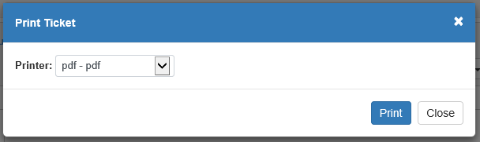

Select a printer and click **Print** to print the ticket.

* **Delete Ticket:** To delete a ticket in Day View, start by hovering your mouse over the ticket entry. You will see a small “x” appear in the entry. Click on it to delete the ticket. The following warning will appear:

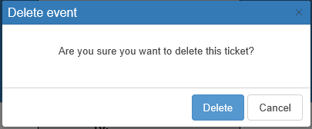

Click **Delete** to delete the ticket.

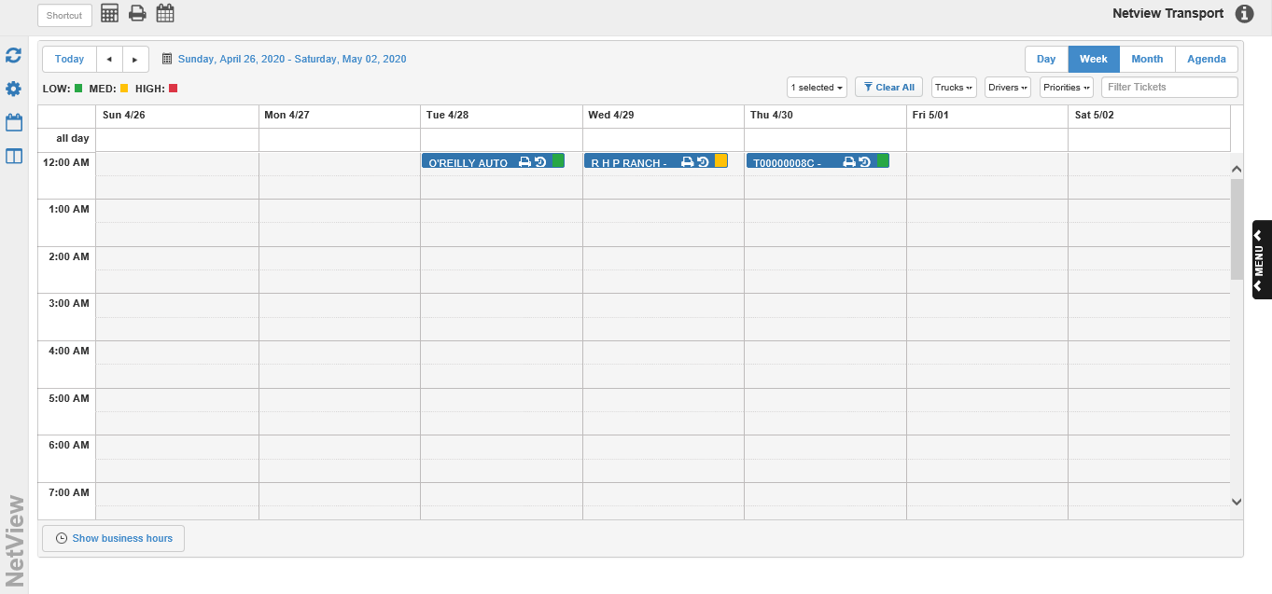

**Week View:** The Week View shows the schedule for the current calendar week (Sunday-Saturday), with each day divided into hour blocks split into two half-hours just like in Day View. See below for how to perform Calendar functions in Week View:

* **Ticket Detail Displays:** Each ticket entry shows the delivery direction and either the customer number (if a customer is assigned) or the ticket number (if a customer is not assigned). It also provides a color-coded priority indicator, which you can interpret using the **Priority Legend** (see that section for details).

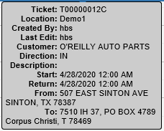

Hovering your mouse over the ticket entry activates a display showing additional information:

* + Ticket Number
  + Dealer Location (if assigned)
  + User Created By
  + User Last Edited By (if edited since creation)
  + Customer Number (if assigned)
  + Delivery Direction
  + Ticket Description (if provided)
  + Start Date/Time
  + End Date/Time
  + Starting (From) Location (if assigned)
  + Ending (To) Location (if assigned)
* **Viewing All Day Tickets:** At the top of the Week View schedule, just above the 12:00 AM time slot on each day, there is a line that says “all day.” If you create a ticket whose time duration is **24 hours,** and **any** part of that time falls on a date in this week, it will appear on the date’s “all day” slot. It will also extend into the “all day” slot for the previous or next date depending on the exact times scheduled. This is to conserve space for other tickets with shorter durations.
* **Edit Ticket:** To edit a ticket in Week View, double-click on the ticket entry. The following window will open:

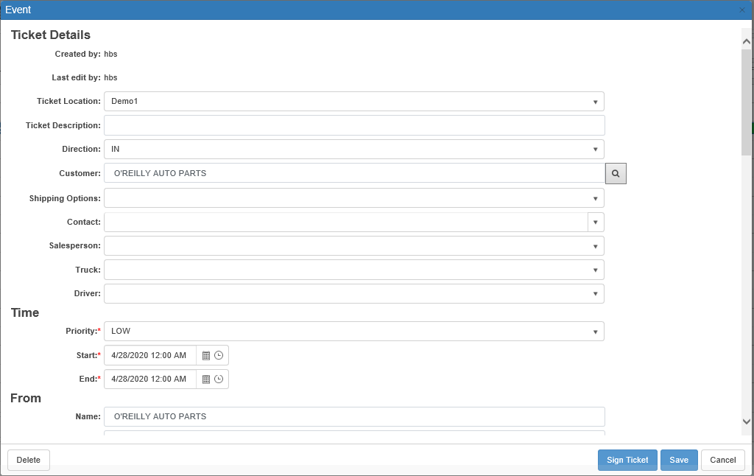

Make the desired changes and click **Save**.

* **Move Ticket:** You can manually adjust the ticket’s spot on the schedule in Week View by clicking on the entry, then dragging it to a new date or time slot while holding down on the mouse key. Dropping it in the new slot will automatically update the ticket information with the new date and times.
* **Expand/Contract Ticket:** When you hover your mouse over a ticket entry in Week View, you will see faint white lines appear at the top and bottom of the ticket entry. These lines allow you to lengthen or shorten the ticket’s delivery duration by making the entry itself longer or shorter. Simply click on a line and, while holding down the mouse key, drag the top or bottom of the entry up or down. Once you release the mouse, the ticket will automatically update to reflect its new duration. For example, if you have a ticket that starts at 12:30 PM, dragging the top of the entry upward to 11 AM will change the ticket’s start time to 11 AM, lengthening the original duration.
* **View Ticket History:** To view the ticket’s edit history in Week View, click the  icon in the ticket’s entry. The following window will appear:



You will see a list of all changes made to the ticket, with the most recent listed at the top by default. You will also be able to see who made the change and what exactly was changed. Additionally, you can resort the list by clicking on any of the column headers, and you can use the **Filter** field to filter the history by typing in specific information.

* **Print Ticket:** Each ticket entry in Week View displays an icon of a printer (). Click this icon to open the following window:



Select a printer and click **Print** to print the ticket.

* **Delete Ticket:** To delete a ticket in Week View, start by hovering your mouse over the ticket entry. You will see a small “x” appear in the entry. Click on it to delete the ticket. The following warning will appear:



Click **Delete** to delete the ticket.



**Month View:** The Month View is the **default** Calendar View when you open TRNS. It shows the schedule for the current calendar month, plus a week before and/or after in order to show 6 weeks total. See below for how to perform Calendar functions in Month View:

* **Ticket Detail Displays:** Each ticket entry shows the delivery direction and either the customer number (if a customer is assigned) or the ticket number (if a customer is not assigned). It also provides a color-coded priority indicator, which you can interpret using the **Priority Legend** (see that section for details).



Hovering your mouse over the ticket entry activates a display showing additional information:

* + Ticket Number
  + Dealer Location (if assigned)
  + User Created By
  + User Last Edited By (if edited since creation)
  + Customer Number (if assigned)
  + Delivery Direction
  + Ticket Description (if provided)
  + Start Date/Time
  + End Date/Time
  + Starting (From) Location (if assigned)
  + Ending (To) Location (if assigned)
* **Edit Ticket:** To edit a ticket in Month View, double-click on the ticket entry. The following window will open:



Make the desired changes and click **Save**.

* **Move Ticket:** You can manually adjust the ticket’s date on the schedule in Month View by clicking on the entry, then dragging it to a new date while holding down on the mouse key. Dropping it in the new date will automatically update the ticket information with the new date and times.
  + **NOTE:** This will allow you to move the ticket to a date in a different month, provided that date is included in the 6 weeks displayed by the view.
  + **NOTE:** This will **not** change the ticket’s scheduled **time**, only the **date**.
* **Expand/Contract Ticket:** When you hover your mouse over a ticket entry in Month View, you will see faint white lines appear on the left and ride ends of the ticket entry. These lines allow you to lengthen or shorten the ticket’s delivery duration by making the entry itself longer or shorter. Simply click on a line and, while holding down the mouse key, drag the edge out (makes it longer) or in (makes it shorter). Once you release the mouse, the ticket will automatically update to reflect its new duration. **NOTE:** The ticket increases or decreases by **24-hour** increments as you drag it out or in by a date.
* **View Ticket History:** To view the ticket’s edit history in Month View, click the  icon in the ticket’s entry. The following window will appear:

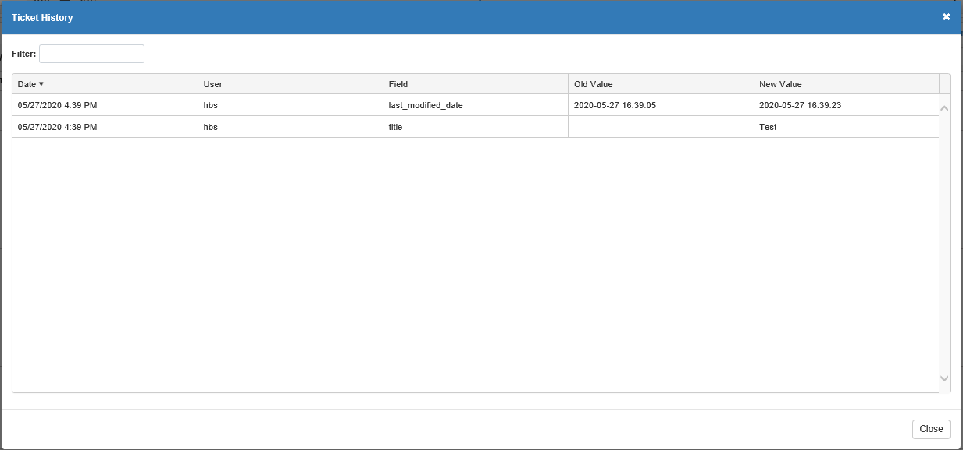

You will see a list of all changes made to the ticket, with the most recent listed at the top by default. You will also be able to see who made the change and what exactly was changed. Additionally, you can resort the list by clicking on any of the column headers, and you can use the **Filter** field to filter the history by typing in specific information.

* **Print Ticket:** Each ticket entry in Month View displays an icon of a printer (). Click this icon to open the following window:



Select a printer and click **Print** to print the ticket.

* **Delete Ticket:** To delete a ticket in Month View, start by hovering your mouse over the ticket entry. You will see a small “x” appear in the entry. Click on it to delete the ticket. The following warning will appear:



Click **Delete** to delete the ticket.

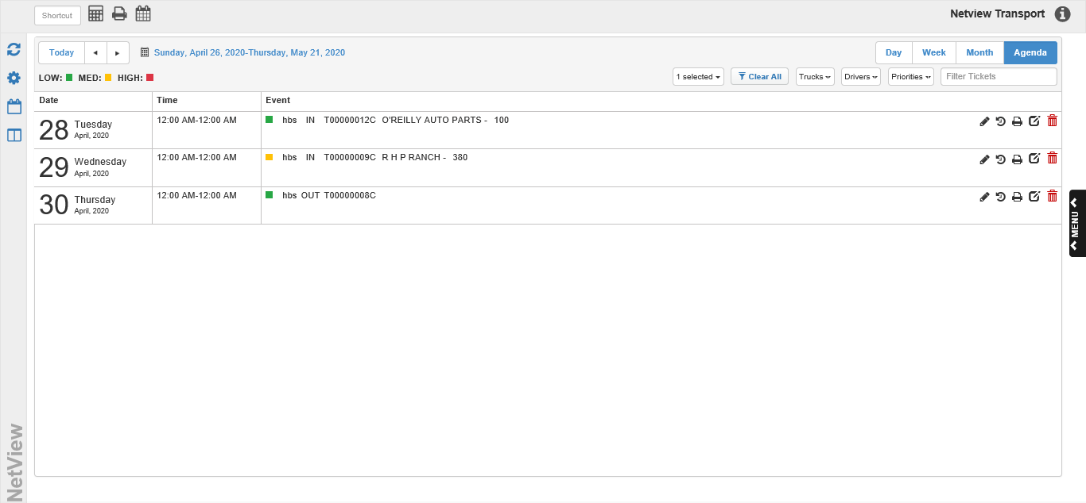

**Agenda View:** The Agenda View differs greatly from the other Calendar views in that it merely lists the events in chronological order, rather than dividing them into time or date blocks. It also covers a unique time span, starting 5 days before the chosen date and ending 20 days after that date (defaulting to the **current** date). In addition, this is the only Calendar View where you **cannot create new tickets**. You will find a list of what Calendar functions you can do in Agenda View below:

* **Ticket Detail Displays:** Each ticket entry in Agenda View shows the following information:
  + Ticket Date
  + Ticket Duration (Start Time to End Time)
  + Ticket Priority
  + Ticket Creator User ID
  + Ticket Direction (Out/In/Rel)
  + Ticket Number
  + Ticket Customer (if assigned)
  + Ticket Description
* **Edit Ticket:** To edit a ticket in Agenda View, find the ticket entry and click the  icon. The following window will open:



Make your desired changes and click **Save** to update the ticket.

* **View Ticket History:** To view the ticket’s edit history in Day View, click the  icon in the ticket’s entry. The following window will appear:



You will see a list of all changes made to the ticket, with the most recent listed at the top by default. You will also be able to see who made the change and what exactly was changed. Additionally, you can resort the list by clicking on any of the column headers, and you can use the **Filter** field to filter the history by typing in specific information.

* **Print Ticket:** To print a ticket in Agenda View, click the “” icon displayed on the ticket entry. The following window will open:



Select a printer and click **Print** to print the ticket.

* **Delete Ticket:** To delete a ticket in Agenda View, find the ticket entry and click the  icon in its entry. The following warning will appear:



Click **Delete** to delete the ticket.



Calendar Features: Calendar View has additional features that either explain or modify the displayed schedule.

**Priority Legend:** The Priority Legend shows which color the system assigns to each ticket priority:



This lets you quickly tell what priority a ticket on the schedule has by letting you match the color of the ticket entry to which priority has that assigned color.

**Date Change:** This feature appears just above the Priority Ledger, and indicates the time period currently displayed on the schedule view:



You can also use the buttons to adjust the date(s) currently shown.

* **Today:** Click the “Today” button to have the schedule view automatically revert to the current date.
  + For **Day** view, the view will change to show the **current date**.
  + For **Week** view, the view will change to show the **week of the current date**.
  + For **Month** view, the view will change to show the **month of the current date**.
  + For **Agenda** view, the view will change to show a time period of **5 days before and 20 days after the current date.**
* **Back:** Click this button to move the view backwards in time (previous day/week/month/etc.).
* **Forward:** Click this button to move the view forward in time (next day/week/month/etc.).
* **Calendar Select:** You can also use the calendar icon to select a specific date you want to look at in the view. The schedule will automatically change to feature that specific date/its week/its month/etc.

**Filters:** Use these options to filter what delivery tickets you want to see on your Calendar schedule, based on information on the tickets.



* **Location:** Select one or more dealership locations whose tickets you want to view on the calendar. The **current** location is selected by **default,** and this field will **not** clear if you click the **Clear All** button—the filters can only be cleared manually.
* **Trucks:** Select one or more trucks here in order to view only tickets assigned to those trucks.
* **Drivers:** Select one or more drivers here in order to view only tickets assigned to those drivers.
* **Priorities:** Select one or more priorities here in order to only view tickets with those priorities.
* **Filter Tickets:** If you want to view tickets with a different set of information than provided in the other filters, enter the information in this field. The program will then filter the schedule to only display tickets with matching information.
* **Clear All:** Click this button to clear any filters you may have placed on the schedule. **This does not affect the Location filter**—any locations you may have marked will require manual clearing.

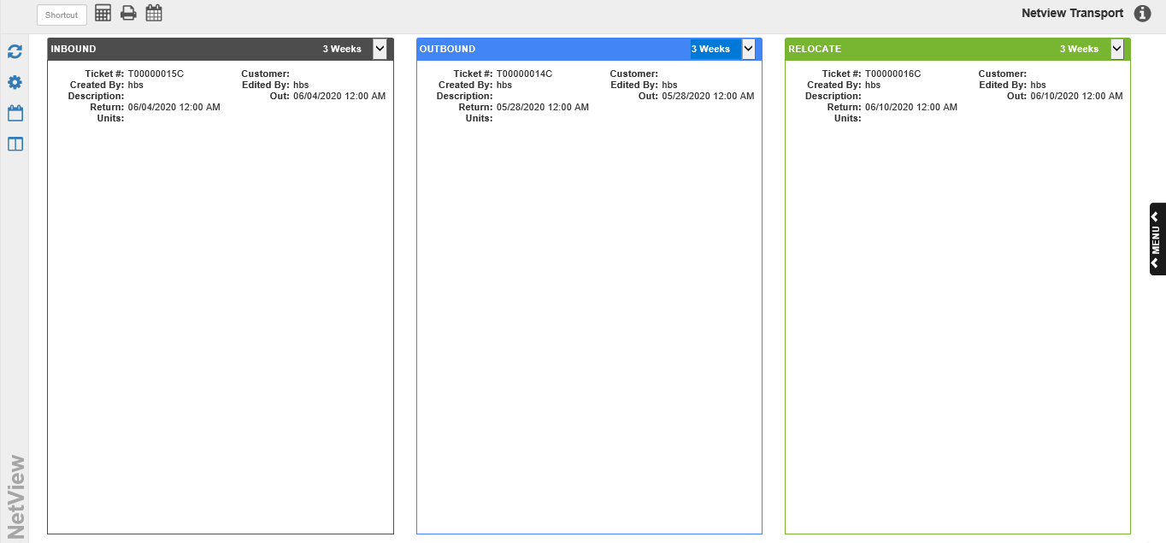

**Swimlanes View:** This is an alternate view to the Calendar View, which divides the delivery tickets into three columns by their assigned direction: Inbound, Outbound, and Relocate. Each column shares the same set of display features (explained below). **NOTE:** This view is **display only**—you cannot view, modify, or create tickets from this screen.

Ticket Entry Display: Each ticket entry in the columns shows the following information:

* Ticket #
* Customer
* User Created By
* User Last Edited By
* Description
* Out (Start) Date/Time
* Return (End) Date/Time
* Delivery Units

Time Filter: Each column has a drop-down menu in its top right-hand corner, which allows you to set the period of time you want the displayed tickets to belong to. Each time period **starts** on the **current date** and moves **forward** in time. Your options are:

* Today (current date)
* 3 Days
* 1 Week
* 2 Weeks
* 3 Weeks
* 4 Weeks

Note that you can set a **default** time filter using the **Swimlanes Default Duration** field in the **Transport Assets** screen (see that section above fore details).