**Warehouses:** The Warehouses tab both contains the list of eligible CNH warehouses for ordering and allows you to order those warehouses so that they will always display your most preferred warehouse first in all CNH Connect (CSPS) screens.

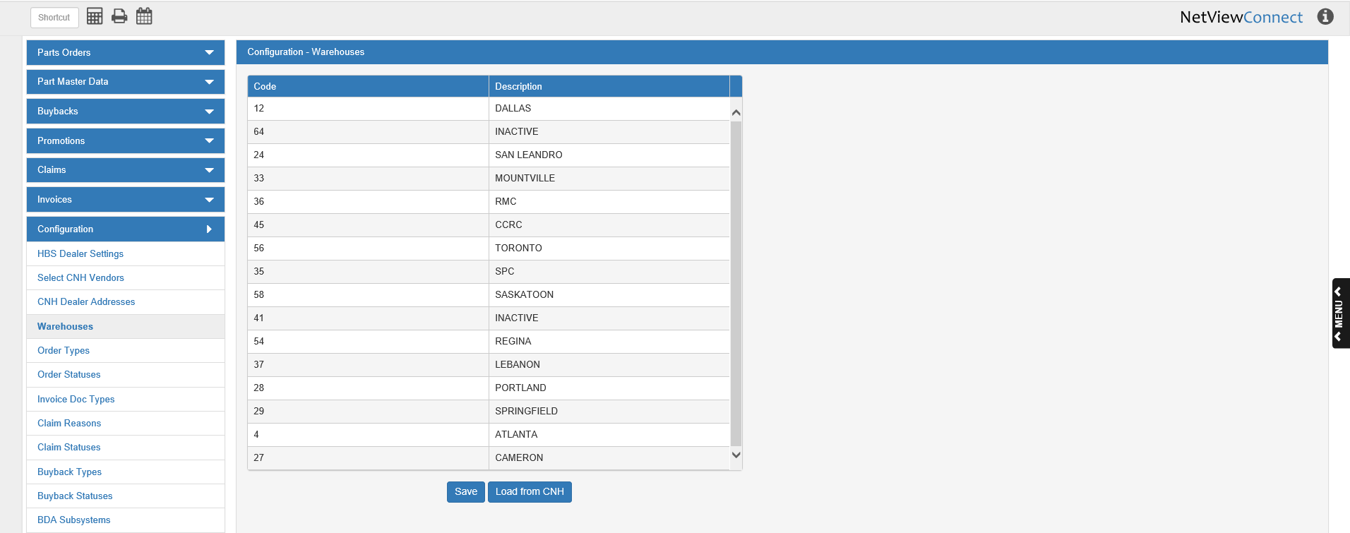

**Code:** This column shows the CNH code for the warehouse.

**Description:** This column shows the warehouse description, and generally serves to indicate where the warehouse is located.

**Load from CNH:** When you first open CSPS, you will need to click this button to load the list of warehouses from CNH. Otherwise, you will not be able to see any information regarding warehouses. The list will automatically reload every 30 days, but you can click this button at any time to reload the most updated version.

**Reordering The Warehouse List:** The warehouse list will initially load in its default numerical order from CNH. To reorder the list so your most preferred warehouse always appears at the top of a warehouse listing, as in the case of part availability:

* Click on the warehouse list entry and hold down the mouse while dragging it to the desired sport.
* Release the mouse button to drop it in the new position.

**Save:** After you have reordered the warehouses, click this button to save the new order setting. All warehouse lists in CSPS will then always show the warehouses in the new list order.