* **Steps to create the template:**

1. Take the existing document (.docx ) file to create the template

Sample file :



1. Identify the parameters/data that needs to be updated in the template

Ex.

Information present against Name , Gender, Age, City Name etc. are the parameters in above sample file

1. Replace the parameters as mentioned below in the entire .docx document

* In place of parameters/data, Use the curly brackets as mentioned below
* Write the Parameter’s name inside the curly brackets

Ex.

* Replace ‘Andrew Simon’ from template 1318.docx with {{ NAME }}
* Replace ‘Male’ with {{ gender }} , ’57’ with {{ Age }}

**Do this in the entire document**

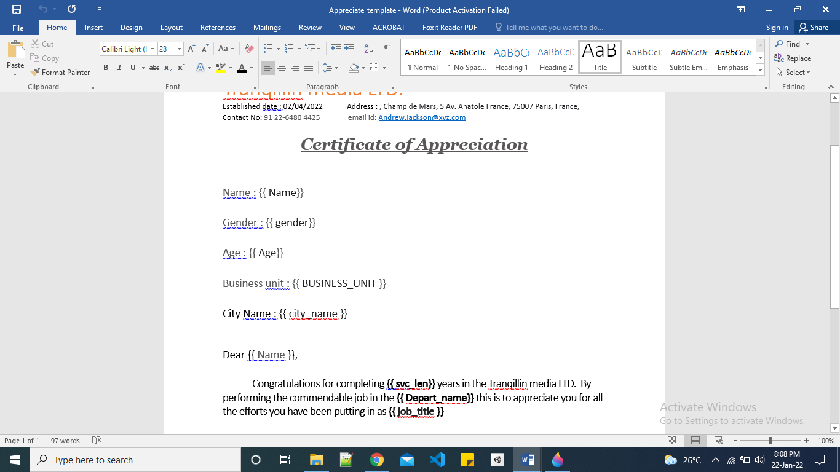

* The Data which will be uploading from the excel **should contain the same parameter name** used in docx template

Ex . column name used in uploading excel must be exactly same which is used in the template

* Name : used as column in excel and inside curly brackets in template i.e. {{ Name }}
* gender : same in excel column and in template {{ gender }}

|  |  |  |  |  |
| --- | --- | --- | --- | --- |
| **Name** | **Age** | **gender** | **BUSINESS_UNIT** | **city_name** |
| Andrew Simon | 57 | Male | HEADOFFICE | Surrey |

1. sample Template and excel data :

 