Electrical Submersible Pump (ESP)

Operation & Trouble Shooting

PTP- 6.2

Table of Contents

Page Number
1. Recording Ammeter 03
2. Motor Controllers - General 03
2.1. Motor Basics 03
2.2. Voltage Damage 03
2.3. Heat Damage 03
2.4. Overcurrent Damage 04
2.5. Controller Basic 04 04
3.0 ESP OPERATION 06
3.1. Operational Features 06
3.2. ESP Start-up 06
4. TROUBLE SHOOTING 07

ESP Operation and Trouble Shooting

RECORDING AMMETER

The recording ammeter should operate on an AC current range 0 - 5 amps with an accuracy of plus or minus 1 % on the top 80 %, and plus or minus 2 % on the bottom 20 % of the scale. With a current range of 0 - 5 amps, current transformers must be employed in the switchboard circuit to reduce the motor running amperage to this range. The ammeter records the value of the AC current on the circular paper chart. A moving iron measuring element responds to the changes of current input and positions the recording pen on the paper chart to corresponds with the running amps of the motor.

2.0. MOTOR CONTROLLERS -GENERAL

2.1. MOTOR BASICS

Any submersible motor must have some protective device to prevent motor damage from electrical or mechanical problems. If there is no mechanical problem, a motor will run when the correct three-phase power flows in its windings. There is only one electrical cause of motor failure - insulation breakdown. When insulation breakdown occurs, electrical energy flows from the windings to ground, instead of through the windings.

2.2. VOLTAGE DAMAGE

High voltage damages a motor by breaking down the winding insulation. The high voltage may be either continuous AC voltage or a temporary "transient" blip on the power lines. The magnitude of the voltage required to actually damage a motor depends on the quality and condition of the insulation.

Most controllers do not attempt to monitor the incoming voltage to the motor, or protect against damage by over voltage. The reason for not doing so depends on the nature of the over-voltage. In the case of continuous AC over-voltage, the motor current will increase sufficiently to cause an overload shutdown (assuming the overload is set correctly). If the over-voltage is only a transient, it is unlikely that the controller will be able to operate quickly enough to prevent damage to the insulation.

2.3. HEAT DAMAGE

Excessive heat is another major cause of motor damage. Prolonged exposure to high temperature causes the winding insulation to degrade and ultimately fail. Heat is generated by current through the windings, friction, and magnetic losses in the motor.

Heat energy is removed from the motor primarily by conduction through the housing to fluid flowing past the motor. If there is insufficient fluid flow past the motor housing, the motor will overheat. The rate at which heat is removed depends on the difference in temperature between the motor housing and the well fluid, and on the thermal conductivity of the housing, coating, and specific heat of the fluid. Higher temperature well fluid is less effective at cooling the motor. Overheating of a motor will not only damage the insulation, but can also harm bearings and seals.

2.4. OVERCURRENT DAMAGE.

The amount of motor current depends mainly on the motor terminal voltage, motor inductance, winding resistance, and the motor shaft load. The resistance of the windings is in turn dependent on the size of winding wire and its temperature.

Every time the motor is started, a high inrush current flows through the windings. This current, which may be six to ten times nameplate current, causes excessive heating of the windings which stresses the insulation. The high current also places high magnetic forces on the windings - an actual push sideways - which would move the windings if they were not securely held in place. Several studies have shown that motors which are started repeatedly fail more frequently than motors which run continuously or are cycled less often.

The ability of a polyphase induction motor to continuously run at 100% of its rated capacity makes it a truly remarkable device. This also makes it easy to push the motor past its limits. The horsepower rating of a motor is determined by how much torque it will produce and how hot it will get when doing so, as well as the torque rating of the shaft. If heat were not a problem only one size motor would be needed (small). Unfortunately, such is not the case. If motor nameplate current is exceeded, that is a good indication that the rated horsepower is also being exceeded. An effective controller will monitor the motor current and shut down if the current limit is exceeded. However, to maintain production it is important not to shut down due to brief spikes of motor current. More severe overloads should result in faster shutdowns. This is called an inverse time curve where smaller overloads are allowed for a longer period of time.

2.5. CONTROLLER BASICS

The high cost of a submersible motor makes an effective protective device a necessity. The cheapest controller on the market is much too expensive if it fails to protect the motor. However, protecting the motor means different things to different people. Some have tried shutting down the motor when the device sensed a thunderstorm approaching (thunder and lightning detector). Others only want to shut down just before the surface equipment catches fire. Most operators will tolerate a few nuisance trips rather than a few motor failures.

The functions which are absolutely required for all motor controllers are overload protection, underload or pumpoff protection, and automatic restart after underload. Some controllers may add shutdown inputs from a pressure switch, underload bypass controls, unbalanced current protection, overvoltage or undervoltage protection, or other functions.

3.0. ESP Operation

Following important features are available with the control panel.

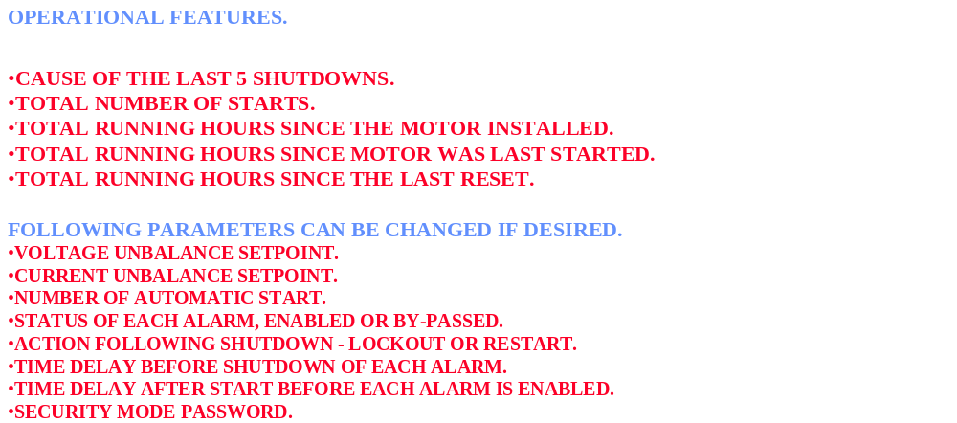

3.2 ESP Start-up sequence

1. LINE-UP THE WELL TO THE STATION.
a. OPEN MANIFOLD VALVES TO SEPARATOR,
b. OPEN LOCATION VALVE,
c. OPEN MASTER VALVE and WING VALVES,
d. OPEN CASING WING VALVES
2. MAKE SURE POWER AVAILABLE ON CONTROL PANEL.
3. ADJUST AMMETER CHART ACCORDING TO TIME.
4. TURN THE SELECTOR SWITCH TO MANUAL MODE.
5. PRESS START BUTTON.
6. CHECK THE WELL IS FLOWING ( ADJUST THE BEAN IF NEEDED).
7. CHECK and RECORD FLOWING THP & CHP.
8. CHECK FOR ANY LEAKS ( WELLHEAD and FLOWLINE).
9. CHECK THE AMMETER READING ON THE CHART.
10. IF ANY PROCESS TRIP, e.g.. HIGH FLOWLINE PRESSURE, etc.
a. FIND OUT THE REASON AND SOLVE THE PROBLEM
b. RESET THE ESP ( TURN THE SELECTOR SWITCH TO “OFF” & BRING TO MANUAL)
11. START THE PUMP ON MANUAL.
12. OR KEEP THE SELECTOR SWITCH ON AUTO, PUMP WILL AUTO START, AFTER THE TIME DELAY.
13. ANY ELECTRICAL TRIP DUE TO OL, UL, UNDER VOLTAGE, HIGH VOLTAGE, UNBALANE etc. SEEK ASSISTANCE FROM ELECTRICAL FOR DETAIL EL. CHECK.
14. IF AFTER WORK OVER or EQUIPMENT CHANGE OUT, ELECTRICIAN HAS TO CHECK THE SYSTEM THOROUGHLY BEFORE A START UP.

4.0. TROUBLESHOOTING

INTERPRETATION OF AMMETER CHARTS.

AMMETER CHARTS ARE CIRCULAR RECORDINGS OF MOTOR CURRENT VERSUS TIME.
24 hr or 7 day CHARTS ARE BEING USED.
24 hr CHARTS PROVIDE MORE DETAILS FOR ANALYSIS and are USED IN NEW WELLS.
OTHERWISE 7 day CHARTS ARE GENERALLY USED.
WITH EXPERIENCE THE OPERATOR CAN USE AMMETER CHARTS FOR PROBLEM SOLVING

Eight typical examples of trouble shooting are given below. Study the ammeter chart for each typical trouble and how it is interpreted.

Trouble shooting Example - 1
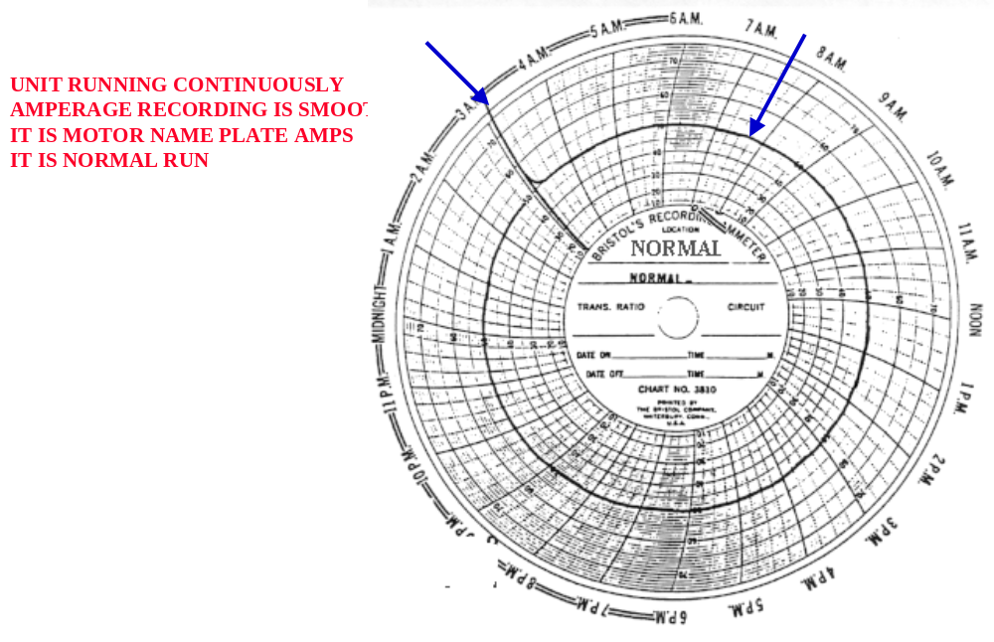

Trouble shooting Example - 2

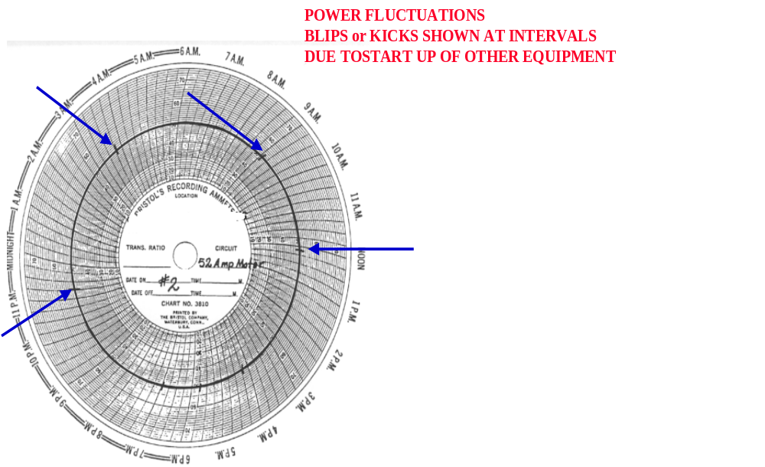

Trouble shooting Example - 3

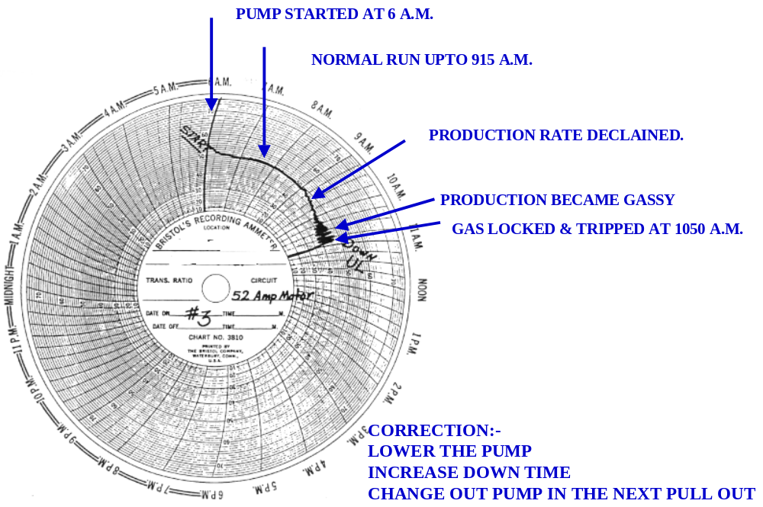

Trouble shooting Example - 4
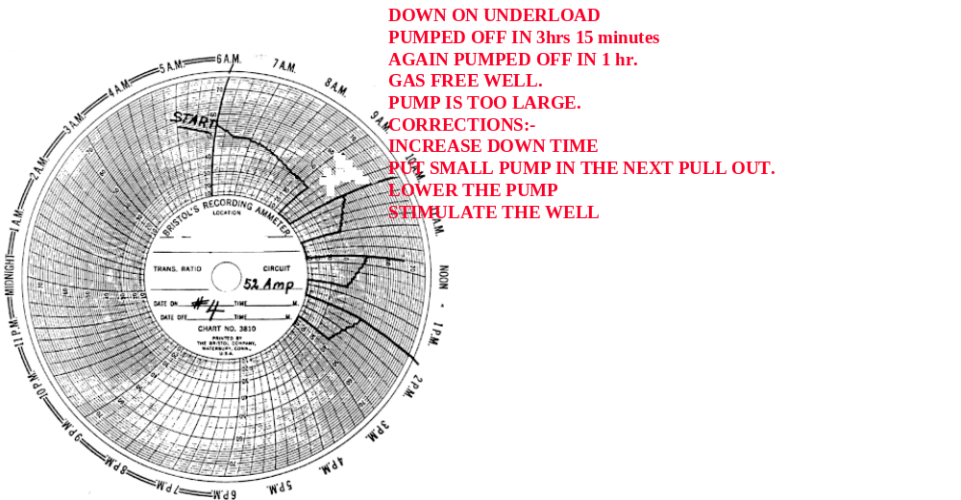

Trouble shooting Example - 5

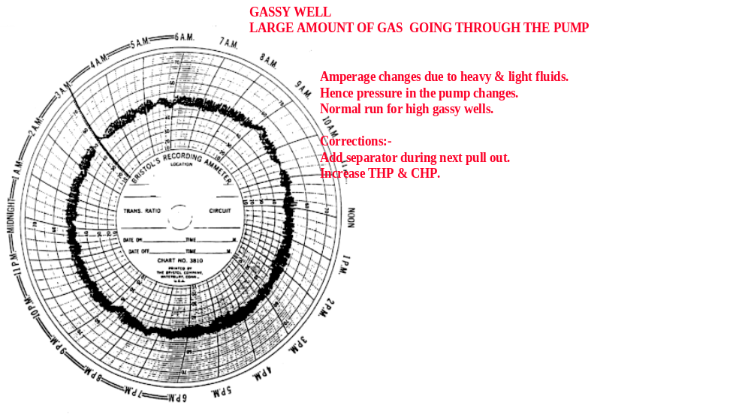

Trouble shooting Example - 6
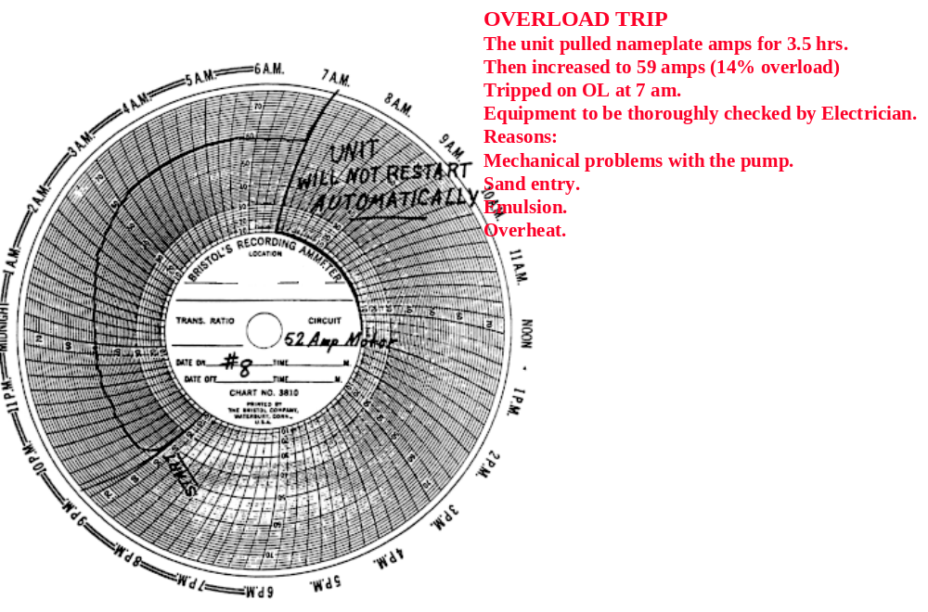

Trouble shooting Example - 7

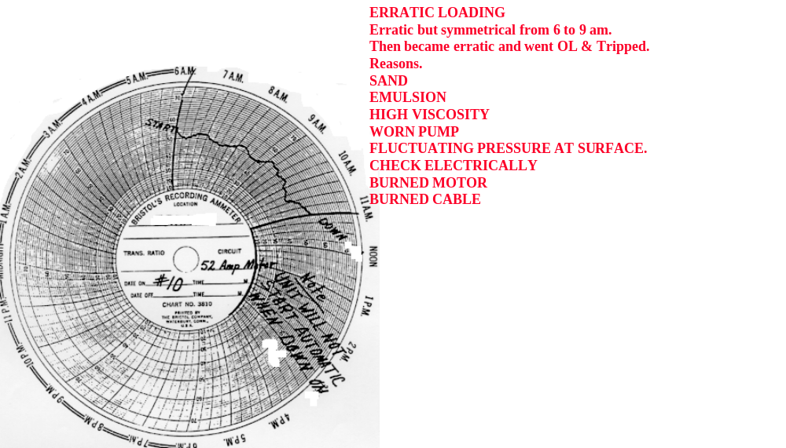

Trouble shooting Example - 8

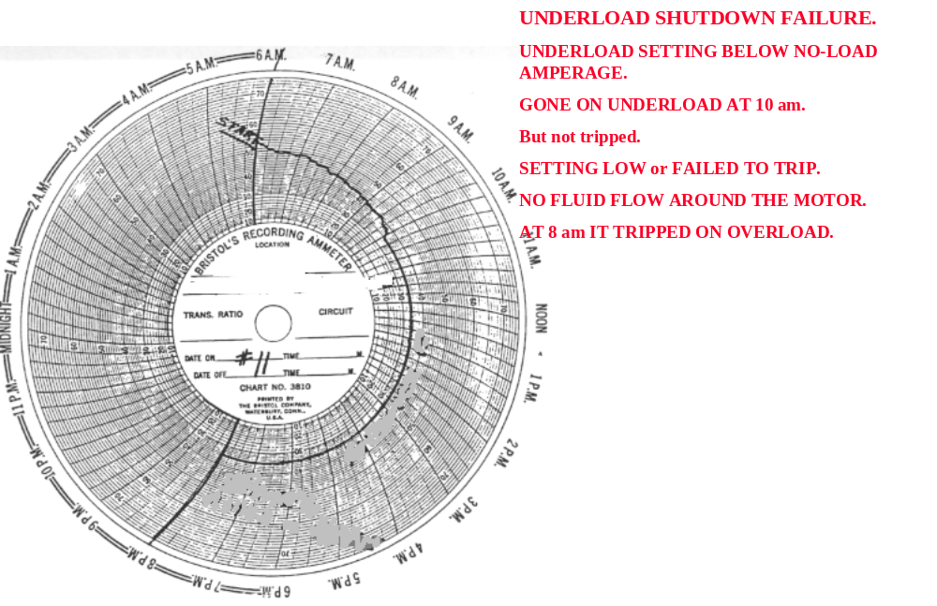

Trouble shooting Example - 9

