AI ConneX — Full Cloud Architecture
SageMaker-Based ML Platform: Dataset Prep → Training → Deployment
Phase 1: Agentic Dataset Preparation | Phase 2: SageMaker Training & Deployment
Architecture Planning Document — Flowcharts, Sequence Diagrams & Data Flow Views

1. Executive Summary
This document lays out the full target cloud architecture for AI ConneX's ML platform, covering both delivery phases end to end: Phase 1 turns raw tenant data into a cleaned, validated, training-ready dataset with full lineage; Phase 2 trains, evaluates, registers, and deploys models through a SageMaker-managed MLOps workflow, exporting approved models for cloud inference and ONNX/WP500 packaging.
Every section below includes a flowchart, a sequence diagram, and a data-flow / architecture view — each rendered as an image and backed by its editable Mermaid source so the diagrams can be dropped into any Mermaid-compatible tool for further iteration.

1.1 Target Architecture Overview
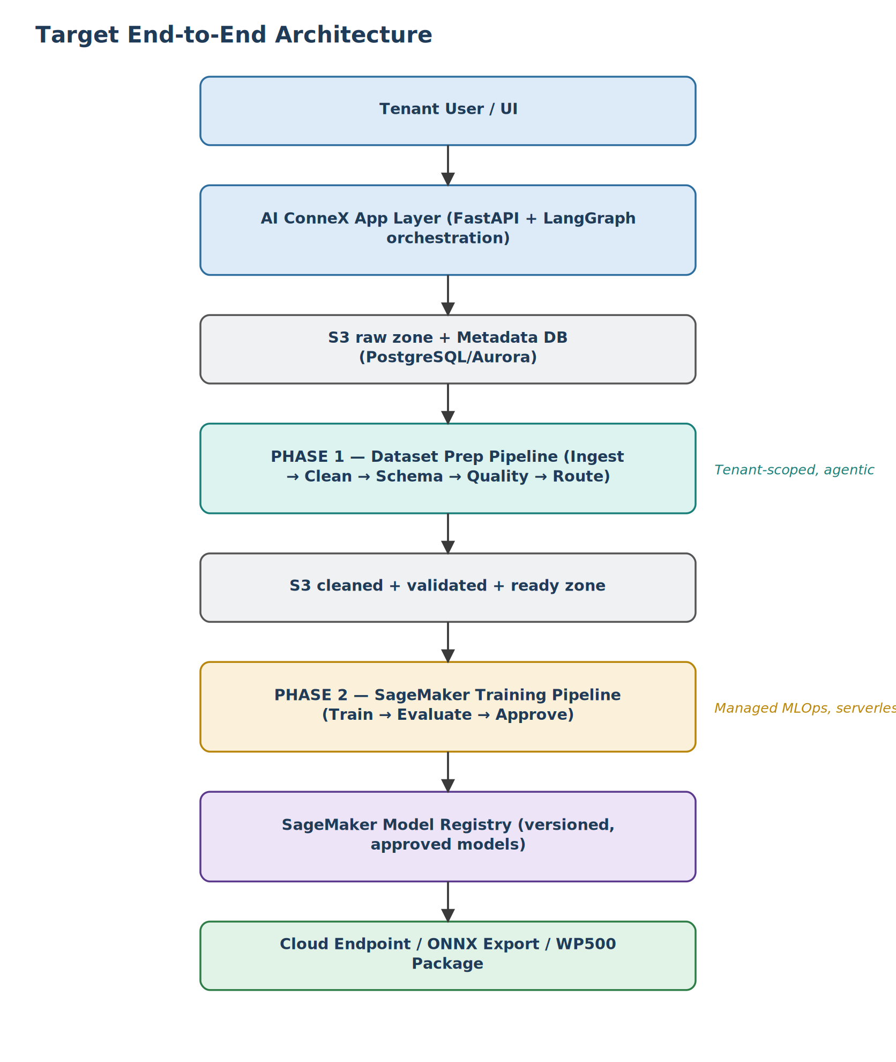
Figure 1 — End-to-end flow from tenant UI through Phase 1 and Phase 2 to deployment.
flowchart TD
A[Tenant User / UI] --> B[AI ConneX App Layer<br/>FastAPI + LangGraph orchestration]
B --> C[S3 raw zone + Metadata DB]
C --> D[Phase 1: Dataset Prep Pipeline]
D --> E[S3 cleaned + validated + ready zone]
E --> F[Phase 2: SageMaker Training Pipeline]
F --> G[SageMaker Model Registry]
G --> H[Cloud Endpoint / ONNX Export / WP500 Package]
Mermaid source above — paste into any Mermaid renderer (mermaid.live, GitHub/GitLab markdown, VS Code Mermaid extension) to get an editable version of the diagram rendered on the previous page.

1.2 Core Platform Choices
- AI ConneX (FastAPI + LangGraph): tenant login, dataset selection, job submission, review screens, and agent-triggered actions.
- Amazon S3: raw, cleaned, validated, and training-ready dataset versions, scoped per tenant.
- SageMaker Pipelines as the orchestration spine for ML jobs — preprocessing, training, evaluation, deployment, and lineage tracking in one managed workflow.

2. Phase 1 — Agentic Dataset Preparation

2.1 Goal
Turn raw tenant data into a cleaned, validated, training-ready dataset with full lineage and repeatability. This aligns directly with the "ML creation support agents" scope from the planning meeting.

2.2 Services
- FastAPI service for the AI ConneX backend.
- S3 buckets/prefixes organized by tenant and pipeline stage.
- Metadata DB (PostgreSQL/Aurora) for job status, dataset manifests, agent logs, and tenant scoping.
- LangGraph inside the app layer for agentic control of ambiguous steps.
- SageMaker Processing jobs for scalable cleaning/validation scripts once logic stabilizes — orchestrated directly by SageMaker Pipelines.

2.3 Storage Layout
- s3://ai-connex/{tenant_id}/raw/
- s3://ai-connex/{tenant_id}/cleaned/
- s3://ai-connex/{tenant_id}/validated/
- s3://ai-connex/{tenant_id}/ready/
- s3://ai-connex/{tenant_id}/manifests/

2.4 Agent Roster
- IngestAgent — pull from upload/DB/source and write raw snapshot.
- CleanAgent — missing values, duplicates, types, basic normalization.
- SchemaAgent — infer and validate structure.
- QualityAgent — null rates, outlier summary, range issues, target presence.
- DatasetClassifierAgent — tag time-series, batch process, telemetry, etc.
- AlgoRouterAgent — choose regression vs. anomaly (vs. forecasting) prep branch.
- Review/ExplanationAgent — LLM only, for explaining issues and suggesting fixes.

2.5 Phase 1 Agentic Flow — Flowchart
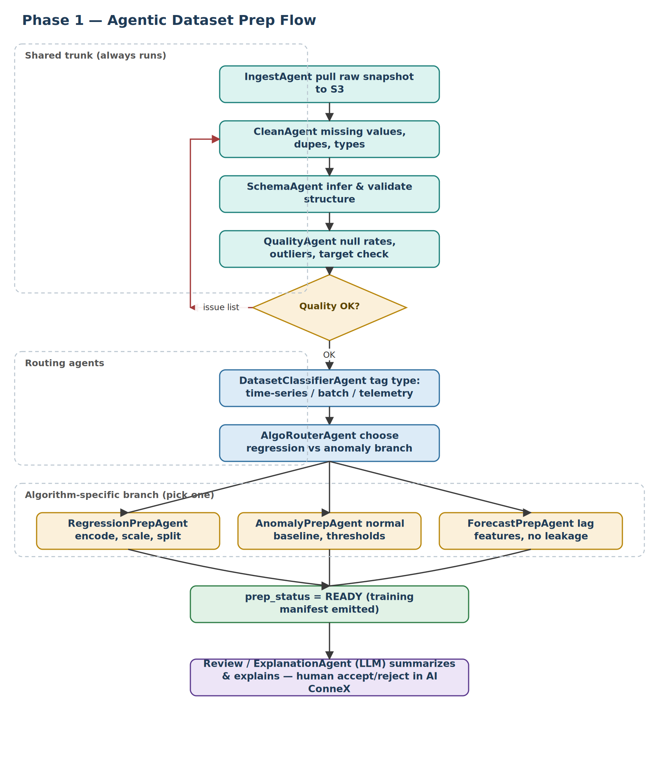
Figure 2 — Shared trunk, quality retry loop, routing, and algorithm-specific branches.
Mermaid source above — paste into any Mermaid renderer (mermaid.live, GitHub/GitLab markdown, VS Code Mermaid extension) to get an editable version of the diagram rendered on the previous page.

2.6 Phase 1 Execution — Sequence Diagram
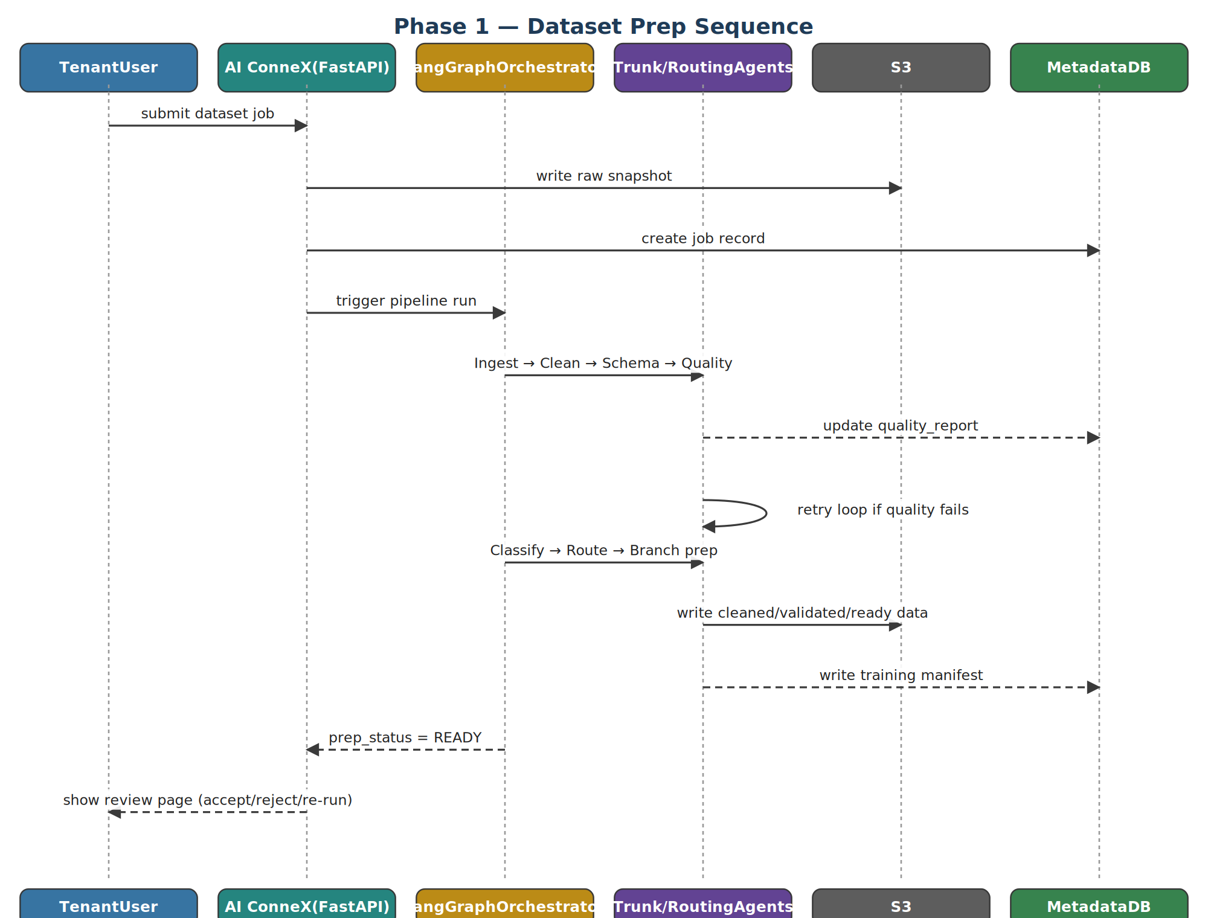
Figure 3 — User submission through orchestration, agent execution, and review.
sequenceDiagram
participant U as Tenant User
participant API as AI ConneX (FastAPI)
participant LG as LangGraph Orchestrator
participant AG as Trunk/Routing Agents
participant S3
participant DB as Metadata DB
U->>API: submit dataset job
API->>S3: write raw snapshot
API->>DB: create job record
API->>LG: trigger pipeline run
LG->>AG: Ingest -> Clean -> Schema -> Quality
AG-->>DB: update quality_report
AG->>AG: retry loop if quality fails
LG->>AG: Classify -> Route -> Branch prep
AG->>S3: write cleaned/validated/ready data
AG-->>DB: write training manifest
LG-->>API: prep_status = READY
API-->>U: show review page (accept/reject/re-run)
Mermaid source above — paste into any Mermaid renderer (mermaid.live, GitHub/GitLab markdown, VS Code Mermaid extension) to get an editable version of the diagram rendered on the previous page.

2.7 Phase 1 Data Flow Architecture
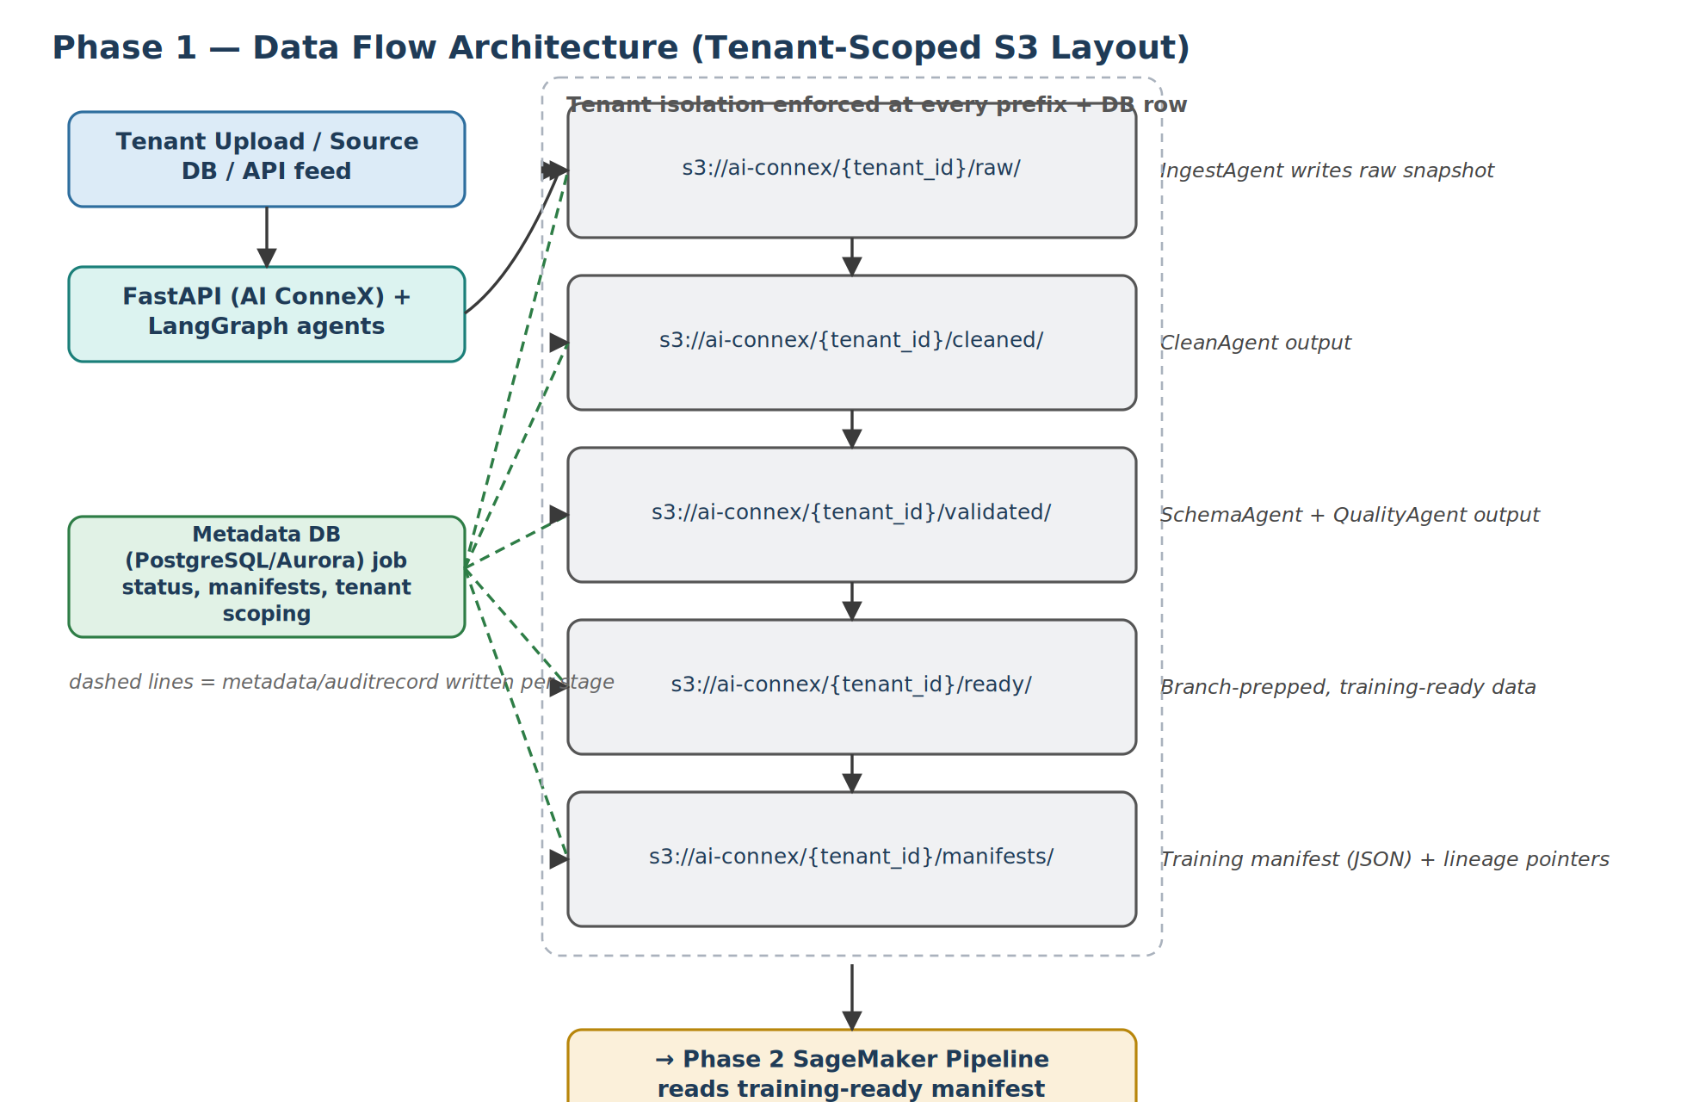
Figure 4 — Tenant-scoped S3 layout with metadata written alongside every stage.
flowchart LR
SRC[Tenant Upload / Source DB] --> APP[FastAPI + LangGraph]
APP --> RAW[s3://tenant/raw/]
RAW --> CLEAN[s3://tenant/cleaned/]
CLEAN --> VALID[s3://tenant/validated/]
VALID --> READY[s3://tenant/ready/]
READY --> MANI[s3://tenant/manifests/]
APP -. metadata .-> DB[(Metadata DB)]
RAW -. metadata .-> DB
CLEAN -. metadata .-> DB
VALID -. metadata .-> DB
READY -. metadata .-> DB
MANI --> P2[Phase 2 SageMaker Pipeline]
Mermaid source above — paste into any Mermaid renderer (mermaid.live, GitHub/GitLab markdown, VS Code Mermaid extension) to get an editable version of the diagram rendered on the previous page.

2.8 Execution Pattern
- User submits dataset job in AI ConneX.
- Backend stores metadata + raw file in S3.
- LangGraph runs the short-loop agent logic for decisions.
- Heavy deterministic transforms run in Python scripts, then move into SageMaker Processing jobs for scale.
- Final output is a training manifest containing: dataset URI, target column, feature schema, split strategy, algorithm family, quality score, and lineage pointers.

2.9 Phase 1 Deliverables
- Cleaned dataset.
- Validation report.
- Training-ready manifest.
- Tenant-scoped lineage trail.
- Human-review page in AI ConneX for accept/reject/re-run.

3. Phase 2 — SageMaker Training & Deployment

3.1 Goal
Train, evaluate, register, and deploy models in a repeatable cloud workflow, then export approved models for cloud inference and WP500/ONNX.

3.2 Services
- SageMaker Pipelines for orchestration — data prep, training, evaluation, model registration, deployment, and monitoring with built-in versioning and lineage.
- SageMaker Training Jobs for regression/anomaly models.
- SageMaker Model Registry for versioned approved models.
- SageMaker Endpoints for cloud inference.
- Optional Lambda/CodePipeline later for CI/CD and promotion to staging/prod.

3.3 Phase 2 Pipeline — Flowchart
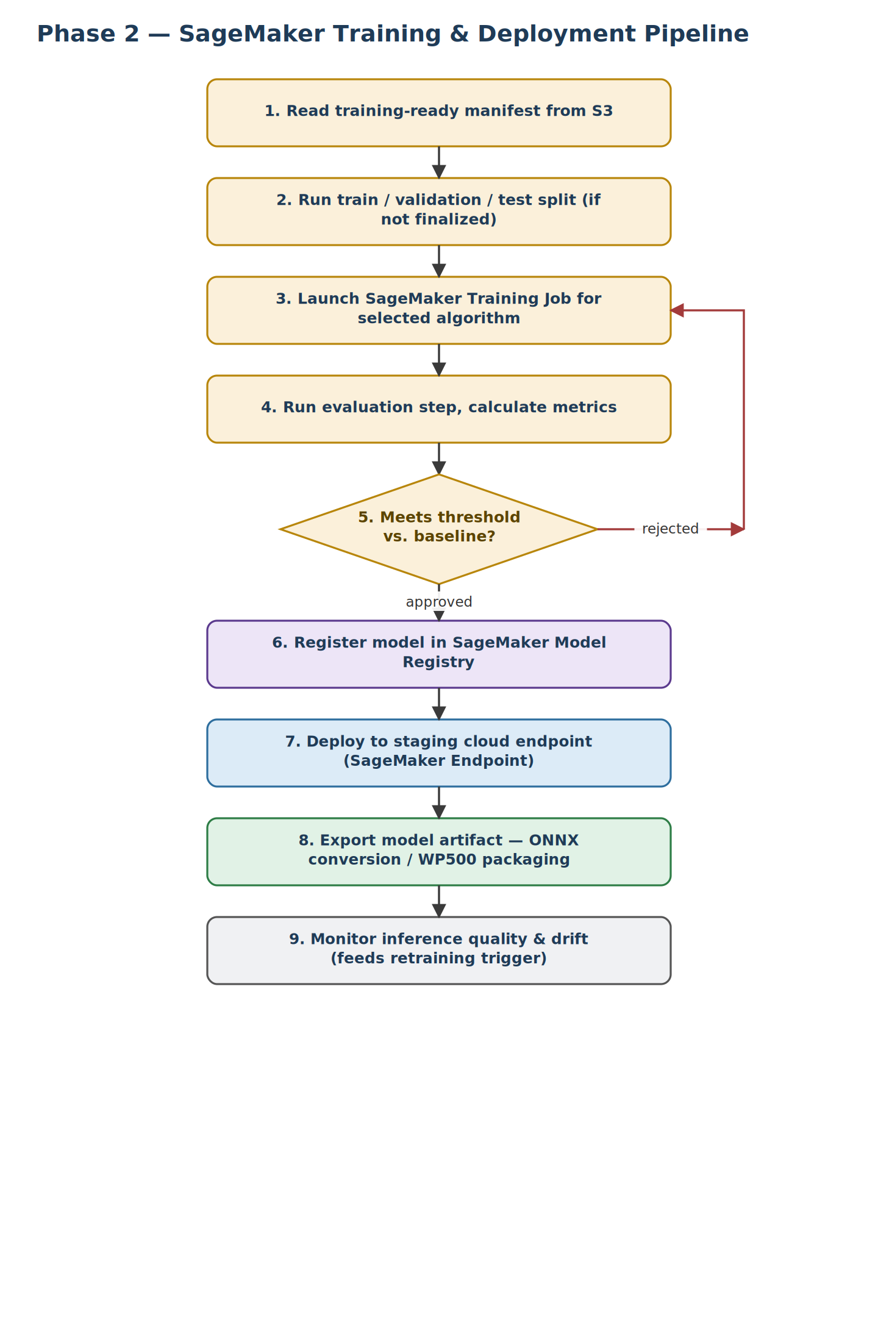
Figure 5 — Nine-step training-to-monitoring pipeline with a retrain loop on rejection.
flowchart TD
S1[1. Read training-ready manifest] --> S2[2. Train/val/test split]
S2 --> S3s[3. Launch SageMaker Training Job]
S3s --> S4[4. Evaluation step + metrics]
S4 --> D{5. Meets threshold vs. baseline?}
D -- Rejected --> S3s
D -- Approved --> S6[6. Register in Model Registry]
S6 --> S7[7. Deploy to staging endpoint]
S7 --> S8[8. Export ONNX / WP500]
S8 --> S9[9. Monitor inference & drift]
Mermaid source above — paste into any Mermaid renderer (mermaid.live, GitHub/GitLab markdown, VS Code Mermaid extension) to get an editable version of the diagram rendered on the previous page.

3.4 Phase 2 Execution — Sequence Diagram
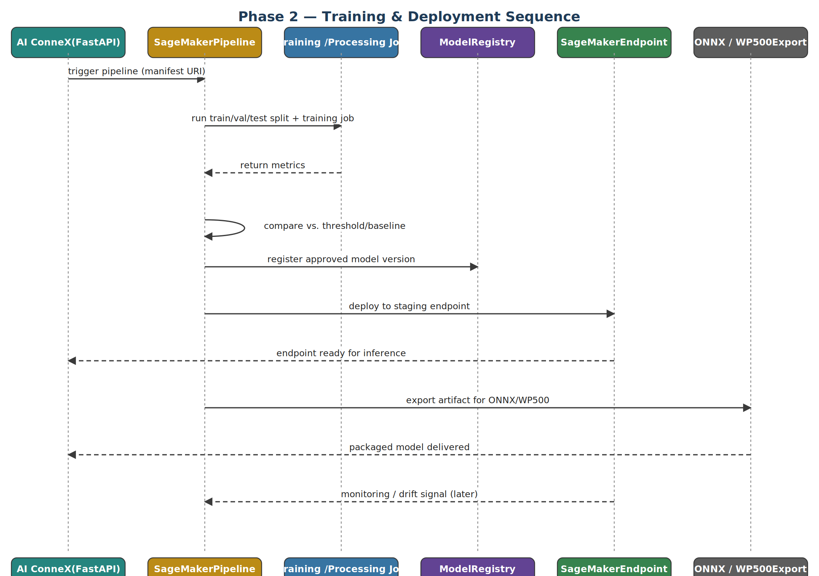
Figure 6 — Pipeline trigger through training, registration, deployment, and export.
sequenceDiagram
participant API as AI ConneX
participant SMP as SageMaker Pipeline
participant TJ as Training/Processing Job
participant MR as Model Registry
participant EP as SageMaker Endpoint
participant EX as ONNX/WP500 Export
API->>SMP: trigger pipeline (manifest URI)
SMP->>TJ: run split + training job
TJ-->>SMP: return metrics
SMP->>SMP: compare vs threshold/baseline
SMP->>MR: register approved model
SMP->>EP: deploy to staging endpoint
EP-->>API: endpoint ready for inference
SMP->>EX: export artifact for ONNX/WP500
EX-->>API: packaged model delivered
EP-->>SMP: monitoring/drift signal (later)
Mermaid source above — paste into any Mermaid renderer (mermaid.live, GitHub/GitLab markdown, VS Code Mermaid extension) to get an editable version of the diagram rendered on the previous page.

3.5 Phase 2 Data Flow Architecture
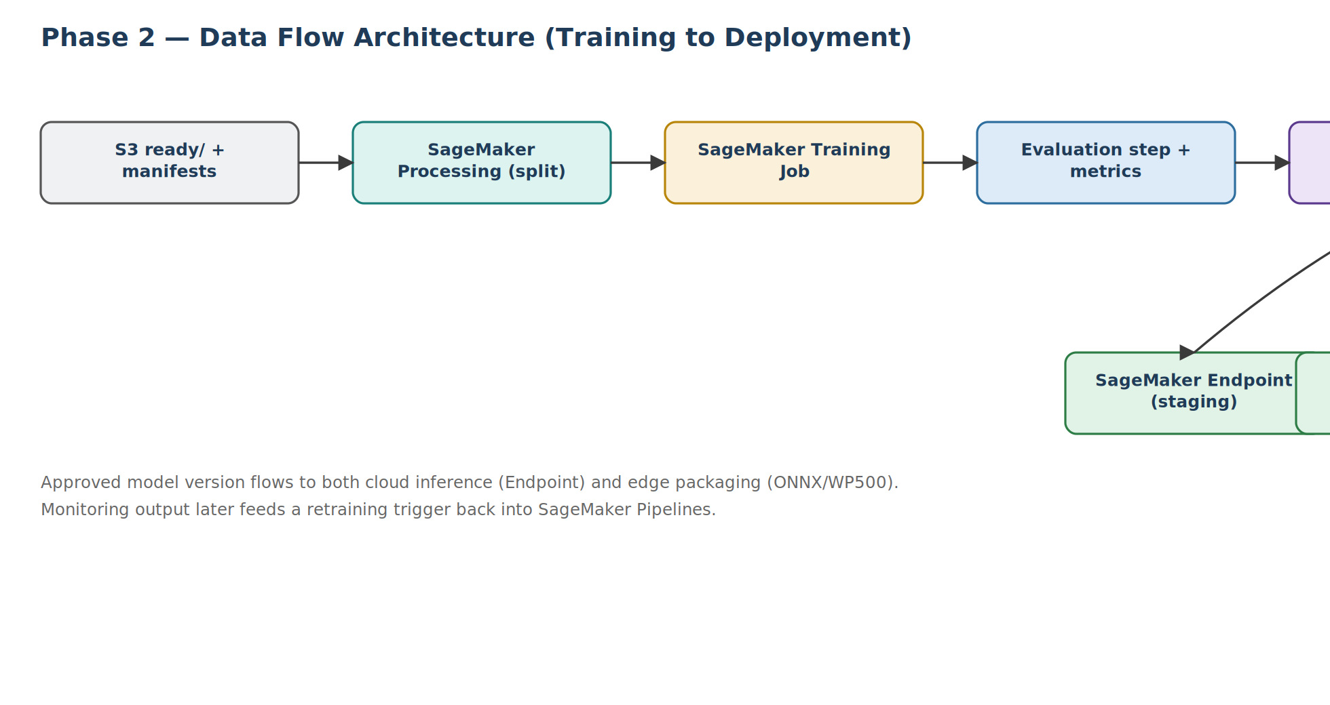
Figure 7 — Manifest through training/evaluation to registry, endpoint, export, and monitoring.
flowchart LR
M[S3 ready/ + manifests] --> PR[SageMaker Processing split]
PR --> TR[SageMaker Training Job]
TR --> EV[Evaluation + metrics]
EV --> REG[Model Registry]
REG --> EP[SageMaker Endpoint staging]
REG --> ONNX[ONNX export / WP500]
EP --> MON[Monitoring & drift]
MON -. retrain trigger .-> PR
Mermaid source above — paste into any Mermaid renderer (mermaid.live, GitHub/GitLab markdown, VS Code Mermaid extension) to get an editable version of the diagram rendered on the previous page.

3.6 Model Families to Start
- Regression.
- Anomaly detection.
These are the two algorithms prioritized in the planning meeting.

3.7 Outputs
- Cloud endpoint for inference.
- Versioned model package.
- Evaluation report.
- Registered model version.
- Export artifact for ONNX conversion.

4. Division of Responsibilities
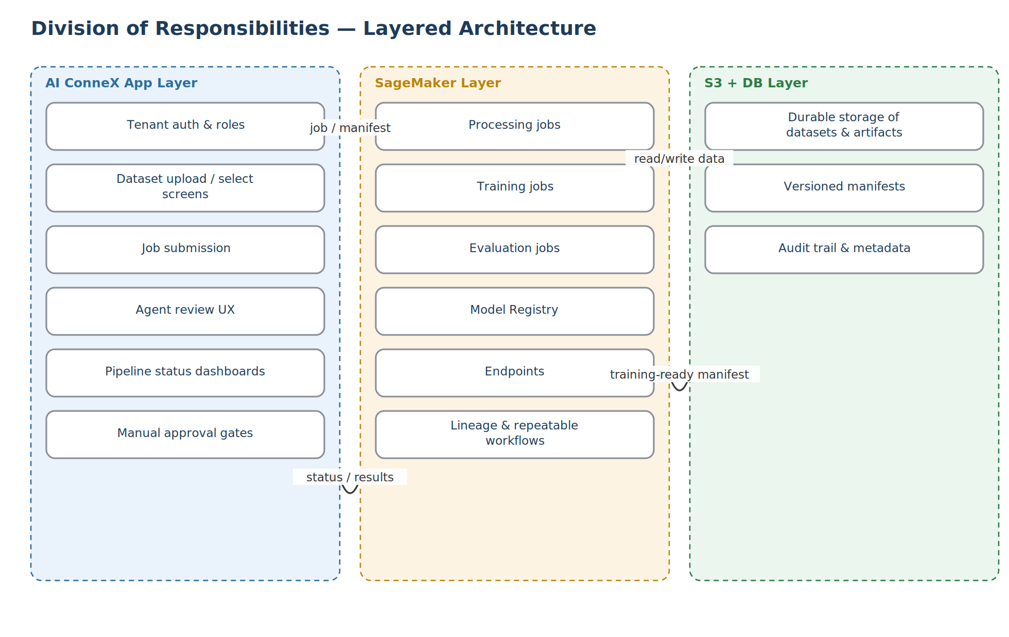
Figure 8 — Layered ownership across the app, SageMaker, and storage layers.
flowchart TB
subgraph L1[AI ConneX App Layer]
A1[Tenant auth & roles]
A2[Dataset upload/select]
A3[Job submission]
A4[Agent review UX]
A5[Pipeline dashboards]
A6[Manual approval gates]
end
subgraph L2[SageMaker Layer]
B1[Processing jobs]
B2[Training jobs]
B3[Evaluation jobs]
B4[Model Registry]
B5[Endpoints]
B6[Lineage & workflows]
end
subgraph L3[S3 + DB Layer]
C1[Durable storage]
C2[Versioned manifests]
C3[Audit trail & metadata]
end
L1 -- job/manifest --> L2
L2 -- status/results --> L1
L2 -- read/write --> L3
L3 -- training-ready manifest --> L2
Mermaid source above — paste into any Mermaid renderer (mermaid.live, GitHub/GitLab markdown, VS Code Mermaid extension) to get an editable version of the diagram rendered on the previous page.

5. Why This Beats Pure Local or Pure EC2
- SageMaker Pipelines is serverless for orchestration and scales automatically — a core advantage over managing your own orchestration infrastructure.
- It integrates directly with training, processing, inference, and lineage tracking in one place.
- EC2 would mean manually building scheduling, retries, lineage, model registration, and deployment plumbing — exactly the undifferentiated work SageMaker removes.

6. Suggested Rollout
Sprint | Focus
Sprint 1 | Set up S3 structure, tenant model, metadata DB. Build FastAPI backend. Implement local Python preprocessing scripts. Add LangGraph orchestration in app layer. Save cleaned outputs and manifests to S3.
Sprint 2 | Migrate heavy preprocessing to SageMaker Processing. Build first SageMaker Pipeline for regression. Train on one real industrial dataset. Store metrics and lineage.
Sprint 3 | Add Model Registry. Deploy cloud inference endpoint. Add anomaly detection branch. Add approval gate in AI ConneX.
Sprint 4 | Export approved model artifact for ONNX conversion. Package for WP500 pipeline. Add monitoring and retraining triggers.

7. Final Stack
Layer | Choice
Frontend/UI | AI ConneX web app
Backend/API | FastAPI
Agentic control | LangGraph
Data processing | Python, pandas, scikit-learn
Storage | Amazon S3
Metadata | PostgreSQL/Aurora
ML orchestration | SageMaker Pipelines
Training/eval | SageMaker Training + Processing
Registry/deploy | SageMaker Model Registry + Endpoints
This gives a full cloud architecture where Phase 1 prepares governed, tenant-scoped datasets and Phase 2 turns them into registered, deployable models through SageMaker-managed MLOps.

8. Agentic Architecture — Detailed Design

8.1 Top-Level Architecture
- Orchestrator: one master agent with a graph/workflow engine (LangGraph or equivalent).
- Stages: common preprocessing trunk (algorithm-agnostic) → dataset/domain routing → algorithm-specific branches (regression, anomaly, forecasting).
flowchart LR
Raw[Raw dataset] --> IB[Ingest + basic clean]
IB --> SQ[Schema + quality check]
SQ --> DC[Dataset/domain classifier]
DC --> AR[Algorithm router]
AR --> AP[Algo-specific prep: reg/anom/forecast]
AP --> TR[Training-ready dataset]
Mermaid source above — paste into any Mermaid renderer (mermaid.live, GitHub/GitLab markdown, VS Code Mermaid extension) to get an editable version of the diagram rendered on the previous page.

8.2 Agent Roles

Shared trunk agents (always run)
- IngestAgent — pulls data from S3/DB/upload into a standard DataFrame.
- CleanAgent — missing values, duplicates, type coercion, basic outlier handling.
- SchemaAgent — infers types, validates columns against expected schema.
- QualityAgent — runs generic checks (null rates, distributions, ranges) and produces a quality report.

Routing agents
- DatasetClassifierAgent — examines schema and metadata, tags dataset type (time-series, batch, sensor telemetry, etc.).
- AlgoRouterAgent — reads user intent + metadata, selects branch: regression vs. anomaly vs. forecasting.

Branch agents
- RegressionPrepAgent — ensures target is continuous, encodes categorical features, handles scaling, splits train/val/test.
- AnomalyPrepAgent — builds normal-only baseline where required, handles label scarcity, sets thresholds/score interpretation metadata.
- ForecastPrepAgent — enforces temporal ordering, builds lag/window features, prevents label leakage (no future info in inputs).

8.3 Shared State Schema
A single "pipeline state" object is passed between agents:
- dataset_ref (S3 URI or DB query)
- df (in-memory handle, not serialized in API responses)
- metadata (columns, units, types)
- quality_report (issues found)
- domain_tags (e.g., {"type": "batch_process", "use_case": "autoclave_quality"})
- algo_choice (e.g., "regression")
- prep_status (enum: RAW, CLEANED, VALIDATED, ROUTED, READY)
Each agent reads state, mutates its piece, and returns updated state.

8.4 Orchestration Logic (LangGraph)
- Nodes: one per agent.
- Edges: RAW → IngestAgent → CleanAgent → SchemaAgent → QualityAgent.
  - From QualityAgent: if quality OK → DatasetClassifierAgent; if quality bad → loop back to CleanAgent with issue list.
  - From DatasetClassifierAgent → AlgoRouterAgent.
  - From AlgoRouterAgent → one of RegressionPrepAgent / AnomalyPrepAgent / ForecastPrepAgent.
  - From branch prep → state READY.
This gives deterministic flow, conditional retries, and an audit trail of decisions.

8.5 Keep Agents Rule-Based; LLM Only Where Needed
- Primary operations: pandas / numpy / scikit-learn preprocessing — fast and deterministic.
- LLM usage: summarizing quality reports, interpreting weird patterns (e.g., mixed units), generating human-readable explanations, proposing fixes when rules are insufficient.
Do not let the LLM be the pipeline — let it handle ambiguous cases and reporting.

8.6 Tenant-Aware Integration
- Every pipeline state carries tenant_id.
- All S3 paths and DB queries are scoped by tenant.
- Agents must never cross-tenant data — no shared DataFrame, no cross-tenant joins.
- Orchestrator enforces tenant isolation at the entry point.

8.7 Wire to SageMaker / Training
Final state prep_status = READY triggers creation of a training manifest containing:
- dataset location
- algo branch used
- feature/target schema
- splits
- quality report
This manifest is passed into a SageMaker training job for regression or anomaly detection, or an EC2-based trainer. ONNX/edge work starts after this training step.

8.8 Concrete Build Order
- Step 1: Implement IngestAgent + CleanAgent + SchemaAgent + QualityAgent with plain Python.
- Step 2: Implement DatasetClassifierAgent + AlgoRouterAgent (rule-based first).
- Step 3: Implement RegressionPrepAgent and AnomalyPrepAgent for one real use case (autoclave quality).
- Step 4: Wrap all agents in a LangGraph (or equivalent) graph and run end-to-end on one tenant dataset.
- Step 5: Add minimal LLM calls for quality-report explanation and ambiguous cleaning suggestions.
- Step 6: Emit a training manifest and hand it to a manual training script as a first integration.
- Step 7: Only after that, connect SageMaker / EC2 training and the ONNX export.
This is the agentic architecture needed now: shared trunk, routing layer, algorithm branches, orchestrated by a master agent in a graph engine, with strict tenant-aware state and clear handoff to training and ONNX.

9. References
- DataCamp — CrewAI vs LangGraph vs AutoGen: https://www.datacamp.com/tutorial/crewai-vs-langgraph-vs-autogen
- MDPI — journal article: https://www.mdpi.com/2673-2688/6/10/257
- Teradata — AI data pipeline insights: https://www.teradata.com/insights/ai-and-machine-learning/ai-data-pipeline
- lakeFS — Data preprocessing in machine learning: https://lakefs.io/blog/data-preprocessing-in-machine-learning/
- Learn with Neeraj — Agentic data pipeline architecture design: https://learnwithneeraj.com/ai-gen-ai/agentic-data-platform/agentic-data-pipeline-architecture-design

