VISION KARNATAKA FOUNDATION
DETAILED PROJECT REPORT (DPR)
BASE64 ASSET & STANDARD CORPORATE REPORT UNIT
DPR Track: DPRTypeEnum.BANK_LOAN | Depth: STANDARD
Location: Bengaluru Urban, Karnataka

1.0 Executive Summary & Project Highlights
Base64 Asset & Standard Corporate Report Unit is a commercial enterprise located in Bengaluru Urban, Karnataka. The total project cost is estimated at ₹2,209,200.00, funded by promoter contribution of ₹1,600,000.00 and bank loan of ₹4,750,000.00. The project features an average 5-year DSCR of -1.01 and break-even point of 85.0%.
Total Project Cost | ₹2,209,200.00
Promoter Equity Contribution | ₹1,600,000.00
Proposed Bank Loan | ₹4,750,000.00
Government Subsidy Claim | ₹0.00
Average 5-Year DSCR | -1.01

2.0 Cost of Project & Means of Finance
Land & Site Development: ₹0.00
Building & Civil Works: ₹1,200,000.00
Furniture & Fixtures: ₹150,000.00
Working Capital Margin: ₹500,000.00
Total Capital Outlay: ₹2,209,200.00

3.0 5-Year Projected Income Statement (P&L)
Metric | Year 1 | Year 2 | Year 3 | Year 4 | Year 5
Capacity Utilization % | 60.0% | 75.0% | 85.0% | 90.0% | 95.0%
Gross Revenue (₹) | ₹6,480,000 | ₹8,100,000 | ₹9,180,000 | ₹9,720,000 | ₹10,260,000
Total OPEX (₹) | ₹8,218,560 | ₹9,378,000 | ₹10,236,060 | ₹10,793,295 | ₹11,362,768
PAT (Net Profit) (₹) | ₹-2,384,560 | ₹-1,829,000 | ₹-1,512,060 | ₹-1,434,295 | ₹-1,368,768
DSCR Ratio | -1.22 | -0.96 | -0.86 | -0.94 | -1.06

4.0 Graphical Financial Projections & Analysis
Chart: Revenue Ebitda
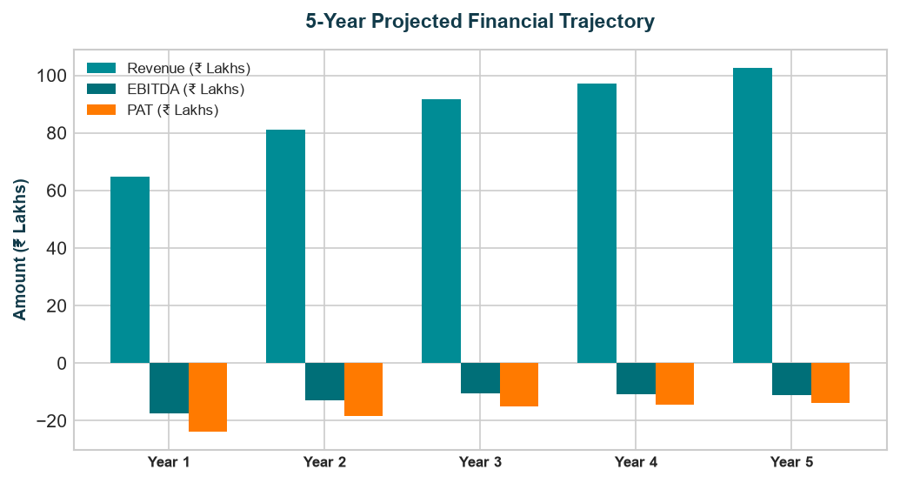
Chart: Capex Pie
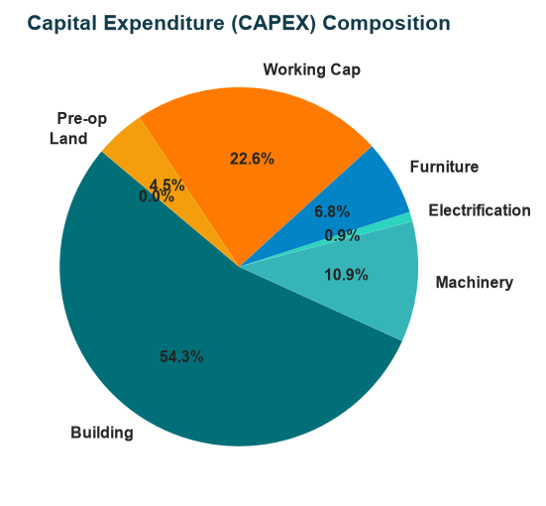
Chart: Finance Pie
