VISION KARNATAKA FOUNDATION
DETAILED PROJECT REPORT (DPR)
KARNATAKA SOLAR GIGA POWER PVT LTD
DPR Track: DPRTypeEnum.CORPORATE_DPR | Depth: DETAILED
Location: Tumakuru, Karnataka

1.0 Executive Summary & Project Highlights
Karnataka Solar Giga Power Pvt Ltd is a commercial enterprise located in Tumakuru, Karnataka. The total project cost is estimated at ₹569,324,800.00, funded by promoter contribution of ₹130,000,000.00 and bank loan of ₹370,000,000.00. The project features an average 5-year DSCR of 1.64 and break-even point of 85.0%.
Total Project Cost | ₹569,324,800.00
Promoter Equity Contribution | ₹130,000,000.00
Proposed Bank Loan | ₹370,000,000.00
Government Subsidy Claim | ₹0.00
Average 5-Year DSCR | 1.64

2.0 Cost of Project & Means of Finance
Land & Site Development: ₹45,000,000.00
Building & Civil Works: ₹25,000,000.00
Furniture & Fixtures: ₹3,000,000.00
Working Capital Margin: ₹15,000,000.00
Total Capital Outlay: ₹569,324,800.00

3.0 5-Year Projected Income Statement (P&L)
Metric | Year 1 | Year 2 | Year 3 | Year 4 | Year 5
Capacity Utilization % | 60.0% | 75.0% | 85.0% | 90.0% | 95.0%
Gross Revenue (₹) | ₹138,105,000 | ₹172,631,250 | ₹195,648,750 | ₹207,157,500 | ₹218,666,250
Total OPEX (₹) | ₹83,233,390 | ₹94,411,938 | ₹102,566,952 | ₹107,703,018 | ₹112,940,127
PAT (Net Profit) (₹) | ₹-45,487,390 | ₹-19,981,354 | ₹-2,960,536 | ₹4,177,862 | ₹10,500,343
DSCR Ratio | 0.96 | 1.43 | 1.77 | 1.94 | 2.11

4.0 Graphical Financial Projections & Analysis
Chart: Revenue Ebitda
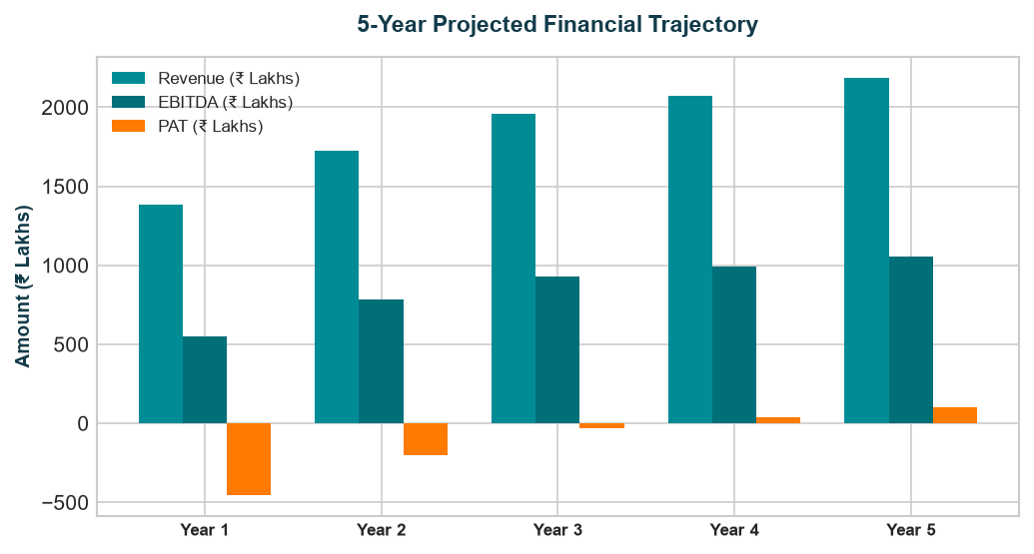
Chart: Capex Pie
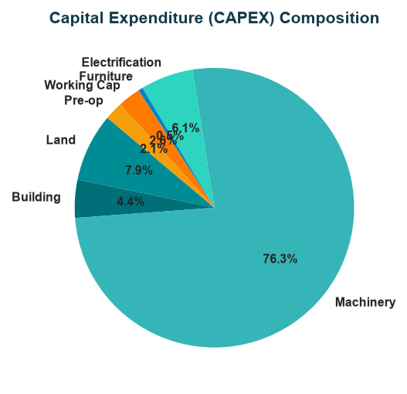
Chart: Finance Pie
