VISION KARNATAKA FOUNDATION
DETAILED PROJECT REPORT (DPR)
VYSHNAVI AUTOMATION & ROBOTICS PVT LTD
DPR Track: DPRTypeEnum.BANK_LOAN | Depth: STANDARD
Location: Bengaluru Urban, Karnataka

1.0 Executive Summary & Project Highlights
Vyshnavi Automation & Robotics Pvt Ltd is a commercial enterprise located in Bengaluru Urban, Karnataka. The total project cost is estimated at ₹29,200,000.00, funded by promoter contribution of ₹8,700,000.00 and bank loan of ₹20,500,000.00. The project features an average 5-year DSCR of 26.87 and break-even point of 25.0%.
Total Project Cost | ₹29,200,000.00
Promoter Equity Contribution | ₹8,700,000.00
Proposed Bank Loan | ₹20,500,000.00
Government Subsidy Claim | ₹0.00
Average 5-Year DSCR | 26.87

2.0 Cost of Project & Means of Finance
Land & Site Development: ₹2,500,000.00
Building & Civil Works: ₹4,500,000.00
Furniture & Fixtures: ₹600,000.00
Working Capital Margin: ₹2,000,000.00
Total Capital Outlay: ₹29,200,000.00

3.0 5-Year Projected Income Statement (P&L)
Metric | Year 1 | Year 2 | Year 3 | Year 4 | Year 5
Capacity Utilization % | 60.0% | 75.0% | 85.0% | 90.0% | 95.0%
Gross Revenue (₹) | ₹157,500,000 | ₹196,875,000 | ₹223,125,000 | ₹236,250,000 | ₹249,375,000
Total OPEX (₹) | ₹21,651,400 | ₹24,911,350 | ₹27,280,380 | ₹28,759,766 | ₹30,267,300
PAT (Net Profit) (₹) | ₹97,909,575 | ₹125,318,738 | ₹143,552,340 | ₹152,609,425 | ₹161,645,400
DSCR Ratio | 16.51 | 22.36 | 27.45 | 31.57 | 36.47

4.0 Graphical Financial Projections & Analysis
Chart: Revenue Ebitda
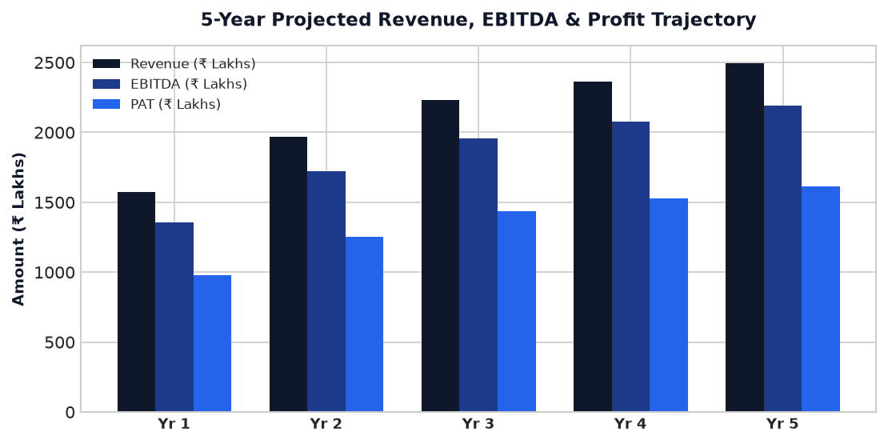
Chart: Capex Pie
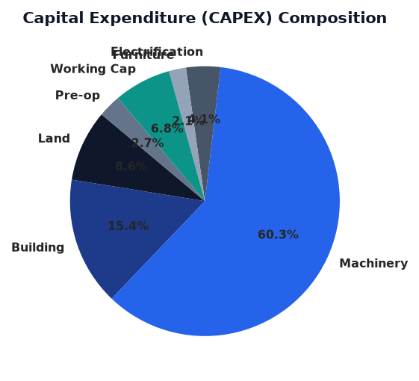
Chart: Finance Pie
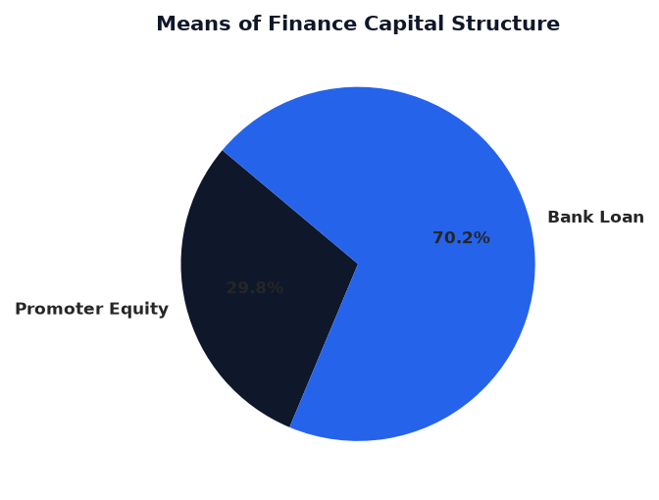
Chart: Dscr Curve
