VISION KARNATAKA FOUNDATION
DETAILED PROJECT REPORT (DPR)
ZERO OVERLAP TOC HEADER REPORT
DPR Track: DPRTypeEnum.BANK_LOAN | Depth: STANDARD
Location: Bengaluru Urban, Karnataka

1.0 Executive Summary & Project Highlights
Zero Overlap TOC Header Report is a commercial enterprise located in Bengaluru Urban, Karnataka. The total project cost is estimated at ₹17,960,000.00, funded by promoter contribution of ₹8,700,000.00 and bank loan of ₹20,500,000.00. The project features an average 5-year DSCR of 3.07 and break-even point of 43.9%.
Total Project Cost | ₹17,960,000.00
Promoter Equity Contribution | ₹8,700,000.00
Proposed Bank Loan | ₹20,500,000.00
Government Subsidy Claim | ₹0.00
Average 5-Year DSCR | 3.07

2.0 Cost of Project & Means of Finance
Land & Site Development: ₹2,500,000.00
Building & Civil Works: ₹4,500,000.00
Furniture & Fixtures: ₹600,000.00
Working Capital Margin: ₹2,000,000.00
Total Capital Outlay: ₹17,960,000.00

3.0 5-Year Projected Income Statement (P&L)
Metric | Year 1 | Year 2 | Year 3 | Year 4 | Year 5
Capacity Utilization % | 60.0% | 75.0% | 85.0% | 90.0% | 95.0%
Gross Revenue (₹) | ₹42,750,000 | ₹53,437,500 | ₹60,562,500 | ₹64,125,000 | ₹67,687,500
Total OPEX (₹) | ₹28,575,500 | ₹34,773,875 | ₹38,991,225 | ₹41,228,105 | ₹43,477,223
PAT (Net Profit) (₹) | ₹7,923,375 | ₹11,597,719 | ₹14,085,956 | ₹15,387,671 | ₹16,680,208
DSCR Ratio | 1.88 | 2.58 | 3.17 | 3.61 | 4.14

4.0 Graphical Financial Projections & Analysis
Chart: Revenue Ebitda
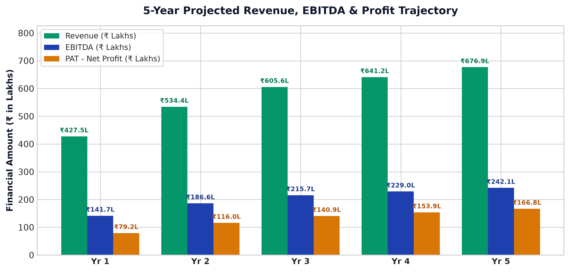
Chart: Capex Pie
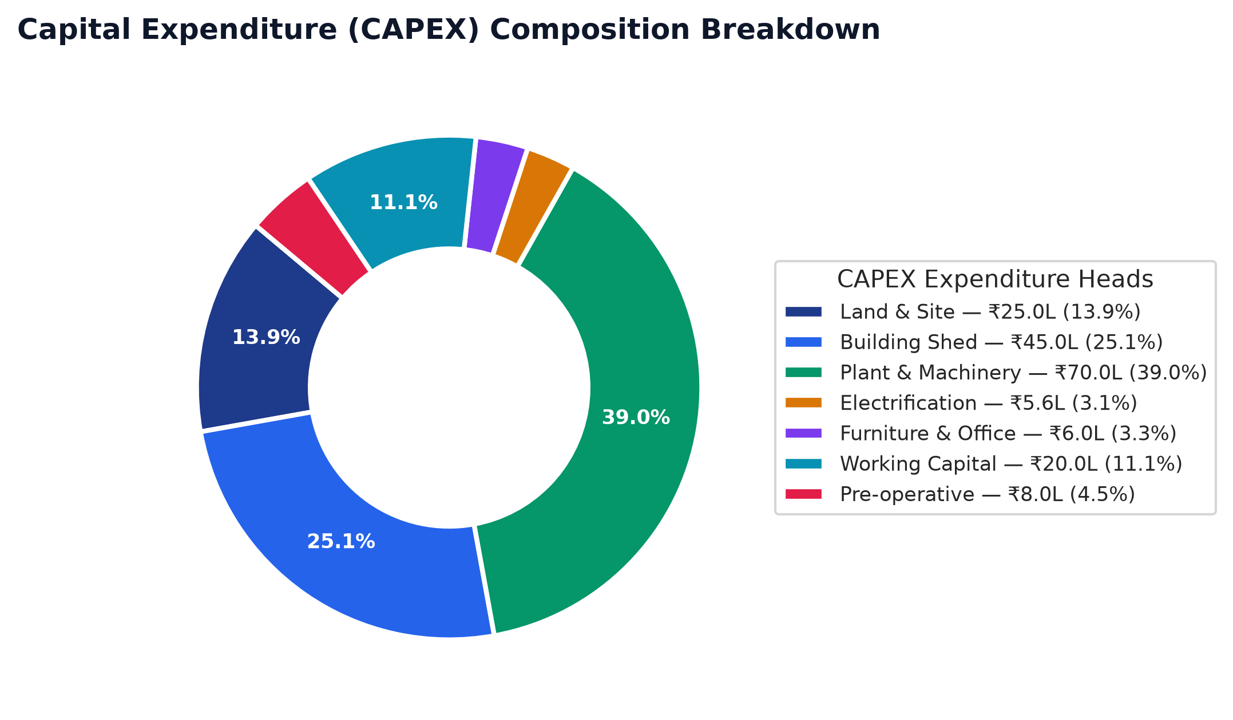
Chart: Finance Pie

Chart: Dscr Curve
