VISION KARNATAKA FOUNDATION
DETAILED PROJECT REPORT (DPR)
KARNATAKA SMART GRID TECHNOLOGIES
DPR Track: DPRTypeEnum.BANK_LOAN | Depth: STANDARD
Location: Mysuru, Karnataka

1.0 Executive Summary & Project Highlights
Karnataka Smart Grid Technologies is a commercial enterprise located in Mysuru, Karnataka. The total project cost is estimated at ₹500,000.00, funded by promoter contribution of ₹5,400,000.00 and bank loan of ₹12,600,000.00. The project features an average 5-year DSCR of -1.08 and break-even point of 85.0%.
Total Project Cost | ₹500,000.00
Promoter Equity Contribution | ₹5,400,000.00
Proposed Bank Loan | ₹12,600,000.00
Government Subsidy Claim | ₹0.00
Average 5-Year DSCR | -1.08

2.0 Cost of Project & Means of Finance
Land & Site Development: ₹0.00
Building & Civil Works: ₹0.00
Furniture & Fixtures: ₹0.00
Working Capital Margin: ₹500,000.00
Total Capital Outlay: ₹500,000.00

3.0 5-Year Projected Income Statement (P&L)
Metric | Year 1 | Year 2 | Year 3 | Year 4 | Year 5
Capacity Utilization % | 60.0% | 75.0% | 85.0% | 90.0% | 95.0%
Gross Revenue (₹) | ₹1,800,000 | ₹2,250,000 | ₹2,550,000 | ₹2,700,000 | ₹2,850,000
Total OPEX (₹) | ₹5,130,000 | ₹5,620,500 | ₹6,023,400 | ₹6,339,195 | ₹6,665,905
PAT (Net Profit) (₹) | ₹-4,653,000 | ₹-4,428,900 | ₹-4,267,200 | ₹-4,168,395 | ₹-4,080,505
DSCR Ratio | -0.87 | -0.94 | -1.05 | -1.19 | -1.37

4.0 Graphical Financial Projections & Analysis
Chart: Revenue Ebitda
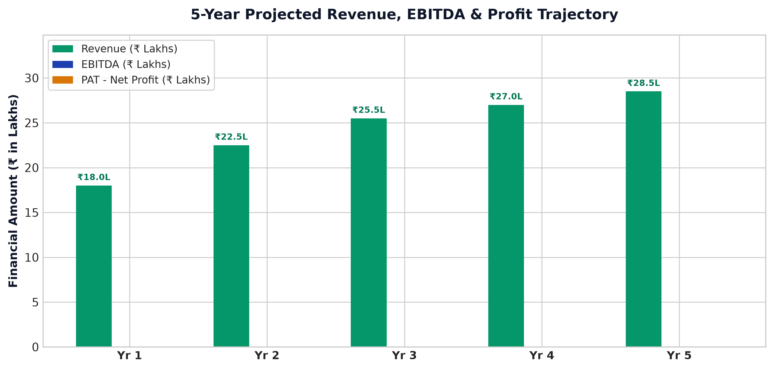
Chart: Capex Pie
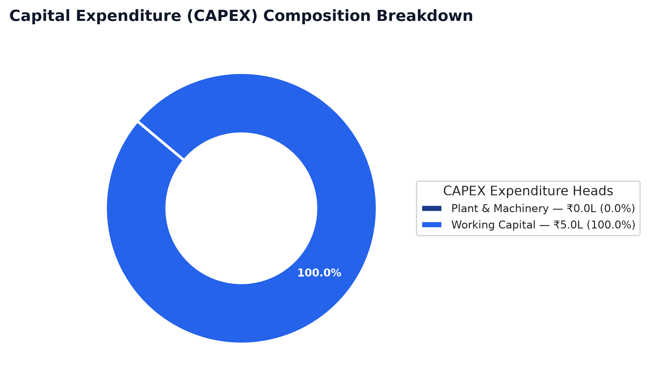
Chart: Finance Pie
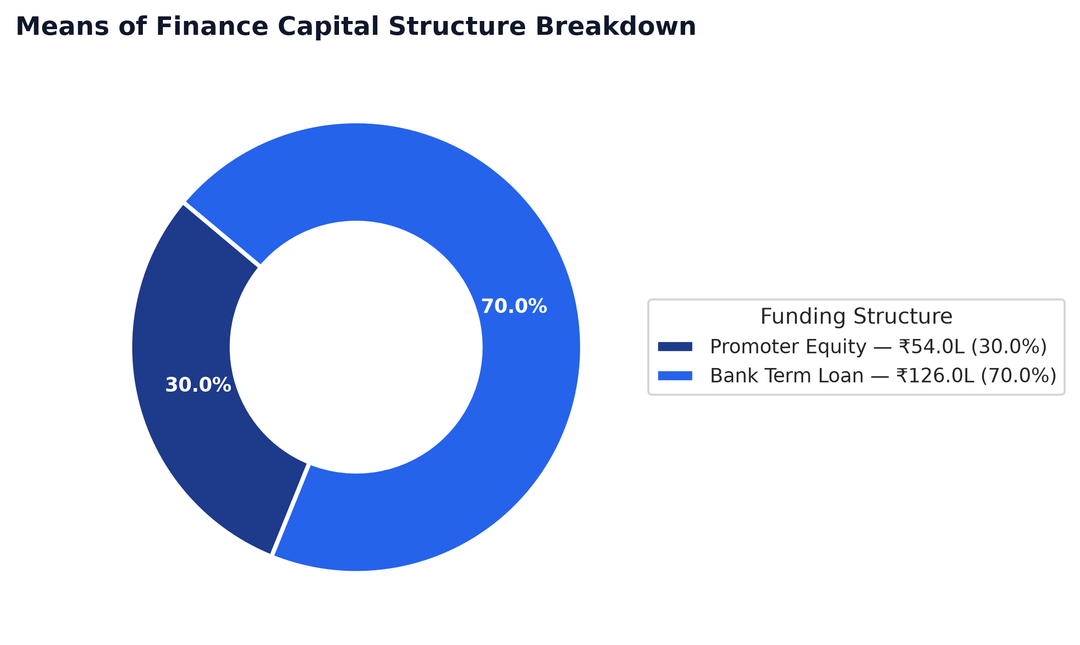
Chart: Dscr Curve
