VISION KARNATAKA FOUNDATION
DETAILED PROJECT REPORT (DPR)
ENTERPRISE
DPR Track: DPRTypeEnum.GOVT_SCHEME | Depth: STANDARD
Location: Bengaluru, Karnataka

1.0 Executive Summary & Project Highlights
Enterprise is a commercial enterprise located in Bengaluru, Karnataka. The total project cost is estimated at ₹500,000.00, funded by promoter contribution of ₹125,000.00 and bank loan of ₹375,000.00. The project features an average 5-year DSCR of -36.43 and break-even point of 85.0%.
Total Project Cost | ₹500,000.00
Promoter Equity Contribution | ₹125,000.00
Proposed Bank Loan | ₹375,000.00
Government Subsidy Claim | ₹0.00
Average 5-Year DSCR | -36.43

2.0 Cost of Project & Means of Finance
Land & Site Development: ₹0.00
Building & Civil Works: ₹0.00
Furniture & Fixtures: ₹0.00
Working Capital Margin: ₹500,000.00
Total Capital Outlay: ₹500,000.00

3.0 5-Year Projected Income Statement (P&L)
Metric | Year 1 | Year 2 | Year 3 | Year 4 | Year 5
Capacity Utilization % | 60.0% | 75.0% | 85.0% | 90.0% | 95.0%
Gross Revenue (₹) | ₹1,800,000 | ₹2,250,000 | ₹2,550,000 | ₹2,700,000 | ₹2,850,000
Total OPEX (₹) | ₹5,130,000 | ₹5,620,500 | ₹6,023,400 | ₹6,339,195 | ₹6,665,905
PAT (Net Profit) (₹) | ₹-3,369,375 | ₹-3,402,000 | ₹-3,497,025 | ₹-3,654,945 | ₹-3,823,780
DSCR Ratio | -29.11 | -31.65 | -35.22 | -40.1 | -46.04

4.0 Graphical Financial Projections & Analysis
Chart: Revenue Ebitda
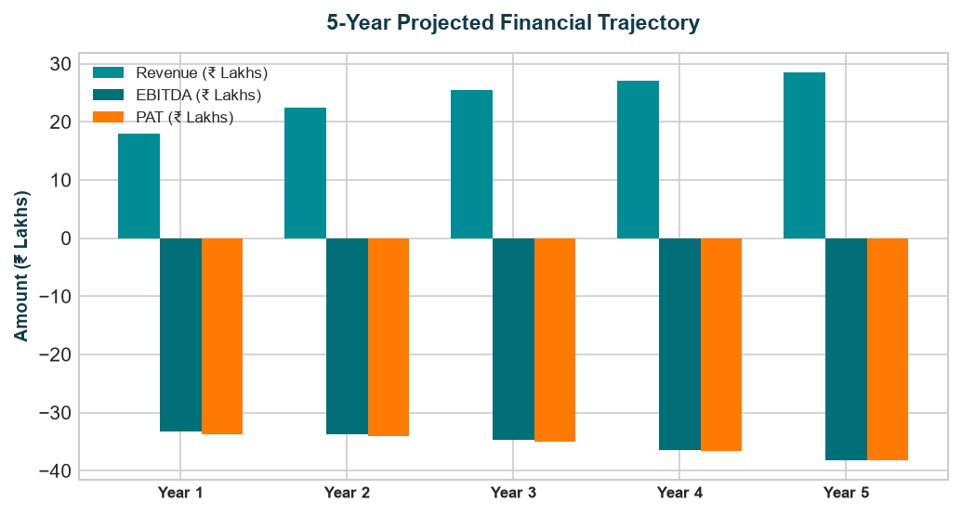
Chart: Capex Pie
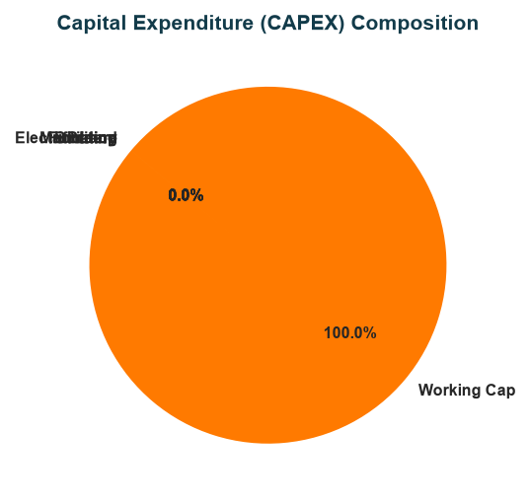
Chart: Finance Pie
