VISION KARNATAKA FOUNDATION
DETAILED PROJECT REPORT (DPR)
SHRI LAKSHMI BESAN & AGRO FOOD PROCESSING UNIT
DPR Track: DPRTypeEnum.BANK_LOAN | Depth: DETAILED
Location: Mysuru, Karnataka

1.0 Executive Summary & Project Highlights
Shri Lakshmi Besan & Agro Food Processing Unit is a commercial enterprise located in Mysuru, Karnataka. The total project cost is estimated at ₹489,800.00, funded by promoter contribution of ₹100,000.00 and bank loan of ₹360,000.00. The project features an average 5-year DSCR of -27.06 and break-even point of 85.0%.
Total Project Cost | ₹489,800.00
Promoter Equity Contribution | ₹100,000.00
Proposed Bank Loan | ₹360,000.00
Government Subsidy Claim | ₹140,000.00
Average 5-Year DSCR | -27.06

2.0 Cost of Project & Means of Finance
Land & Site Development: ₹0.00
Building & Civil Works: ₹150,000.00
Furniture & Fixtures: ₹35,000.00
Working Capital Margin: ₹80,000.00
Total Capital Outlay: ₹489,800.00

3.0 5-Year Projected Income Statement (P&L)
Metric | Year 1 | Year 2 | Year 3 | Year 4 | Year 5
Capacity Utilization % | 60.0% | 75.0% | 85.0% | 90.0% | 95.0%
Gross Revenue (₹) | ₹2,160,000 | ₹2,700,000 | ₹3,060,000 | ₹3,240,000 | ₹3,420,000
Total OPEX (₹) | ₹4,559,140 | ₹5,068,450 | ₹5,468,250 | ₹5,758,933 | ₹6,058,282
PAT (Net Profit) (₹) | ₹-2,479,590 | ₹-2,442,060 | ₹-2,475,020 | ₹-2,578,863 | ₹-2,691,372
DSCR Ratio | -22.59 | -23.84 | -26.03 | -29.4 | -33.46

4.0 Graphical Financial Projections & Analysis
Chart: Revenue Ebitda
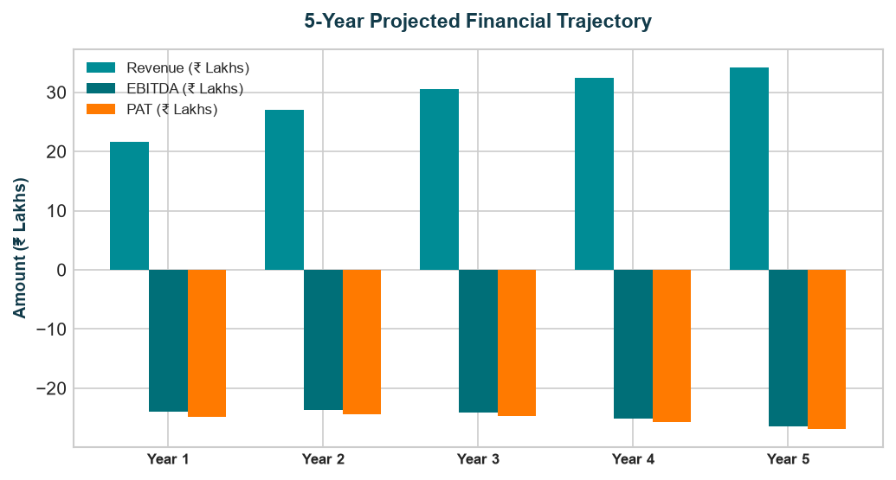
Chart: Capex Pie
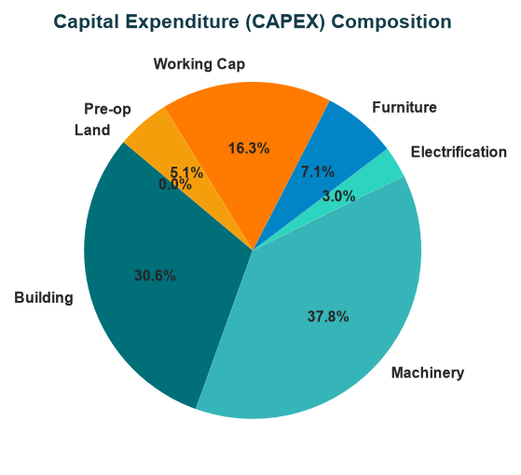
Chart: Finance Pie
