VISION KARNATAKA FOUNDATION
DETAILED PROJECT REPORT (DPR)
ZERO OVERLAP DONUT CHARTS UNIT
DPR Track: DPRTypeEnum.BANK_LOAN | Depth: STANDARD
Location: Bengaluru Urban, Karnataka

1.0 Executive Summary & Project Highlights
Zero Overlap Donut Charts Unit is a commercial enterprise located in Bengaluru Urban, Karnataka. The total project cost is estimated at ₹15,152,000.00, funded by promoter contribution of ₹8,700,000.00 and bank loan of ₹20,500,000.00. The project features an average 5-year DSCR of 2.09 and break-even point of 56.6%.
Total Project Cost | ₹15,152,000.00
Promoter Equity Contribution | ₹8,700,000.00
Proposed Bank Loan | ₹20,500,000.00
Government Subsidy Claim | ₹0.00
Average 5-Year DSCR | 2.09

2.0 Cost of Project & Means of Finance
Land & Site Development: ₹2,500,000.00
Building & Civil Works: ₹4,500,000.00
Furniture & Fixtures: ₹600,000.00
Working Capital Margin: ₹2,000,000.00
Total Capital Outlay: ₹15,152,000.00

3.0 5-Year Projected Income Statement (P&L)
Metric | Year 1 | Year 2 | Year 3 | Year 4 | Year 5
Capacity Utilization % | 60.0% | 75.0% | 85.0% | 90.0% | 95.0%
Gross Revenue (₹) | ₹30,600,000 | ₹38,250,000 | ₹43,350,000 | ₹45,900,000 | ₹48,450,000
Total OPEX (₹) | ₹21,373,600 | ₹25,784,500 | ₹28,810,200 | ₹30,451,255 | ₹32,104,548
PAT (Net Profit) (₹) | ₹4,504,800 | ₹7,241,625 | ₹9,104,850 | ₹10,094,059 | ₹11,074,089
DSCR Ratio | 1.26 | 1.75 | 2.16 | 2.46 | 2.81

4.0 Graphical Financial Projections & Analysis
Chart: Revenue Ebitda
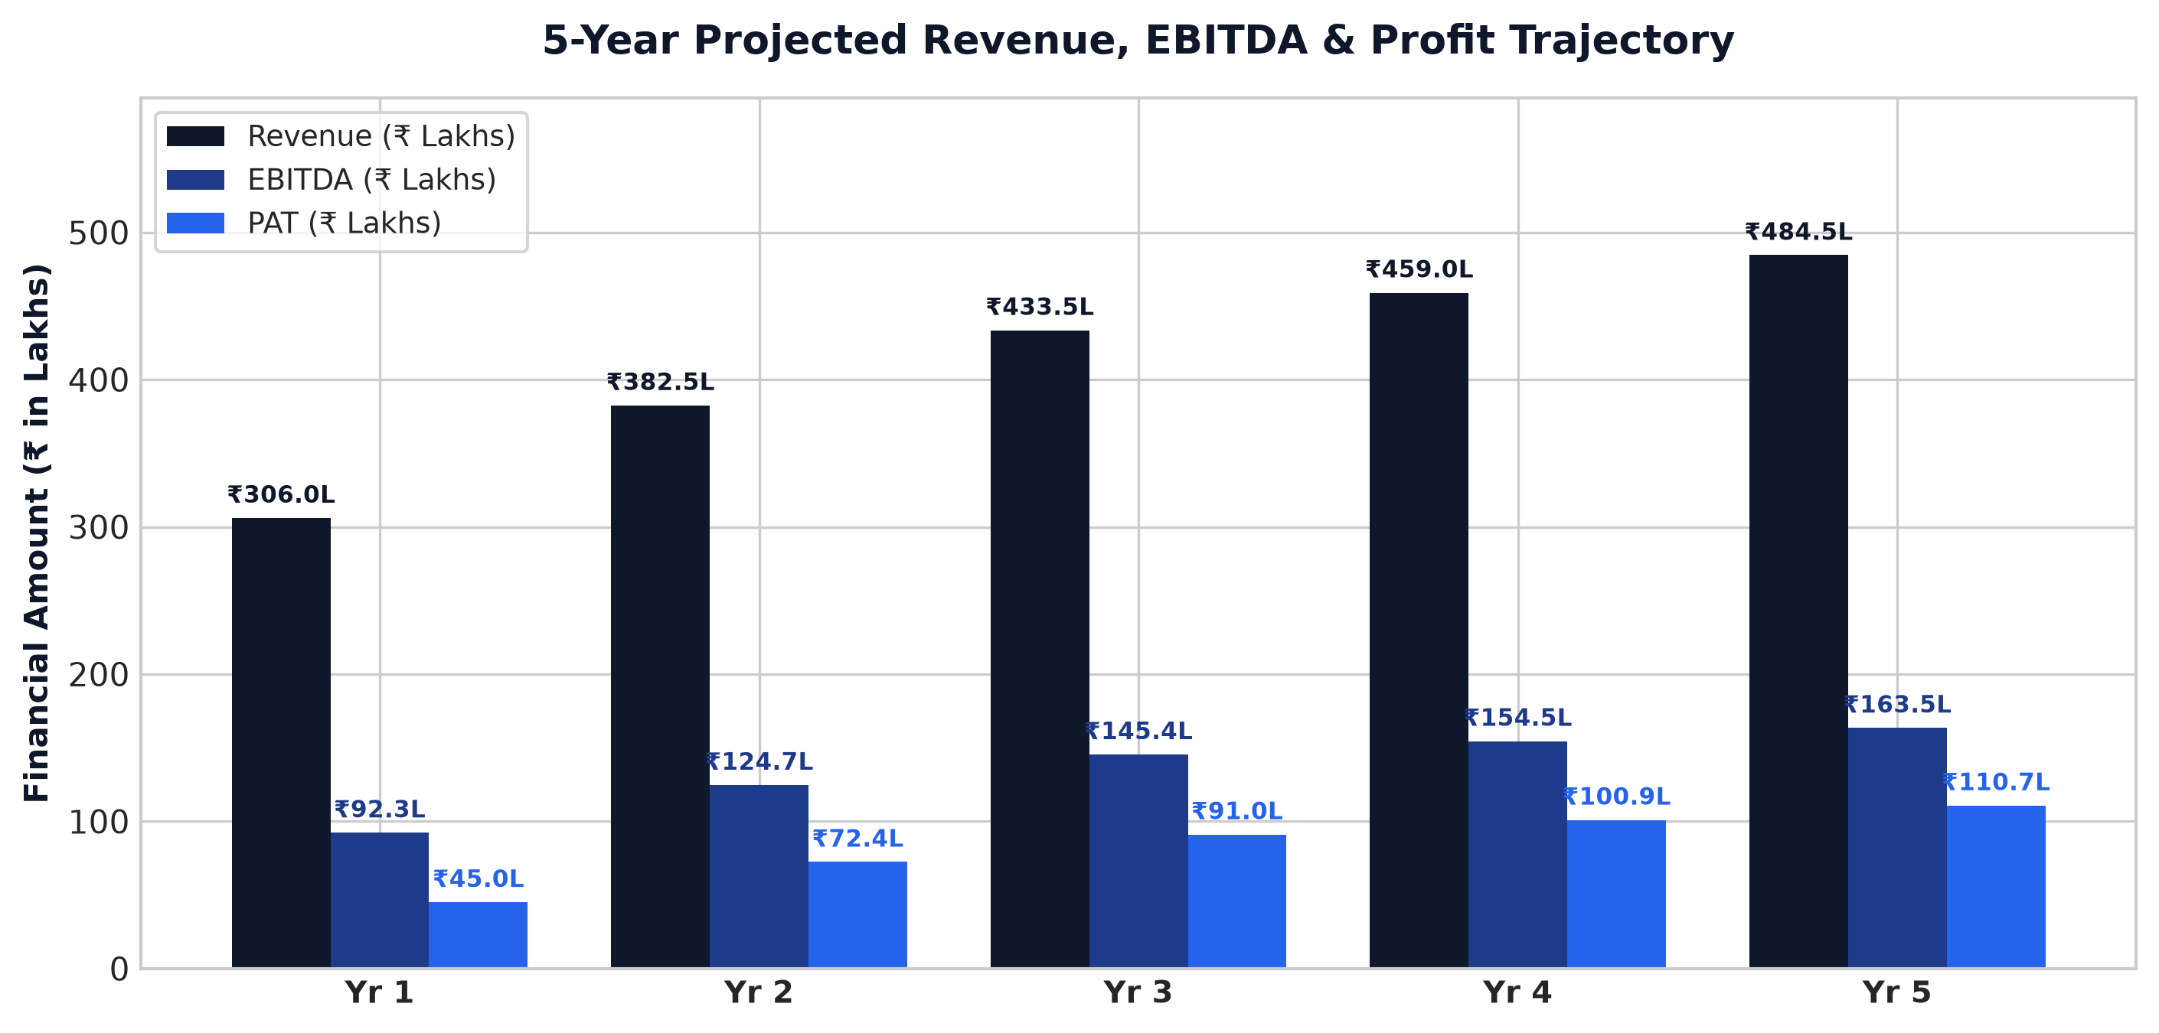
Chart: Capex Pie
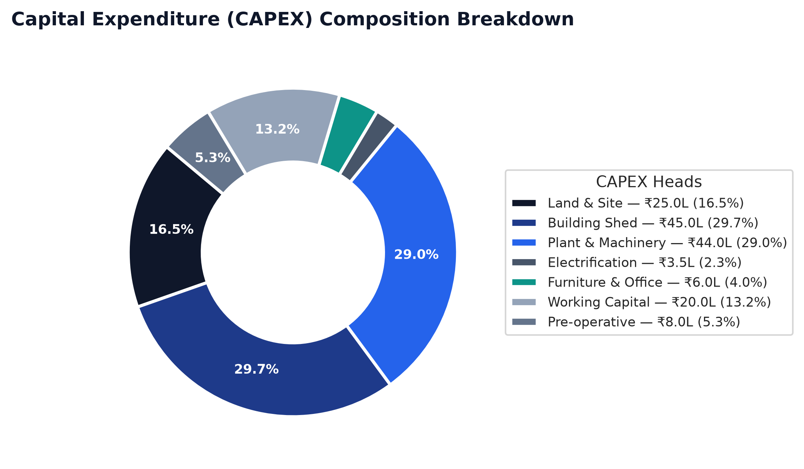
Chart: Finance Pie
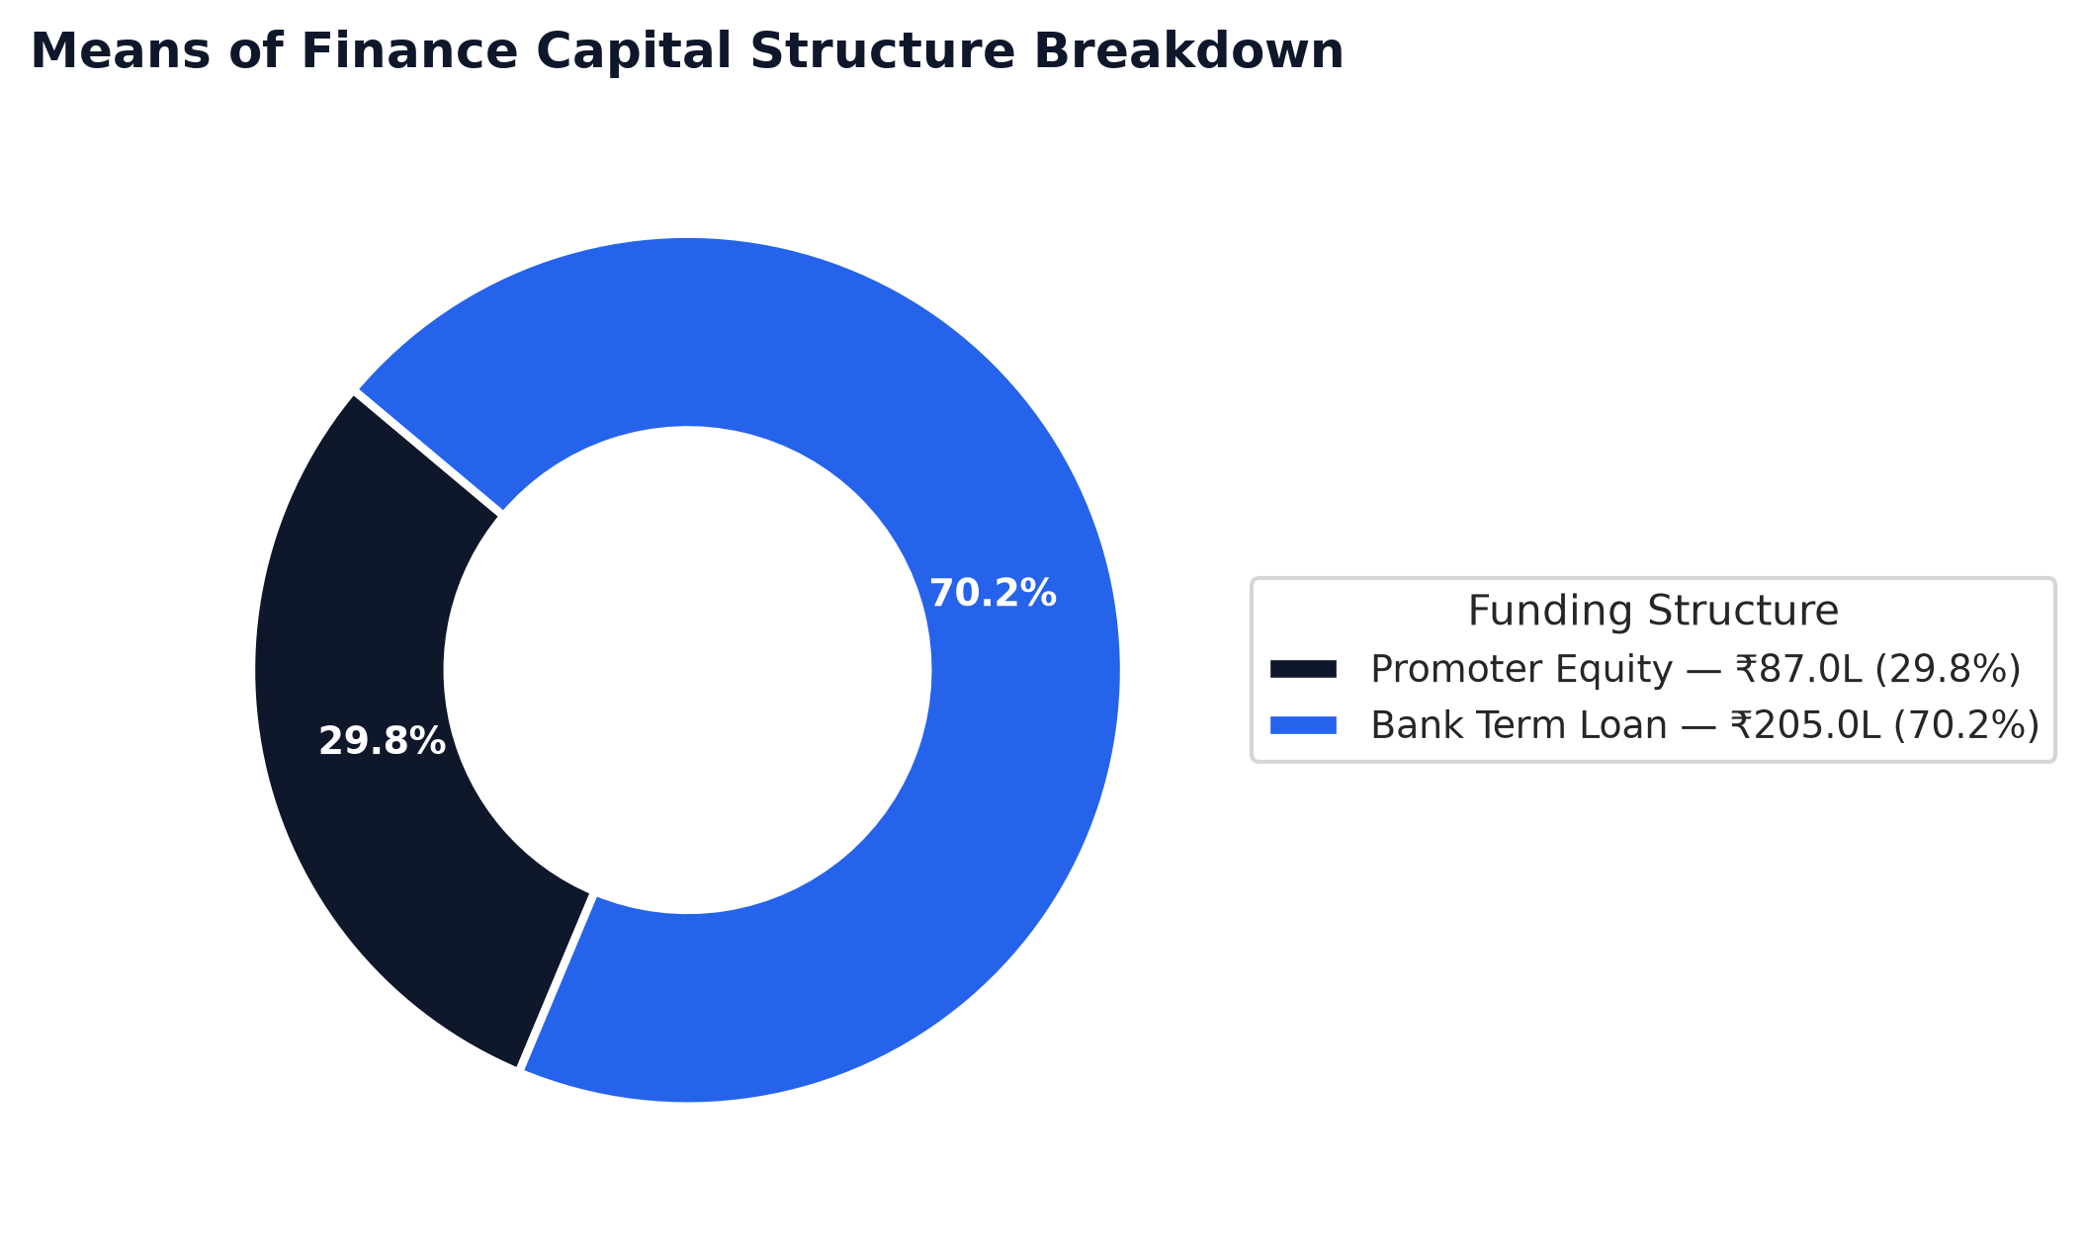
Chart: Dscr Curve
