VISION KARNATAKA FOUNDATION
DETAILED PROJECT REPORT (DPR)
NANDI ORGANIC SPICES & PULVERIZING UNIT
DPR Track: DPRTypeEnum.GOVT_SCHEME | Depth: STANDARD
Location: Chikkaballapur, Karnataka

1.0 Executive Summary & Project Highlights
Nandi Organic Spices & Pulverizing Unit is a commercial enterprise located in Chikkaballapur, Karnataka. The total project cost is estimated at ₹629,200.00, funded by promoter contribution of ₹120,000.00 and bank loan of ₹450,000.00. The project features an average 5-year DSCR of -13.79 and break-even point of 85.0%.
Total Project Cost | ₹629,200.00
Promoter Equity Contribution | ₹120,000.00
Proposed Bank Loan | ₹450,000.00
Government Subsidy Claim | ₹210,000.00
Average 5-Year DSCR | -13.79

2.0 Cost of Project & Means of Finance
Land & Site Development: ₹0.00
Building & Civil Works: ₹200,000.00
Furniture & Fixtures: ₹40,000.00
Working Capital Margin: ₹100,000.00
Total Capital Outlay: ₹629,200.00

3.0 5-Year Projected Income Statement (P&L)
Metric | Year 1 | Year 2 | Year 3 | Year 4 | Year 5
Capacity Utilization % | 60.0% | 75.0% | 85.0% | 90.0% | 95.0%
Gross Revenue (₹) | ₹4,860,000 | ₹6,075,000 | ₹6,885,000 | ₹7,290,000 | ₹7,695,000
Total OPEX (₹) | ₹6,782,560 | ₹7,684,000 | ₹8,360,860 | ₹8,813,635 | ₹9,277,325
PAT (Net Profit) (₹) | ₹-2,029,810 | ₹-1,706,800 | ₹-1,564,210 | ₹-1,602,535 | ₹-1,651,775
DSCR Ratio | -14.01 | -12.59 | -12.47 | -13.99 | -15.91

4.0 Graphical Financial Projections & Analysis
Chart: Revenue Ebitda
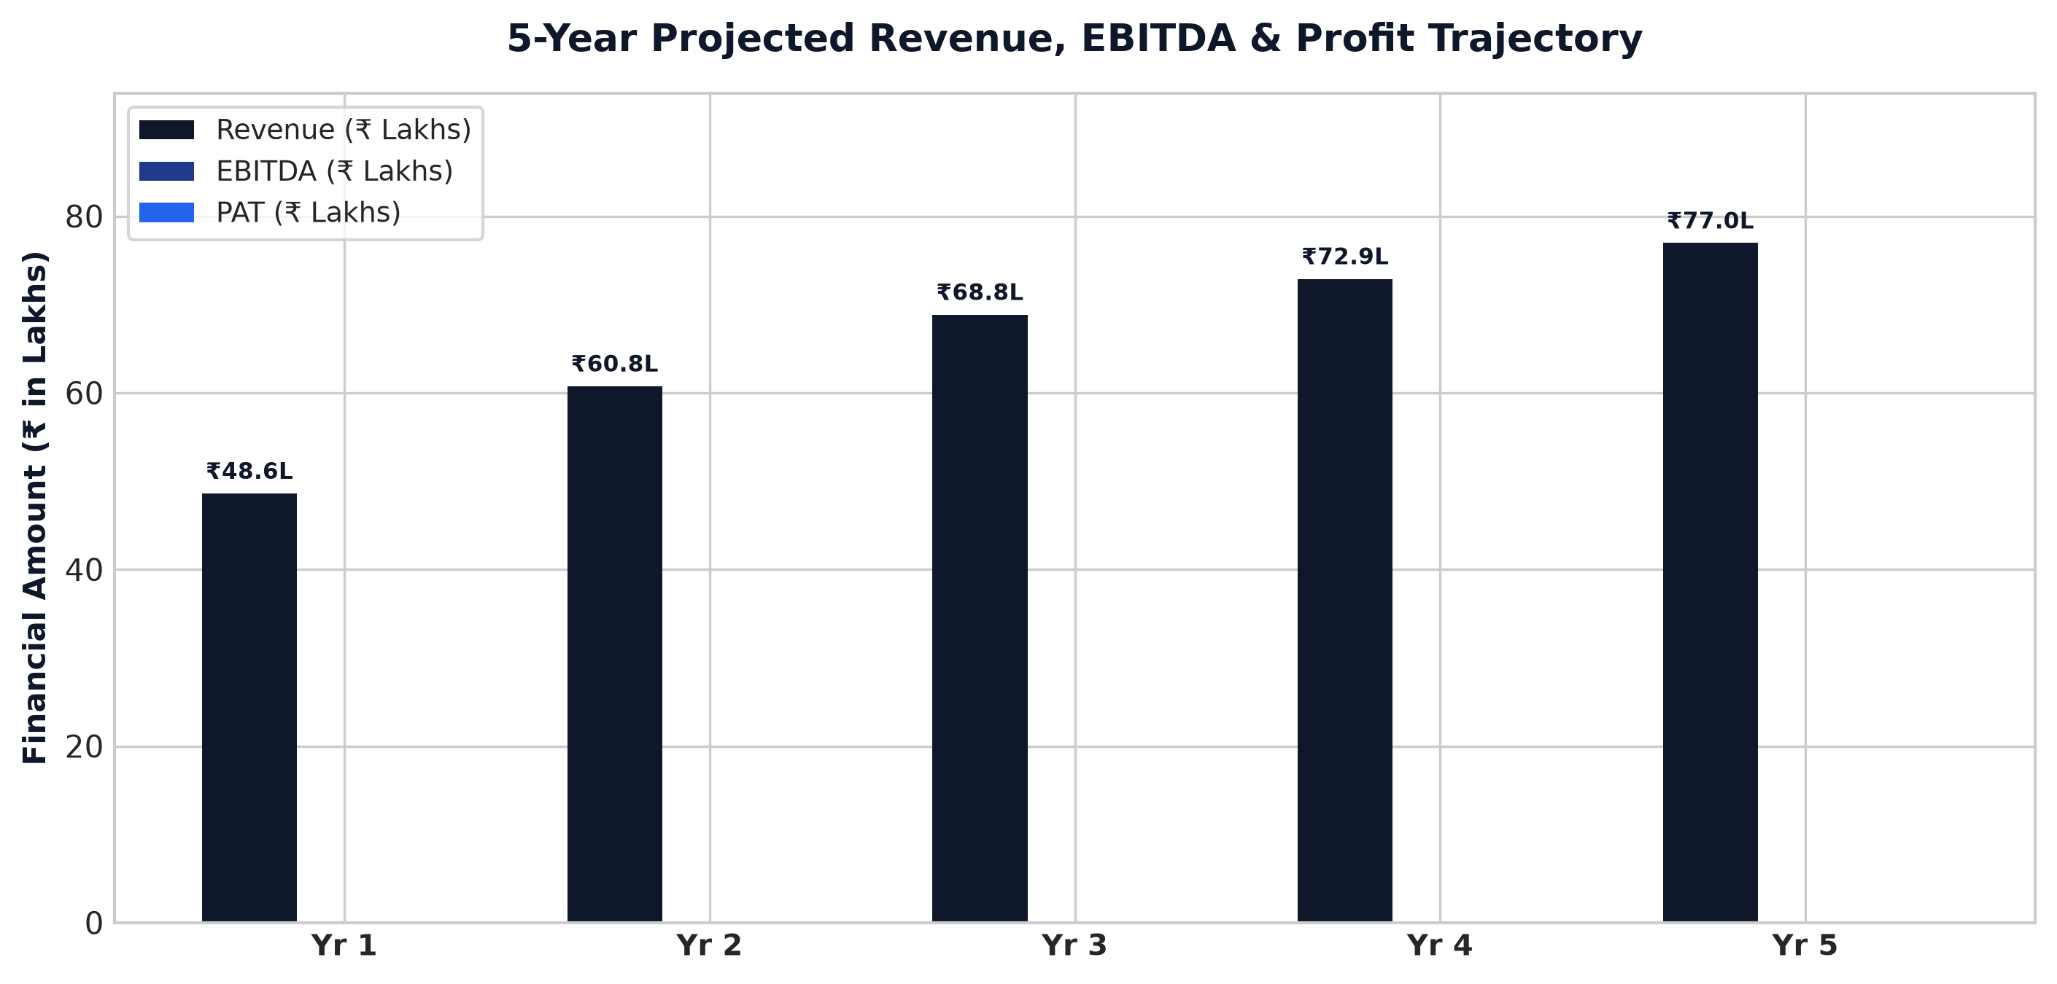
Chart: Capex Pie
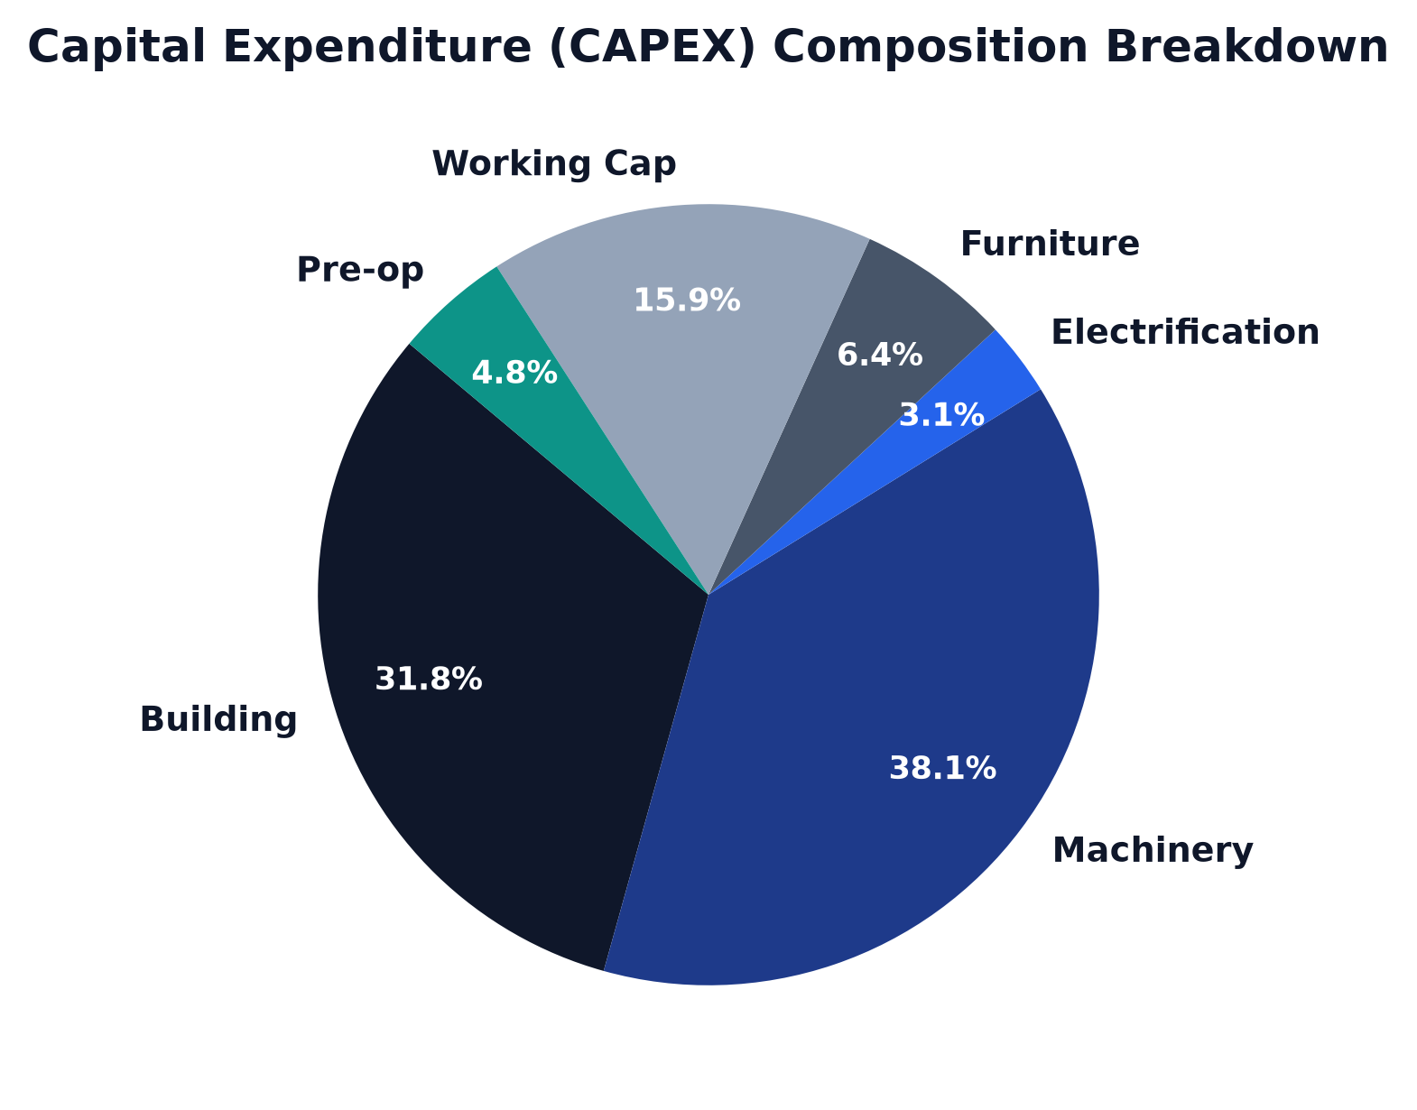
Chart: Finance Pie
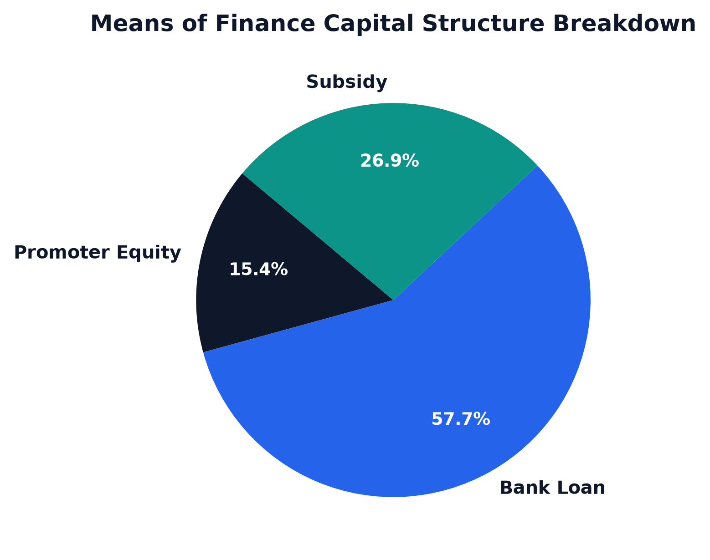
Chart: Dscr Curve
