VISION KARNATAKA FOUNDATION
DETAILED PROJECT REPORT (DPR)
VISION KARNATAKA ENTERPRISE TRACK
DPR Track: DPRTypeEnum.BANK_LOAN | Depth: STANDARD
Location: Bengaluru, Karnataka

1.0 Executive Summary & Project Highlights
Vision Karnataka Enterprise Track is a commercial enterprise located in Bengaluru, Karnataka. The total project cost is estimated at ₹500,000.00, funded by promoter contribution of ₹4,500,000.00 and bank loan of ₹10,500,000.00. The project features an average 5-year DSCR of -1.3 and break-even point of 85.0%.
Total Project Cost | ₹500,000.00
Promoter Equity Contribution | ₹4,500,000.00
Proposed Bank Loan | ₹10,500,000.00
Government Subsidy Claim | ₹0.00
Average 5-Year DSCR | -1.3

2.0 Cost of Project & Means of Finance
Land & Site Development: ₹0.00
Building & Civil Works: ₹0.00
Furniture & Fixtures: ₹0.00
Working Capital Margin: ₹500,000.00
Total Capital Outlay: ₹500,000.00

3.0 5-Year Projected Income Statement (P&L)
Metric | Year 1 | Year 2 | Year 3 | Year 4 | Year 5
Capacity Utilization % | 60.0% | 75.0% | 85.0% | 90.0% | 95.0%
Gross Revenue (₹) | ₹1,800,000 | ₹2,250,000 | ₹2,550,000 | ₹2,700,000 | ₹2,850,000
Total OPEX (₹) | ₹5,130,000 | ₹5,620,500 | ₹6,023,400 | ₹6,339,195 | ₹6,665,905
PAT (Net Profit) (₹) | ₹-4,432,500 | ₹-4,252,500 | ₹-4,134,900 | ₹-4,080,195 | ₹-4,036,405
DSCR Ratio | -1.04 | -1.13 | -1.26 | -1.43 | -1.64

4.0 Graphical Financial Projections & Analysis
Chart: Revenue Ebitda
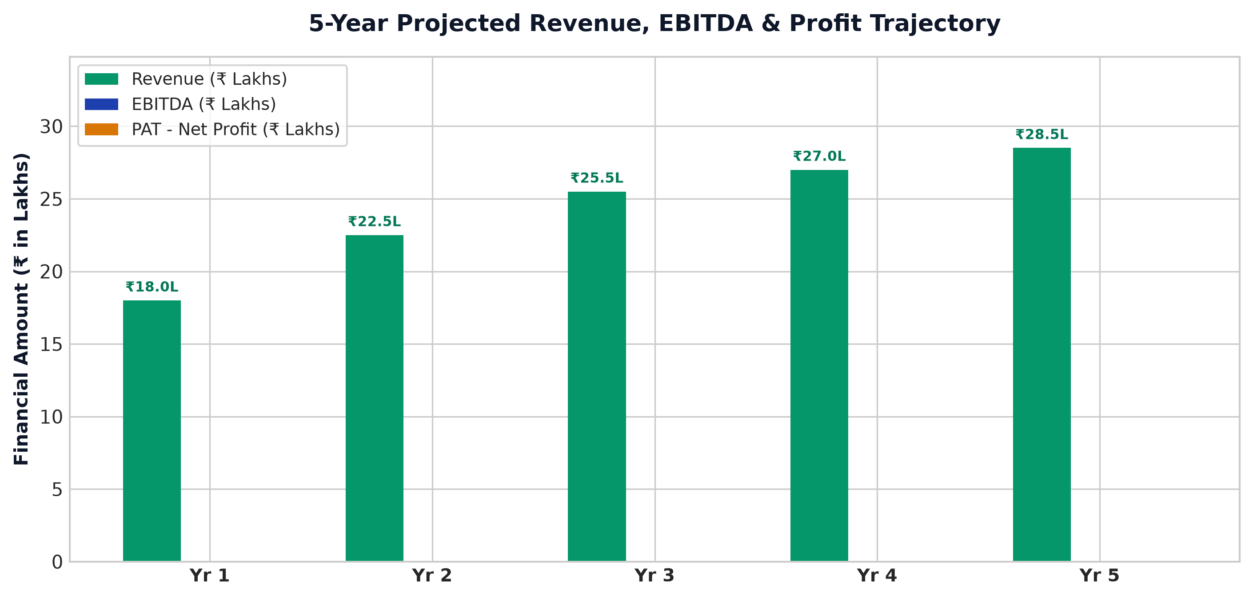
Chart: Capex Pie
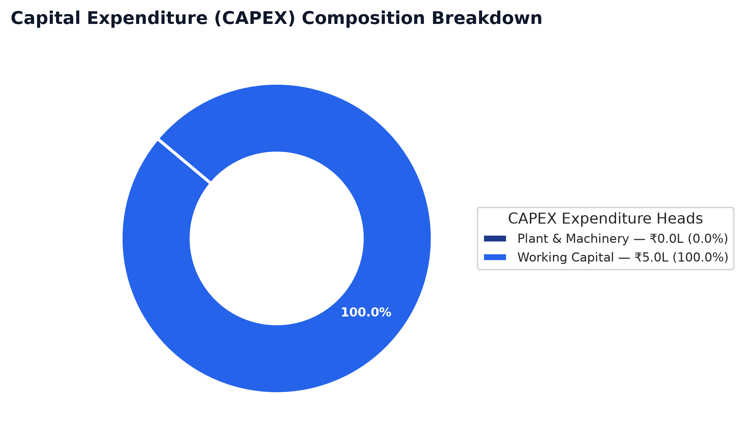
Chart: Finance Pie
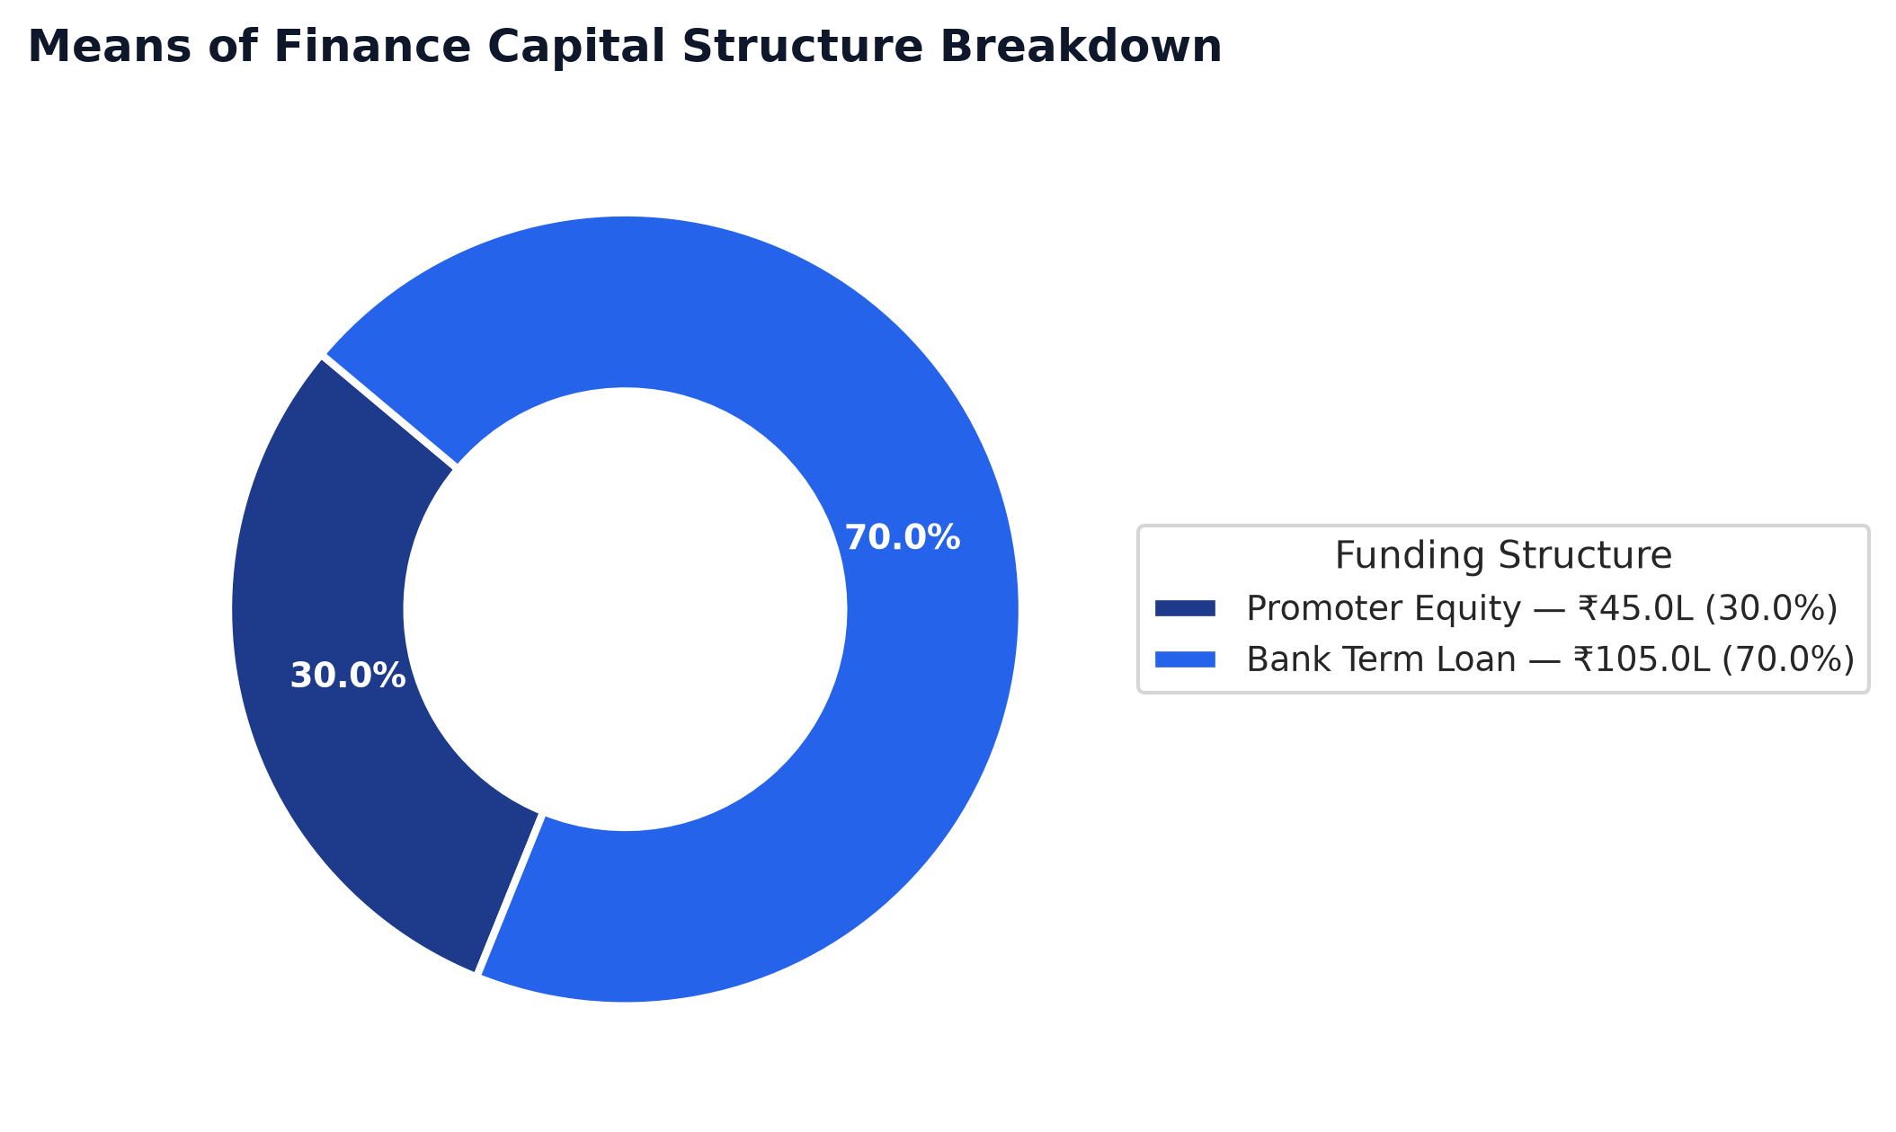
Chart: Dscr Curve
