VISION KARNATAKA FOUNDATION
DETAILED PROJECT REPORT (DPR)
WIKIPEDIA
DPR Track: DPRTypeEnum.BANK_LOAN | Depth: STANDARD
Location: Mysuru, Karnataka

1.0 Executive Summary & Project Highlights
Wikipedia is a commercial enterprise located in Mysuru, Karnataka. The total project cost is estimated at ₹13,400,000.00, funded by promoter contribution of ₹3,900,000.00 and bank loan of ₹9,100,000.00. The project features an average 5-year DSCR of 9.42 and break-even point of 25.3%.
Total Project Cost | ₹13,400,000.00
Promoter Equity Contribution | ₹3,900,000.00
Proposed Bank Loan | ₹9,100,000.00
Government Subsidy Claim | ₹0.00
Average 5-Year DSCR | 9.42

2.0 Cost of Project & Means of Finance
Land & Site Development: ₹1,500,000.00
Building & Civil Works: ₹3,500,000.00
Furniture & Fixtures: ₹500,000.00
Working Capital Margin: ₹1,800,000.00
Total Capital Outlay: ₹13,400,000.00

3.0 5-Year Projected Income Statement (P&L)
Metric | Year 1 | Year 2 | Year 3 | Year 4 | Year 5
Capacity Utilization % | 60.0% | 75.0% | 85.0% | 90.0% | 95.0%
Gross Revenue (₹) | ₹53,550,000 | ₹66,937,500 | ₹75,862,500 | ₹80,325,000 | ₹84,787,500
Total OPEX (₹) | ₹33,339,500 | ₹40,849,475 | ₹45,931,105 | ₹48,584,879 | ₹51,249,435
PAT (Net Profit) (₹) | ₹13,612,875 | ₹18,157,519 | ₹21,176,546 | ₹22,669,591 | ₹24,154,548
DSCR Ratio | 5.74 | 7.86 | 9.67 | 11.07 | 12.73

4.0 Graphical Financial Projections & Analysis
Chart: Revenue Ebitda
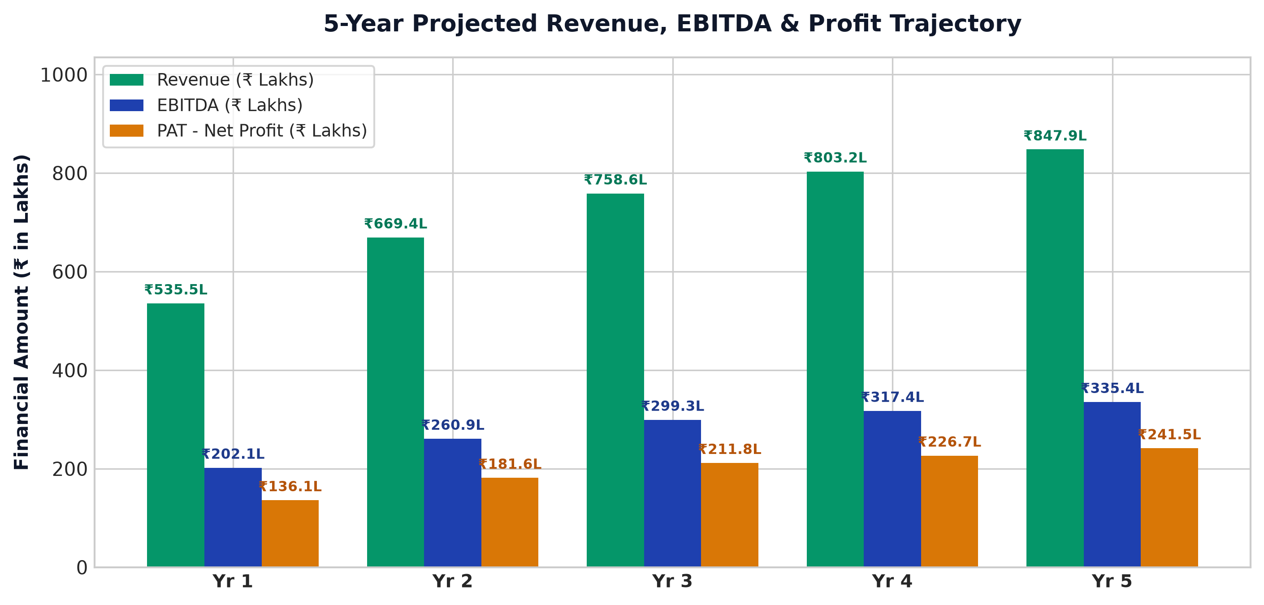
Chart: Capex Pie
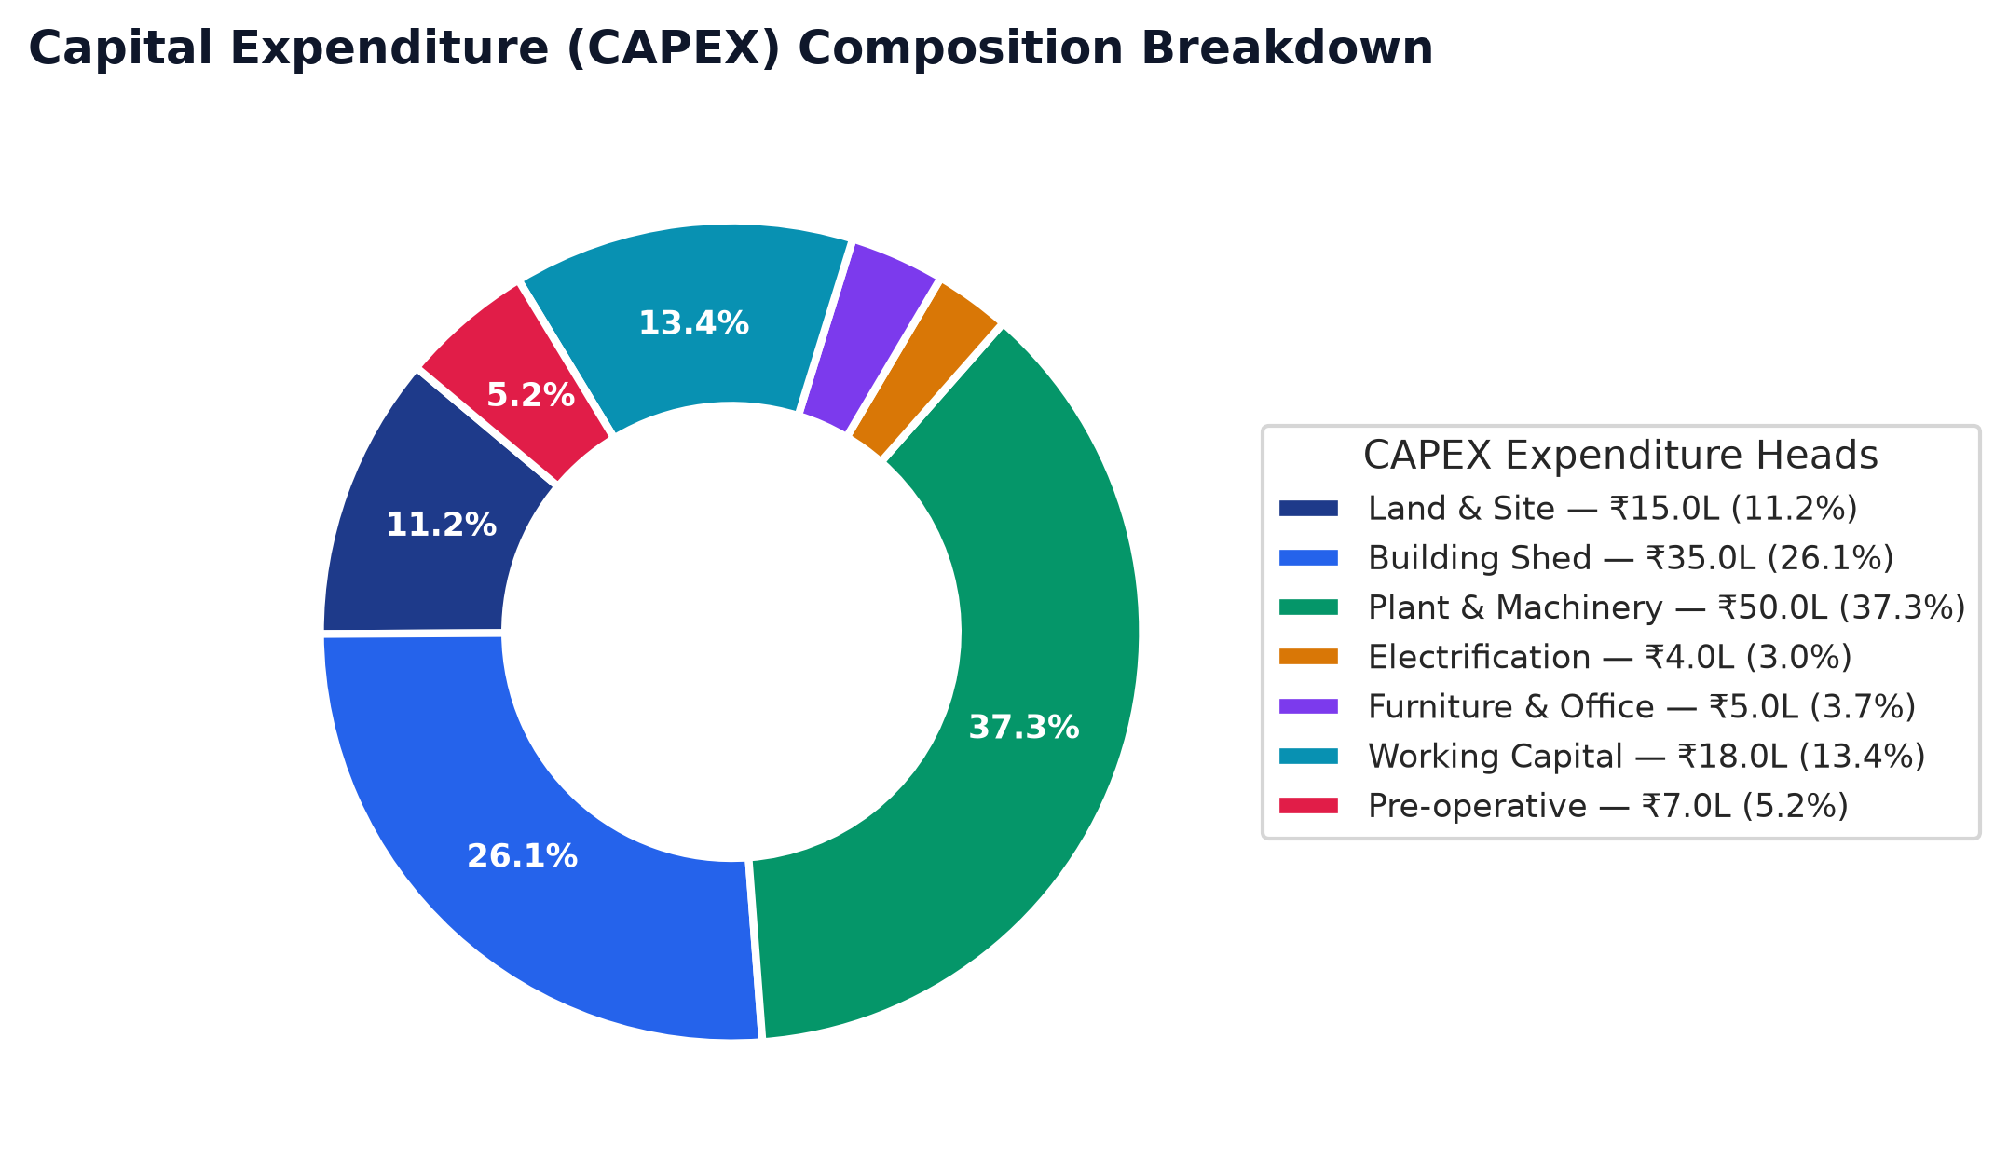
Chart: Finance Pie
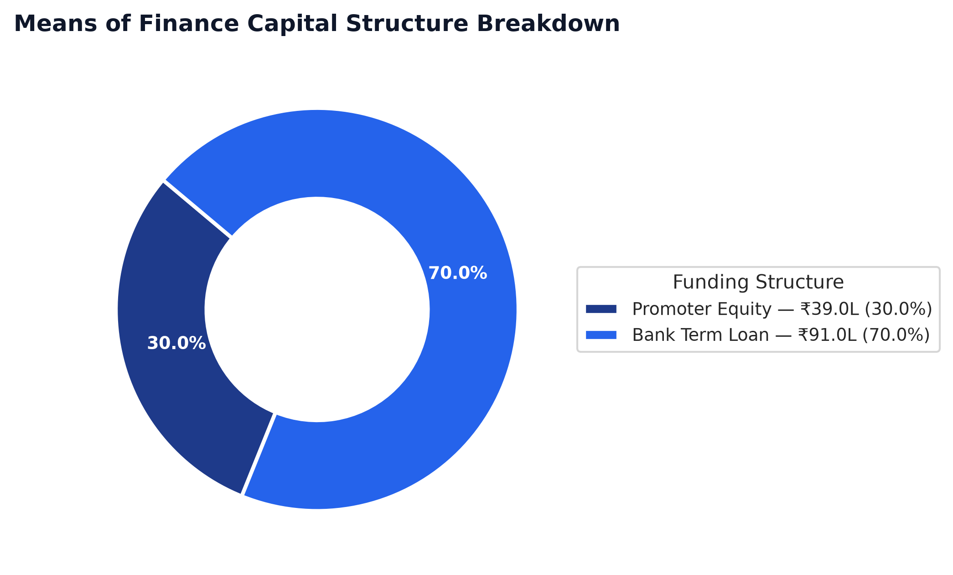
Chart: Dscr Curve
