VISION KARNATAKA FOUNDATION
DETAILED PROJECT REPORT (DPR)
OFFLINE MSME UNIT (NO WEBSITE)
DPR Track: DPRTypeEnum.BANK_LOAN | Depth: STANDARD
Location: Mysuru, Karnataka

1.0 Executive Summary & Project Highlights
Offline MSME Unit (No Website) is a commercial enterprise located in Mysuru, Karnataka. The total project cost is estimated at ₹7,692,000.00, funded by promoter contribution of ₹1,600,000.00 and bank loan of ₹3,900,000.00. The project features an average 5-year DSCR of 13.46 and break-even point of 25.0%.
Total Project Cost | ₹7,692,000.00
Promoter Equity Contribution | ₹1,600,000.00
Proposed Bank Loan | ₹3,900,000.00
Government Subsidy Claim | ₹0.00
Average 5-Year DSCR | 13.46

2.0 Cost of Project & Means of Finance
Land & Site Development: ₹1,200,000.00
Building & Civil Works: ₹2,200,000.00
Furniture & Fixtures: ₹300,000.00
Working Capital Margin: ₹1,000,000.00
Total Capital Outlay: ₹7,692,000.00

3.0 5-Year Projected Income Statement (P&L)
Metric | Year 1 | Year 2 | Year 3 | Year 4 | Year 5
Capacity Utilization % | 60.0% | 75.0% | 85.0% | 90.0% | 95.0%
Gross Revenue (₹) | ₹32,400,000 | ₹40,500,000 | ₹45,900,000 | ₹48,600,000 | ₹51,300,000
Total OPEX (₹) | ₹19,877,600 | ₹24,370,400 | ₹27,409,070 | ₹28,993,894 | ₹30,584,968
PAT (Net Profit) (₹) | ₹8,634,488 | ₹11,399,850 | ₹13,230,810 | ₹14,127,155 | ₹15,018,811
DSCR Ratio | 8.17 | 11.21 | 13.81 | 15.85 | 18.27

4.0 Graphical Financial Projections & Analysis
Chart: Revenue Ebitda
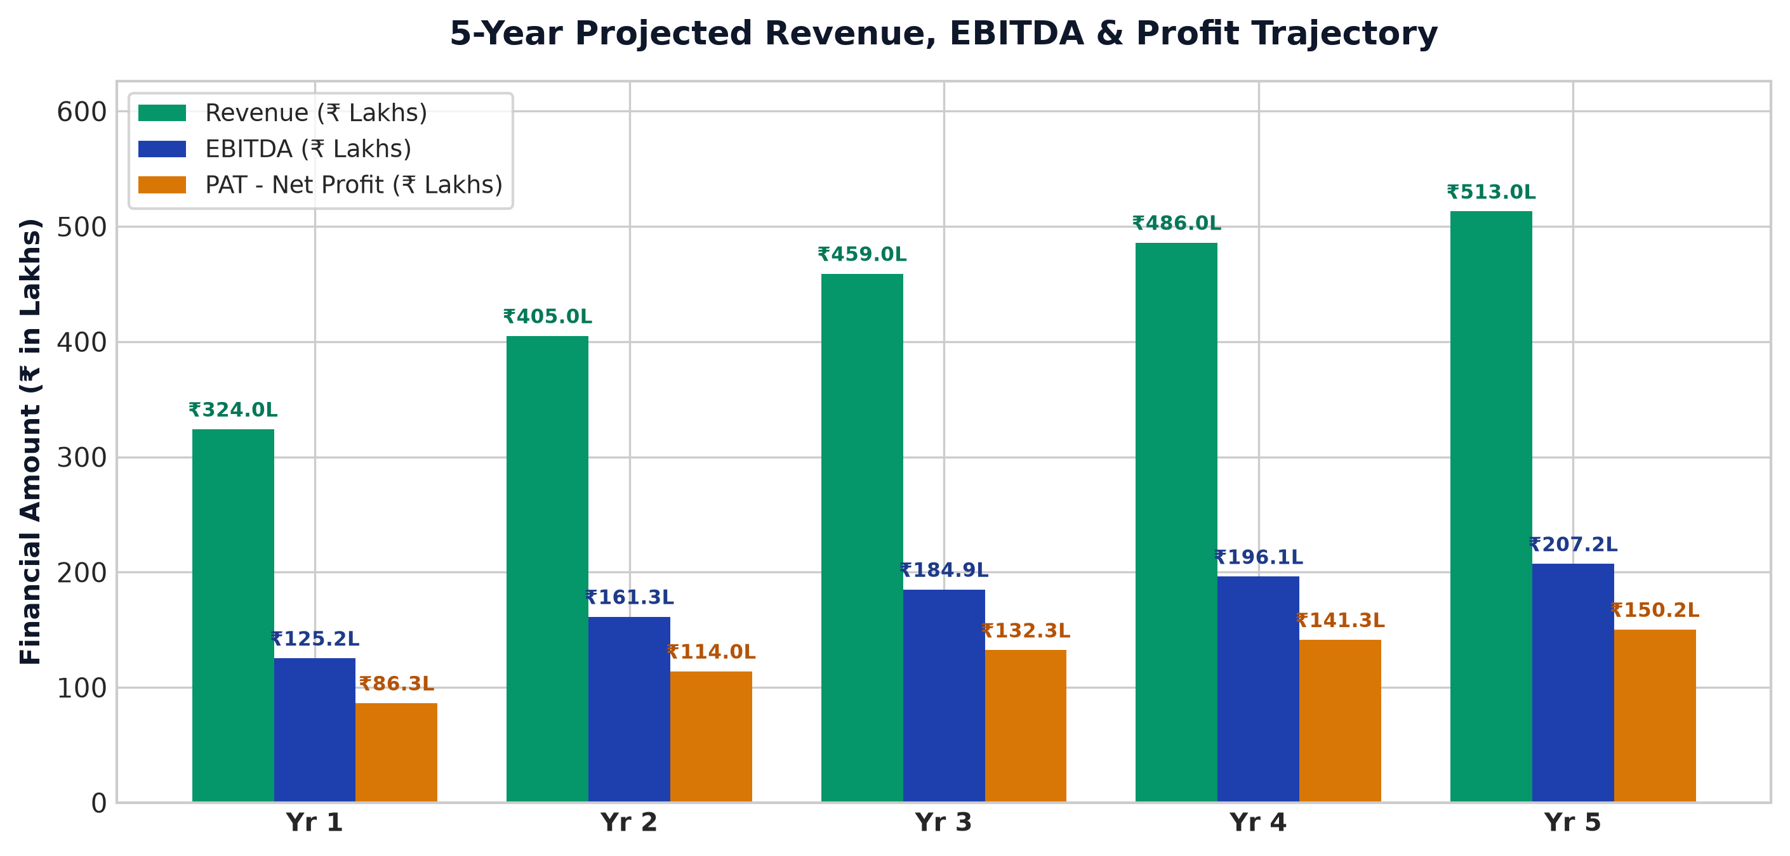
Chart: Capex Pie
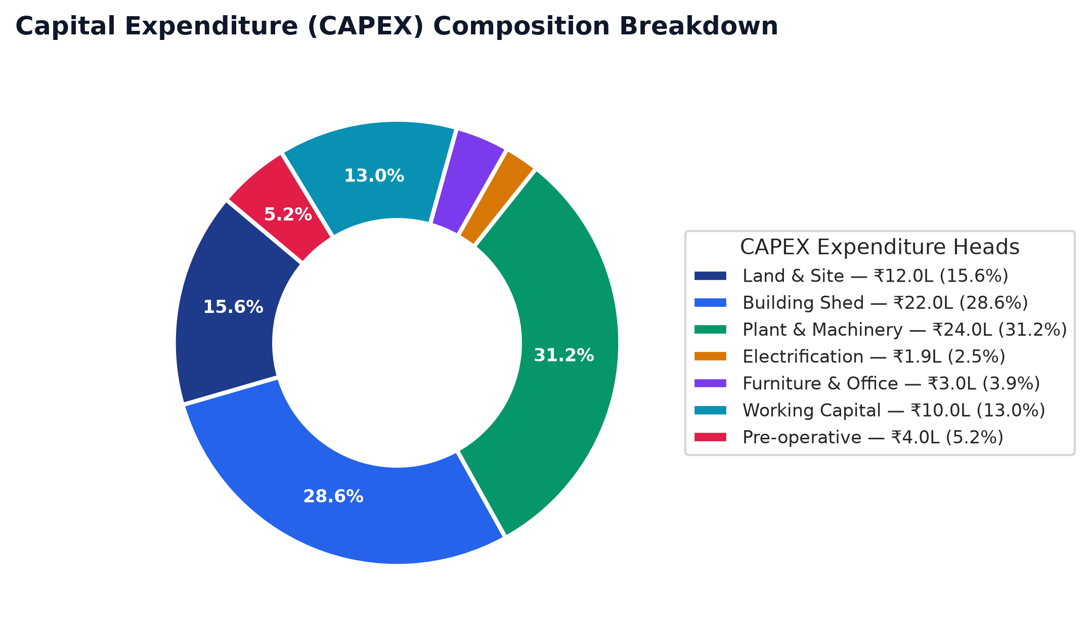
Chart: Finance Pie
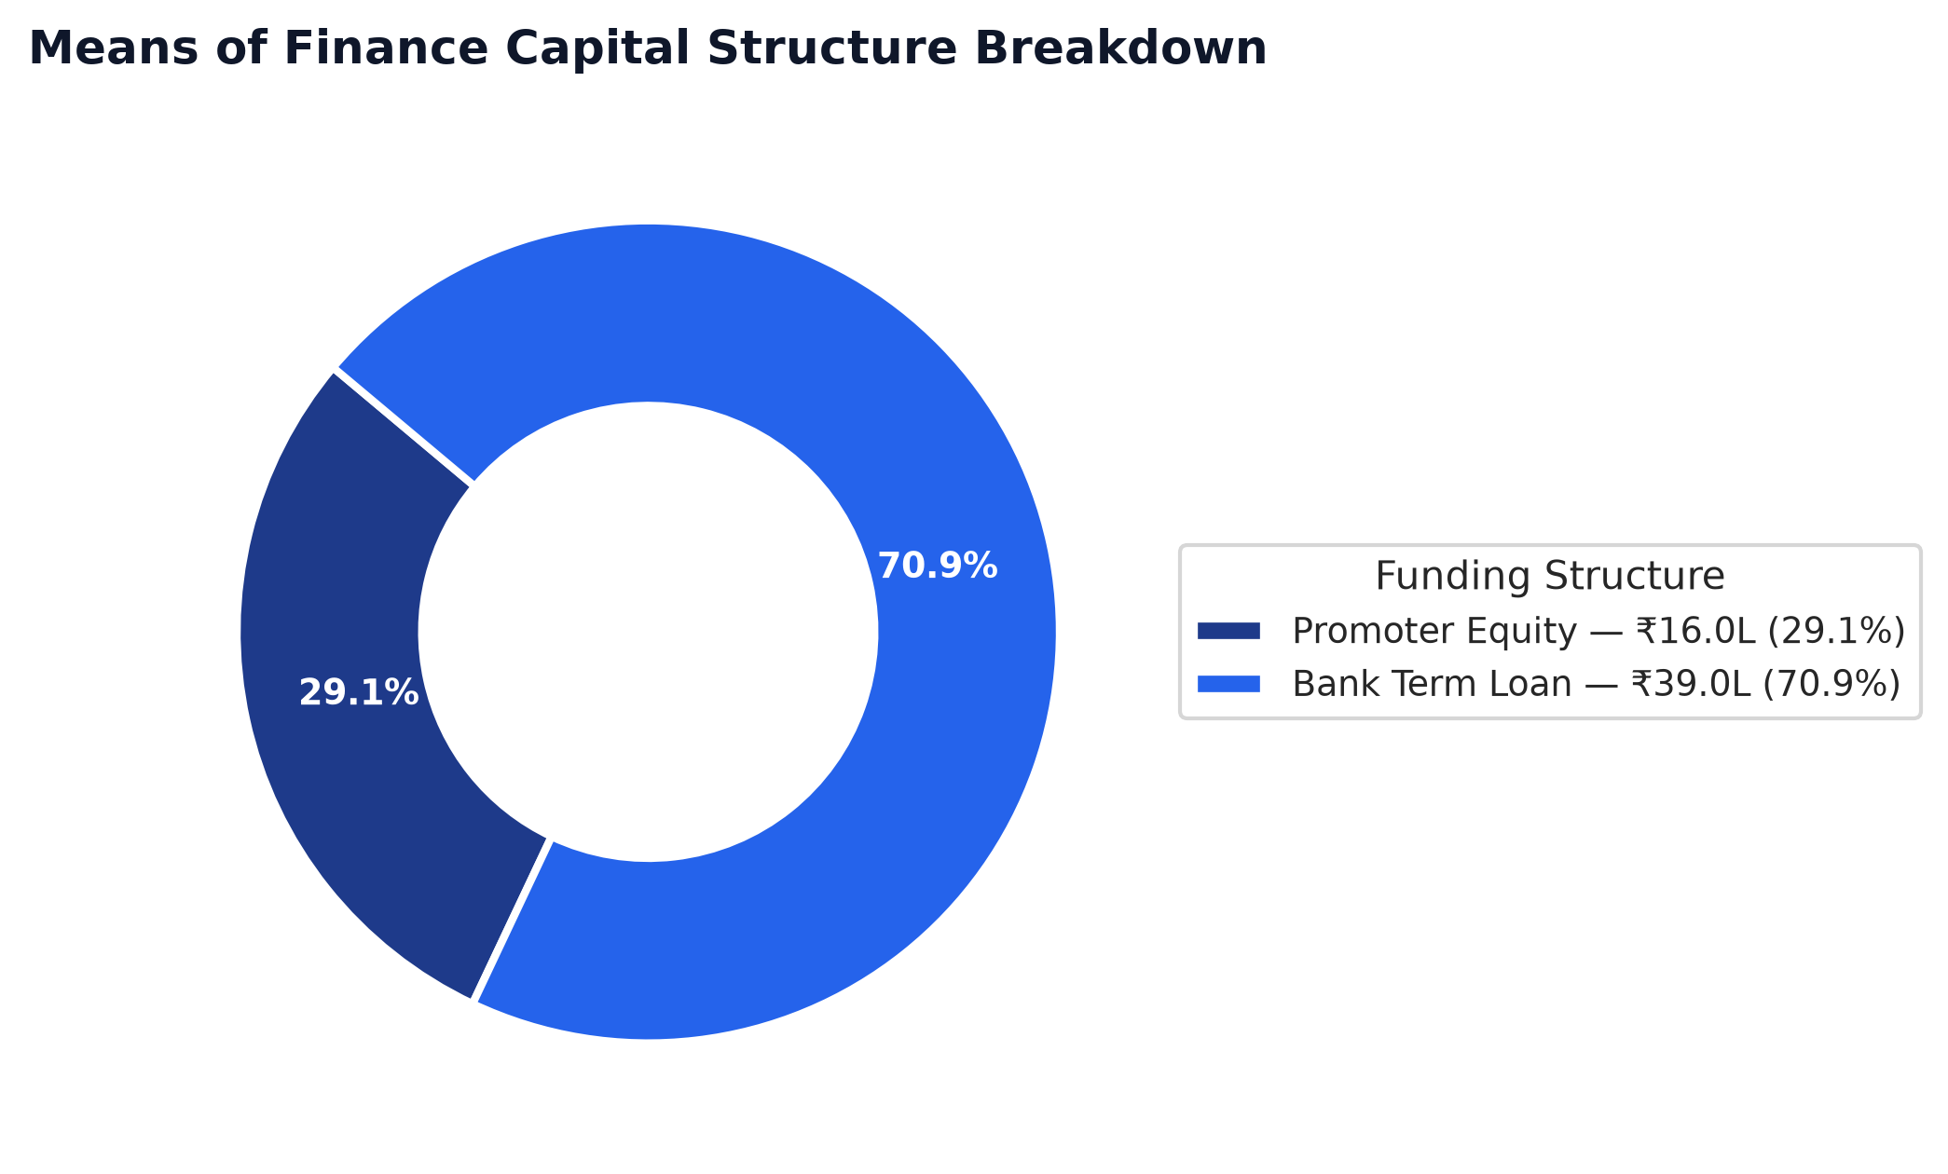
Chart: Dscr Curve
