VISION KARNATAKA FOUNDATION
DETAILED PROJECT REPORT (DPR)
OFFICIAL STANDARD CORPORATE UNIT
DPR Track: DPRTypeEnum.BANK_LOAN | Depth: STANDARD
Location: Bengaluru Urban, Karnataka

1.0 Executive Summary & Project Highlights
Official Standard Corporate Unit is a commercial enterprise located in Bengaluru Urban, Karnataka. The total project cost is estimated at ₹6,702,000.00, funded by promoter contribution of ₹1,600,000.00 and bank loan of ₹4,750,000.00. The project features an average 5-year DSCR of 8.78 and break-even point of 42.1%.
Total Project Cost | ₹6,702,000.00
Promoter Equity Contribution | ₹1,600,000.00
Proposed Bank Loan | ₹4,750,000.00
Government Subsidy Claim | ₹0.00
Average 5-Year DSCR | 8.78

2.0 Cost of Project & Means of Finance
Land & Site Development: ₹0.00
Building & Civil Works: ₹1,200,000.00
Furniture & Fixtures: ₹150,000.00
Working Capital Margin: ₹500,000.00
Total Capital Outlay: ₹6,702,000.00

3.0 5-Year Projected Income Statement (P&L)
Metric | Year 1 | Year 2 | Year 3 | Year 4 | Year 5
Capacity Utilization % | 60.0% | 75.0% | 85.0% | 90.0% | 95.0%
Gross Revenue (₹) | ₹30,600,000 | ₹38,250,000 | ₹43,350,000 | ₹45,900,000 | ₹48,450,000
Total OPEX (₹) | ₹21,307,600 | ₹25,718,500 | ₹28,744,200 | ₹30,385,255 | ₹32,038,548
PAT (Net Profit) (₹) | ₹6,016,800 | ₹8,517,375 | ₹10,144,350 | ₹10,897,309 | ₹11,641,089
DSCR Ratio | 5.11 | 7.29 | 9.09 | 10.42 | 11.99

4.0 Graphical Financial Projections & Analysis
Chart: Revenue Ebitda
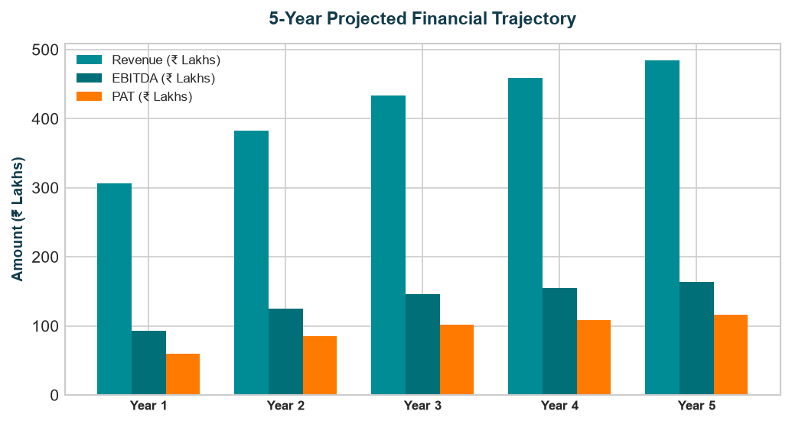
Chart: Capex Pie
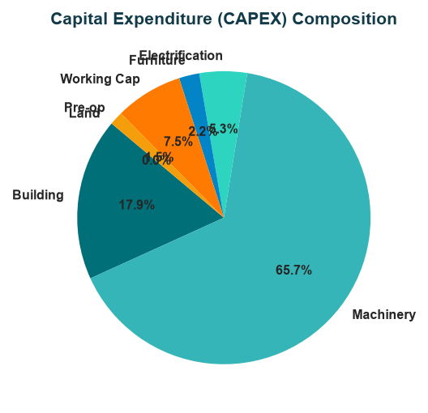
Chart: Finance Pie
