VISION KARNATAKA FOUNDATION
DETAILED PROJECT REPORT (DPR)
PRECISION ROBOTICS & AUTOMATION PVT LTD
DPR Track: DPRTypeEnum.BANK_LOAN | Depth: DETAILED
Location: Bengaluru Urban, Karnataka

1.0 Executive Summary & Project Highlights
Precision Robotics & Automation Pvt Ltd is a commercial enterprise located in Bengaluru Urban, Karnataka. The total project cost is estimated at ₹22,280,000.00, funded by promoter contribution of ₹7,000,000.00 and bank loan of ₹21,000,000.00. The project features an average 5-year DSCR of 13.15 and break-even point of 25.0%.
Total Project Cost | ₹22,280,000.00
Promoter Equity Contribution | ₹7,000,000.00
Proposed Bank Loan | ₹21,000,000.00
Government Subsidy Claim | ₹0.00
Average 5-Year DSCR | 13.15

2.0 Cost of Project & Means of Finance
Land & Site Development: ₹2,500,000.00
Building & Civil Works: ₹4,500,000.00
Furniture & Fixtures: ₹600,000.00
Working Capital Margin: ₹2,000,000.00
Total Capital Outlay: ₹22,280,000.00

3.0 5-Year Projected Income Statement (P&L)
Metric | Year 1 | Year 2 | Year 3 | Year 4 | Year 5
Capacity Utilization % | 60.0% | 75.0% | 85.0% | 90.0% | 95.0%
Gross Revenue (₹) | ₹157,500,000 | ₹196,875,000 | ₹223,125,000 | ₹236,250,000 | ₹249,375,000
Total OPEX (₹) | ₹90,661,000 | ₹111,206,350 | ₹125,098,980 | ₹132,340,166 | ₹139,609,500
PAT (Net Profit) (₹) | ₹46,855,500 | ₹61,308,488 | ₹70,907,265 | ₹75,650,875 | ₹80,373,375
DSCR Ratio | 8.0 | 10.94 | 13.47 | 15.48 | 17.88

4.0 Graphical Financial Projections & Analysis
Chart: Revenue Ebitda
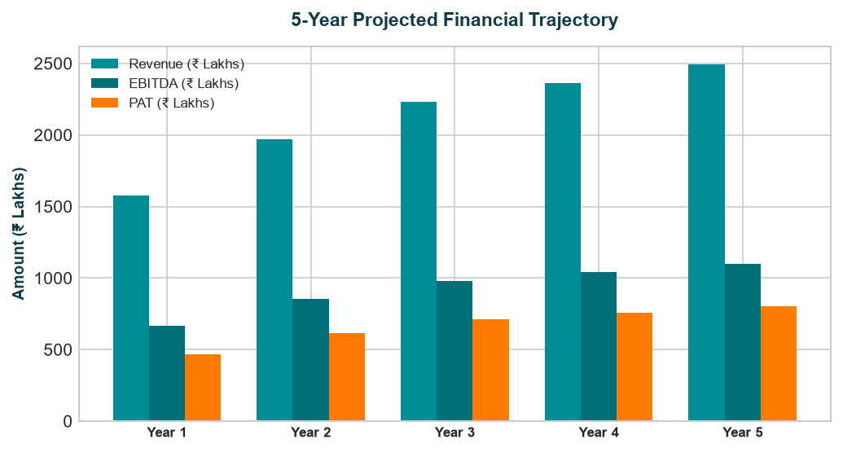
Chart: Capex Pie
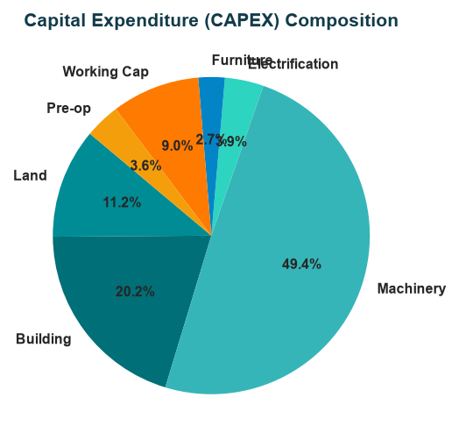
Chart: Finance Pie
