 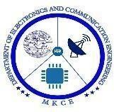 

A Minor Project II Report on

SMART STICK FOR BLIND PEOPLE

Submitted in partial fulfillment of requirements for the award of the Degree of

# BACHELOR OF ENGINEERING

in

# ELECTRONICS AND COMMUNICATION ENGINEERING

**Submitted By**

**Aakash T**

**Ajay Rahul R**

**Athil Abdul Rahim M**

**Dharaneswara V**

**DEPARTMENT OF ELECTRONICS AND COMMUNICATION ENGINEERING**

**M.KUMARASAMY COLLEGE OF ENGINEERING**

(Autonomous)

# KARUR – 639 113 APRIL-2023

M.KUMARASAMY COLLEGE OF ENGINEERING, KARUR

**BONAFIDE CERTIFICATE**

Certified that this project report **“SMART BLIND STICK”** is the bonafide work of **“AAKASH T(927621BEC001), AJAY RAHUL R(927621BEC010), ATHIL ABDUL RAHIM M(927621BEC016), DHARANESWARA V(927621BEC037)”** who carried out the project work under my supervision in the academic year 2022-2023.

**SIGNATURE SIGNATURE**

Dr.S.PALANIVEL RAJAN, M.E.,Ph.D.,

**HEAD OF THE DEPARTMENT**

PROFESSOR

Department of Electronics and Communication Engineering,

M.Kumarasamy College of Engineering, Thalavapalayam, Karur-639113

Dr. R. KALAIARASAN M.E.,Ph.D.,

**SUPERVISOR**

ASSISTANT PROFESSOR

Department of Electronics and Communication Engineering, M.Kumarasamy College of Engineering, Thalavapalayam, Karur-639113

This project report has been submitted for the **18ECP104L-Minor Project II** Viva Voice Examination held at M.Kumarasamy College of Engineering, Karur on .

# PROJECT COORDINATOR

**Vision and Mission of the Institute and Department Vision**

To emerge as a leader among the top institutions in the field of technical education.

**Mission**

* Produce smart technocrats with empirical knowledge who can surmount the global challenges.
* Create a diverse, fully-engaged, learner-centric campus environment to provide quality education to the students.
* Maintain mutually beneficial partnerships with our alumni, industry and professional associations.

**Department of Electronics and Communication Engineering Vision**

* To empower the Electronics and Communication Engineering students with Emerging Technologies, Professionalism, Innovative Research and Social Responsibility.

**Mission**

* Attain the academic excellence through innovative teaching learning process, research areas & laboratories and Consultancy projects.
* Inculcate the students in problem solving and lifelong learning ability.
* Provide entrepreneurial skills and leadership qualities.  Render the technical knowledge and industrial skills of faculties.

# PROGRAM EDUCATIONAL OBJECTIVES (PEO'S)

* **PEO1:** Graduates will have a successful career in academia or industry associated with electronics and communication engineering
* **PEO2:** Graduates will provide feasible solutions for the challenging problems through comprehensive research and innovation in the allied areas of electronics and communication engineering.
* **PEO3:** Graduates will contribute to the social needs through lifelong learning, practicing professional ethics and leadership quality

# PROGRAM OUTCOMES(PO'S)

* **PO1: Engineering knowledge:** Apply the knowledge of mathematics, science, engineering fundamentals, and an engineering specialization to the solution of complex engineering problems
* **PO2: Problem analysis:** Identify, formulate, review research literature, and analyze complex engineering problems reaching substantiated conclusions using first principles of mathematics, natural sciences, and engineering sciences
* **PO3: Design/development of solutions:** Design solutions for complex engineering problems and design system components or processes that meet the specified needs with appropriate consideration for the public health and safety, and the cultural, societal, and environmental considerations
* **PO4: Conduct investigations of complex problems:** Use research-based knowledge and research methods including design of experiments, analysis and interpretation of data, and synthesis of the information to provide valid conclusions
* **PO5: Modern tool usage:** Create, select, and apply appropriate techniques, resources, and modern engineering and IT tools including prediction and modeling to complex engineering activities with an understanding of the limitations
* **PO6: The engineer and society:** Apply reasoning informed by the contextual knowledge to assess societal, health, safety, legal and cultural issues and the consequent responsibilities relevant to the professional engineering practice
* **PO7: Environment and sustainability:** Understand the impact of the professional engineering solutions in societal and environmental contexts, and demonstrate the knowledge of, and need for sustainable development
* **PO8: Ethics: Apply** ethical principles and commit to professional ethics and responsibilities and norms of the engineering practice
* **PO9: Individual and team work:** Function effectively as an individual, and as a member or leader in diverse teams, and in multidisciplinary settings
* **PO10: Communication:** Communicate effectively on complex engineering activities with the engineering community and with society at large, such as, being able to comprehend and write effective reports and design documentation, make effective presentations, and give and receive clear instructions
* **PO11: Project management and finance:** Demonstrate knowledge and understanding of the engineering and management principles and apply these to one’s own work, as a member and leader in a team, to manage projects and in multidisciplinary environments
* **PO12: Life-long learning:** Recognize the need for, and have the preparation and ability to engage in independent and life-long learning in the broadest context of technological change.

# PROGRAM SPECIFIC OUTCOMES(PSO'S)

* **PSO1**: Applying knowledge in various areas, like Electronics, Communications, Signal processing, VLSI, Embedded systems etc., in the design and implementation of Engineering application.
* **PSO2**: Able to solve complex problems in Electronics and Communication Engineering with analytical and managerial skills either independently or in team using latest hardware and software tools to fulfil the industrial expectations**.**

**MAPPING OF PROJECT WITH POs AND PSOs**

|  |  |
| --- | --- |
| **Abstract** | **Matching with** |
| **EMBEDDED SYSTEM** | **PO1,PO2,PO3,PO4,PO5,PO6,PO7,PSO1, PSO2** |

# ABSTRACT

The smart stick for the blind as the name suggests is a device for the visually impaired to guide the user to respective destination and avoiding to collidewith the obstacles. It uses two ultrasonic sensors HC SR 04 to detect the depth below or the obstacles in between. In this Smart stick there is a sensor which senses the obstacles or walls from1 or half meter range then this stick vibrates & makes buzz sound. This Smart Stick warns the blind person that there is an obstacle or wall in front of him/her. Then that person will be warnedfrom obstacle or wall. The advantage of our project is that it can detect any obstacle with the helpof ultrasonic sensor and it can provide correct location of obstacles by using the GPS system. Thus,it will help blind people when they are walking outside from their home.

**Keywords:** Arduino Nano, Ultrasonic sensor, Buzzer*.*

|  |  |  |
| --- | --- | --- |
| **Chapter** | **Particulars** | **page** |
| **No.** |  | **No.** |
|  | Vision and Mission of the Institute and Department | 3 |
|  | POs,PSOs of the Department | 4 |
|  | Mapping of project with POs and PSOs | 5 |
|  | Abstract | 6 |
|  | List of Figure | 7 |
|  | List of Tables | 7 |
| 1 | Introduction | 8 |
|  | 1.1 Objectives |  |
| 2 | Literature Review | 9 |
| 3 | Tools Required | 9 |
| 4 | Working | 10 |
|  | 4.1 Sensing Module | 16 |
|  | 4.2 Processing Module | 17 |
|  | 4.3 GSM Module | 17 |
| 5 | Conclusion | 18 |
| 6 | References | 19 |

# INTRODUCTION

The smart stick for the blind as the name suggests is a device for the visually impaired to guide the user to respective destination and avoiding to collidewith the obstacles. It uses two ultrasonic sensors HC SR 04 to detect the depth below or the obstacles in between.

Along with that it uses Arduino as the main controller. And 1sheeld as the Bluetooth interface between the controller and smartphone. Whenever there is anyobstacle in front. The sensor will detect the distance from the obstacle and send to the controller. The controller will then convert in audio format. Currently there are thousands of blind people all over the globe. These include people from low sightseeing to complete loss of visual.

They find it very difficult while crossing the road or reaching to their respective destination with the help any other individual. The traditional stick cannot help to detect the obstacles in front or the potholes in the way. It is outdated. Hence there is a need to update it using today's technology.

# LITERATURE REVIEW

Smart Stick for the Blind a complete solution to reach the destination. This system uses Ultrasonic sensor, water sensor to detect the obstacle. However, this system just gives an alert if any one of the sensors is triggered, it uses a buzzer to alert the blind person. This system does not use any location identifier or location indicator.

# TOOLS USED

* ARDUINO UNO
* ULTRASONIC SENSOR
* BUZZER
* LED
* BREAD BOARD

# BLOCK DIAGRAM

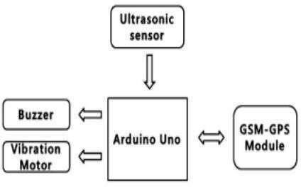

**CIRCUIT DIAGRAM**

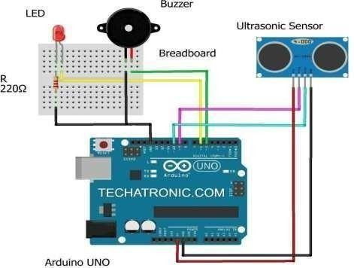

**Figure 1: Schematic diagram**

# MICROCONTROLLER (ATMEGA328P)ARDUINO UNO:

Arduino UNO is a microcontroller board based on the ATmega328P. It has 14 digital input/output pins (of which 6 can be used as PWM outputs), 6 analog inputs, a 16 MHz ceramic resonator, a USB connection, a power jack, an ICSP header and a reset button.

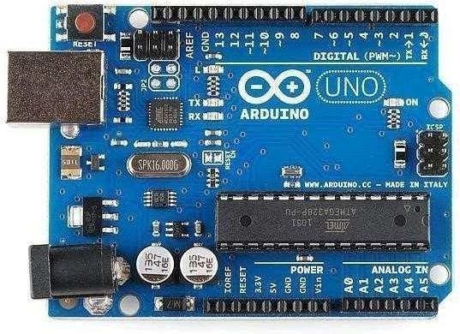

**Figure 2: ARDUINO UNO (ATMEGA328P)**

# ULTRASONIC SENSOR

An ultrasonic sensor is an electronic device that measure the distance of a target object by emitting ultrasonic sound waves, and converts the reflected sound into an electrical signal.

**Features:**

* Transparent object detectable
* Resistant to mist and dirt
* Complex shaped objects detectable

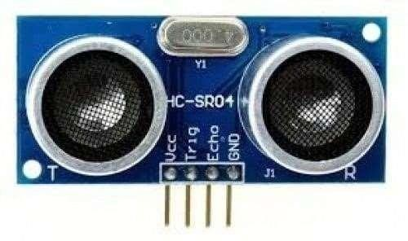

**Figure 3: ULTRASONIC SENSOR LED**

# LED

A Light Emitting Diode (LED) is semiconductor device, which can emit light when an electric current passes through it. To do this, holes from p-type semiconductors recombine with electrons from n-type semiconductors to produce light. The wavelength of the light emitted depends on the bandgap of the semiconductor material.

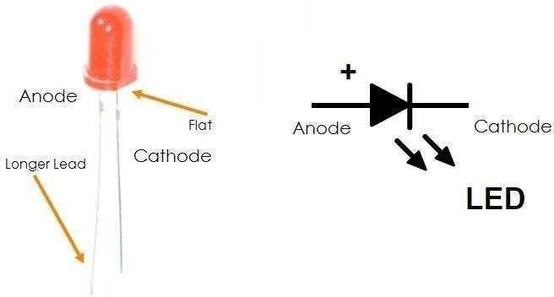

**Figure 4: LED**

# BUZZER

Buzzer is a device which uses sound to indicate the user. It is controlled by the microcontroller Arduino uno. When the digital pin is high to the Buzzer. The Buzzer is activatedand it creates the sound and indicates the user.

**SPECIFICATIONS:**

* Color is black.
* The frequency range is 3,300Hz.
* Operating Temperature ranges from – 20° C to +60°C.
* Operating voltage ranges from 3V to 24V DC.
* The sound pressure level is 85dBA or 10cm.
* The supply current is below 15mA.

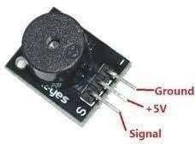

**Figure 5: Buzzer**

**PROJECT MODULE**

**SENSING MODULE:**

This system functions similarly to a white cane in that it assists blind people in scanningtheir surroundings for obstacles or orientation marks. Sensing or detecting the presence of a signal without prior knowledge of the signal characteristics or channel information. This system will be mounted on a white cane with an ultrasonic sensor, and a water sensor to detect changes in the environment. It uses two ultrasonic sensors HC SR 04 to detect the depth below or the obstacles in between.

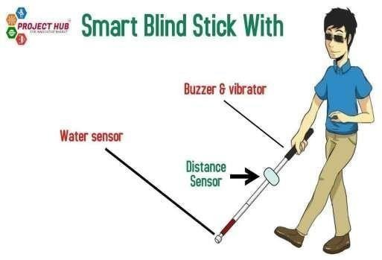

**Figure 6: SENSING MODULE**

# PROCESSING MODULE

The smart blind stick automatically detects the obstacle in front of the person and give him a response to the person by vibrating the stick and also with a warning sound.Through this, the blind person can aware about the obstacles in front of him. I used Ultrasonic sensor for detecting the obstacles.

# GSM MODULE

A GSM modem or GSM module is a device that uses GSM mobile telephone technology to provide a wireless data link to a network. GSM modems are used in mobile telephones and other equipment that communicates with mobile telephone networks. They use SIMs to identify their device to the network.

# CONCLUSION

* A smart walking stick for visually impaired people has been proposed in this work. which comprises of sensors integrated with the microcontroller and the output.
* The Blind Walking Stick has been finally made into prototype that can be used to guidethe blind.
* It aims to solve the problems faced by the blind people in their daily life.
* The system also takes the measure to ensure their safety.
* This project will help all the blind people in the world and will make it easier for themto walk.
* It was done to help the blind move ahead very well.
* It helps to facilitate the movement ensuring safety.

# REFERENCES

1. Agrawal, M.P., Gupta, A.R.: Smart stick for the blind and visually impaired people. In: 2018 Second International Conference on Inventive Communication and Computational Technologies (ICICCT). pp. 542–

545. IEEE (2018)

1. Dakopoulos, D., Bourbakis, N.G.: Wearable obstacle avoidance electronic travel aids for blind: a survey. IEEE Transactions on Systems, Man, and Cybernetics, Part C (Applications and Reviews) 40(1), 25–35 (2009)
2. Dandona, L., Dandona, R., John, R.K.: Estimation of blindness in india from 2000 through 2020: implications for the blindness control policy. The National medical journal of India 14(6), 327–334 (2001)
3. Dey, N., Paul, A., Ghosh, P., Mukherjee, C., De, R., Dey, S.: Ultrasonic sensor based smart blind stick. In:2018 19 International Conference on Current Trends to-wards Converging Technologies (ICCTCT). pp. 1–4. IEEE (2018)
4. Jameson, B., Manduchi, R.: Watch your head: A wearable collision warning system for the blind. In: SENSORS, 2010 IEEE. pp. 1922–1927. IEEE (2010)
5. Laurent, B., Christian, T.N.A.: A sonar system modeled after spatial hearing and echolocating bats for blind mobility aid. International Journal of Physical Sciences 2(4), 104–111 (2007)
6. Liarokapis, F.: Location-based mixed reality for mobile information services. Advanced Imaging-Fort Atkinson 21(4), 22–25 (2006)
7. Loomis, J.M., Lippa, Y., Klatzky, R.L., Golledge, R.G.: Spatial updating of loca-tions specified by 3-d sound and spatial language. Journal of Experimental Psychology: Learning, Memory, and Cognition 28(2), 335 (2002)
8. Sharma, S., Gupta, M., Kumar, A., Tripathi, M., Gaur, M.S.: Multiple distance sensors based smart stick for visually impaired people. In: 2017 IEEE 7th Annual Computing and Communication Workshop and Conference (CCWC). pp. 1–5. IEEE (2017)
9. Yusro, M., Hou, K., Pissaloux, E., Shi, H., Ramli, K., Sudiana, D.: Sees: Concept and design of a smart environment explorer stick. In: 2013 6th International Conference on Human System Interactions (HSI). pp. 70–

77. IEEE (2013)



# SMART STICK FOR BLIND PEOPLE

The smart stick for the blind as the name suggests is a device for the visually impaired to guide the user to respective destination and avoiding to collide with the obstacles. It uses two ultrasonic sensors HC SR 04 to detect the depth below or the obstacles in between. In this Smart stick there is a sensor which senses the obstacles or walls from 1 or half meter range then this stick vibrates & makes buzz sound. This Smart Stick warns the blind person that thereis an obstacle or wall in front of him/her. Then that person will be warned from obstacle or wall. The advantage of our project is that it can detect any obstacle with the help of ultrasonicsensor and it can provide correct location of obstacles by using the GPS system. Thus, it will help blind people when they are walking outside from their home.