# **Driving Towards Dominance: Tesla's Disruptive Impact on Industries and Markets**

Title: The Rise of Tesla: Disrupting Industries and Dominating Markets.

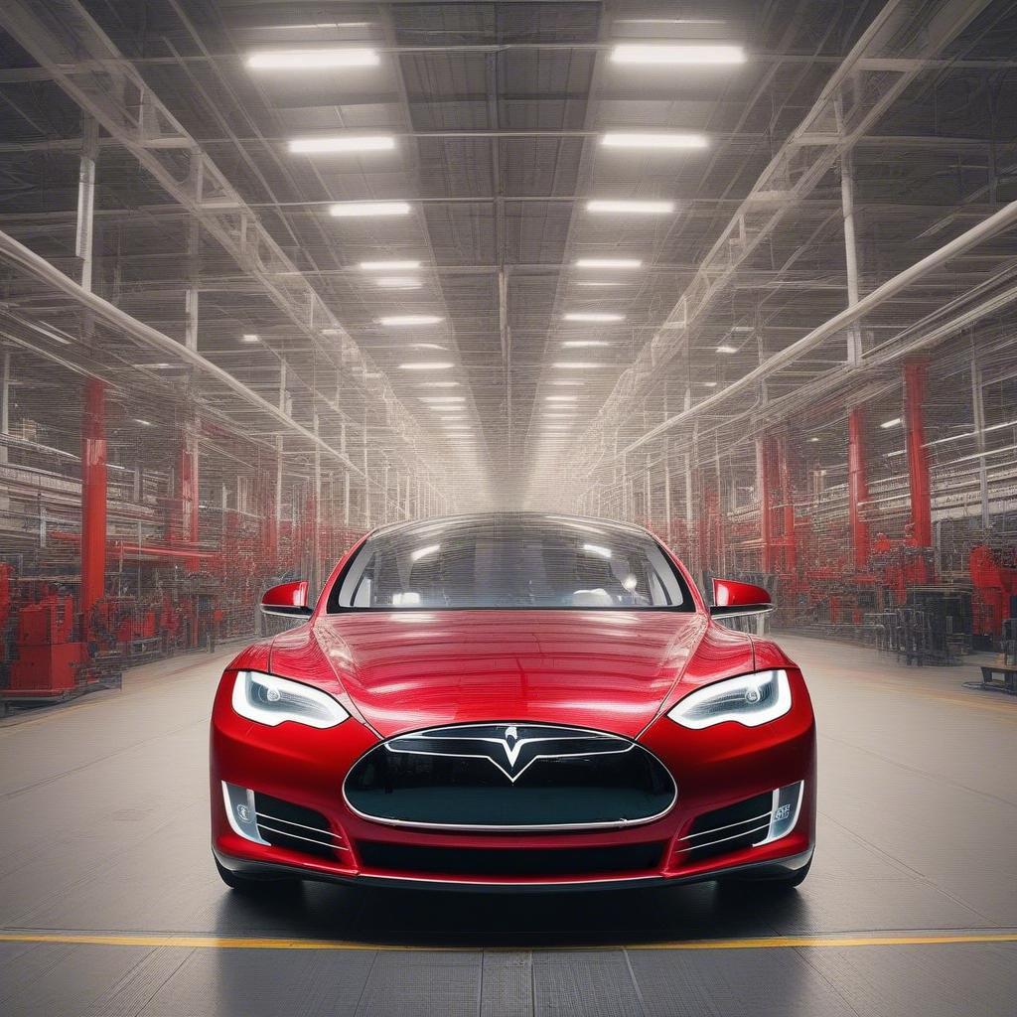**Introduction:**   
In recent years, Tesla has emerged as a dominant force in the electric vehicle (EV) industry and beyond. With its innovative technologies and ambitious vision, the company is poised to revolutionize multiple sectors, from energy storage to artificial intelligence. Despite market fluctuations, many believe that Tesla has the potential to become the biggest company in the world.

**Tesla's Diversified Portfolio:**   
One of the key strengths of Tesla is its diversified portfolio of products and services. As Stefano Boglioni pointed out in a recent tweet, Tesla is not just a car company. In addition to its market-leading EVs, Tesla is also involved in energy storage, mining, insurance, charging networks, AI, autonomous cars, robotaxis, and humanoid robots. This broad range of offerings positions Tesla as a leader in multiple industries and allows the company to stay ahead of the competition.

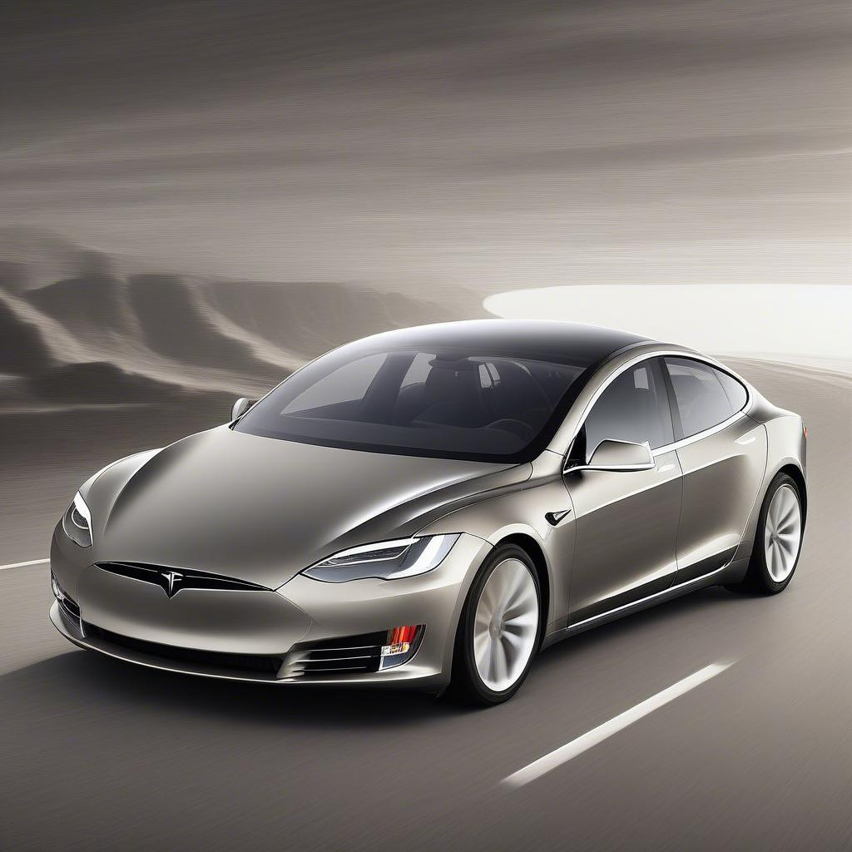**The Future of Autonomous Vehicles:**   
The development of autonomous vehicles, or self-driving cars, has been a major focus for Tesla in recent years. With its Full Self-Driving (FSD) technology, Tesla aims to revolutionize transportation by eliminating the need for human drivers. This technology has the potential to not only improve road safety but also transform the way we travel and commute. As Dario Mijač highlighted in a tweet to ARKInvest, the combination of FSD technology and Tesla's market dominance could have far-reaching implications for the EV industry and battery production.

**Tesla's Impact on Battery Supply:**   
One of the potential challenges facing the EV industry is the availability of batteries. As EV production continues to grow, there is a concern that a shortage of batteries could hinder the industry's expansion. Tesla, with its large-scale production capabilities and ambitious plans for robotaxis, could potentially buy up a significant portion of the global battery supply. This could have a major impact on other EV manufacturers, potentially preventing them from achieving mass production and market dominance.

Market Speculation vs. Long-Term Vision:   
Despite fluctuations in Tesla's stock price and market performance, many investors and analysts remain confident in the company's long-term potential. As Stefano Boglioni emphasized in his tweet, it is important to focus on Tesla's ongoing improvements and technological advancements rather than short-term market fluctuations. By staying true to its vision and continuing to innovate, Tesla has the opportunity to reshape industries and become a global leader in sustainable transportation and energy solutions.

**Conclusion**:   
In conclusion, Tesla's rise to prominence in the EV industry and beyond is a testament to the company's innovative spirit and ambitious vision. By diversifying its portfolio, investing in autonomous technologies, and prioritizing long-term growth over short-term market fluctuations, Tesla has positioned itself as a disruptor in multiple industries. As the company continues to push the boundaries of technology and sustainability, the impact of Tesla's success will be felt far and wide. From energy storage to autonomous vehicles, Tesla is leading the charge towards a cleaner, smarter future.