ESTIMATION OF BUSINESS EXPENSES

INTRODUCTION
A business estimate is a document that provides potential clients with an approximation of the costs associated with the goods or services they are interested in. It is important to remember that an estimate is not a binding contract, but rather a tool used to help secure business. siness, such as equipment, rent, inventory, and marketing. By calculating these costs properly to be incurred in the execution of the eligible works together with the amount of the costs which the Authority considers have been properly incurred, or are properly to be incurred, with respect to preliminary or ancillary.

Overview
This involves estimating all the expenses required to start and operate the business, such as equipment, rent, inventory, and marketing. By calculating these costs upfront, business owners can better plan their budget and avoid unexpected expenses.

purpose
Estimates are important because they allow businesses to set expectations for their customers. They also help businesses determine whether or not a project is feasible and how much profit they can expect to make upfront, business owners can better plan their budget and avoid unexpected expenses.
Estimated expense means the amount of the expenses which the Authority consider are. Estimating also allows businesses to plan for unforeseen expenses and keep track of spending.

PROBLEM DEFINITION & DESIGN THINKING

Empathy map

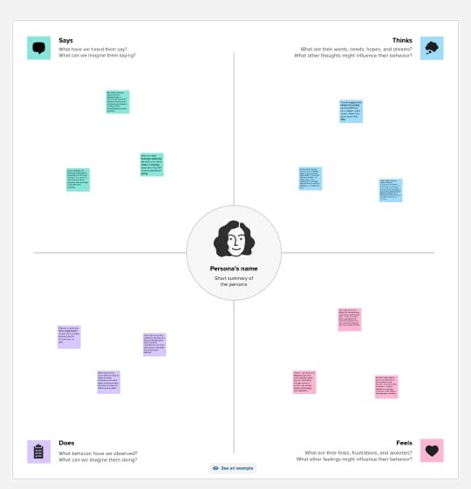
Ideation & Brainstorming Map

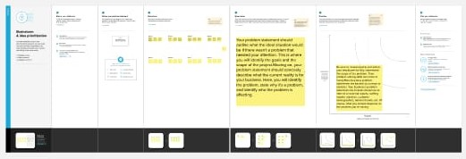
Result
Here we provide the result of the tableau provide result of Estimation of Business Expenses that a decrease in equity during the reporting period. And as a general, an increase in any type of business expense lowers profit.

ADVANTAGES

Cost estimation should be the first step in any business proposal you make. This stage is important because you have to give an estimate of the actual market costs involved in the task you would like to take on for your customers, like construction, maintenance, etc.
An estimate is an educated guess about the future. In this case, it’s an educated guess about the future costs you might encounter when completing a job. An estimate is a more detailed version of a budget, which covers the expenses of a project before you begin.

Building stronger client relations
Estimation benefits you and your client by helping in better planning for all the construction costs of doing business. This also shows your clients that you take the time to understand how you can help them and how much money they’re investing in your business. Another benefit of estimating costs for a project is to help everyone involved be aware of what it costs.

Prior Prediction
A benefit of the cost estimating process is that you are prepared for any situation. If things go wrong, you’re prepared. If they go well, you’re prepared. Using a budget to determine how much to spend can help project managers determine what they can spend on different materials or construction processes. Knowing what you can spend can help you make right decisions for the entire team.

Simplification
The first and maybe the most critical thing about creating templates is to understand that you require a lot of different template construction. You don’t want them to be too complex, but you don’t want to have to reinvent the wheel every time you’re faced with a new job.

Avoiding Errors
Small mistakes can cost a lot of money and cost overruns in such cases. If you are trying to run a business, you need to be precise about your numbers and know the difference between the estimated value and the exact answer. If you have precise construction cost estimation, you know when to expect more revenue or loss. You will be able to progress with confidence if your construction estimates are precise.

Checking profitability
Estimating management costs is a critical part of operating a business. It helps you to know whether or not you will be able to profit off of a product. It allows you to know whether you need to raise the price of your product or if you can keep it at a steady cost.
Estimating business costs involves knowing your profit margins, accurate estimating of the time that will take, and considering the risks involved with completing the job. After writing out a practical estimate, you can decide if it is worth your time and effort. You can also show the client your estimate and decide if they’re willing to take the risk. This helps the client feel informed and confident in their decision.

DISADVANTAGES

Costs
The benefits of cost accounting come with a price. Since costing methods differ from organization to organization, it's not clear how these costs might manifest themselves until a specific firm is examined.

Complexity
Generally speaking, complex cost accounting systems require a lot of work on the front end, and constant adjustments need to be made for improvements.

Additional Steps to Verify Accuracy
Even if the rigidity of financial accounting creates some inherent disadvantages, it does remove the uncertainty and misapplication of accounting guidelines of cost accounting. Uncertainty equals risk, which always comes at a cost. This means additional—and often more vigorous—reconciliation to verify accuracy.

Reliance on Highly-Skilled Talent
Higher-skilled accountants and auditors are likely to charge more for their services. Employees have to receive extra training and must sufficiently cooperate with data input. Non-cooperation can render ineffective an otherwise beautifully constructed system.

Special Considerations
The repeated trade-off in any accounting method is accuracy versus expediency. Cost accounting reflects this more dramatically than other accounting methods because of its pliability. Every business needs to find its own balance between the two.

Costing methods are typically not useful for figuring out tax liabilities, which means that cost accounting can't provide a complete analysis of a company's true costs. It's easy enough to compensate for this by combining financial accounting with cost accounting but it, nevertheless, highlights a flaw in cost accounting.

APPLICATIONS
Tracking your business expenses should become a habit. By making it part of your regular workflow, you’re less likely to miss expenses that can reduce your overall tax burden. And by keeping an eye on your expenses and revenue through your income statement, you’re able to better monitor the financial health of your company.
- Open a business bank account. Make sure this is separate from your personal checking account and only use it for business expenses. This will make it easier to track your business charges. And you may be eligible for business credit or debit cards that come with perks like cash back or no-interest financing for three months.
- Formalize how you store receipts. Consider scanning receipts and keeping digital copies. Try and make it part of your regular workflow. If not daily, try to set aside the same time each week to scan and organize receipts. Write the business purpose on the receipt so you can remind yourself later, if needed.
- Review and categorize your expenses regularly. Examine each transaction and track your spending by category. By comparing your expenses to revenue, you can see how much it costs to produce an amount of revenue in a given time.
- Consider buying business accounting software. Save time and ensure you have the most up-to-date information with an accounting platform. Store and track receipts and easily categorize expenses. You can see charts and dashboards of your financial information, as well as generate important reports, like the income statement
CONCLUSION

In conclusion,cost estimation is an important component of project management that ensures projects are finished on schedule and within budget. Since inaccurate cost estimates can have serious financial consequences for businesses, accurate cost estimating is crucial for all stakeholders engaged in a project.

FUTURE SCOPE

Expense management software solutions have come a long way from being mere reporting tools. They have evolved because of the advances in the spheres of automation and artificial intelligence. Expense management software that employ the latest technology are an absolute must-have for every organization, irrespective of the size or industry.
Companies have been gradually adopting expense management software in a bid to mitigate the losses associated with expense frauds and wasted time. The speed of adoption and change, however, needs to keep pace with emerging trends in the industry.
Technavio analysts believe that the travel and expense management (T&E) software market will grow at a CAGR of 12% in the period 2019 – 2023.
In 2018, companies made advances in expense management practices such as
- digital transformation and moving ERP systems to the cloud
- adopting software with user-centric design and interface
- accepting spending outside of preferred channels.
2019 will see a continuing upswing in the sophistication of software capabilities and maturity in expense management practices.

APPENDIX

A business plan is essential in starting a business, improving a business, or raising capital, and is a detailed view of the business. A Sample Business Plan is found in Appendix J. Low-cost assistance and training in preparing a business plan is available from Small Business Development Centers (SBDC) located throughout the United States.

Although a complete business plan as found in Appendix J is recommended, the minimum requirements for the Business Plan are as follows:
- Documentation of Business, Company, or Organization
- 2. Narrative Description of Who Will Perform Work
- 3. Description of Business Experience and Past Performance Evaluations
- 4. Financial Resources (Financial Statement, Form FS-6500-24, and Request for Verification, Form FS-6500-25) Appendix 17 & 18.
- 5. Payment History/Credit References
- 6. Cash Flow Projection for The First Three Years of Operation
- 7. Income Projection by Month For the First Three Years of Operation
- 8. Estimated Fee to the Government

