INFORMATION SECURITY
UNIT-2
Legal, ethical, and professional issues
Legal, ethical, and professional issues are crucial considerations in many fields, including healthcare, business, education, and technology. These concepts serve as guidelines and frameworks for responsible and accountable behavior, ensuring individuals and organizations operate within the bounds of the law, uphold moral principles, and maintain professional standards. Here's an overview of each:

Legal Issues
- Definition: Legal issues pertain to rules and regulations established by governments or governing bodies to ensure order and justice.
- Key Focus: Compliance with laws, avoiding violations, and addressing disputes or liabilities.
- Examples:
  - In healthcare: patient privacy laws like HIPAA (in the U.S.).
  - In business: adherence to contracts, consumer protection laws, and employment regulations.
  - In technology: intellectual property rights and cybersecurity legislation.

Ethical Issues
- Definition: Ethical issues involve moral principles and values that guide behavior and decision-making.
- Key Focus: Acting in ways that are fair, just, and respectful of others.
- Examples:
  - Maintaining honesty and transparency.
  - Avoiding conflicts of interest.
  - Ensuring equity and fairness in opportunities.

Professional Issues
- Definition: Professional issues relate to adherence to industry standards, codes of conduct, and practices specific to a profession.
- Key Focus: Demonstrating competence, integrity, and responsibility in one’s professional role.
- Examples:
  - Following a professional code of ethics (e.g., medical ethics, legal ethics).
  - Meeting continuing education or certification requirements.
  - Respecting boundaries in professional-client relationships.
****************************************************************************************

Law and Ethics in Information Security
Information security focuses on protecting information from unauthorized access, disruption, or destruction. Both legal frameworks and ethical principles play pivotal roles in shaping practices to secure data and systems responsibly.

Laws in Information Security
Legal frameworks ensure that organizations and individuals comply with regulations to protect data and maintain security. Key laws include:

1. Data Protection and Privacy Laws
- General Data Protection Regulation (GDPR):
  - Applies to organizations handling the personal data of EU citizens.
  - Focuses on consent, data minimization, transparency, and the right to access and erase data.
- California Consumer Privacy Act (CCPA):
  - Empowers California residents with rights over their personal data.
  - Requires businesses to disclose data collection practices and allows users to opt out.
- Health Insurance Portability and Accountability Act (HIPAA):
  - Protects health-related data in the U.S.
  - Mandates safeguards for electronic protected health information (ePHI).

2. Cybersecurity and Cybercrime Laws
- Computer Fraud and Abuse Act (CFAA) (U.S.): Criminalizes unauthorized access to computer systems and networks.
- Cybersecurity Information Sharing Act (CISA): Promotes sharing of cyber threat information between the government and private sector.
- Convention on Cybercrime (Budapest Convention): An international treaty aiming to standardize cybercrime laws and promote global cooperation.

3. Intellectual Property Laws
- Protect software, algorithms, and digital content under copyright, patent, and trademark laws.
- Address issues like software piracy, reverse engineering, and unauthorized distribution.

4. Industry-Specific Regulations
- Sarbanes-Oxley Act (SOX): Ensures accurate financial reporting by enforcing strong IT controls.
- Payment Card Industry Data Security Standard (PCI DSS): Protects credit card information through security protocols.
**********************************************************************************

Ethics in Information Security:

Key Concepts
Ethics in information security emphasizes the responsible handling and protection of user data. Below are some key ethical considerations that ensure fairness, respect, and accountability:

1. User Privacy
- Protecting individuals' personal information from unauthorized access, misuse, or exposure.
- Ensuring privacy rights are respected in all stages of data collection, storage, and usage.

2. Informed Consent
- Collecting user data only after providing clear, accurate information about what is being collected and why.
- Users must have the choice to agree or decline and should be aware of their rights.

3. Data Minimization
- Collecting only the data that is necessary for a specific purpose.
- Avoiding the storage or use of excessive or irrelevant information to reduce risks of misuse or breaches.

4. Transparency
- Being open and honest about data collection practices, how data is used, and who it is shared with.
- Providing easy-to-understand privacy policies and terms of use to users.

5. Responsible Disclosure
- Reporting security vulnerabilities or breaches to the appropriate parties without exploiting them.
- Informing affected users or organizations promptly so they can take necessary actions.
*****************************************************************************
Difference between Law and Ethics
This table provides a clear comparison between law and ethics, highlighting their differences and interconnections:
Aspect | Law | Ethics
Definition | Rules enforced by governing authorities to maintain order. | Moral principles guiding behavior based on right and wrong.
Source | Created by legislative bodies, courts, or regulatory authorities. | Derived from societal norms, personal values, or philosophical beliefs.
Enforcement | Enforced by legal institutions (police, courts, etc.). | Self-enforced or guided by societal judgment and conscience.
Scope | Focuses on minimum standards of behavior for order and justice. | Encourages higher standards of behavior beyond legal requirements.
Flexibility | Static until officially amended or repealed. | Dynamic and evolves with societal norms and values.
Consequences | Violations result in legal penalties such as fines, imprisonment, or other sanctions. | Violations result in social disapproval, guilt, or damage to reputation.
Objective | Ensures societal order, protects rights, and resolves disputes. | Promotes moral integrity, fairness, and respect in personal and professional behavior.
Examples | Traffic laws, tax regulations, prohibition of theft. | Honesty, fairness, respecting confidentiality.
Relationship | Represents what is legally obligatory or forbidden. | Reflects what is morally right or wrong, often influencing laws.
*******************************************************************
Relevant U.S Laws, International Laws, Legal Laws:
- U.S Laws:

1. Privacy and Data Protection Laws
- Health Insurance Portability and Accountability Act (HIPAA):
  - Protects the privacy and security of healthcare data (ePHI).
  - Applies to healthcare providers, insurers, and their business associates.
  - Requires safeguards for storing, accessing, and transmitting health information.
- Children’s Online Privacy Protection Act (COPPA):
  - Protects the privacy of children under 13 online.
  - Requires parental consent for collecting, using, or disclosing children’s personal information.
- California Consumer Privacy Act (CCPA):
  - Grants California residents rights over their personal data, such as access, deletion, and opting out of data sales.
  - Requires businesses to disclose data collection practices.
- Family Educational Rights and Privacy Act (FERPA):
  - Protects the privacy of student education records applies to education institutions..
  - Grants students and parents rights to access and correct records.

2. Cybersecurity Laws
- Computer Fraud and Abuse Act (CFAA):
  - Prohibits unauthorized access to computer systems and data.
  - Addresses hacking, phishing, and other forms of cybercrime.
- Cybersecurity Information Sharing Act (CISA):
  - Encourages the sharing of cyber threat information between the government and private sector to prevent and mitigate attacks.
- Gramm-Leach-Bliley Act (GLBA):
  - Requires financial institutions to protect customers' sensitive data.
  - Mandates the implementation of data security plans and customer privacy notifications.

3. Breach Notification Laws:
- A data breach is an incident where sensitive, confidential is accessed unauthorized individuals.
- The California Consumer Privacy Act (CCPA) is a comprehensive data privacy law designed to give California residents greater control over their personal information
_______________________________________________________________
- International Laws:
Countries around the world have enacted various data protection and privacy laws to safeguard personal information and provide individuals with rights over their data. Below are some of the major international data protection laws:

1. GDPR (General Data Protection Regulation) – European Union
A law to protect the privacy and personal data of people in the EU.Gives people control over their personal data.Requires companies to ask for clear consent before using your data.People can ask to see or delete their data.

2. PIPEDA (Personal Information Protection and Electronic Documents Act) – Canada
A law that controls how businesses collect, use, and share personal data in Canada.
  - Businesses must get your consent to use your data.
  - You can access your personal data and ask for corrections.
  - Companies must notify you if your data is stolen.

3. APPI (Act on the Protection of Personal Information) – Japan
- What it is: A law to protect personal data in Japan.
- Key Points:
  - Requires companies to get your consent to collect your data.
  - Companies must protect your data and keep it safe.
  - You can ask to see or delete your personal data.
***************************************************************************************

Ethics and Information Security :

Ethics in information security is about doing the right thing when protecting data. It ensures data is kept safe, used responsibly, and respects people's rights.
Key Points:
- Confidentiality: Keep information private and accessible only to authorized people.
- Integrity: Ensure data is accurate and not altered without permission.
- Transparency: Be honest about how data is collected, stored, and used.
- Accountability: Take responsibility for security breaches or misuse of data.

1.User Privacy:
User privacy means protecting personal information and letting people control how their data is used.
- Get permission before collecting personal data.
- Only collect the data you need.
- Keep data anonymous when possible.
- Clearly explain your privacy policies.
- Follow privacy laws like GDPR or HIPAA.

2.Ethical Dilemmas:

Ethical dilemmas happen when we face tough choices between two conflicting values,
Sometimes it’s hard to decide what’s right. For example:

Balancing Security and Privacy :Security protects people and systems, but too much security can invade privacy. Use monitoring tools that focus on threats, not personal information, and inform employees about them.

Use of Surveillance Technologies: Surveillance technologies, like cameras and facial recognition, can prevent crimes but also invade privacy. Set clear rules for when and how surveillance is used, ensuring it's not abused.

Cybersecurity and Hacking: Hacking can protect or harm, depending on the intent. Use ethical hacking only with permission and for improving systems, not personal gain.

Data Breaches: A data breach happens when sensitive information is exposed. The ethical dilemma is deciding how to respond.

3.Professional Code of Ethics
A code of ethics is a set of rules professionals follow to act responsibly.
- Be honest and fair.
- Keep personal information confidential.
- Always try to protect society and people from harm.
- Keep learning to stay good at your job.
*******************************************************************************
What is privacy I an information security context?
In an information security context, privacy is the right to control how personal information is collected, stored, and used. It's also known as information privacy or data privacy.
Privacy is important for a number of reasons, including:
- Protecting personal information
Keeping personal data safe from unauthorized access can help prevent identity theft and fraud.
- Establishing trust
When organizations are transparent about how they collect and use data, it helps build trust with their users.
- Complying with regulations
Many governing bodies have regulations in place to protect personal information.
- Maintaining ethical practices
Data privacy is essential for maintaining ethical practices in the use of personal information.
Here are some ways to protect your privacy:
- Use strong, unique passwords for accessing business systems and applications.
- Only download apps and visit websites from trusted sources.
- Review app permissions before giving them access to your personal data.
- Install and keep updated trusted antivirus and anti-malware software on your devices.
- Regularly scan your devices for malware and delete any detected threats.

Threats to Privacy
- Data Breaches: Unauthorized access to sensitive information.
- Phishing Attacks: Deceptive tactics to steal personal information.
- Third-Party Sharing: Unauthorized sharing of data with external entities.
- Surveillance: Excessive or unjustified monitoring of user activities.
************************************************************************************
RISK MANAGEMENT :
Overview of Risk Management/Types of Risk Management.
Risk management is the process of identifying, assessing, and handling potential risks that might harm a project or business. The goal is to reduce the chance or impact of problems while maximizing opportunities.

Types of Risks

1. Project Risks
Risks that impact the success, timeline, or budget of a project.
Examples:
- Scope creep: Unexpected changes in project requirements.
- Resource issues: Shortage of people, materials, or tools.
- Delays: Missed deadlines.
- Budget problems: Spending more money than planned.

2. Technical Risks
Risks related to technology, design, or systems used in a project.
Examples:
- Unproven tech: Using new tools or methods that might fail.
- Integration issues: Trouble combining different parts of a system.
- Performance problems: Systems not working as required.
- Cybersecurity risks: Data breaches or hacking threats.

3. Business Risks
Risks that affect the broader business environment or goals.
Examples:
- Market changes: Fluctuations in customer needs or demand.
- Competition: New or better rivals entering the market.
- Regulations: New laws or rules to follow.
- Financial issues: Lack of funds or economic downturns.
Components of Risk management/Steps In Risk Management :
the components of risk management divided into three main steps: Risk Identification, Risk Assessment, and Risk Control. Here's an explanation of each step, as shown in the diagram:
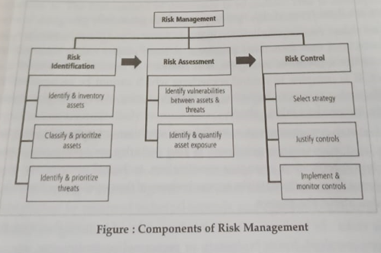

1. Risk Identification
This step focuses on discovering risks to an organization or project:
- Identify and inventory assets: List all the critical resources (e.g., data, hardware, software, or business processes).
- Classify and prioritize assets: Categorize these resources based on their value or importance to operations. High-priority assets are given more attention.
- Identify and prioritize threats: Recognize the potential dangers (e.g., cyberattacks, natural disasters) and rank them based on their likelihood and potential impact.

2. Risk Assessment
In this stage, the identified risks are evaluated to understand their severity:
- Identify vulnerabilities between assets and threats: Identify gaps or weaknesses in systems, processes, or resources that threats could exploit.
- Identify and quantify risk exposure: Assess the likelihood of each risk occurring and its potential impact, assigning a risk level to prioritize actions.

3. Risk Control
This step involves selecting and applying measures to manage risks:
- Select strategy: Choose an appropriate response to address each risk, such as avoiding, mitigating, transferring, or accepting the risk.
- Justify controls: Ensure the control measures are cost-effective and feasible relative to the risks being managed.
- Implement and monitor controls: Put the selected strategies into action and continuously monitor them for effectiveness, updating as needed.
********************************************************************************
who is responsible for risk management in an organization
Risk management in an organization is typically a shared responsibility, but the following roles are usually involved:
- Board of Directors: They provide oversight and governance, ensuring that risk management aligns with the organization's objectives. They set the overall risk management strategy and policies.
- Chief Risk Officer (CRO): In larger organizations, the CRO is responsible for overseeing risk management processes and ensuring that risks are properly identified, assessed, and mitigated. They report to the executive leadership or board.
- Risk Management Department: This department, if separate from other departments, manages day-to-day risk identification, assessment, and mitigation strategies. They work closely with other departments to address risk issues.
- Executive Leadership (CEO, CFO, etc.): These leaders are responsible for integrating risk management into strategic decisions and ensuring the organization’s goals align with its risk appetite.
- Department Heads and Managers: Managers at various levels are responsible for identifying and managing risks within their specific areas (e.g., finance, operations, HR). They must implement risk management strategies and report potential risks.
- Internal Audit: This function plays a key role in evaluating and monitoring the effectiveness of the organization’s risk management processes and controls.
- Employees: Everyone in the organization plays a role in risk management by adhering to policies, identifying potential risks, and following established protocols to minimize risk exposure.
**************************************************************************************

Risk Identification:
Risk identification involves recognizing all the potential risks that an organization could face. This is a proactive activity aimed at identifying and listing all possible threats, both internal and external, that could impact the business.

Key Elements of Risk Identification:
- Documenting Potential Risks: A comprehensive list or "risk register" is created to capture all possible risks. These risks could include financial, operational, reputational, legal, environmental, and technological risks, among others.
- Risk Categories: Risks are categorized into different types to make them easier to manage. Common categories include:
  - Strategic Risks: Risks arising from the organization’s business strategy, including market competition, regulatory changes, or failure to meet objectives.
  - Operational Risks: Risks related to internal processes, such as supply chain issues, technology failures, or human error.
  - Financial Risks: Risks related to financial performance, including cash flow issues, market fluctuations, and fraud.
  - Compliance Risks: Risks arising from failure to comply with laws and regulations.
  - Environmental and External Risks: Risks stemming from factors like natural disasters, geopolitical instability, or changes in the economy.
- Current and Emerging Risks: Identifying both the risks that the organization is currently facing and those that may arise in the future. This requires foresight and staying updated on industry trends, emerging technologies, and evolving regulations.

Methods for Identifying Risks:
- Brainstorming Sessions: Engage with key stakeholders, including department heads, employees, and even external experts, to gather insights on potential risks.
- Risk Workshops: Structured workshops with teams can help uncover risks from different perspectives.
- SWOT Analysis: A technique that assesses the organization’s Strengths, Weaknesses, Opportunities, and Threats to identify potential risks.
- Historical Data Analysis: Reviewing past incidents and risks faced by the organization or industry to uncover recurring or similar risks.
- Scenario Planning: This involves imagining different future scenarios (such as economic downturns or technological disruptions) to identify risks that could arise in those situations.
**************************************************************************
Risk assessment:
Risk assessment is a systematic process used to identify, evaluate, and prioritize risks to help organizations minimize the potential negative impact on their objectives. The major stages of risk assessment typically include:

Diagram of Major Stages of Risk Assessment:

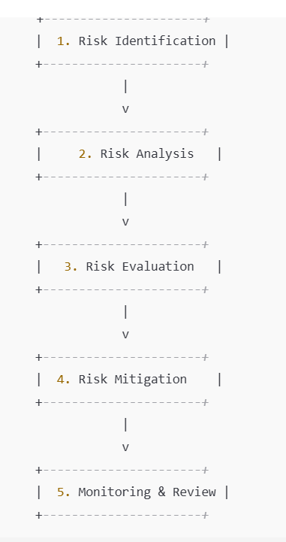
a risk management process flowchart. Here is a textual representation and explanation of the steps:
- Risk Identification
  - Identify potential risks that could impact objectives, operations, or projects.
  - Example: Brainstorming sessions, checklists, and historical data analysis.
  - Methods: Brainstorming, SWOT analysis, interviews with stakeholders, historical data review, and scenario planning
- Risk Analysis
  - Assess the likelihood and impact of identified risks.
  - Techniques: Quantitative (numerical models) or qualitative (rating scales).
  - Methods: Qualitative analysis (e.g., low, medium, high) and quantitative analysis (e.g., probabilities, financial impact).
- Risk Evaluation
  - Prioritize risks based on their significance to determine which need action.
  - Compare analyzed risks to acceptable levels of risk (risk appetite).
  - Method: Risk matrix (likelihood vs. impact) or scoring systems.
- Risk Mitigation
  - Develop and implement strategies to reduce, transfer, accept, or avoid risks.
  - Example: Implementing controls, purchasing insurance, or redesigning processes.
  - Methods: Risk avoidance, risk reduction, risk transfer (e.g., insurance), or risk acceptance.
- Monitoring & Review
  - Continuously track risks and their mitigation measures to ensure effectiveness.
  - Update the risk management plan as new risks arise or circumstances change.
  - Methods: Regular risk audits, performance reviews, and updates to the risk register.
**********************************************************************************
Risk Control Strategies :
1. Risk control strategy refers to the methods or actions that an organization uses to manage, mitigate, or eliminate identified risks.
2. It involves implementing measures to reduce the likelihood of a risk event occurring or to minimize its potential impact on the organization.
3.The goal is to ensure that risks are appropriately controlled in line with the organization's risk tolerance and objectives.

Types of Risk Control Strategies:
- Risk Avoidance
  - Description: This strategy involves eliminating the risk entirely by changing plans, processes, or strategies to avoid the risk altogether.
  - Example: A company decides not to enter a high-risk market due to political instability, thus avoiding the risk of losing investment.
- Risk Reduction (Mitigation)
  - Description: This strategy seeks to reduce the likelihood of a risk occurring or minimize its impact if it does happen. It involves taking steps to control and minimize the effects of a potential risk.
  - Example: Installing fire safety equipment, implementing cybersecurity measures, or training employees to handle specific risks better.
- Risk Transfer
  - Description: This strategy involves shifting the impact or responsibility of a risk to a third party, typically through insurance, outsourcing, or contractual agreements.
  - Example: Purchasing insurance to cover potential losses from natural disasters or outsourcing operations to a third party to manage risks related to labor and logistics.
- Risk Acceptance (Retention)
  - Description: In this strategy, the organization decides to accept the risk, usually because the cost of mitigating or transferring it outweighs the potential impact of the risk itself. This approach is suitable for risks that are low in impact or likelihood.
  - Example: A company may accept the risk of minor operational delays during peak seasons rather than spend resources to eliminate the risk.
- Risk Sharing
  - Description: This involves distributing the risk across multiple parties, so no single entity bears the entire burden of the risk. It is similar to transfer but typically involves partnerships or joint ventures.
  - Example: Two companies may enter into a partnership where they share the costs and risks of a new product launch.
6. Risk Termination
  - Description: This involves distributing the risk across multiple parties, so no single entity bears the entire burden of the risk. It is similar to transfer but typically involves partnerships or joint ventures.
  - Example: If a company finds that a certain project is too risky and could cause major losses, it may decide to cancel or stop the project completely. Similarly, if a product line is too risky, the company might stop selling it.

****************************************************************************************
Selecting Risk Control Stategies/Rules for Risk Control Stategies.
This is a flowchart titled "Risk Handling Decision Points." It outlines a systematic approach to identifying, assessing, and deciding on handling risks related to system vulnerabilities. Here's a step-by-step summary:

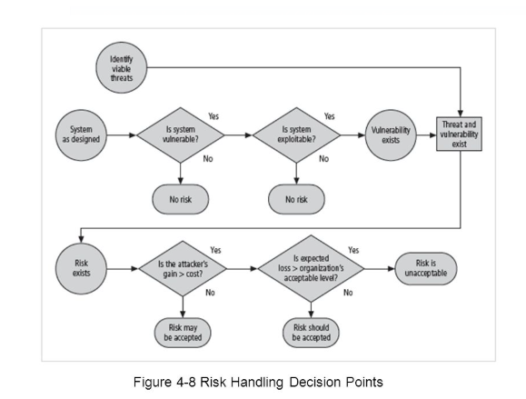

- Identify Viable Threats:
  - Begin by identifying threats to the system.
- System Evaluation:
  - Check if the system as designed is vulnerable.
    - If "No," there's no risk.
    - If "Yes," proceed to assess if the system is exploitable.
- Exploitation Check:
  - Is the system exploitable?
    - If "No," there's no risk.
    - If "Yes," a vulnerability exists, and a threat and vulnerability are established.
- Risk Exists:
  - If a threat and vulnerability are confirmed, evaluate the risk:
    - Assess if the attacker's gain exceeds the cost of the attack.
      - If "No," the risk may be accepted.
      - If "Yes," check if the expected loss is acceptable to the organization.
- Risk Acceptance:
  - If the expected loss is within the organization's acceptable level, the risk should be accepted.
  - If not, the risk is deemed unacceptable and likely requires mitigation.
*****************************************************************

Quantitative Risk Control Practice:
Quantitative risk control involves assigning numerical values to risks based on data, probability, and financial impact. This approach uses statistical methods and mathematical models to evaluate and manage risks.

Key Characteristics
- Numerical Measurement: Risks are measured in terms of probability and potential financial impact.
- Data-Driven: Relies on historical data, statistical analysis, and simulations.
- Cost-Benefit Analysis: Focuses on comparing the cost of implementing controls versus the financial benefit of reducing risk.
- Objective Decision-Making: Reduces subjectivity by providing quantifiable results.
- Models and Tools:
  - Tools like Monte Carlo simulations, decision trees, and probability distributions.
  - Financial models to calculate metrics like Annualized Loss Expectancy (ALE).

Advantages
- Clear Decisions: Helps prioritize actions with exact figures.
- Cost-Effective: Shows if spending money to fix a risk is worth it.
- Easy to Share: Converts risks into financial terms that everyone understands.

Disadvantages
- Needs Data: Without good data, results can be unreliable.
- Complex: Sometimes hard to use and understand without training.
- Costly: Takes time, tools, and expertise to do right.
Imagine your system has a 5% chance of a $10,000 loss in a year.
EX:Risk = Probability × Impact = 0.05 × $10,000 = $500.
- Spending $300 to fix the risk
- And amount to reduces the risk is $100.
- 500-100=400
- Since $300 is less than the $400 savings, it's worth fixing.
_________________________________________________________________
Qualitative risk control practice:
Qualitative risk control is a subjective approach to managing risks, focusing on identifying, assessing, and prioritizing risks based on their likelihood and potential impact, typically using descriptive or categorical terms (e.g., "high," "medium," "low").

Key Characteristics
- Uses Descriptions: Rates risks as "high impact," "medium likelihood," etc.
- No Numbers: Doesn't rely on financial or statistical data.
- Expert Opinions: Involves team discussions and brainstorming.
- Tools: Uses simple charts like risk matrices (likelihood vs. impact).

Advantages
- Easy to Use: Simple and quick, no need for complex tools or data.
- Broad Application: Works well when data is unavailable.
- Flexible: Covers intangible risks like reputation damage.
- Collaborative: Encourages team input and diverse viewpoints.

Disadvantages
- Subjective: Relies on opinions, which can vary or be biased.
- Less Precise: Doesn’t provide exact financial or numerical impact.
- Hard to Compare: Risks may not be ranked consistently across teams.
- Oversimplifies: May miss complexities of certain risks.

Example
- Risk: A hacker might breach your system.
  - Likelihood: "High" (based on past events).
  - Impact: "Severe" (due to sensitive data loss).
  - Action: Strengthen security measures.
- Since the risk is "high," you prioritize fixing it.
________________________________________________________________________________
Ex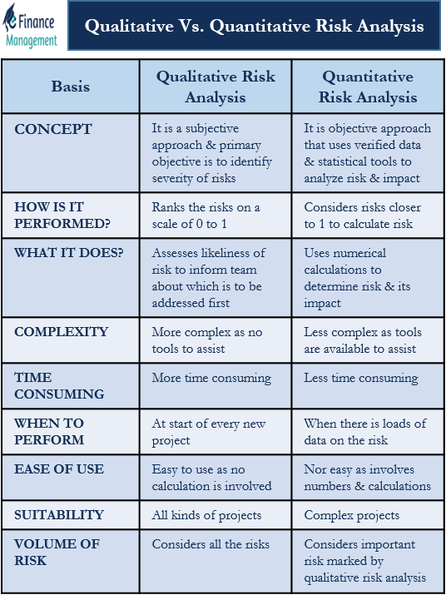
*******************************************************************

Recommended risk control practices include:
- Risk assessment: Determines the likelihood of a risk and the potential consequences of it happening.
- Risk identification: The first step in accounting for any roadblocks.
- Risk monitoring: Helps identify, assess, and mitigate risks.
- Risk reporting: Regularly report on risk measures to ensure that risk remains at an acceptable level.
- Prioritize risks: Give more attention and resources to high-impact risks.
- Risk management planning: Establish a common understanding of the project's key parameters, management's risk tolerance, and how the process will work.
- Internal controls: Implement internal controls.
- Incident response plans: Develop and test incident response plans.
- Software and systems: Maintain up-to-date software and systems.
- Access control: Implement access control and authentication measures.
- Data encryption: Implement data encryption and backup strategies.
********************************************************************************************

Which law amended the Computer Fraud and Abuse Act of 1986, and what did it change

Original CFAA (1986):
The Computer Fraud and Abuse Act was enacted as an amendment to the Comprehensive Crime Control Act of 1984 in response to growing concerns over hacking and computer crimes. It was designed to:
- Criminalize unauthorized access to federal and financial computer systems.
- Protect classified information and government data.
- Impose criminal penalties for damaging protected computers.

💡 Key Provisions (1986):
- Protected Computers: Initially limited to:
  - Computers owned by the U.S. government.
  - Computers at financial institutions.
  - Systems related to interstate or foreign commerce.
- Criminal Penalties:
  - Unauthorized access or exceeding authorized access.
  - Fines and imprisonment for up to 10 years for repeated offenses.
Gradual Expansion:
- 1994 Amendment:
  - Introduced civil liability, allowing companies to sue for damages.
  - Lowered the threshold for prosecution by defining specific harms (e.g., $5,000 financial loss, physical injury, or threats to public safety).
- 1996 Amendment (National Information Infrastructure Protection Act):
  - Expanded protected computers to include any device involved in interstate or foreign commerce (effectively covering most internet-connected devices).
- 2001 USA PATRIOT Act:
  - Expanded FBI powers for search and seizure of ISP records.
  - Included foreign computers impacting U.S. commerce under protection.
  - Added cyberterrorism provisions.
- 2008 Identity Theft Enforcement and Restitution Act:
  - Extended the definition of protected computers further by including any device "affecting" interstate commerce.
  - Made it easier for victims to claim damages.
********************************************************************************
What are the primary examples of public law.
The Two primary examples of public law :
- Constitutional Law – deals with the structure and powers of government, and the fundamental rights of citizens.
- Criminal Law – governs crimes and punishments, ensuring protection of society and maintaining public order.
********************************************************************************
Define MAC
- MAC stands for Media Access Control. It is a sublayer of the Data Link Layer that uses a unique MAC address to identify devices on a network and control how they access the communication medium.
********************************************************************************
What is Risk appetite.
- Risk Appetite is the level of risk an organization is willing to accept or tolerate while achieving its objectives.
- It helps in making decisions by defining how much uncertainty or potential loss is acceptable.
********************************************************************************
What legal consequences can an organization face for a data breach ?
An organization can face legal consequences such as heavy fines, lawsuits, and regulatory penalties for a data breach. It may also be required to compensate affected customers and comply with strict legal and regulatory actions.
********************************************************************************
Write about IS governance .
Information Systems (IS) Governance refers to the framework of policies, processes, and structures that ensure an organization’s information systems support and align with its business goals.
IS governance defines who makes decisions, how decisions are made, and how accountability is maintained for the effective and secure use of IT and information systems. It helps organizations ensure that IT investments deliver value, manage risks, and comply with laws and regulations.
Key aspects of IS Governance include:
- Strategic alignment: Ensuring IS strategies support business objectives.
- Value delivery: Maximizing benefits from IT investments.
- Risk management: Identifying and controlling IS-related risks.
- Resource management: Efficient use of IT resources such as people, infrastructure, and data.
- Performance measurement: Monitoring and evaluating IS performance using metrics.
Overall, IS governance improves decision-making, enhances security and compliance, and ensures that information systems contribute effectively to organizational success.
********************************************************************************
Role of corporate governance in ensuring ethical compliance in IS
Role of Corporate Governance in Ensuring Ethical Compliance in IS :
- Establishes ethical policies and codes of conduct for the use of information systems.
- Ensures compliance with laws and regulations related to data protection, privacy, and cybersecurity.
- Promotes data security and privacy through controls, standards, and risk management practices.
- Defines clear roles and responsibilities for management and IT to ensure accountability.
- Conducts regular audits, monitoring, and reporting to identify and prevent unethical practices.
********************************************************************************
How can employee training and awareness programs serve as an effective risk control.

Employee Training and Awareness Programs as an Effective Risk Control:
- Educate employees about security policies, procedures, and best practices.
- Reduce risks caused by human errors, negligence, and lack of awareness.
- Help employees identify and respond to threats such as phishing, malware, and social engineering attacks.
- Ensure compliance with organizational policies and legal requirements.
- Promote a security-conscious culture, thereby minimizing operational and information security risks.
********************************************************************************

QUESTIONS:
1. Explain various legal, ethical and professional issues.
2.Write the difference between law ad ethics.
3. What is privacy I information security context.
4.Explain ethics and laws in information security.
5.Explain various Laws.
6.What is risk managements, writes its components/overview.
7.Explain risk identification, risk assessment.
8.Explain Risk control strategy. Ad how to select a risk control strategy.
9.Write the difference between Quantitative and Quantitative Risk Control Practice.
10.What is recommended risk control process.
11. Define MAC.
12.Primary examples of public law.
13. What is risk appetite.
14. What legal consequences can an organization face for a data breach ?
15. Write about IS governance .
16. Role of corporate governance in ensuring ethical compliance in IS
17. How can employee training and awareness programs serve as an effective risk control.

