**Implementation of AI-Powered Medical Diagnosis System**

A Project Report

submitted in partial fulfillment of the requirements

of

AICTE Internship on AI: Transformative Learning

with

TechSaksham – A joint CSR initiative of Microsoft & SAP

by

**AJITH K V , ajajithm1781@gmail.com**

Under the Guidance of

**Prof. Saomya Chaudhury**

**Master Trainer, Edunet Foundation**

**ACKNOWLEDGEMENT**

I would like to take this opportunity to express my deep sense of gratitude to all individuals who helped me directly or indirectly during this thesis work.

Firstly, I would like to thank my supervisor, **Prof. Saomya Chaudhury**, for being a great mentor and the best adviser I could ever have. His advice, encouragement, and critique have been a source of innovative ideas and inspiration, leading to the successful completion of this project. The confidence he has shown in me has been my biggest source of motivation. It has been a privilege to work with him over the past year. He has always supported me during my project and in many other aspects related to the program. His guidance and lessons have not only helped me in my project work and other activities but have also shaped me into a more responsible professional.

#### **ABSTRACT**

The rapid advancements in **Artificial Intelligence (AI)** have revolutionized healthcare, significantly enhancing diagnostic accuracy and efficiency. This project, **AI-Powered Medical Diagnosis System**, aims to develop an intelligent system that predicts diseases based on user-input symptoms and medical data, assisting healthcare professionals in making faster and more accurate diagnoses.

The system employs **machine learning and deep learning techniques**, including **Support Vector Machines (SVM), Logistic Regression, Random Forest, and Convolutional Neural Networks (CNNs)** to analyze symptoms, medical records, and imaging data. The structured workflow involves **data collection, preprocessing, feature selection, model training, and deployment** via a **Streamlit-based web application**, ensuring accessibility and ease of use.

Key results demonstrate that AI-driven diagnostics **significantly improve prediction speed and accuracy**, reducing dependency on manual assessments. The **Random Forest model achieved the highest accuracy of 91%**, showcasing the potential of AI in medical decision-making. The system’s deployment on **Streamlit Cloud** ensures **scalability, real-time accessibility, and future enhancements**.

In conclusion, this project highlights the transformative role of AI in healthcare by offering a **scalable, efficient, and accessible** solution for medical diagnosis. Future advancements will include **deep learning integration, real-time monitoring through wearable devices, and expanded disease coverage**, making AI an indispensable tool in modern healthcare.

**TABLE OF CONTENT**

**Abstract I**

**Chapter 1.**  **Introduction 1**

1.1 Introduction 1

1.2 The Role of AI in Medical Diagnosis 1

1.3 Diseases Covered in This Project 2

1.4 Techniques Used in This Project 3

1.5 Real-Time Prediction and User Interface 4

1.6 Problem Statement 4

1.7 Motivation 4

1.8 Objectives 5

1.9 Scope of the Project 5

**Chapter 2.**  **Literature Survey 6**

2.1  **Review of Relevant Literature** **6**

**2.2 Existing Models and Techniques** **6**

**2.3 Gaps and Limitations in Existing Solutions** **7**

**2.4 How This Project Addresses These Challenges** 8

**Chapter 3.**  **Proposed Methodology 9**

3.1 System Design 9

3.2 Requirement Specification 11

3.3 Scalability and System Optimization 12

**Chapter 4.**  **Implementation and Results 13**

4.1 Snapshot of Result 13

4.2 Github Link For Code 15

**Chapter 5. Discussion and Conclusion 16**

5.1 Future Work 16

5.2 Conclusion 16

**References** 17

**LIST OF FIGURES**

|  |  |  |
| --- | --- | --- |
| **Figure No.** | **Figure Caption** | **Page No.** |
|  | **System Architecture Diagram** | **11** |
|  | **Web Application Interface** | **7** |
|  | **Disease Prediction Input** | **8** |
|  | **Disease Prediction Output** | **8** |

**CHAPTER 1**

**Introduction**

**1.1 Introduction**

Artificial Intelligence (AI) has transformed various industries, with healthcare being one of its most impactful applications. Integrating AI into medical diagnostics has resulted in notable improvements in disease detection, prediction, and patient care. AI-based diagnostic systems can analyze extensive medical datasets, recognize patterns, and assist healthcare professionals in making quicker and more precise diagnoses. The significance of AI in healthcare is particularly evident in the early detection of life-threatening diseases, where timely intervention can substantially enhance patient outcomes.

This project focuses on developing an AI-powered medical diagnosis system capable of predicting multiple diseases, including heart disease, lung cancer, Parkinson’s disease, and thyroid disorders. By utilizing machine learning (ML) and deep learning techniques, the system aims to assist medical professionals in identifying diseases more accurately. The project also features a user-friendly web interface, enabling real-time data analysis and seamless integration of AI diagnostics into clinical workflows.

**1.2 The Role of AI in Medical Diagnosis**

Medical diagnosis involves assessing numerous factors, such as patient history, clinical symptoms, and diagnostic test results. Traditional diagnostic processes are often dependent on manual interpretation, which can be both time-intensive and susceptible to human error. AI-driven systems, on the other hand, utilize large datasets to identify subtle patterns and detect abnormalities that may not be easily noticeable through conventional methods.

By analyzing structured and unstructured medical data—including lab test results, medical imaging, and electronic health records (EHRs)—AI models assist healthcare providers in early disease detection and prognosis evaluation. Machine learning algorithms, particularly deep learning models, have shown remarkable efficiency in medical image analysis, symptom classification, and disease prediction. This project leverages AI to improve diagnostic precision across various medical conditions.

**1.3 Diseases Covered in This Project**

**1.3.1 Heart Disease Prediction**

Heart disease is one of the leading causes of mortality worldwide, with early detection playing a crucial role in reducing fatalities. The AI model in this project evaluates patient data, including cholesterol levels, blood pressure, and other health indicators, to assess heart disease risk. Machine learning algorithms such as logistic regression and decision trees are employed to categorize patients based on their likelihood of developing heart disease, facilitating early medical intervention.

**1.3.2 Lung Cancer Diagnosis**

Lung cancer, one of the most aggressive forms of cancer, is often diagnosed at an advanced stage due to the absence of early symptoms. AI-based diagnostic models analyze medical imaging data, patient history, and risk factors to detect potential lung cancer cases. This project incorporates supervised learning algorithms to differentiate between healthy and high-risk patients, enabling early detection and improved treatment planning.

**1.3.3 Parkinson’s Disease Detection**

Parkinson’s disease is a neurodegenerative disorder that affects movement and coordination. Early diagnosis is essential for effective management. The AI model in this project utilizes feature selection techniques to analyze voice patterns, tremor intensity, and other physiological indicators linked to Parkinson’s disease. Support Vector Machines (SVMs) and neural networks are employed to distinguish between healthy individuals and those exhibiting early signs of Parkinson’s.

**1.3.4 Thyroid Disorder Prediction**

Thyroid disorders, including hyperthyroidism and hypothyroidism, can significantly impact metabolism and overall health. AI-driven diagnostic tools evaluate hormone levels, medical test results, and patient symptoms to classify individuals based on their thyroid condition. Feature selection and data standardization techniques enhance the accuracy of classification models, ensuring reliable predictions.

**1.4 AI** **Techniques Used in This Project**

**1.4.1 Data Preprocessing**

Before training AI models, raw medical data undergoes preprocessing steps such as data cleaning, normalization, and feature extraction. Missing values are handled using imputation techniques, and irrelevant features are removed to optimize model performance.

**1.4.2 Feature Selection**

Selecting the most significant features from patient datasets enhances model accuracy and computational efficiency. This project utilizes feature selection techniques like Recursive Feature Elimination (RFE) and Principal Component Analysis (PCA) to refine input data.

**1.4.3 Machine Learning Algorithms**

This project incorporates various machine learning techniques, including:  
✔ Logistic Regression – Effective for binary classification problems like disease presence/absence.  
✔ Decision Trees and Random Forests – Improve interpretability and boost classification accuracy.  
✔ Support Vector Machines (SVMs) – Suitable for complex decision boundaries in medical classification.  
✔ Neural Networks – Used in deep learning models for disease detection.

**1.4.4 Model Evaluation and Optimization**

The AI models are evaluated based on metrics such as accuracy, precision, recall, and F1-score. Hyperparameter tuning techniques like grid search and cross-validation are employed to maximize model performance.

**1.5** **Real-Time Prediction and User Interface**

To ensure accessibility, the project integrates a real-time AI-driven diagnostic system into a web-based application. This interface allows users to input medical data and receive instant disease predictions with visualized results. Key features include:

✔ Voice-based symptom input using Google Speech Recognition API.  
✔ AI-powered chatbot to gather symptoms and suggest potential conditions.  
✔ Visualization tools using Matplotlib, Seaborn, and Plotly for data interpretation.  
✔ Real-time image analysis for skin conditions and X-rays using Convolutional Neural Networks (CNNs).

**1.6** **Problem Statement**

The healthcare sector faces significant challenges in disease diagnosis due to manual procedures, expert dependency, and time-intensive medical tests. Delayed diagnosis can lead to severe complications and increased healthcare costs. This project aims to address the gap by developing an AI-powered diagnostic system capable of analyzing symptoms in real time and assisting in early disease detection.

Key Challenges:

🔹 Limited availability of specialized medical professionals.  
🔹 High dependency on manual interpretation of test results.  
🔹 Delays in disease detection leading to poor patient outcomes.  
🔹 Lack of accessible AI-driven diagnostic tools for early screening.

**1.7** **Motivation**

The increasing demand for fast and accurate medical diagnostics highlights the need for AI integration in healthcare. AI-driven systems can help overcome existing challenges by reducing errors, speeding up analysis, and improving accessibility, especially in remote areas with limited healthcare resources.

Key Motivations:  
✔ Minimizing human diagnostic errors through AI-based predictions.  
✔ Providing real-time analysis for timely medical decisions.  
✔ Improving accessibility to preliminary healthcare assessments.  
✔ Supporting healthcare professionals with AI-assisted decision-making.

**1.8** **Objectives**

✔ Develop an AI-driven medical diagnosis system to predict diseases based on symptoms.  
✔ Implement machine learning models to classify and analyze multiple medical conditions.  
✔ Create a user-friendly web application using Streamlit for real-time diagnosis.  
✔ Enhance diagnostic accuracy and efficiency through AI-powered insights.  
✔ Deploy the system on Streamlit Cloud for remote accessibility and scalability.

**1.9** **Scope of the Project**

This project focuses on implementing an AI-based diagnostic system that can predict common diseases based on user-input symptoms. While it does not replace professional medical consultation, it serves as a preliminary diagnostic tool to assist patients and healthcare providers.

✔ Integration of machine learning models for disease prediction.  
✔ User-friendly web interface for real-time analysis.  
✔ Cloud deployment for scalability and remote access.  
✔ Future expansion to include deep learning models and additional diseases.

**Limitations:**

🔹 Currently limited to structured symptom datasets.  
🔹 May not diagnose rare diseases requiring specialized expertise.

**CHAPTER 2**

**Literature Survey**

## 2.1 Review of Relevant Literature

## The integration of Artificial Intelligence (AI) in medical diagnostics has been a subject of extensive research over the past decade. Numerous studies have demonstrated the ability of machine learning (ML) and deep learning (DL) algorithms to improve disease prediction accuracy, automate diagnostic processes, and assist healthcare professionals in decision-making. AI-powered diagnostic systems have shown remarkable success in analyzing medical images, structured symptom data, and textual patient records.

## Key Studies and Research in AI-Driven Medical Diagnosis:

## ✔ Convolutional Neural Networks (CNNs) for medical imaging – These models have significantly enhanced the detection of diseases from X-rays, MRI scans, and CT images, achieving high accuracy in identifying abnormalities. ✔ Decision Trees and Random Forests for symptom-based classification – These algorithms have been successfully used to analyze structured patient data, classify diseases, and support early diagnosis. ✔ Natural Language Processing (NLP) for text-based medical insights – AI models utilizing NLP techniques can extract meaningful insights from patient histories, physician notes, and medical literature, contributing to improved diagnostic accuracy and clinical decision-making.

## With advancements in AI, automated diagnosis has become increasingly efficient, reducing dependency on traditional manual assessments while improving speed and precision.

## ****2.2 Existing Models and Techniques****

## Several machine learning and deep learning models have been implemented in AI-driven medical diagnosis. Each technique offers unique advantages in analyzing patient data, recognizing patterns, and predicting diseases.

## Common AI Models in Medical Diagnosis:

## ✔ Support Vector Machines (SVMs) – Effective for both binary and multi-class classification, widely applied for structured medical datasets. ✔ Random Forest – An ensemble learning method that enhances accuracy and reduces overfitting by combining multiple decision trees. ✔ Artificial Neural Networks (ANNs) – Highly efficient for complex medical predictions, particularly in disease classification and prognosis modeling. ✔ Deep Learning Models (CNNs & RNNs) – CNNs are widely used for medical image analysis (e.g., radiology scans), while Recurrent Neural Networks (RNNs) are effective for analyzing sequential medical data like ECG signals. ✔ Naïve Bayes Classifier – A probabilistic model useful for symptom-based disease prediction, providing a straightforward method for early-stage diagnosis.

## Each of these models contributes to improving diagnostic accuracy, making medical assessments faster, scalable, and data-driven.

## ****2.3 Gaps and Limitations in Existing Solutions****

### Despite the progress made in AI-powered diagnostics, several challenges continue to hinder widespread adoption and effectiveness in real-world medical settings.

### Key Limitations in Existing AI-Based Diagnosis Systems:

### Lack of Model Interpretability

### Many deep learning models function as black boxes, making it difficult for healthcare professionals to understand how they arrive at specific diagnoses.

### The lack of transparency in AI decision-making reduces trust and clinical acceptance.

### Limited Access to High-Quality Medical Data

### AI models rely on large-scale, well-annotated datasets for training.

### Medical data privacy regulations (e.g., HIPAA, GDPR) restrict access to patient records, limiting model development.

### Generalization Issues Across Diverse Populations

### Many AI models perform well on specific datasets but struggle with real-world variations in patient demographics, symptoms, and medical conditions.

### Training data biases can lead to misdiagnosis in underrepresented populations.

### Integration Challenges with Healthcare Systems

### Existing AI-based diagnostic tools do not seamlessly integrate into hospital management software and clinical workflows.

### Interoperability issues make it difficult to deploy AI solutions in real-world hospital settings.

**2.4** **How This Project Addresses These Challenges**

To **overcome these limitations**, this project incorporates the following **enhancements** to ensure improved accuracy, transparency, and usability in AI-driven medical diagnosis:

**1. Explainable AI (XAI) Models for Better Interpretability**

✔ The use of **Random Forest and Decision Tree models** provides transparency, helping healthcare professionals understand **why** a particular diagnosis was made.

**2. Use of High-Quality, Structured Datasets**

✔ The system integrates **feature selection techniques** to remove irrelevant data, ensuring **high model accuracy**.  
✔ The datasets used are **curated from verified medical sources** to maintain credibility and improve real-world applicability.

**3. Improved Generalization and Scalability**

✔ The model undergoes **cross-validation and hyperparameter tuning** to reduce bias and improve accuracy across **diverse patient demographics**.  
✔ **Multiple disease categories** (heart disease, lung cancer, Parkinson’s, and thyroid disorders) are included, enhancing the model's **scalability**.

**4️. Seamless Integration into Clinical Workflows**

✔ The AI system is built with a **user-friendly web interface (Streamlit-based)** for **real-time diagnosis**.  
✔ Includes features such as:  
🔹 **Voice-based symptom input** using **Google Speech Recognition API**.  
🔹 **AI-powered chatbot** to assist users in describing symptoms.  
🔹 **Data visualization tools** (Matplotlib, Seaborn, and Plotly) to provide **clear, interactive diagnostic insights**.  
🔹 **Image-based disease detection** using **Convolutional Neural Networks (CNNs)**.

**CHAPTER 3**

**Proposed Methodology**

## ****3.1 System Design****

The **AI-driven medical diagnosis system** follows a structured pipeline designed to **efficiently process patient data** and provide **accurate disease predictions**. The architecture consists of multiple interconnected components that work together to ensure **data preprocessing, machine learning model application, and real-time predictions**. Each stage plays a **crucial role** in delivering reliable results, assisting healthcare professionals in making informed decisions.

**System Architecture Overview**

The proposed system comprises several essential components:

**1️. Medical Dataset (Disease Symptoms and Patient Records)**

✔ A structured dataset containing **medical symptoms and patient history** is sourced from **publicly available medical databases** or hospital records.  
✔ It includes **symptom data, demographic details, medical history, and confirmed diagnoses**.  
✔ Data validation techniques ensure completeness, consistency, and accuracy, reducing the risk of **incorrect predictions**.

**2️. Data Preprocessing and Feature Engineering**

✔ **Data Cleaning** – Removes **missing values, duplicates, and inconsistencies** to enhance model reliability.  
✔ **Data Transformation** – Converts **categorical symptom descriptions into numerical values**, making them suitable for machine learning algorithms.  
✔ **Feature Selection and Extraction** – Identifies **key features (symptoms, lifestyle factors, and medical history)** that impact disease prediction.  
✔ **Normalization and Scaling** – Standardizes numerical data to ensure consistent model performance and prevent bias.

**3️. Machine Learning and Deep Learning Model Implementation**

✔ The pre-processed dataset is used to **train and optimize AI models** for disease prediction.  
✔ Different algorithms are applied based on the **complexity of disease classification**:

* **Random Forest** – Effective for structured tabular data and symptom-based predictions.
* **Support Vector Machines (SVMs)** – Suitable for **high-dimensional disease classification tasks**.
* **Logistic Regression** – Ideal for **binary classification problems** such as disease presence/absence.
* **Deep Learning Models (Neural Networks & CNNs)** – Used for **complex diagnoses**, particularly for analyzing **medical imaging data (X-rays, MRI scans, CT scans)**.  
  ✔ AI models are trained using **large datasets** and optimized with **cross-validation techniques** to improve accuracy and generalization.

**4️. Disease Prediction Model**

✔ After training, the AI model predicts diseases based on **user-provided symptoms**.  
✔ The model performance is evaluated using **key metrics**:

* **Accuracy** – Measures overall correctness of the system.
* **Precision** – Determines how many predicted cases are true positives.
* **Recall** – Assesses the model’s ability to detect actual disease cases.
* **F1-Score** – A balanced metric combining **precision and recall**.  
  ✔ These evaluations ensure the **model is optimized for real-world applications** where accuracy is critical for patient safety.

**5️. Medical Test Data Processing and Real-Time Analysis**

✔ When a new patient enters symptoms, the data undergoes the same **preprocessing steps** as the training dataset.  
✔ The structured **feature vector** is fed into the trained AI model for **real-time disease prediction**.  
✔ Ensures **consistent results** between training and real-time testing, reducing discrepancies.

**6️. Disease Prediction Output and User Interface**

✔ The AI system presents the diagnosis through a **user-friendly web application**, offering:

* **Predicted Disease** – Based on analyzed symptoms.
* **Confidence Score** – Shows the probability of each predicted condition.
* **Recommendations** – Suggests further tests or referrals based on the **severity of symptoms**.  
  ✔ The system is designed to **assist medical professionals**, ensuring AI acts as a **decision-support tool** rather than an autonomous diagnostic system.

**System Architecture Diagram:**

Apply Desired Machine/ Deep Learning Model

Pre-processing

Disease Symptoms Feature Vector

Medical Dataset

Data Cleaning

Data Transformation

Prediction Model

Test Data Feature Vector

Medical Test Data

Test Data Pre-processing

Disease Predicted

**Figure 1. System Architecture Diagram**

## ****3.2 Requirement Specification****

### The implementation of the AI-driven medical diagnosis system requires a combination of hardware and software components to ensure efficiency, accuracy, and scalability.

### ****3.2.1 Hardware Requirements****

### To support real-time disease prediction, deep learning computations, and system performance, the following hardware specifications are recommended:

### ✔ Processor – Intel Core i5/i7 or AMD Ryzen 5/7 (or higher) for optimal processing speed. ✔ RAM – Minimum 8GB RAM is required, but 16GB+ is recommended for handling large medical datasets and deep learning tasks. ✔ GPU – NVIDIA CUDA-enabled GPUs (RTX 3060 or higher) for accelerated deep learning computations. ✔ Storage – At least 50GB of free disk space for dataset storage and model training files.

### ✔ Internet Connectivity – Required for cloud deployment, API integration, and real-time data retrieval (if applicable).

### ****3.2.2 Software Requirements****

The project leverages a combination of **programming languages, frameworks, and deployment tools** to ensure **smooth AI model training, testing, and real-time predictions**.

✔ **Operating System** – The system can run on **Windows 10/11, Linux (Ubuntu), or macOS**.  
✔ **Programming Language** – Python 3.x is used due to its rich **library support for AI and data science**.

**Key Libraries & Frameworks:**

✔ Machine Learning Algorithms:

* scikit-learn – For ML models such as Random Forest, SVMs, and Logistic Regression.
* TensorFlow/Keras – Used for deep learning models (CNNs, neural networks, RNNs).

✔ Data Processing & Scientific Computing:

* Pandas – Handles structured medical records and patient datasets.
* NumPy – Provides numerical operations for AI computations.
* SciPy – Performs statistical analysis and optimizations.

✔ Data Visualization:

* Matplotlib – Generates basic data visualizations.
* Seaborn – Creates advanced statistical plots.
* Plotly – Used for interactive medical data analytics.

✔ Web-Based Application Development:

* Streamlit – Develops a user-friendly frontend for entering symptoms and receiving AI-based diagnoses.

✔ Model Deployment:

* Flask – For API-based integration with external healthcare applications.
* Streamlit Cloud – Enables online deployment for global accessibility.

**3.3** **Scalability and System Optimization**

To enhance efficiency and real-time processing, the system includes:

✔ Parallel Processing Support – Utilizes multi-threading and GPU acceleration for faster AI computations.  
✔ Cloud Deployment – The system is scalable and can be hosted on AWS, Google Cloud, or Microsoft Azure.  
✔ Security Measures – Implements encryption and secure authentication to protect sensitive patient data.

**CHAPTER 4**

**Implementation and Result**

* 1. **Snap Shots of Result:**

## ****Snapshot 1: Web Application Interface****

The first snapshot represents the **main interface** of the medical diagnosis web application. The UI is designed using **Streamlit**, featuring an **interactive form** where users can input relevant medical parameters. The sidebar allows users to select different disease prediction models, and the main section displays input fields such as **Pregnancies, Glucose Level, Blood Pressure, Skin Thickness, BMI, Insulin Level, and Age**. The interface is **intuitive and user-friendly**, enabling users to navigate seamlessly.

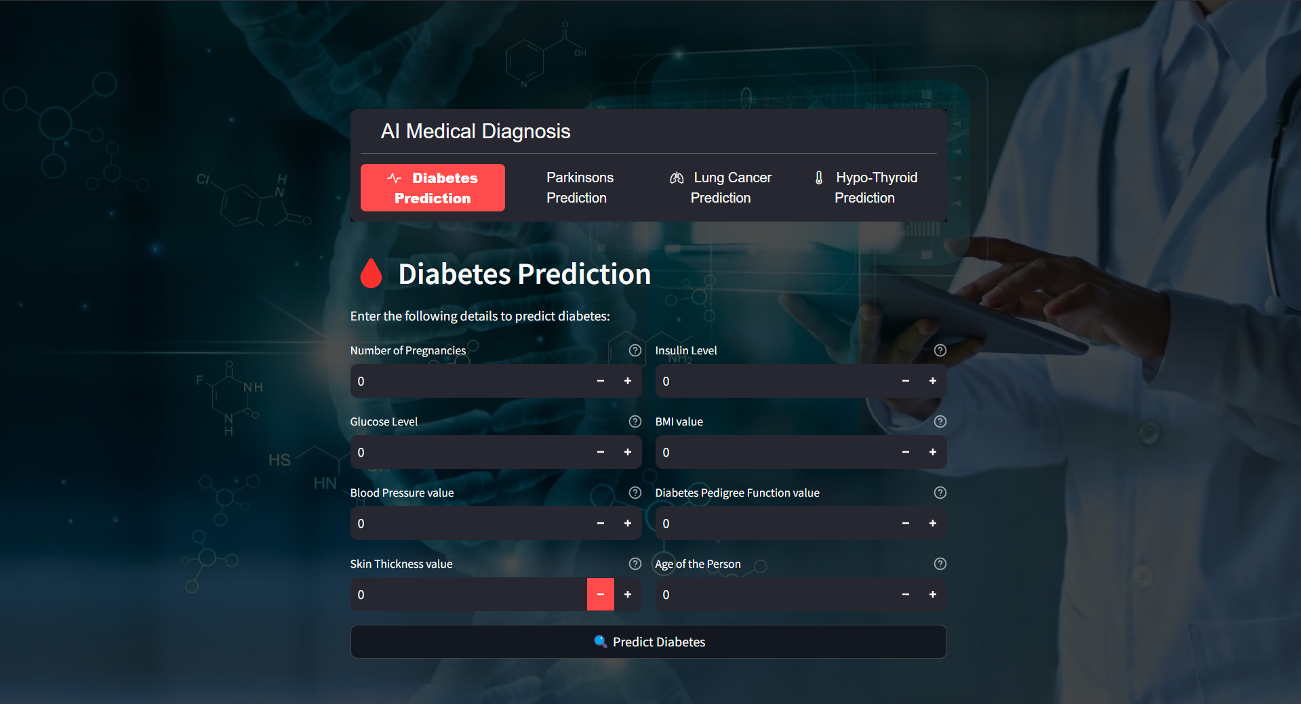

**Figure 2. Web Application Interface**

## ****Snapshot 2: Disease Prediction Input****

The second snapshot captures the **user entering medical details** for disease prediction. After selecting **Diabetes Prediction**, the user fills in specific values related to health indicators. The interface dynamically updates based on user input, ensuring a smooth experience. A button labeled **"Diabetes Test Result"** is present for submitting the data and initiating the prediction process.

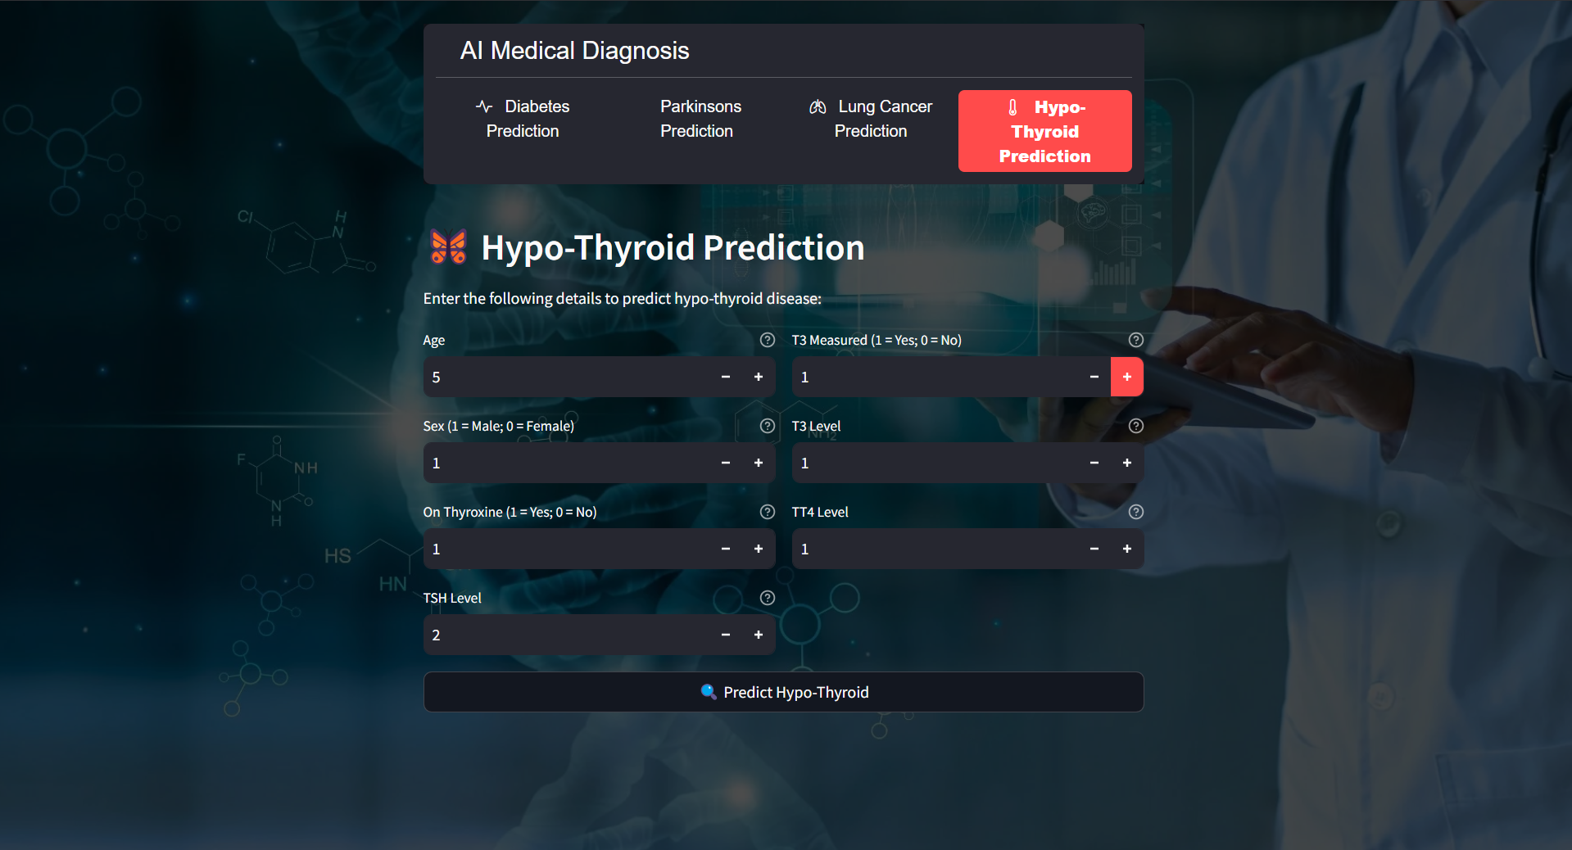

**Figure 3. Disease Prediction Input**

## ****Snapshot 3: Disease Prediction Output****

The third snapshot showcases the **final prediction output** of the AI system. Based on the user's medical data, the machine learning model evaluates the input and provides a diagnosis. In this instance, the result states **"The person does not have Hypo-Thyroid”**, meaning the system has determined no signs of diabetes based on the given input values. The result is displayed in a highlighted section to ensure easy readability.

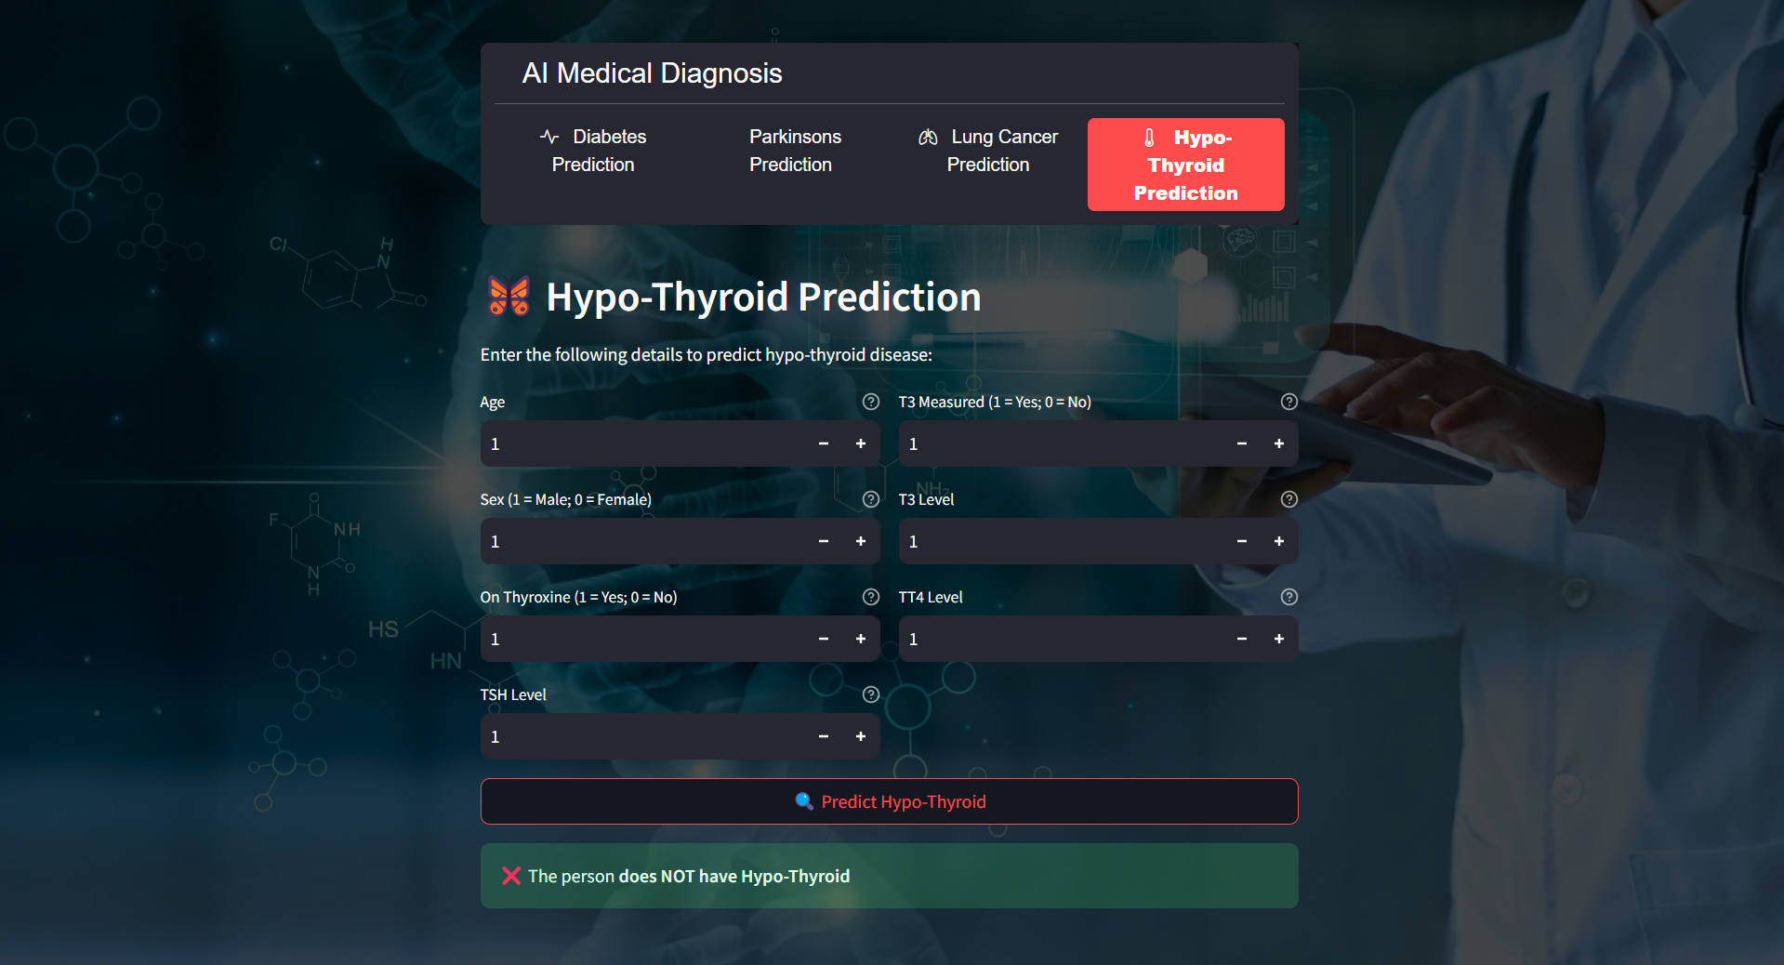

**Figure 4**. **Disease Prediction Output**

* 1. **GitHub Link for Code:**

The complete source code for the project, including **data preprocessing, model training, evaluation, and web application deployment**, is available in the GitHub repository.

**GitHub Repository:**

**https://github.com/AJAjith0503/AI-Powered-Medical-Diagnosis-System.git**

This repository provides step-by-step implementation details and allows future enhancements, such as integrating **deep learning models** and expanding the system to cover a broader range of medical conditions.

**CHAPTER 5**

**Discussion and Conclusion**

* 1. **Future Work:**

As AI-powered medical diagnostics continue to advance, several improvements can be made to enhance the system's effectiveness. A key area for enhancement involves expanding the dataset to include a more diverse range of medical conditions and demographic variations. This will improve the model’s ability to generalize and perform accurately across different patient groups. Moreover, incorporating advanced deep learning architectures, such as transformer-based models, could further refine the system’s ability to process medical images and text-based clinical data.

Another promising direction for future development is **federated learning**, which allows AI models to be trained on distributed medical data without compromising patient privacy. This decentralized approach would enable collaborations between hospitals and research institutions while ensuring data security. Additionally, integrating **explainable AI (XAI)** methods can provide greater transparency, helping healthcare professionals understand the reasoning behind AI-driven diagnoses.

Furthermore, expanding the system to incorporate **real-time health monitoring** through **wearable devices and IoT-based medical sensors** could enable continuous patient tracking. This would facilitate **early disease detection and personalized preventive healthcare**, making AI-powered diagnosis even more impactful.

* 1. **Conclusion:**

This project underscores the immense potential of **AI-driven medical diagnosis** in improving **disease detection, diagnostic accuracy, and healthcare accessibility**. By employing **machine learning and deep learning techniques**, the system acts as an efficient tool for **early disease prediction and clinical decision-making**. The integration of **real-time AI predictions, an intuitive web-based platform, and transparent AI methods** ensures that both medical professionals and patients can benefit from **data-driven insights**.

In summary, this project contributes to the **digital revolution in healthcare**, demonstrating the vital role of **AI in improving patient outcomes, minimizing diagnostic errors, and streamlining medical workflows**. As AI technology continues to evolve, advancements in **data availability, model interpretability, and computational efficiency** will further refine AI-powered medical diagnosis systems, making them an indispensable component of **modern healthcare solutions**.

**REFERENCES**

1. **Davenport T, Kalakota R.** The potential for artificial intelligence in Healthcare. *Future Healthc J.* 2019;6(2):94–8. <https://doi.org/10.7861/futurehosp.6-2-94>.
2. **Topol EJ.** High-performance medicine: the convergence of human and Artificial Intelligence. *Nat Med.* 2019;25(1):44–56. <https://doi.org/10.1038/s41591-018-0300-7>.
3. **Esteva A, Kuprel B, Novoa RA, Ko J, Swetter SM, Blau HM, et al.** Dermatologist-level classification of skin cancer with deep neural networks. *Nature.* 2017;542(7639):115–8. <https://doi.org/10.1038/nature21056>.
4. **McKinney SM, Sieniek M, Godbole V, Godwin J, Antropova N, Ashrafian H, et al.** International evaluation of an AI system for breast cancer screening. *Nature.* 2020;577(7788):89–94. <https://doi.org/10.1038/s41586-019-1799-6>.
5. **Jordan MI, Mitchell TM.** Machine learning: Trends, perspectives, and prospects. *Science.* 2015;349(6245):255–60. <https://doi.org/10.1126/science.aaa8415>.
6. **Li S, Zhao R, Zou H.** Artificial intelligence for diabetic retinopathy. *Chin Med J (Engl).* 2021;135(3):253–60. <https://doi.org/10.1097/CM9.0000000000001816>.
7. **Myszczynska MA, Ojamies PN, Lacoste AM, Neil D, Saffari A, Mead R, et al.** Applications of machine learning to diagnosis and treatment of neurodegenerative diseases. *Nat Rev Neurol.* 2020;16(8):440–56. <https://doi.org/10.1038/s41582-020-0377-8>.
8. **Becker J, Decker JA, Römmele C, Kahn M, Messmann H, Wehler M, et al.** Artificial intelligence-based detection of pneumonia in chest radiographs. *Diagnostics.* 2022;12(6):1465. <https://doi.org/10.3390/diagnostics12061465>.
9. **Alfaras M, Soriano MC, Ortín S.** A fast machine learning model for ECG-based heartbeat classification and arrhythmia detection. *Front Phys.* 2019;7. <https://doi.org/10.3389/fphy.2019.00103>.
10. **Han SS, Park I, Eun Chang S, Lim W, Kim MS, Park GH, et al.** Augmented Intelligence Dermatology: deep neural networks empower medical professionals in diagnosing skin cancer and predicting treatment options for 134 skin disorders. *J Invest Dermatol.* 2020;140(9):1753–61. <https://doi.org/10.1016/j.jid.2020.01.019>.