**ANALYSIS OF INTERFACES**

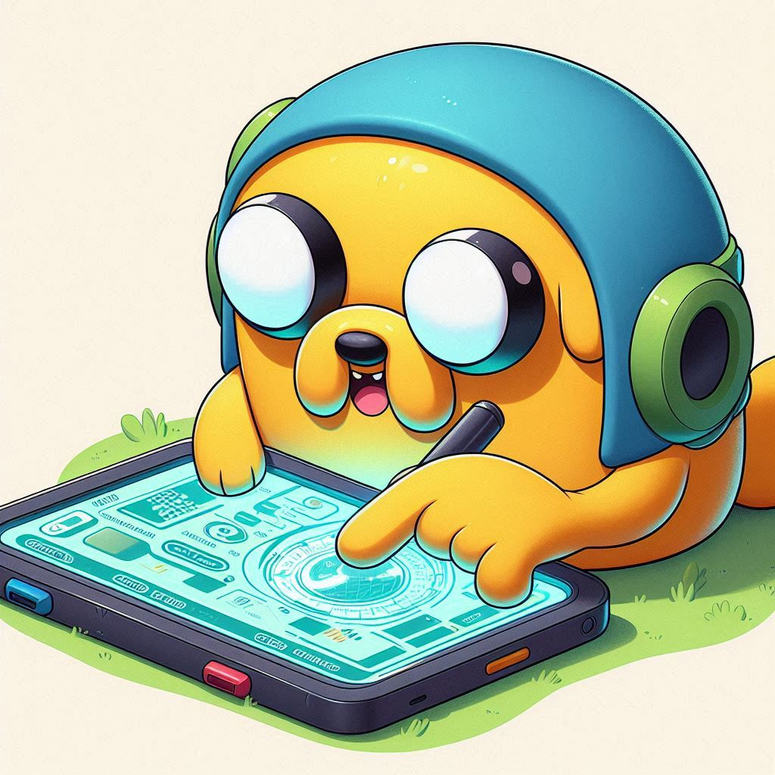

**Austin Jenner Beltran Panghulan**

**1.0 DIGITAL Interface 1** 4

**1.1 Smart voice control home hub (Alexa and Google):** 4

1.1.1 Information Architecture 4

1.1.2 Behavior of Interaction Elements 4

1.1.3 Relationship with Device Characteristics 4

1.1.4 Use of Graphic Resources 4

1.1.5 Cultural Conventions 4

1.1.6 Contribution to Usability 4

1.1.7 Feeling of Transparency 5

**2.0 DIGITAL Interface 2 6**

**2.1 Digital kiosk touchscreen** 6

2.1.1 Information Architecture 6

2.1.2 Behavior of Interaction Elements 6

2.1.3 Relationship with Device Characteristics 6

2.1.4 Use of Graphic Resources 6

2.1.5 Cultural Conventions 6

2.1.6 Contribution to Usability 6

2.1.7 Feeling of Transparency 7

**3.0 ANALOG Interface 1 8**

**3.1 Mechanical rotary timer** 8

3.1.1 Information Architecture 8

3.1.2 Behavior of Interaction Elements 8

3.1.3 Relationship with Device Characteristics 8

3.1.4 Use of Graphic Resources 8

3.1.5 Cultural Conventions 8

3.1.6 Contribution to Usability 8

3.1.7 Feeling of Transparency 8

**4.0 ANALOG Interface 2 9**

**4.1 Manual thermostat** 9

4.1.1 Information Architecture 9

4.1.2 Behavior of Interaction Elements 9

4.1.3 Relationship with Device Characteristics 9

4.1.4 Use of Graphic Resources 9

4.1.5 Cultural ConventionsEE 9

4.1.6 Contribution to Usability 9

4.1.7 Feeling of Transparency 9

# **1.0 DIGITAL Interface 1**

### **1.1 Smart Voice-Controlled Home Hub (e.g., Alexa and Google)**

**1.1.1 Information Structure**

* **Strengths:** The system is organized around voice commands, so users just ask for what they want, like "turn on the lights" or "play music." This makes interaction direct and simple.
* **Weaknesses:** There are no visible menus or options, which can be tough for people who don’t know what commands are possible or available.

**1.1.2 How Interaction Works**

* **Strengths:** Voice commands are easy and feel natural, like having a conversation. It’s convenient, hands-free, and great for people who struggle with physical controls.
* **Weaknesses:** The system sometimes struggles with different accents or speech styles, which can be frustrating. Complex actions, like managing multiple devices at once, can also be harder to set up.

**1.1.3 Relationship with Device Features**

* **Strengths:** The hub uses its built-in microphone, speaker, and internet connection to make voice control easy without needing a screen. It’s small and can blend into a home without standing out.
* **Weaknesses:** Without a screen, it can’t show much information, so users have to rely only on voice responses.

**1.1.4 Use of Visual Elements**

* **Strengths:** When the hub has a screen (like the Echo Show), visuals are simple, with clear text and minimal graphics to keep things easy to understand.
* **Weaknesses:** Most of the time, everything is voice-based, so if visuals are needed, users often have to use a phone app to get more details or make changes.

**1.1.5 Cultural Conventions**

* **Strengths:** Voice assistants use natural conversation styles, making them easy and comfortable to use. They also support different languages and adapt to accents, making them accessible worldwide.
* **Weaknesses:** Differences in phrasing or speech patterns across cultures can make interaction less smooth, especially if the command style differs from what's expected.

**1.1.6 Contribution to Usability**

* **Strengths:** Voice hubs are excellent for simple tasks like turning on lights, playing music, or setting reminders. They allow hands-free use, perfect for multitasking or people with physical disabilities.
* **Weaknesses:** Complicated tasks are harder, and voice recognition can fail, requiring repeated commands. Without visual aids, more advanced features can be confusing to use.

**1.1.7 Feeling of Ease and Understanding**

* **Strengths:** For simple commands, the system feels very easy to use, as if you’re just talking to someone else.
* **Weaknesses:** For less common commands, it can be confusing, requiring users to remember specific phrases or look them up.

# **2.0 DIGITAL Interface 2**

### **2.1 Digital Kiosk Touchscreen**

**2.1.1 Information Structure**

* **Strengths:** Kiosks usually have a simple menu system that guides users step-by-step (e.g., buying tickets, checking in at an airport). The most important functions are easy to find.
* **Weaknesses:** Deep menus can be confusing, especially if the options aren’t clear or there’s too much text without helpful visuals.

**2.1.2 How Interaction Works**

* **Strengths:** Users can tap and swipe like they do on a smartphone. Big buttons and icons make it easy for anyone, even if they haven’t used that specific kiosk before.
* **Weaknesses:** The touchscreen might not work well with wet fingers or gloves, and sometimes the layout can be hard to use quickly.

**2.1.3 Relationship with Device Features**

* **Strengths:** The large screen is great for showing clear prompts and feedback. The touch feature allows users to directly interact with what they see.
* **Weaknesses:** The size and positioning of the kiosk can make it hard for some users, like those in wheelchairs, to reach comfortably.

**2.1.4 Use of Visual Elements**

* **Strengths:** Kiosks use icons, colors, and contrast (e.g., green for “go” and red for “stop”) to help guide users. Photos and simple graphics make it easy to understand.
* **Weaknesses:** Too much text or a cluttered layout can overwhelm users, especially if they need to do something quickly.

**2.1.5 Cultural Conventions**

* **Strengths:** Kiosks often use universal symbols like arrows and checkmarks. They also usually let users pick their language, making them more accessible.
* **Weaknesses:** Some symbols or layouts may not make sense to users from different cultures, leading to confusion.

**2.1.6 Contribution to Usability**

* **Strengths:** Kiosks are generally very easy to use for simple tasks, with large buttons and clear prompts to guide users.
* **Weaknesses:** Usability drops if the touchscreen is unresponsive, or if there are too many options on the screen. A dirty or smudged screen can also make it harder to use.

**2.1.7 Feeling of Ease and Understanding**

* **Strengths:** When designed well, kiosks are easy to navigate, allowing users to move quickly through tasks.
* **Weaknesses:** If there are technical issues, like lag or an unresponsive screen, it can frustrate users and make it harder to use.

# **3.0 ANALOG Interface 1**

### **3.1 Mechanical Rotary Timer**

**3.1.1 Information Structure**

* **Strengths:** Very simple and clear—it’s only for setting a timer. Turning the dial makes it obvious how it works.
* **Weaknesses:** The timer is limited—you can only choose certain time intervals, often without much precision.

**3.1.2 How Interaction Works**

* **Strengths:** Turning the dial gives immediate feedback you can feel. It’s a direct interaction that confirms what the user is doing.
* **Weaknesses:** It can be hard to set an exact time, and the dial might be tough for some people to turn if it’s stiff.

**3.1.3 Relationship with Device Features**

* **Strengths:** The design is simple and doesn’t rely on electricity or batteries, making it reliable.
* **Weaknesses:** Once set, you can’t easily adjust the timer without starting over. It also doesn’t provide any advanced feedback.

**3.1.4 Use of Visual Elements**

* **Strengths:** Clear numbers or markings around the dial make it easy to see the setting. The design is minimal and focused.
* **Weaknesses:** Limited use of color or graphics may make it harder for people with visual impairments to use.

**3.1.5 Cultural Conventions**

* **Strengths:** Rotary dials have been used for decades, so they’re familiar to many people.
* **Weaknesses:** Younger users might find them old-fashioned and less intuitive compared to digital interfaces.

**3.1.6 Contribution to Usability**

* **Strengths:** Simple and reliable for short tasks. No need for instructions or experience.
* **Weaknesses:** It lacks flexibility, feedback, or precision, which makes it less ideal for more detailed timing needs.

**3.1.7 Feeling of Ease and Understanding**

* **Strengths:** Very transparent—you turn the dial, and it works. The simplicity makes it easy to understand.
* **Weaknesses:** It’s not great for tasks that require precision or adjustment, which reduces its transparency for more complex needs.

# **4.0 ANALOG Interface 2**

### **4.1 Manual Thermostat**

**4.1.1 Information Structure**

* **Strengths:** Simple dial for adjusting temperature, with a clear link between turning the dial and changing the temperature.
* **Weaknesses:** Limited in options—no ability to schedule temperature changes, and no extra feedback beyond turning the dial.

**4.1.2 How Interaction Works**

* **Strengths:** Turning the dial is direct and easy, providing immediate feedback.
* **Weaknesses:** It’s hard to set an exact temperature or schedule changes, reducing flexibility.

**4.1.3 Relationship with Device Features**

* **Strengths:** Matches the simplicity of its purpose—no electricity needed. It’s a straightforward mechanical device.
* **Weaknesses:** No visual feedback beyond the dial, like lights or displays, to show the current setting.

**4.1.4 Use of Visual Elements**

* **Strengths:** Minimal visuals—usually just a temperature scale and pointer, keeping it simple.
* **Weaknesses:** Limited use of colors or features to help people with poor vision.

**4.1.5 Cultural Conventions**

* **Strengths:** The rotary dial is familiar, especially in older homes. The convention of turning left for cooler and right for warmer is easy to understand.
* **Weaknesses:** Younger users might find it outdated compared to digital smart thermostats.

**4.1.6 Contribution to Usability**

* **Strengths:** Very easy to use just turn the dial. No tech knowledge required.
* **Weaknesses:** Lacks advanced features like scheduling or remote control, which limits usability.

**4.1.7 Feeling of Ease and Understanding**

* **Strengths:** Simple and easy to operate. Users can understand it immediately.
* **Weaknesses:** The lack of features or feedback can be frustrating for users who want more control or flexibility.

# **Conclusion**

The four interfaces analyzed Smart Voice Hub, Digital Kiosk Touchscreen, Rotary Timer, and Manual Thermostat show how transparency in design makes interfaces easier to use without much thought. Transparent interfaces feel natural and intuitive, helping users interact smoothly.

### **Key Factors for Transparent Interfaces**

**Simple Layout and Familiar Actions:**

Interfaces like Rotary Timers are easy to use because of their straightforward actions. Touchscreens and Voice Hubs use gestures or spoken commands, making interaction familiar.

**Matching Device Abilities:**

Smart Hubs effectively use voice input, and Rotary Timers use tactile feedback, matching what they’re designed for. Matching the interface to the device’s natural capabilities makes it more transparent.

**Visual Design and Feedback:**

Touchscreens use clear visuals and buttons to guide users, while analog devices keep it simple with basic markings. Clear feedback makes interactions more predictable and easier to understand.

**Ease of Use:**

Analog devices are more transparent due to their simplicity, but they lack flexibility. Digital devices provide more features but can be harder to learn.

### **Digital vs. Analog Interfaces**

Digital: More features but complex (e.g., Touchscreens and Smart Hubs).

Analog: Simple and intuitive but limited (e.g., Rotary Timers and Thermostats).

**Summary**

Transparent interfaces are simple, intuitive, and match the user’s expectations. Digital interfaces offer more flexibility, while analog interfaces provide a more straightforward experience. Good interface design balances usability, functionality, and familiarity.