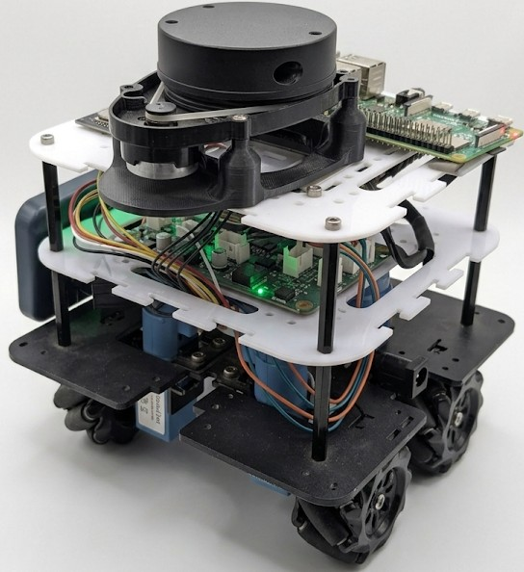

GATIBOT
Technical Operations Guide
ROS2 | AUTONOMOUS MOBILE ROBOT |

1. System Overview

1.1 What is Gatibot?
The Gatibot is a modular, reconfigurable wheeled robot designed for research and education which is a autonomous mobile robot (AMR). It features a custom electronics stack, mecanum wheels for omnidirectional movement, a LiDAR sensor, and runs ROS2 on a Raspberry Pi.
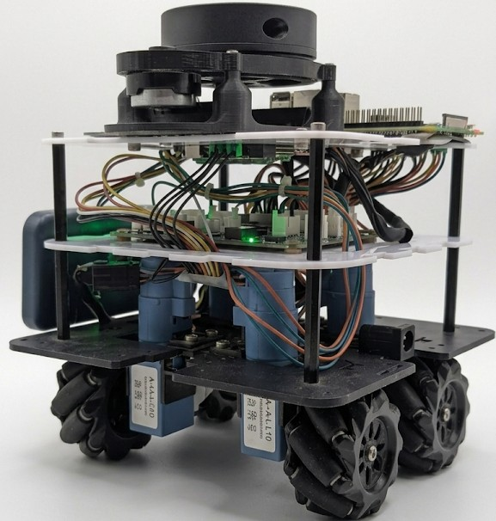

Fig 1.1 —GATIBOT (side view) and (front view)

1.2 Hardware Components
- Raspberry Pi — main compute unit, runs ROS2
- ESP32 MASTERBOARD — motor controller via USB serial
- SLAVE BOARD (TB6612FNG Motor Driver IC )— dual H-bridge (x2 units, 4 motors total)
- 4x DC Geared Motors with Encoders
- Mecanum Wheels — omnidirectional drive
- LiDAR Sensor — mounted on top, used for SLAM and navigation
- Battery Pack — onboard power supply
- WiFi / Bluetooth — onboard via ESP32
- Plug the USB in board as shown in the image

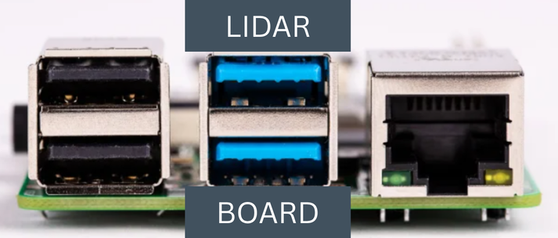

1.3 Software Stack
Layer | Component
High-level Navigation | ROS2 Nav2 (navigation2 stack)
SLAM / Mapping | slam_toolbox (online_async)
Robot Description | smorphi_bringup package
Sensor Driver | LiDAR ROS2 driver
Odometry | Encoder feedback via ESP32

2. Accessing Gatibot via Remote Desktop

2.1 Step 1 – Connect Monitor, Mouse, and Keyboard
- First, connect the Gatibot computer to a monitor using an HDMI cable. Also connect a USB mouse and keyboard to the system. Power on the Gatibot and wait for the operating system to boot.
- Username : smorphi
- Password : smorphi

2.2 Step 2 – Connect to Network
Once the system has started, connect the Gatibot to the internet using either:
- Wi-Fi connection, or
- Ethernet cable (recommended for stable connection)

Ensure the network connection is successful.

2.3 Step 3 – Find the IP Address
- Open the terminal on the Gatibot and type:
hostname -I
- Note down the IP address displayed (for example: 192.168.1.47 in my case). This
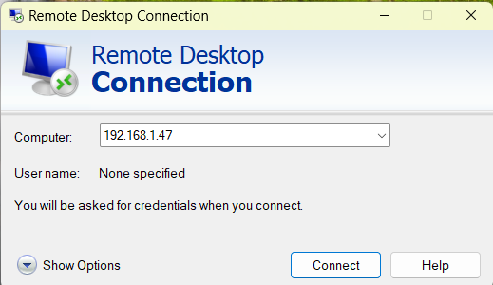
IP address will be used to connect remotely.

2.4 Step – Connect Using Remote Desktop
On your laptop or desktop computer (connected to the same network):
- Open Remote Desktop software (such as Remote Desktop Connection / Remmina).
- Enter the Gatibot IP address.
- Enter the username and password of the Gatibot system.
- Click Connect.
You should now be able to access the Gatibot desktop remotely.

Summary:
Connect HDMI → Connect keyboard/mouse → Connect internet → Find IP address → Remote desktop connection.

2.5 Step 5 – Enter the Username and Password
- Username : smorphi
- Password : smorphi

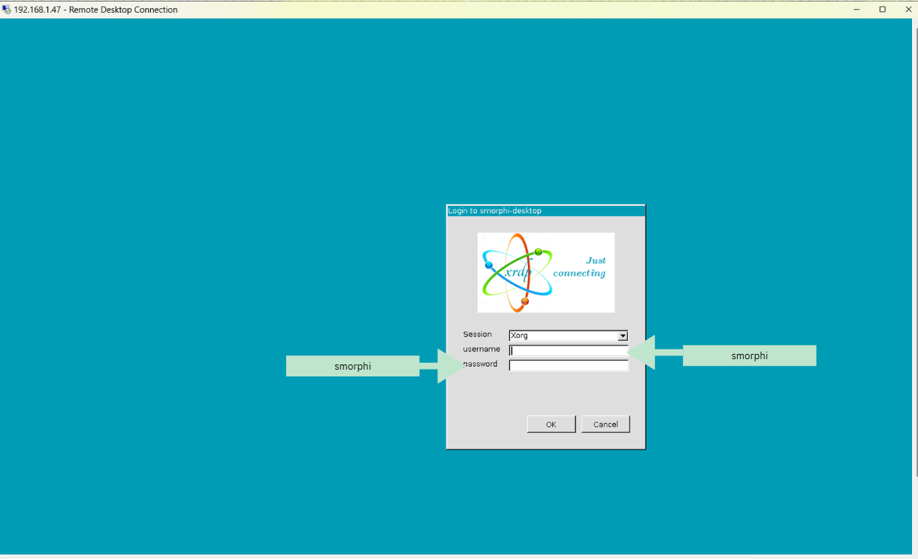

3. Launching the Robot

3.1 Prerequisites
- Workspace sourced: source /home/smorphi/s_ws/install/setup.bash

3.2 Step 1 — Core Bringup
Open a terminal and run:

ros2 launch smorphi_bringup smorphi.launch.py

- Starts LiDAR sensor driver
- Starts robot_state_publisher (URDF model)
- Starts joint_state_publisher
- Opens RViz2 window

After launching bringup , RViz2 shows the robot coordinate axes (RGB) at the origin on a 3D grid, with scattered red LiDAR scan dots around it. This confirms the system is ready:
- LiDAR active — /scan topic publishing
- TF tree working — robot frame visible
- Fixed Frame set to odom (default)

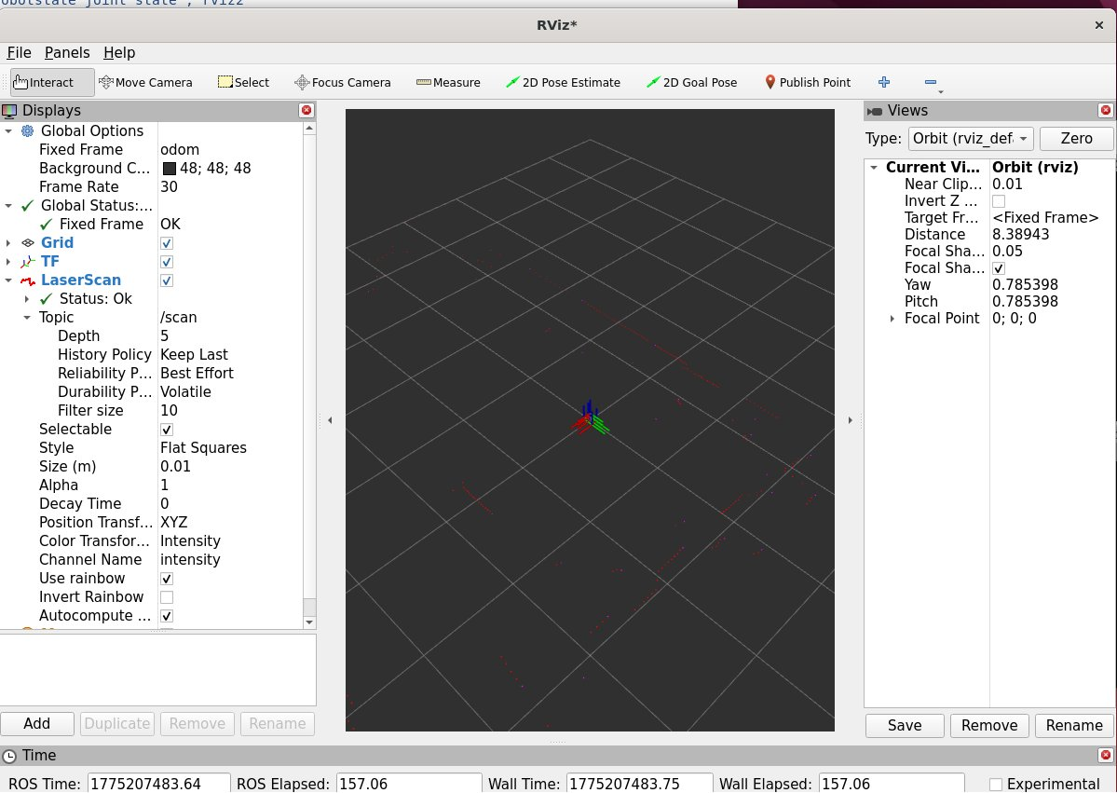

4. SLAM Mapping — Step-by-Step

Follow all steps in order to build a map of a new environment. Bringup must already be running.

4.1 Step 1 — Initial RViz2 State After Bringup
After launching bringup , RViz2 shows the robot coordinate axes (RGB) at the origin on a 3D grid, with scattered red LiDAR scan dots around it. This confirms the system is ready:
- LiDAR active — /scan topic publishing
- TF tree working — robot frame visible
- Fixed Frame set to odom (default)


Fig 3.1 — RViz2 after bringup. Fixed Frame = odom. LiDAR scan (red dots) visible around robot axes. LaserScan Status: OK.

4.2 Step 2 — Launch SLAM Toolbox
In a new terminal, start SLAM mapping:

ros2 launch slam_toolbox online_async_launch.py

Once launched, the LiDAR point cloud in RViz2 expands into a dense starburst pattern as the SLAM algorithm starts processing scan data:

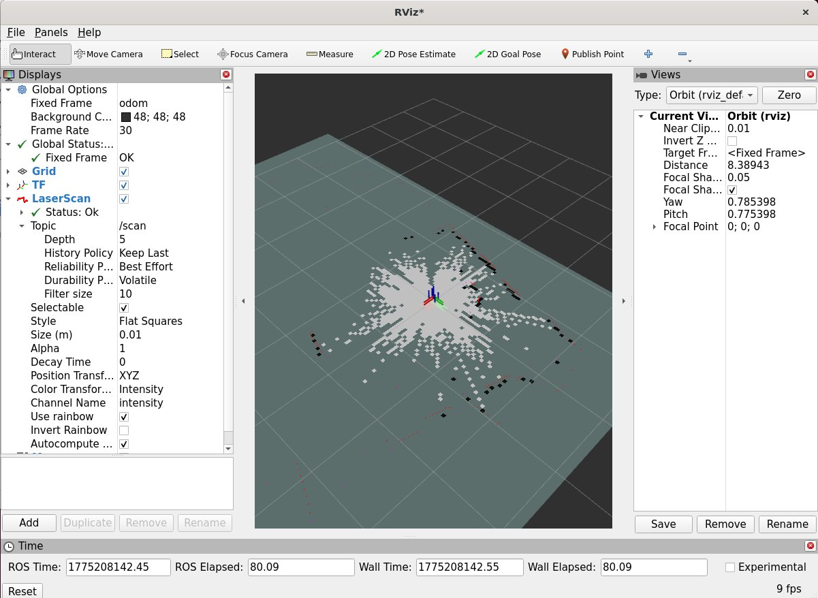
Fig 3.2 — SLAM toolbox running. Dense LiDAR point cloud forms around robot. Map building has begun.

4.3 Step 3 — Map Appears in RViz2
As the robot begins scanning, the Map display will appear in RViz2 (add it if not visible: Add → By topic → /map → OccupancyGrid). The map grows outward from the starting position:
- White = free space (passable)
- Black = obstacles (walls, furniture)
- Dark grey = unknown (not yet scanned)

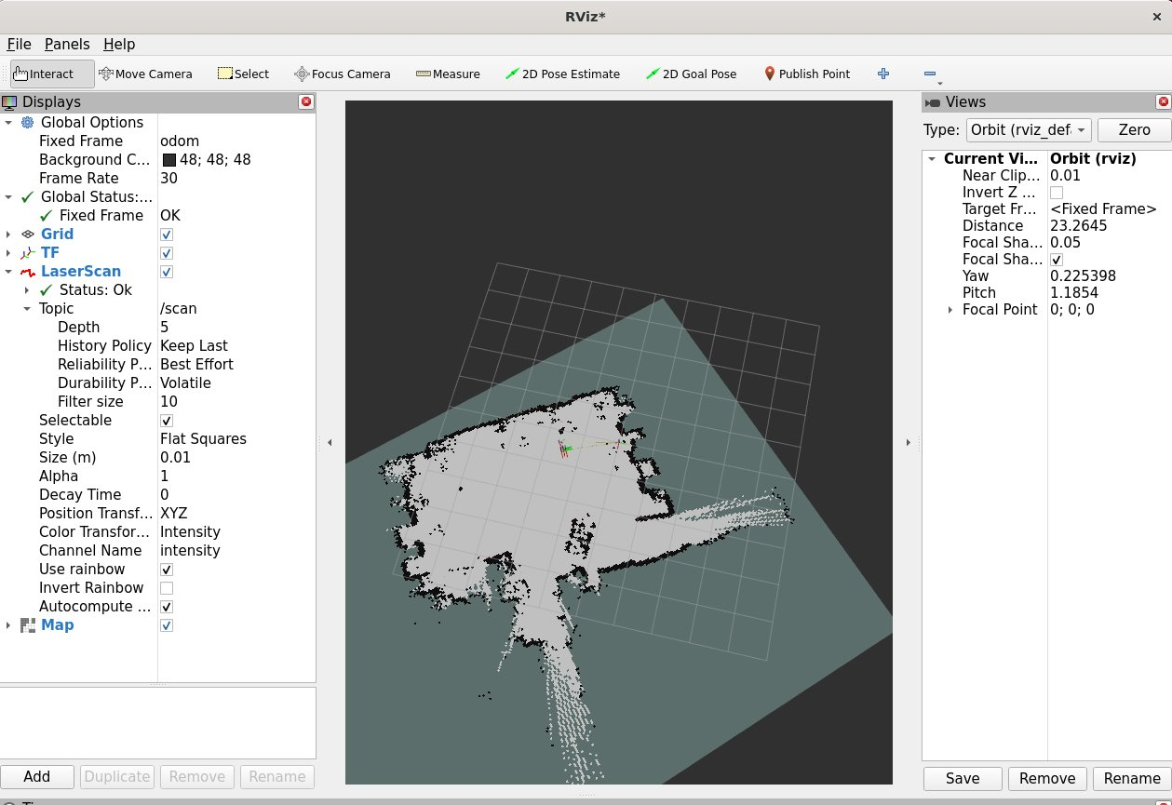
Fig 3.3 — Occupancy grid map building in RViz2. White = free space, black = obstacles. Map and LaserScan both visible in Displays panel.

4.4 Step 4 — Drive the Robot to Expand the Map
Open a new terminal and run keyboard teleop:

ros2 run teleop_twist_keyboard teleop_twist_keyboard

Key | Action
i | Move Forward
, | Move Backward
j | Turn Left
l | Turn Right
u / o | Diagonal forward-left / forward-right
k | Stop
q / z | Increase / Decrease speed

IMPORTANT: Drive slowly and avoid sharp turns. Fast or jerky movement causes odometry drift and degrades map quality.

4.5 Step 5 — Add SlamToolboxPlugin Panel to Save the Map
To save the map, add the slam_toolbox GUI panel to RViz2. Click Panels → Add New Panel from the menu bar:

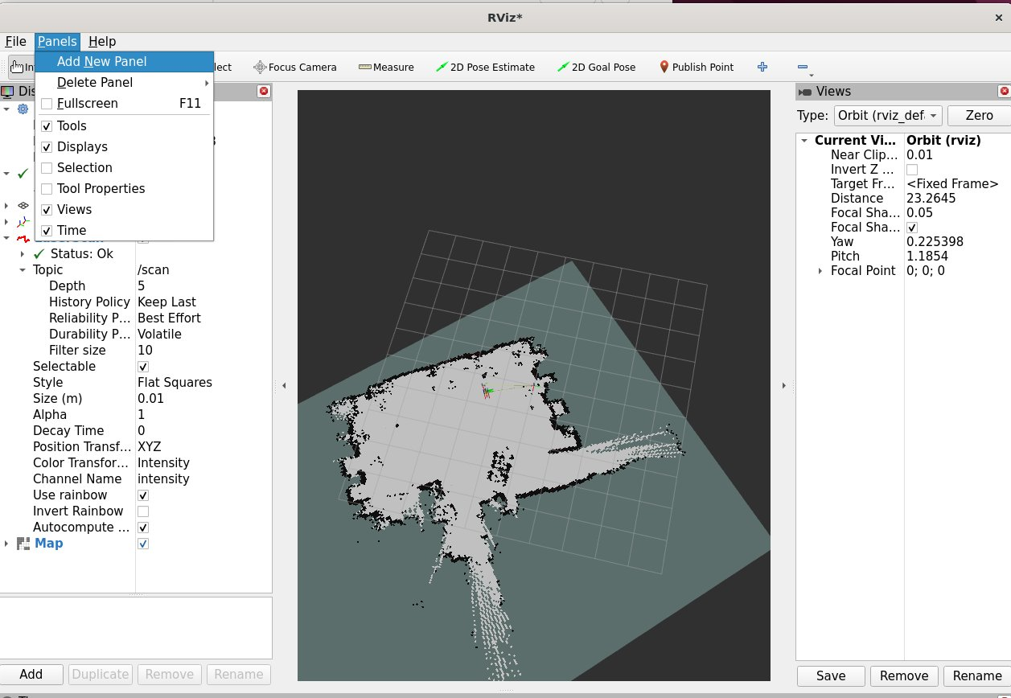
Fig 3.5a — Click Panels → Add New Panel from the RViz2 menu bar to open the Panel Type dialog.
In the Panel Type dialog, expand the slam_toolbox folder, select SlamToolboxPlugin, and click OK:

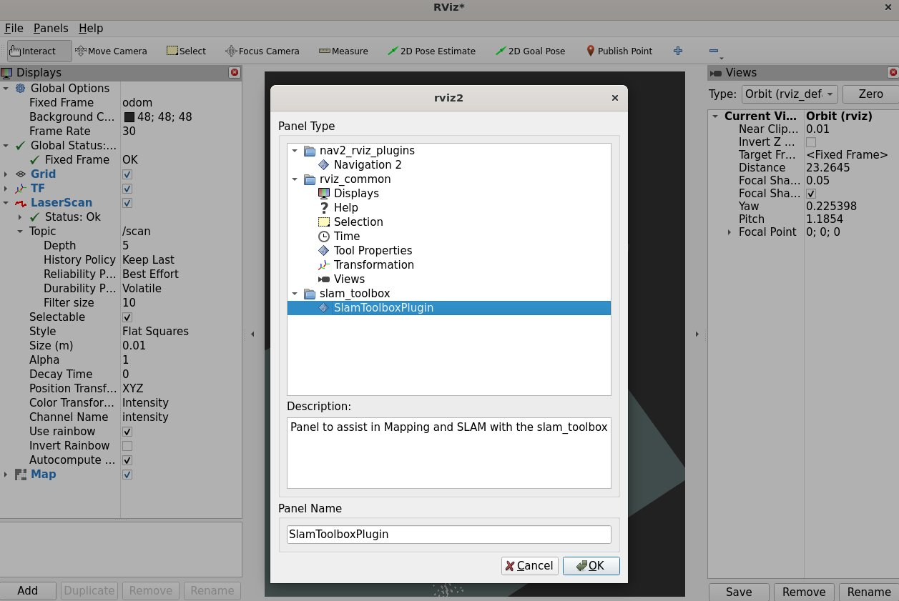
Fig 3.5b — Select slam_toolbox → SlamToolboxPlugin (description: 'Panel to assist in Mapping and SLAM with the slam_toolbox'). Click OK.
In the SlamToolboxPlugin panel that appears:
- Type a name for your map in the Map Name field
- Click Serialize Map to save the map to disk

NOTE: The map is saved as two files: map_name.yaml (metadata) and map_name.pgm (occupancy grid image). Use an absolute path like /home/smorphi/s_ws/passage to save to a known location.

4.6 Step 6 — Stop All Nodes
- Press Ctrl+C in the slam_toolbox terminal
- Press Ctrl+C in the teleop terminal
- Press Ctrl+C in the bringup terminal

IMPORTANT: Always save the map BEFORE pressing Ctrl+C on slam_toolbox. Stopping without saving will permanently lose the map.

5. Autonomous Navigation — Step-by-Step

Follow all steps in order. You must have a saved map from the SLAM Mapping section before proceeding.

5.1 Step 1 — Launch Bringup, Motor Node and Navigation

Terminal 1 — Bringup
ros2 launch smorphi_bringup smorphi.launch.py

Terminal 2 — Navigation Stack
ros2 launch smorphi_bringup navigation_launch.py map:=/home/smorphi/s_ws/passage.yaml

# Or without specifying a map (uses default configured map):
ros2 launch smorphi_bringup navigation_launch.py

NOTE: Wait for all three terminals to finish initialising before proceeding. Watch for 'Nav2 is ready' in the navigation terminal.

5.2 Step 2 — Set Fixed Frame to 'map' and Set Map Durability
In RViz2 after navigation launches, the map will not yet be visible. Two settings must be changed:

Change Fixed Frame
- Displays panel → Global Options → Fixed Frame
- Change odom to map, press Enter

Add Map Display and Set Durability to Transient Local
- Click Add → By topic → /map → OccupancyGrid → OK
- In the new Map display, find Durability Policy
- Change from Volatile to Transient Local

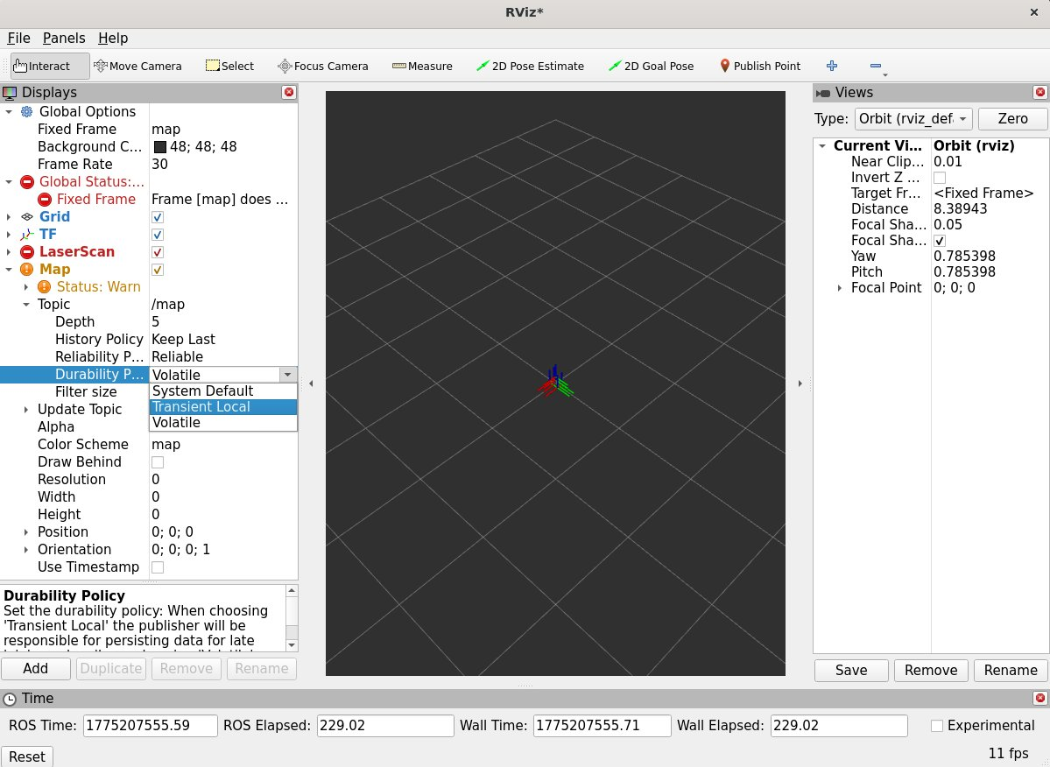
Fig 5.2 — Map display settings. Durability Policy dropdown open showing Transient Local option (highlighted in blue). Fixed Frame already set to 'map'. Note the orange warning icons — these disappear once Transient Local is selected.
After selecting Transient Local, the map immediately becomes visible in the RViz2 viewport:

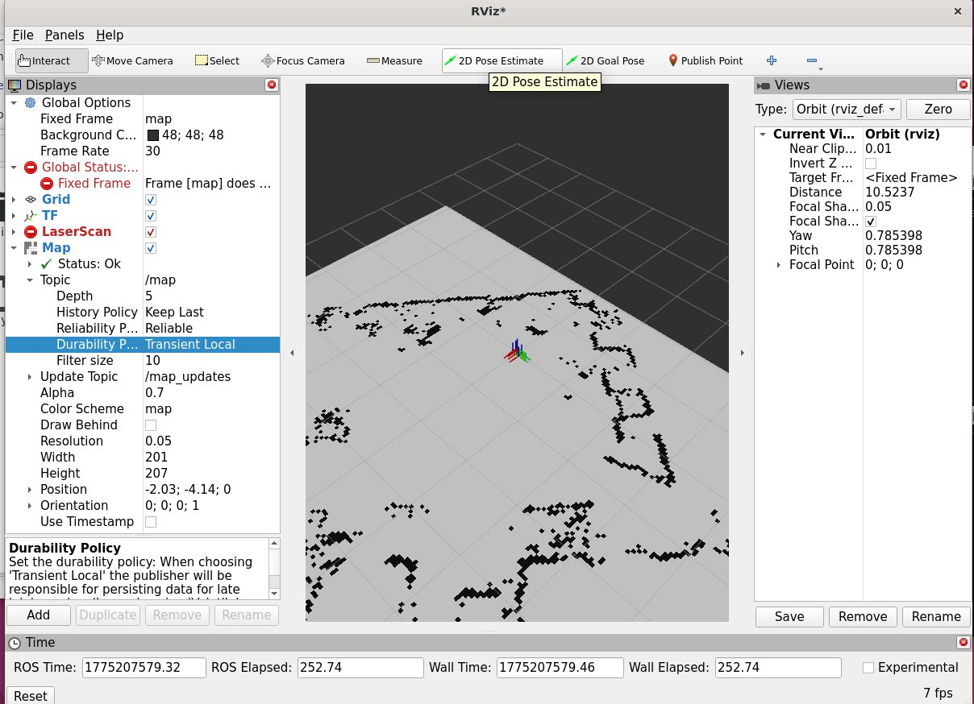
Fig 5.3 — Map now fully visible. Durability = Transient Local confirmed in Displays panel. Map Status: OK. White = free space, black = obstacles.
NOTE: If the map still does not appear after setting Transient Local, verify navigation is running and publishing /map by running: ros2 topic echo /map --once

5.3 Step 3 — Set Initial Robot Pose with '2D Pose Estimate'
The robot does not yet know where it is on the map. You must manually set its starting position and orientation using the 2D Pose Estimate tool in the RViz2 toolbar:
- Click the 2D Pose Estimate button (green arrow icon) in the toolbar
- Click on the map at the location corresponding to the robot's real-world position
- Hold and drag to set the direction the robot is facing, then release

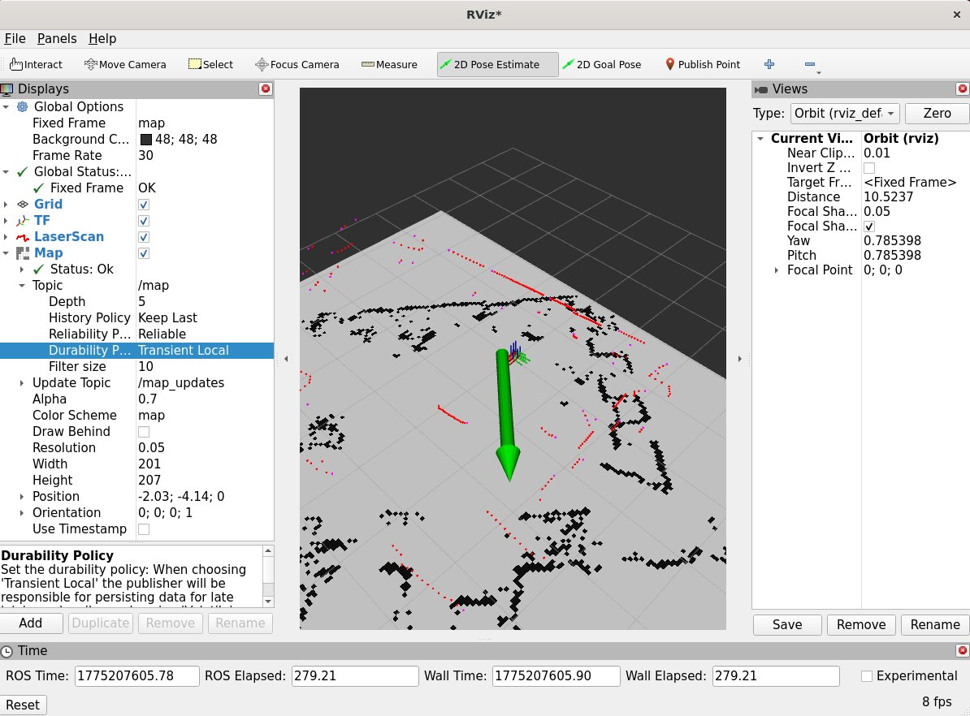
Fig 4.4 — 2D Pose Estimate active (button highlighted in toolbar). Large green arrow shows the pose being set — the arrow points in the robot's facing direction. Click and drag on the white area of the map.

5.4 Step 4 — Verify Pose by Aligning LiDAR Scan to Map
After setting the 2D Pose Estimate, the LiDAR scan dots should align with the black obstacle boundaries on the map. This confirms AMCL localisation is working correctly:

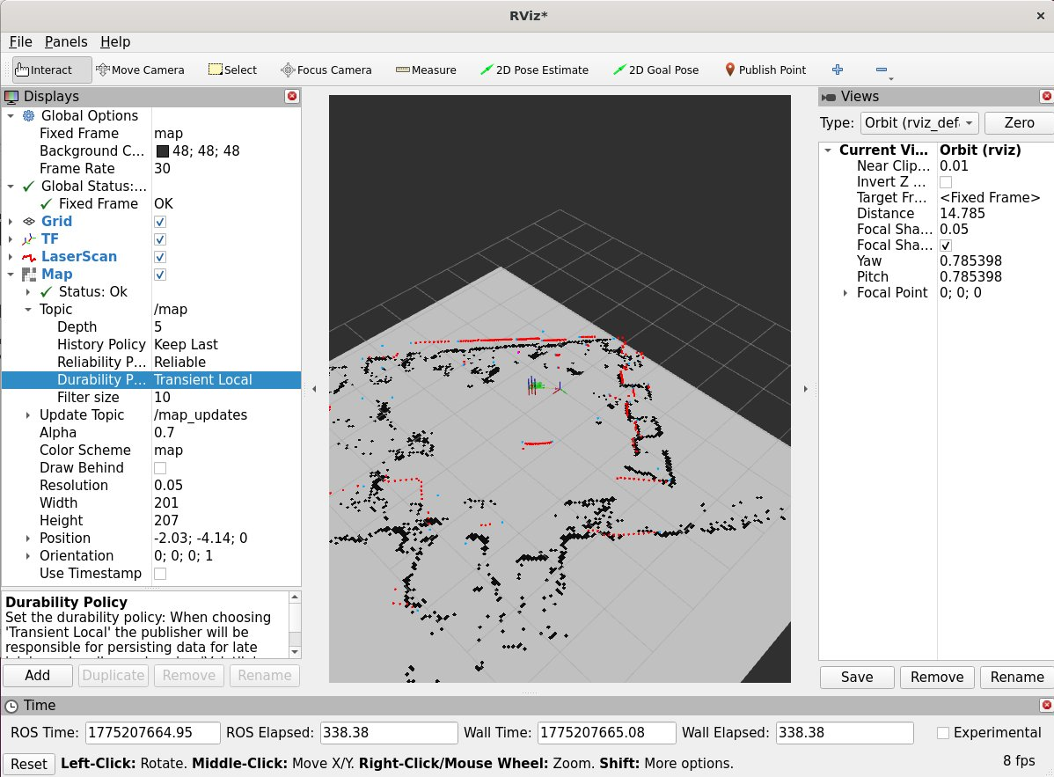
Fig 5.5 — LiDAR scan dots (coloured) aligning with black obstacle boundaries on map. Global Status: OK — localisation confirmed working. The robot's position is now known on the map.

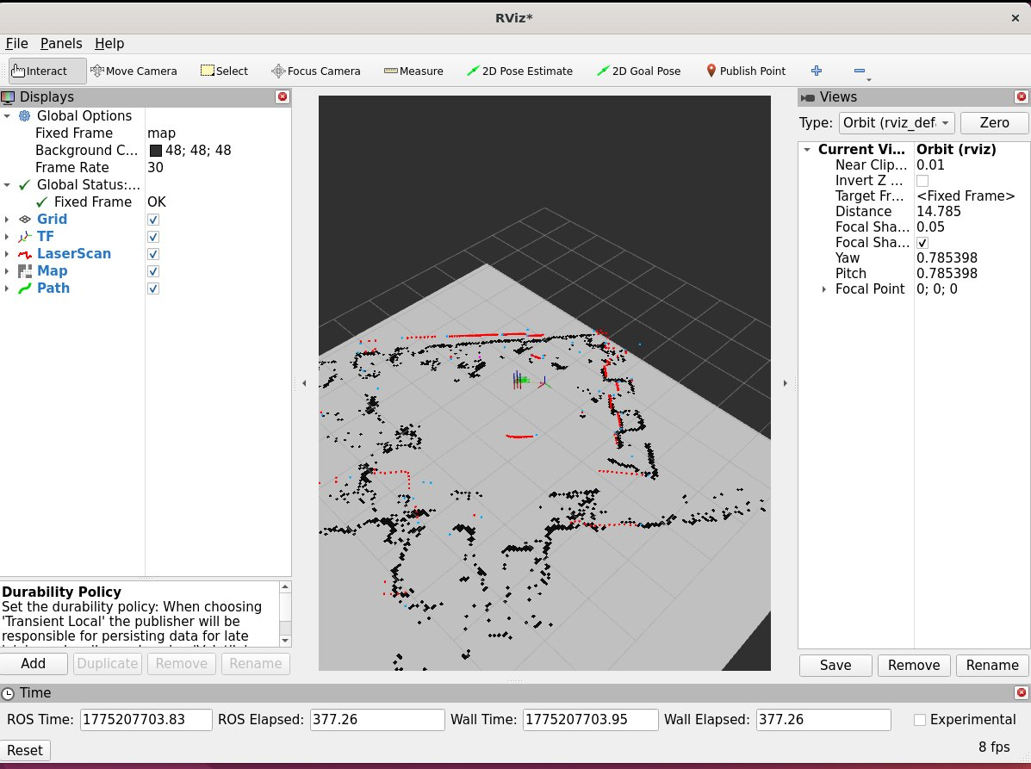
Fig 5.6 — Robot localised. Scan well-aligned to map obstacles. 'Path' display added to Displays panel (green item visible). Fixed Frame = map, Global Status: OK.
IMPORTANT: If the scan dots do NOT align with the map obstacles, the pose estimate is wrong. Repeat Step 4.3 — click 2D Pose Estimate again and reposition more carefully to match the robot's actual location in the real environment.

5.5 Step 5 — Add Path Display
To see the planned navigation path in RViz2, add a Path display:
- Click Add in the Displays panel
- Select the By topic tab
- Find /plan in the topic list
- Select Path under /plan, then click OK

The Path display (green item in Displays panel) will draw the planned route as a line across the map once a navigation goal is sent.

5.6 Step 6 — Add Global Costmap Display
The global costmap shows inflated obstacle zones used by Nav2 for collision-free path planning. To add it:
- Click Add in the Displays panel
- Select the By topic tab
- Expand /global_costmap → /costmap
- Select Map under /costmap, then click OK

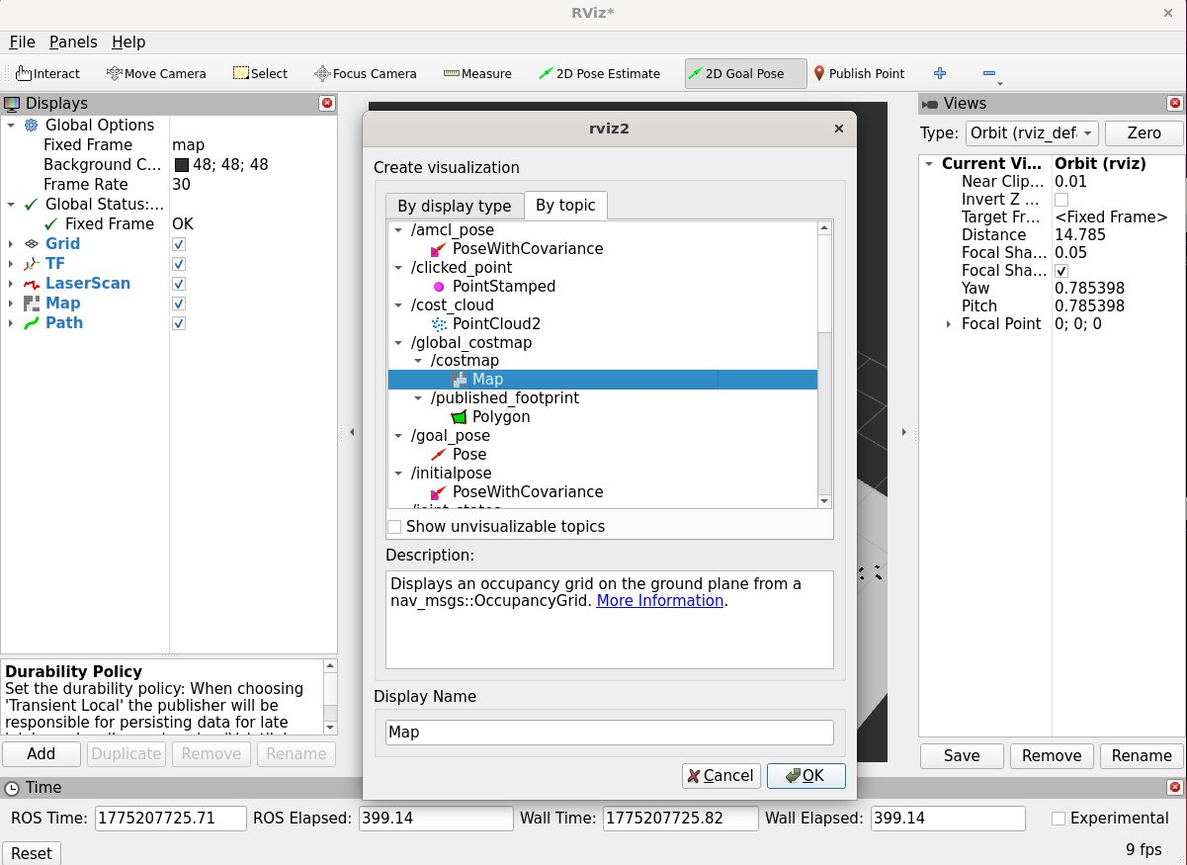
Fig 4.7 — 'Create visualization' dialog. By topic tab open. /global_costmap → /costmap → Map is highlighted. Click OK to add.

The costmap overlay (grey inflated zones) now appears on top of the SLAM map. Nav2 treats these grey zones as off-limits for path planning:

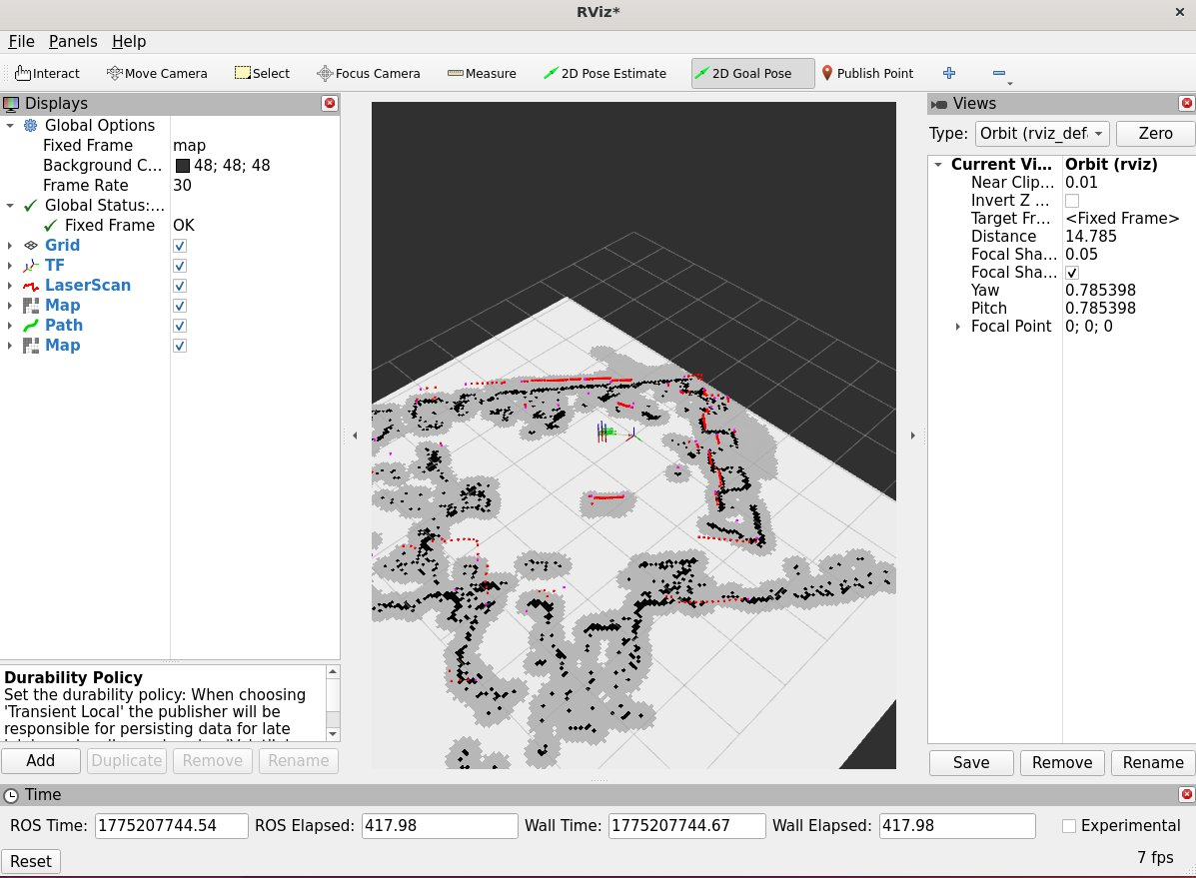
Fig 4.8 — Both Map displays active: SLAM map (black/white) and global costmap (grey inflation zones around obstacles). Two Map entries now appear in the Displays panel. Global Status: OK.

5.7 Step 7 — Send Navigation Goal with '2D Goal Pose'
With the robot localised and all displays configured, send a goal:
- Click the 2D Goal Pose button in the RViz2 toolbar
- Click on any white (free space) area of the map to set the destination
- Drag to set the desired arrival orientation, then release

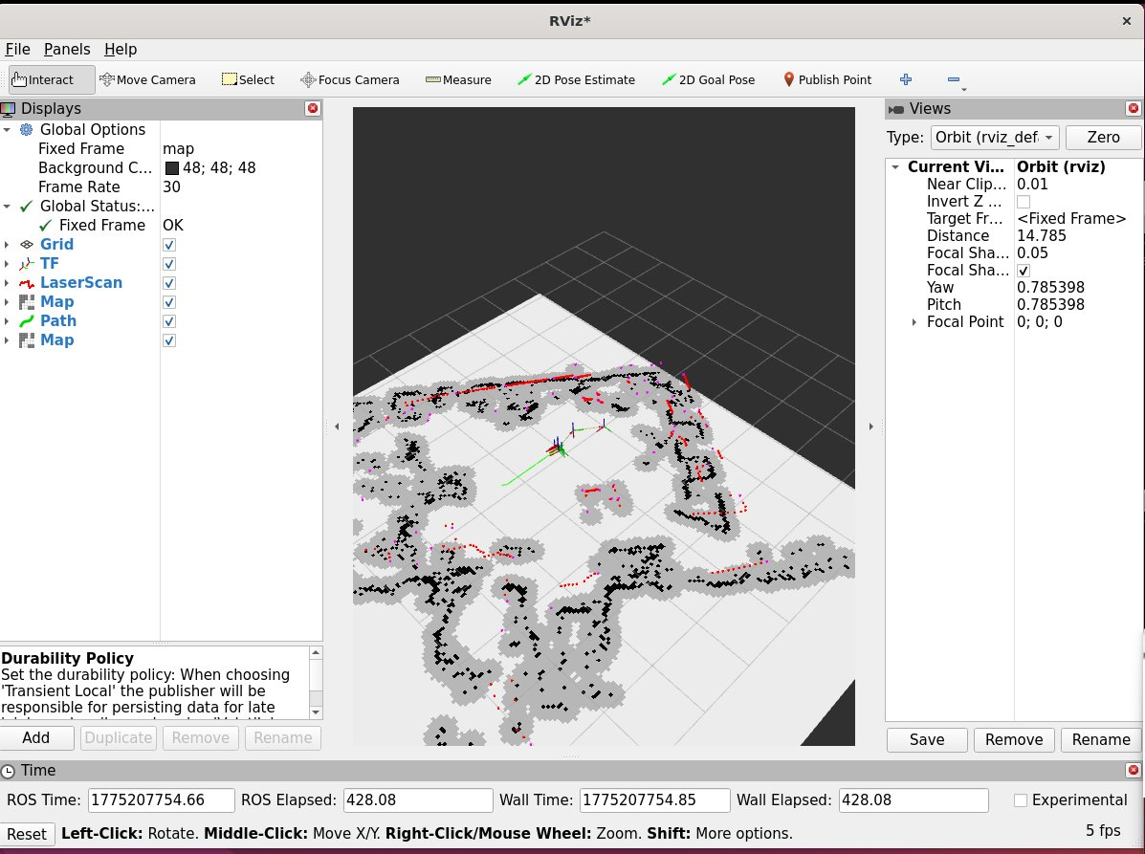
Fig 4.9 — Robot navigating autonomously. Green path line shows planned route. Robot follows the path, avoiding black obstacles and grey costmap inflation zones. The robot travels along the green line to the goal.

Nav2 will automatically:
- Plan a collision-free path from current position to the goal
- Display the planned route as a green line (Path display)
- Drive the robot along the path using the local planner
- Avoid new obstacles detected in real time by the LiDAR
- Re-plan if an obstacle blocks the current path

IMPORTANT: Only set 2D Goal Pose on WHITE (free space) areas of the map. Clicking on black (obstacle) or dark grey (unknown) regions will cause Nav2 to reject or fail the goal.

6. Communication Interfaces

Interface | Usage
USB Serial (UART) | Primary: Raspberry Pi ↔ ESP32 Masterboard (motor commands + encoder data)
WiFi (ESP32) | Remote SSH / ROS2 DDS communication over local network
Bluetooth (ESP32) | Optional configuration / debug interface
I2C | Onboard peripheral communication
SPI | High-speed peripheral communication on Masterboard

NOTE: Serial port is typically /dev/smorphi_mb. Run: ls /dev/smorphi_mb to confirm before launching bringup

7. Troubleshooting

Issue | Likely Cause | Fix
motor3.py cannot open serial port | /dev/smorphi_mb not found | Check USB cable. Run: ls /dev/smorphi_mb
Robot does not move on cmd_vel | motor3.py not running | Confirm motor3.py terminal is active. Run: ros2 topic echo /cmd_vel
Map not visible in RViz2 | Durability = Volatile or wrong frame | Set Fixed Frame to 'map'. Set Map Durability to Transient Local
LiDAR scan not aligned to map | Wrong 2D Pose Estimate | Click 2D Pose Estimate again and reposition accurately
Nav2 rejects goal pose | Goal on obstacle or unknown space | Only click 2D Goal Pose on white (free space) areas
LiDAR not publishing /scan | Driver node not started | Check bringup terminal for LiDAR node errors
SLAM map looks distorted | Odometry drift from fast movement | Drive slower. Verify motor3.py is running and publishing /odom
Nav2 not localising | Poor initial pose estimate | Redo 2D Pose Estimate. Match robot orientation carefully
Green LEDs off on robot | Battery low or power issue | Check EVM battery charge level

7.1 Useful Debug Commands
# Check all active ROS2 topics
ros2 topic list

# Monitor LiDAR scan rate
ros2 topic hz /scan

# View TF transform tree
ros2 run tf2_tools view_frames

# Check serial port
ls /dev/smorphi_mb
ls /dev/lidar

# Echo odometry
ros2 topic echo /odom

# Source workspace
source /home/smorphi/s_ws/install/setup.bash

8. Quick Reference — All Commands

Task | Command
Bringup (LiDAR + state publishers) | ros2 launch smorphi_bringup smorphi.launch.py
SLAM mapping | ros2 launch slam_toolbox online_async_launch.py
Keyboard teleop | ros2 run teleop_twist_keyboard teleop_twist_keyboard
Navigation (with saved map) | ros2 launch smorphi_bringup navigation_launch.py map:=<path_to_map>
Navigation (default) | ros2 launch smorphi_bringup navigation_launch.py
Save map (CLI) | ros2 run nav2_map_server map_saver_cli -f /home/smorphi/s_ws/my_map
List active topics | ros2 topic list
View TF tree | ros2 run tf2_tools view_frames

— End of Manual —

