Falcon-8 CPU Documentation

Author: Abdullah Almutairi
Processor: Falcon-8
Version: v1.0
Architecture: Single-Cycle 8-bit Processor

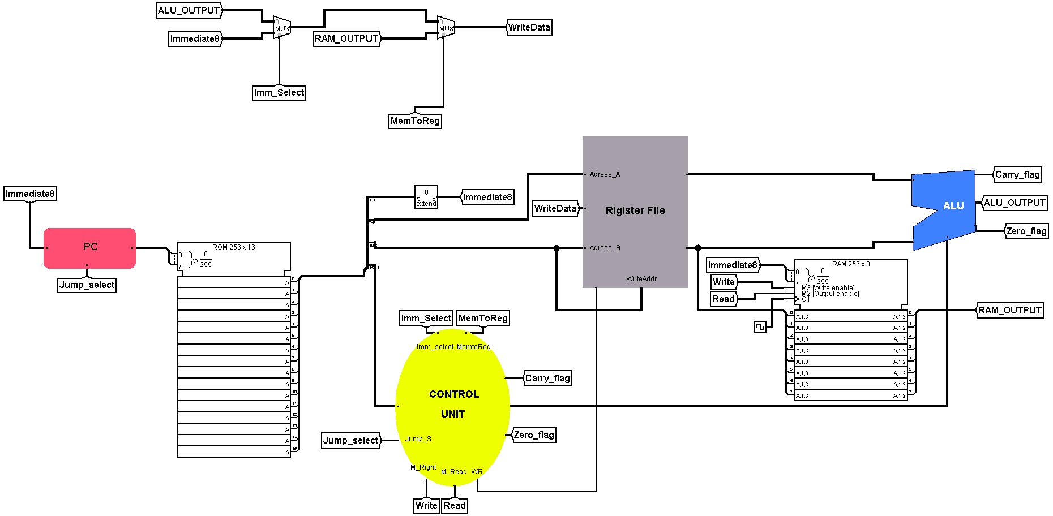

1. CPU Specifications
Item | Value
CPU Name | Falcon-8
Version | v1.0
Architecture | Single-Cycle
Data Width | 8-bit
Instruction Width | 16-bit
Program Counter | 8-bit
Registers | 8 General Purpose Registers
Register Width | 8-bit
Instruction Memory | ROM 256 x 16-bit
Data Memory | RAM 256 x 8-bit
Address Space | 256 Addresses
Flags | Zero, Carry

2. Instruction Format
Instruction Layout:
[15:11] Opcode (5 bits)
[10:8] RD
[7:5] RS
[4:0] Immediate

Register Encoding
Register | Binary
R0 | 000
R1 | 001
R2 | 010
R3 | 011
R4 | 100
R5 | 101
R6 | 110
R7 | 111

Instruction Set
Mnemonic | Opcode | Description
ADD | 00000 | RD = RD + RS
SUB | 00001 | RD = RD - RS
AND | 00010 | RD = RD AND RS
OR | 00011 | RD = RD OR RS
XOR | 00100 | RD = RD XOR RS
NOT | 00101 | RD = NOT RD
LOAD | 00110 | Load RAM[Imm] into RD
STORE | 00111 | Store RD into RAM[Imm]
MOV | 01000 | RD = RS
LDI | 01001 | Load Immediate into RD
JMP | 01010 | Jump to Immediate
JZ | 01011 | Jump if Zero
JNZ | 01100 | Jump if Not Zero
JC | 01101 | Jump if Carry
HLT | 01110 | Stop execution

3. Architecture
Main Components:
• Program Counter
• Instruction ROM
• Control Unit
• Register File
• Arithmetic Logic Unit (ALU)
• Data RAM
• Write-Back Unit
Execution Flow:
PC -> ROM -> Control Unit -> Register File -> ALU -> RAM (optional) -> Write Back -> Register File

4. Engineering Log

Bug #1
Register address mapping corrected: Address_A = RS, Address_B = RD, WriteAddr = RD.

Bug #2
RegWrite remained enabled after execution. Fixed through Control Unit.

Bug #3
MemToReg signal direction corrected.

Bug #4
RAM write logic restricted to STORE instruction.

Bug #5
Branch logic corrected for JMP/JZ/JNZ/JC.

Bug #6
Empty ROM locations (0000) interpreted as ADD. Programs now terminate using HLT.

Bug #7
Verified each module independently before full CPU integration.

Lessons Learned
This project covered:
• CPU Architecture
• Instruction Set Architecture (ISA)
• Register File Design
• ALU Design
• Datapath Design
• Control Unit Design
• Memory Interface
• Hardware Debugging
• Processor Verification

5. Project Summary

Architecture
Single-Cycle 8-bit CPU
Modules Implemented
- Program Counter
- ROM
- Control Unit
- Register File
- ALU
- RAM
- Branch Unit
- Write Back
Supported Instructions
15 Instructions
Verification
All instructions have been functionally verified using custom assembly test programs.
Future Version
Falcon-X Processor (Under Planning)

