

**De La Salle University- Manila**

**Gokongwei College of Engineering**

PROLOGI

Programming Logic and Design

Team Odin Project Proposal

Supermarket Ordering System

John Patrick Arevalo

Aaron James Capinpin

Sisinio Angelo Caranzo

**Project Description**

Supermarket Management System is a comprehensive software program designed to streamline the operations of a supermarket. With a user-friendly login system, the program can differentiate between customers and employees, providing them with personalized features and functionalities.

For customers, the system facilitates shopping, order placement, payment processing, and order tracking. They can easily browse through the store's product inventory, select the items they wish to purchase, add them to their cart, and complete the payment process. They can also track the status of their orders, such as order processing, shipment, and delivery.

For employees, the system offers efficient inventory management tools, order processing, and payment processing. They can easily update the supermarket's inventory, track product stocks, and manage orders from customers. The program also offers integrated payment processing, making the checkout process swift and seamless.

The Supermarket Management System is designed to cater to the various needs of supermarket operations, providing a simple and easy-to-use interface, all powered by the Python programming language. By utilizing this program, supermarkets can enhance their efficiency, reduce human error, and improve overall customer satisfaction.

**IPO**

Login

| **Input** | **Process** | **Output** |
| --- | --- | --- |
| User  Password | Check if Customer Login  Check if Employee Login | CustomerMenu  EmployeeMenu |

Customer Menu

| **Input** | **Process** | **Output** |
| --- | --- | --- |
| Choice Numbers  Grocery Items  Item Search | Orderlist = [Grocery Items]  OrderTotal = Total number of items’ price  Checkout  Get SearchedItem | CustomerMenu  OrderTotal  OrderList  GroceryList  SearchedItem |

Employee Menu

| **Input** | **Process** | **Output** |
| --- | --- | --- |
| Choice  New Item data | GroceryList = Update of product details and quantity Get Customer OrderList Get Customer OrderTotal | Updated GroceryList  Updated Customer OrderList and OrderTotal |

The model is split into three IPO tables, one for Login, one for Customer Menu and one for Employee menu. The login requires a user login, and processes and identifies the login details to determine whether to display a Customer Menu or an Employee menu.   
  
For the customers menu, the customer inputs a choice to select between the inventory search, grocery list view, cart summary view and for checkout, and outputs the respective functions’ outputs.

For the employee menu, the employee can choose between inventory management where they can manage and update the Grocery List, and see the availability of the items, or choose to manage customer orders, where they can choose to see the details of customer orders and can also choose to process them.

**Methodology**

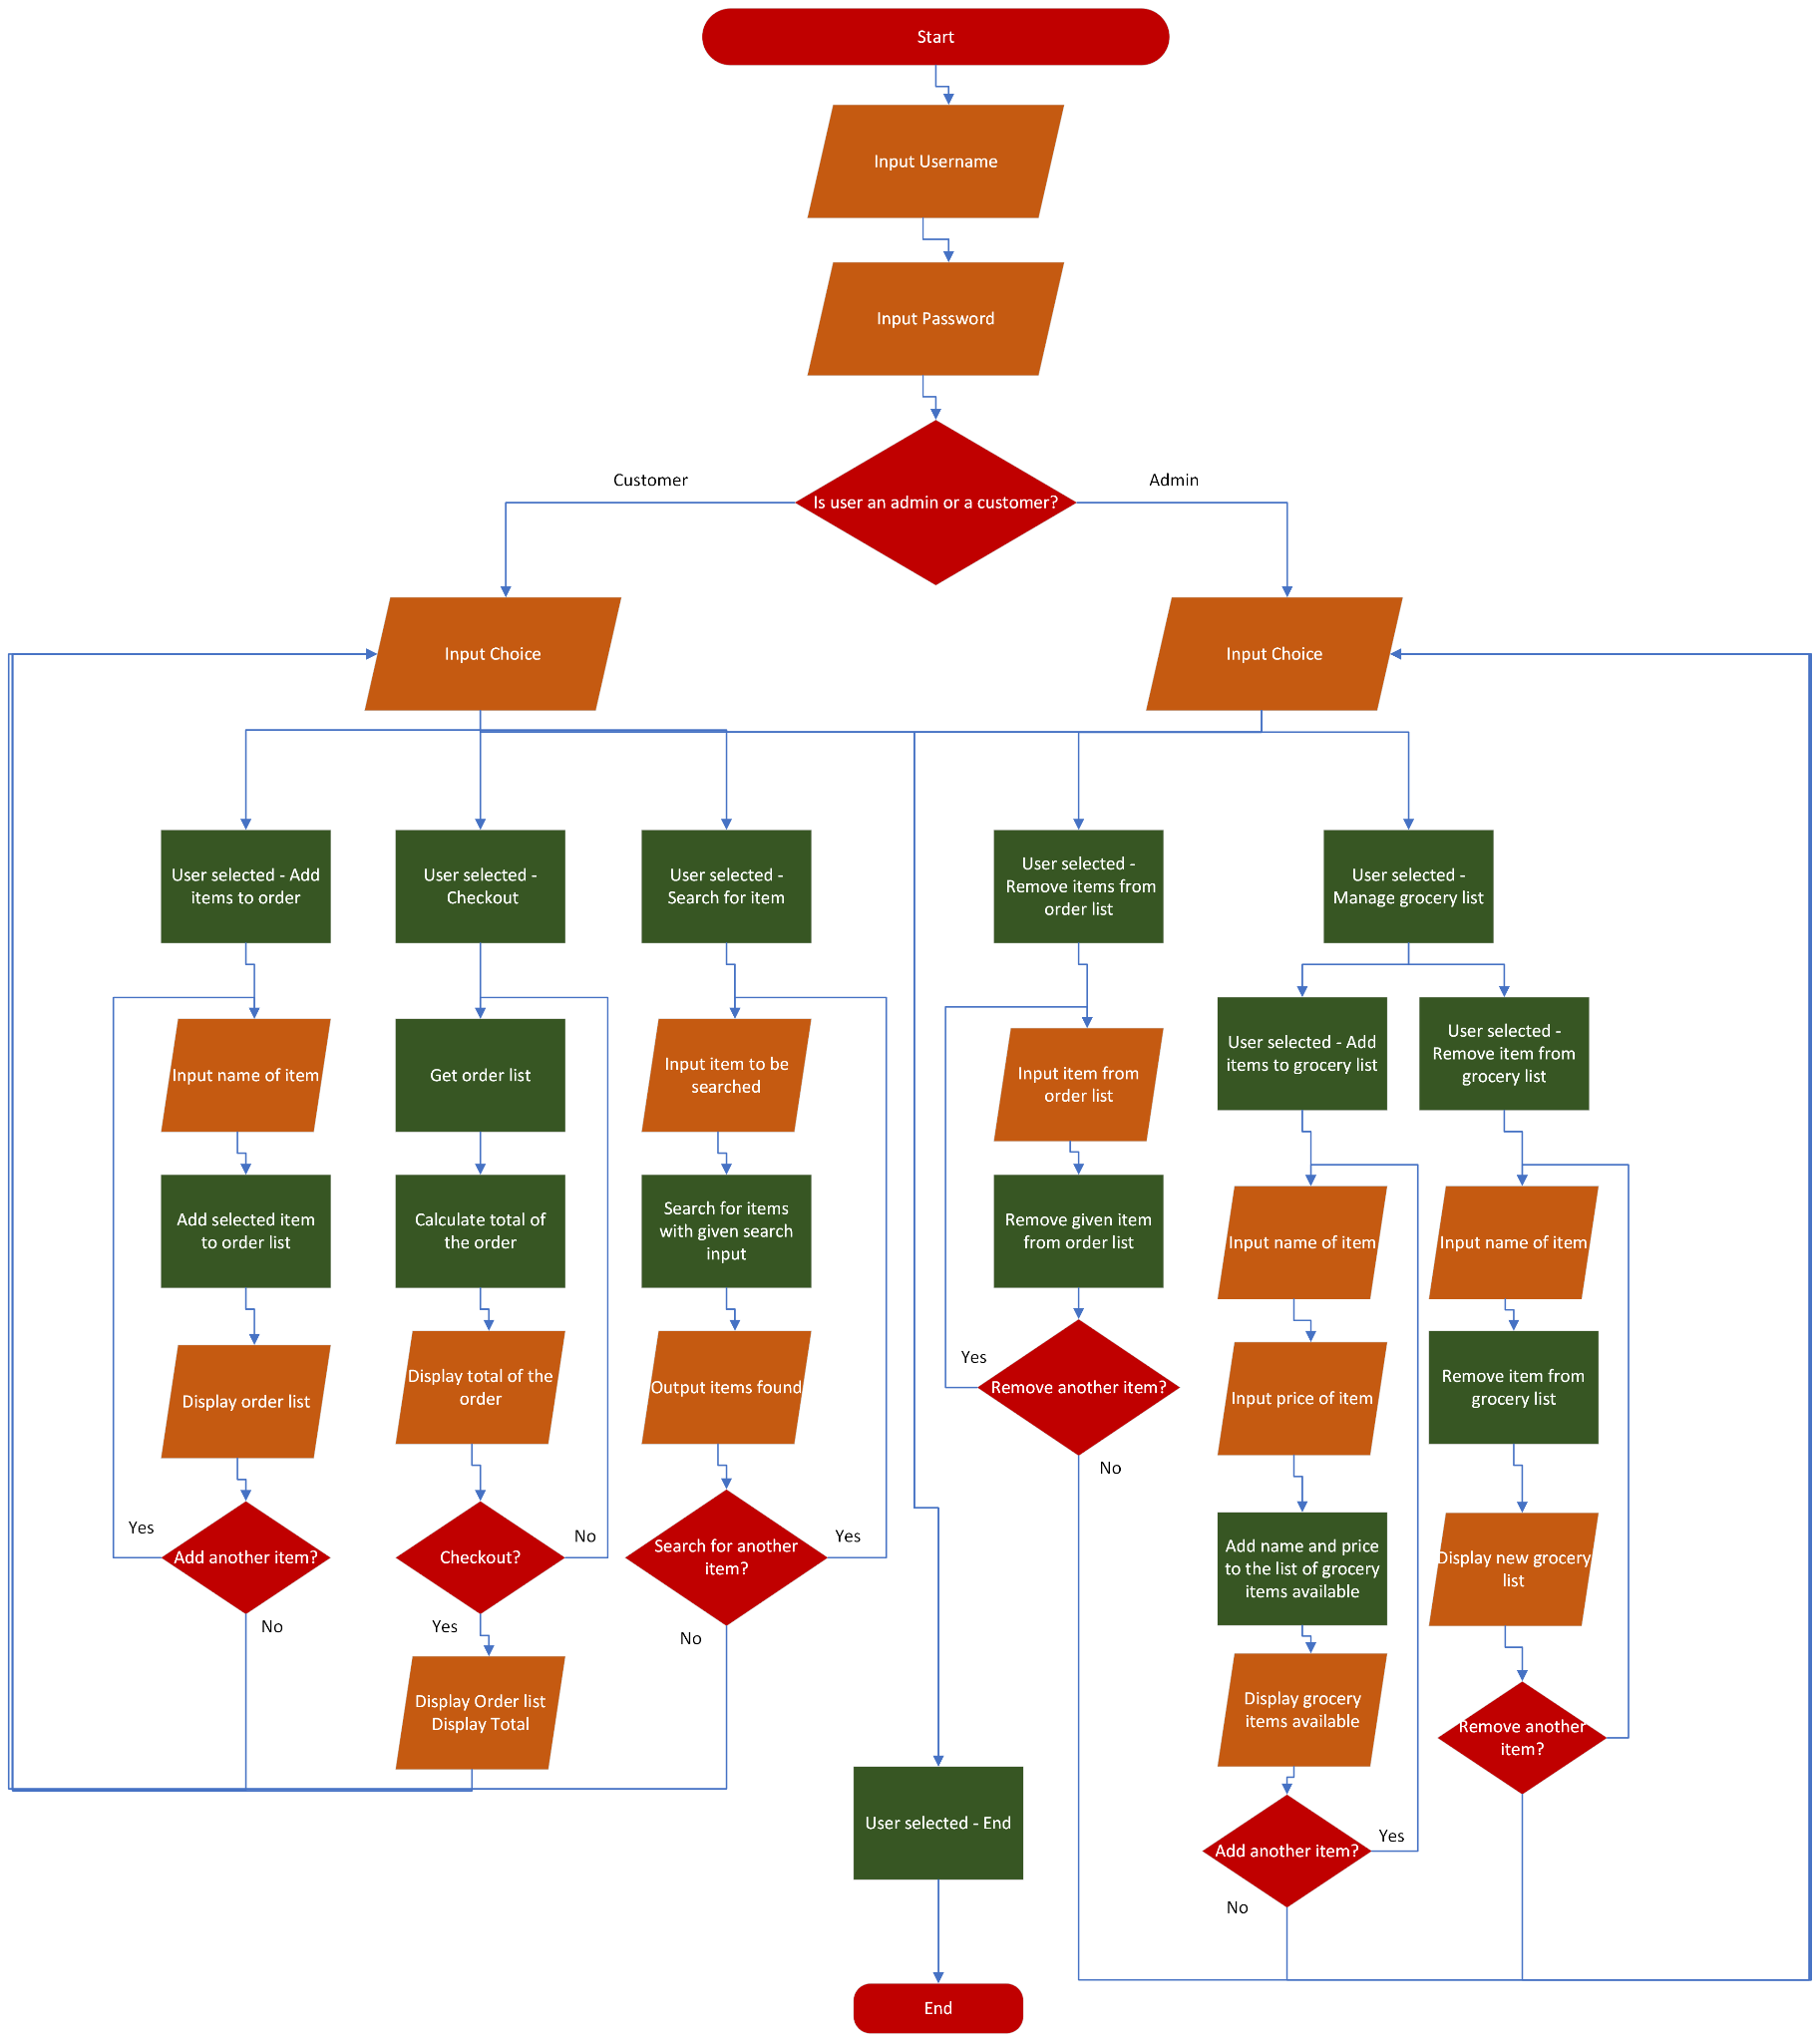

[Final Project Proposal.vsdx](https://dlsuedu-my.sharepoint.com/:u:/g/personal/aaron_james_capinpin_dlsu_edu_ph/EUKzxSedA7NDiqkt3JqKpIIB-73xUJEOd9RHti9rv9KnbA?e=i6vzlW)

This system will take use of if statements, while loops, dictionaries, and lists- all of which are available in the python language using the Jupyter Notebook IDE.

Dictionaries and lists would be used when creating the list of items available in the grocery

If statements and while loops would be used for the general processes

File writing (Module creation and calling) may also be used for creating a more permanent list for grocery items

**Schedule of Activities**

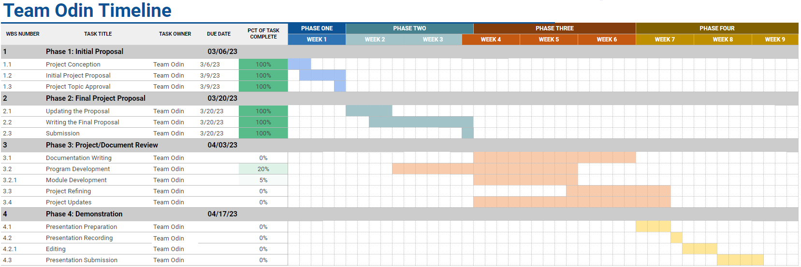

<https://docs.google.com/spreadsheets/d/11n3Gzbw_AaHKpXNtDkiVaSVe5JiEiZgfzIkYw1bruQQ/edit?usp=sharing>