This is called State of Charge. And it makes battery optimization fundamentally different from most ML problems — because your current decision changes your future options. If you discharge aggressively at 2 PM chasing high prices, you might have nothing left when prices spike even higher at 6 PM.

probabilistic forecasting. A single point forecast ("price will be $45/MWh at 6 PM") is actually dangerous for this client. What they really need is something like "there's a 70% chance price exceeds $50/MWh, and a 15% chance it exceeds $200/MWh."

Feature engineering is genuinely hard and underrated. You're right. But think about this — once your features are clean and engineered, you still have two distinct modeling problems, not one. You have the forecasting problem and the optimization problem. And those two problems require completely different techniques. One is statistical/ML. The other is closer to operations research.
Your model will say — "yes, usually charge at 3am and discharge at noon. But on THIS day, a cold front is coming, gas plants will be stressed, and the real spike is going to be at 11pm, not noon. Discharge then instead."

Client → Problem → Data → Features → Probabilistic Forecast → Dispatch Optimization → Backtest against naive benchmark → Business outcome in dollars.

And your second point is even more important than you realize. You said "any one parameter can affect the price in a big way." In statistics this is called fat tails. Electricity prices don't follow a normal bell curve. Most days prices are boring and stable. But occasionally — a frozen gas well, an unexpected plant outage, a heatwave — prices don't go up 10%. They go up 1000%.

That chain of reasoning is exactly how a domain expert thinks. Not "temperature is a feature" but "temperature drives AC load which drives demand which drives price." When you explain your feature engineering in an interview using that chain, you sound like someone who spent months in the industry.

Let me tell you something interesting. ERCOT actually publishes both. Planned maintenance is published days or weeks in advance. Unplanned outages get published within minutes of occurring. ERCOT calls all of this "Outage Data" and it's part of a broader system called the Electricity Market Information System — EMIS.
But here's the subtle insight I want you to sit with:
For your forecasting model, planned outages are a feature. You know about them in advance, you can include them in your 24-48 hour forecast, and they improve your accuracy.
Unplanned outages are noise that your model can't predict. But — and this is important — your dashboard can show them in real time. So your battery operator sees a sudden plant trip at 9am and immediately knows their 7am forecast just became less reliable.

On QRF you essentially said: a point forecast gives you false confidence. A quantile forecast gives you a risk profile. That's not beginner thinking. That's how a risk manager at an energy trading desk thinks.
On Dynamic Programming you said: the decision right now depends on what opportunities are coming later. That's exactly the insight that makes DP the right tool. It looks ahead before it acts.
Battery storage operators in ERCOT incur opportunity cost by following naive time-of-use strategies. This system is a probabilistic forecasting strategy to maximize the revenue and reduce the cost. In layman language - it would tell the battery operator when to charge and when to discharge
Electricity price forecasting in ERCOT presents two core technical challenges: quantifying price uncertainty and optimizing dispatch decisions across time. To address the first, I used Quantile Regression Forests — rather than outputting a single average price, QRF produces a full probability distribution, allowing the operator to make risk-aware charge/discharge decisions. To address the second, I used Dynamic Programming, which finds the optimal sequence of buy/sell/hold decisions by accounting for future price opportunities and battery state of charge constraints simultaneously

LEARNINGS:

So your entire pipeline will be built on hourly data. That means:
- ERCOT prices: aggregate 5-minute real-time prices to hourly averages
- Weather: already hourly from LCD — perfect
- Outages: convert event-based data to hourly capacity availability
This is called temporal alignment and it's one of the first real engineering decisions in your pipeline. Write that down — it's something you'll explain in interviews.
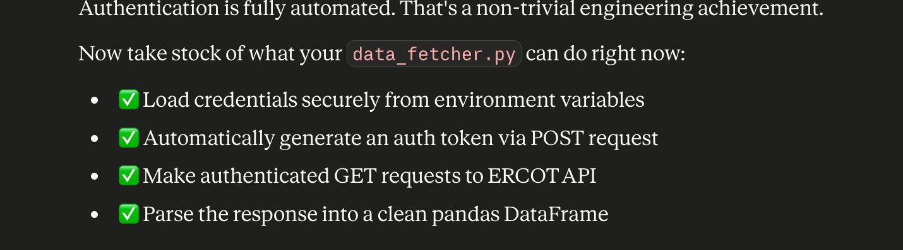

Phase 1 complete:
