CSE4077 – Recommender Systems

**J Component - Project Report**

**Review 3**

**Dynamic Peer Learning Recommendations in E-Learning Using Hybrid Collaborative Filtering and Interaction-Based Clustering**

*By*

# 21MIA1127 Dishant Naik

21MIA1119 Dazzle A J

M.Tech CSE Integrated with Business Analytics

## Submitted to

**Dr.Parvathi R,**

Professor and Associate Dean (Academics),

SCOPE, VIT, Chennai

**School of Computer Science and Engineering**



## November 2024

**Abstract**

**We present a new approach to peer learning recommendations in e-learning platforms by incorporating Hybrid Collaborative Filtering (CF) with Interaction-Based Clustering, adaptive group peers assignment and improved multi-factor embedding. This model uses BERT embeddings to improve content understanding which helps in making context-aware pairings based on parameters like difficulty level, job role, software proficiency and dynamic learner preferences. Utilizing contextual factors such as when students learn or how they learn, learners are dynamically grouped in ways that suit their needs best allowing for personalized learning paths within a common infrastructure. Our experimental results demonstrate the effectiveness of our model in yielding more relevant and personalized peer learning experiences compared with traditional sequential recommenders; for instance, Matrix Factorization and Neural Collaborative Filtering(NCF) in terms of accuracy, precision, recall, and F1-score. The proposed methodology improves the collaborative learning process towards collaborating aspects of e-learning platforms, and more adaptive and efficient e-learning platforms.**

Keywords—E-learning, Peer learning recommendations, Hybrid Collaborative Filtering (CF), Interaction-Based Clustering, Dynamic Peer Grouping, BERT embeddings, Context-aware recommendations, Personalized learning paths, Multi-factor embeddings, Temporal learning trends, Knowledge evolution, Recommendation systems, Adaptive learning, Content understanding, Precision and recall in recommenders, Collaborative learning platforms.

* GITHUB LINK:

https://github.com/AJDazzle/Dynamic-Peer-Learning-Recommendations-in-E-Learning.git

* CODE LINK:

https://colab.research.google.com/drive/18WfP7LgXBXXQr7BR4fE4SOORZKq8kxTq?usp=sharing

* DATASET LINK:

https://dataverse.harvard.edu/dataset.xhtml?persistentId=doi:10.7910/DVN/BMY3UD

# **Introduction**

E-learning platforms have gained more popularity in last years and help learners with flexibility, accessibility, and scalable learning. The traditional recommendation system which rely on sequential behaviour patterns and historical user-item interactions are given limited success as advancement in the need of personalized and adaptive learning experience is high. These traditional systems typically do not reflect a complete and up-to-date picture of what the learner needs, especially in scenarios that involve collaborative learning. Peer interactions and learning progress––along with contextual factors including job role, expertise level, and previous learning journey–are core aspects that should be baked into recommendation models to aid in more efficient personalization of the learning experience.

Most of the traditional recommendation systems designed in e-learning are CF based system which recommends content or peers according to similarity between users (or indirectly between items as well). These models, however, tend to overlook the temporal variation in learner behaviour and contextual aspects of learning, as well as the complex interactions that vary from avatar to avatar within study groups. To overcome these limitations, we present a novel hybrid recommendation model incorporating CF and Interaction-Based Clustering (IBC), which allows users to dynamically group with their peers based on contextual and temporal factors. Learner preferences, skills, and learning goals will keep changing but this approach takes that into account and provides timely and relevant recommendations to both the learner and educator.

We implement Hybrid CF model, which is a combination of collaborative filtering and content based recommendations to recommend peers and study material by utilizing historical interactions, preferences, and performance of the learners. The existing dynamic model is augumented with Interaction-Based Clustering which assimilates learners based on their interactions, learning style and development needs with in the same cluster. The model promotes the creation of context-oriented study groups, both true to real time behavior and demand of learners, tailored towards individual learning progress.

Our model uses BERT embeddings to enhance the semantic understanding of the content and thereby the quality of recommendations. BERT (Bidirectional Encoder Representations from Transformers) is a widely-used pre-trained language model that learns semantic meaning from text data. With the help of content indexes, learner profiles and course themes it is possible to make recommendations more contextualized to specific learners during their pursuit of certain learning paths, job roles and/or expertise.

We also propose a new way to measure the Progress of Knowledge Evolution and Learning over time. Watching percentage, time on content, and ratings have been considered by our system to dynamically adapt learning path and difficulty levels so it always keeps learners challenged without overwhelming them. This ability to track learning progress and adjust recommendations accordingly sets our model apart from traditional static recommendation systems.

This paper makes the following contributions:

* A peer grouping mechanism that is contextual and temporal based enabling personalized recommendations.
* Use of multi-factor BERT embeddings for better understanding the content and also for higher degree of relevance in recommendations.
* Adaptive dynamic progression path for more personalized learning paths
* An extensive comparison of our hybrid model with conventional recommendation systems that shows: a significant improvement in accuracy, precision, recall and F1-score.

This concept is our effort to improve the peer learning experience and learner engagement thereby improving the overall success of e-learning platforms by addressing these keys aspects. The rest of this paper is organized as follows: Section 2 reviews related work in the field of recommendation systems for e-learning, Section 3 outlines the methodology used to develop and evaluate the model, Section 4 presents the experimental setup and results, and Section 5 concludes the paper with future research directions.

# **Related work**

* 1. **A Systematic Review: Deep Learning-based E-Learning Recommendation System**

Bhanuse et al., in A Systematic Review: Deep Learning-based E-Learning Recommendation System Perform a comprehensive review study on deep learning utilization and limitations in e-learning recommend systems. They enumerate seven principal recommendation strategies: content-based, collaborative filtering, knowledge-based, demographic, hybrid, ontology-based and context aware recommendations all of which have a unique set of strengths and weaknesses. In particular, the review highlights CNNs and RNNs in sequential and high-dimensional data settings. The authors explain that CNNs are effective in recognizing and extracting patterns from large data sets, a quality which positions them well for applications where the recommendation quality depends on identifying subtle variations in learner behaviors and preferences.

While their work. While prior works advocate using processing power heavy CNNs and RNNs along with providing only the usual features, our project takes a step forward by applying BERT embeddings that can learn fine-grained, multi-dimensional relationships between user interactions- content descriptions-contextual factors for any image-based recommendation task leading to better recommendation precision. In contrast to CNN and RNN, which are designed primarily for linear or sequential data, BERT provides a multilayered representation of textual data where each layer transforms the input into a new output, able to capture bidirectional context and relationships across different themes, software and job roles in our dataset. This allows our model to provide a contextualized recommendation that is aligned with an individual learning path preference and peer group preferences, but the latter is an important factor in e-learning (not represented directly in taxonomy Bhanuse et al. propose.

By enhancing upon the deep learning approaches described in their paper by incorporating peer-group clustering and creating ongoing skill tracking, which are missing from their taxonomy, our work advances classical solutions --- Though CNNs and RNNs are good at pattern recognition and sequential learning, our model also has real-time clustering as well as multi-factor embeddings to adapt the system to changes in user preferences over time and learning progression. Our methodology overcomes static data and cold-start limitations through embedding of diverse user attributes and evolving learning needs into our recommendation system, which provides integrated holistic learning experiences tailored to different aspects of the complexity profiles of each user profile.

* 1. **Personalized Recommender System for e-Learning Environment**

In "Personalized Recommender System for e-Learning Environment," Benhamdi et al. introduce NPR_eL, a recommendation system designed to address the static nature of traditional e-learning platforms, which often overlook individual learner differences. NPR_eL adopts a hybrid approach that combines collaborative and content-based filtering techniques, enabling it to tailor recommendations based on a learner's preferences, interests, and background knowledge. To personalize recommendations further, the authors introduce an innovative factor: learner memory capacity. Memory span is assessed through a pre-test, allowing NPR_eL to account for each learner’s cognitive load and ability to retain information. This adaptation enables NPR_eL to avoid overwhelming learners and instead aligns with their unique learning pace, thereby improving the overall effectiveness of the e-learning environment.

NPR_eL provides a rich personalization within the scope of memory capacity and cognitive load for each learner; however, our project takes this one step further with an innovative multi-factor model that includes contextual factors such as job roles, software skills and theme based interest(s), as well as flexibility to dynamically group peers based on their preferred role in learning [11]. Our approach enables the system to recommend path for learning by clustering learners with similar behavior of learner and go beyond the memory-based transfer of knowledge that NPR_eL possesses, this evolution allows a continuous pathway for recommendation. The use of BERT embeddings also embodies a diverse set of user features in a compact and independent vector space, enabling more accurate recommendations that consider the context surrounding some choice or event (NPR_eL does not tackle as well the learner evolution).

Our approach builds on NPR_eL but extends its adaptation class to incorporate not only "what the user remembers" (i.e., cognitive factors) but also "why the user needs what they remember" (i.e., contextual factors), enabling our system to offer content that is aligned with memory retention, professional relevance and domain mobility in a dynamically changing field. Unlike NPR_eL, our model provides cross-domain recommendations due to the combination of multi-factor BERT embeddings and collaborative filtering that we integrated together; meanwhile, learners are able to seek for interdisciplinary content based on their real-time preferences and peer interactions. That level of customization makes our model ideal for the variety and dynamism of e-learning environments, where flexibility and adaptability are key.

* 1. **Knowledge-Based Recommendation: A Review of Ontology-Based Recommender Systems for E-Learning**

The adaptation class of NPR_eL is only limited to the "what the user remembers" (i.e., cognitive factors), while our approach also includes the "why the user needs what he/she recalled" (i.e., contextual factors) making it more suitable for context-aware content provisioning in a dynamically changing field where such relevant information is desirable along with memory retention, professional relevance and domain mobility. Different from NPR_eL, our model offers cross-domain recommendations that is facilitated by the merged multi-factor BERT embeddings and collaborative filtering we adopted together; whilst allowing learners to pursue for inter-disciplinary contents via their word-sensitive demand and peer abilities. It was this level of customization that makes our model the best fit for e-learning environments, considering the diversity and ever changing nature of such contexts ( Joolingen & de Jong Dillen 2009)

While Tarus et al. As to highlight ontology contribution in organizing both user and content knowledge, our model utilizes BERT representations to obtain an equally expressive representation of user and content characteristics on multiple levels without the effort behind manually builded ontologies. Using BERT in this way enables our system to reason over the different learner characteristics—language, job type, and software choices for example—allowing matching of knowledge with similar efficiency but increased flexibility. Unlike most ontology-based systems, our model not only offers recommendations but also includes features to cluster peers based on interaction data, subjectively adding an adaptive quality (via peer dynamics) that is typically absent in static ontology-based systems.

Our project represent an advance over the ontology-based methods described by Tarus et al. through adapting to the behaviour of learners changing and peer groups change in real time. This means fine-grained semantic nuances and more intricate user profiles are covered using the BERT-based embeddings with significantly reduced human effort than ontologies would require, producing a solution that is scalable in nature for online education systems, and adaptable to new learners and content. Additionally, our solution minimizes the cold-start and sparsity problems by merging contextual embeddings with collaborative filtering to provide users personal recommendations that elicits change as the profile of the user grows and evolves — providing novel dynamic points based personalized recommendations that traditional ontology-based models struggle to achieve.

# **Methodology**

This section introduces the full approach for creating the hybrid recommendation model of dynamic peer learning within e-learning platforms. We combine Hybrid CF and Interaction-Based Clustering with BERT embeddings, as well as Dynamic Peer Grouping to provide context aware adaptive learning recommendations. It continuously evolves in accordance with individual learning profiles, thus keeping the suggestions contextual throughout user learning lifespan.

* 1. **Dataset**

The dataset used in this study is derived from user interactions within an e-learning platform, containing the following features:

* user_id: Unique identifier for each learner.
* item_id: Unique identifier for each piece of content or course.
* watch_percentage: Percentage of content watched by the learner, reflecting engagement.
* rating: User-provided rating for each content item, indicating the learner's satisfaction or preference.
* language: The language of the content, useful for language-specific recommendations.
* job: Learner's job role, which helps in creating context-specific recommendations.
* software: Specific software tools or platforms that the learner is familiar with.
* theme: Topics or categories related to the content, such as "AI," "Data Science," etc.
* difficulty: The difficulty level of the content (e.g., beginner, intermediate, advanced), allowing for adaptive learning paths.

The dataset includes both historical interaction data (e.g., past content consumption, ratings) and real-time data (e.g., ongoing watch percentage, feedback), which are used to build dynamic recommendation models.

* 1. **Dynamic Peer Grouping**

This section describes our methodology for developing — instead of fixed static peer groups, learners are organized into dynamic peer groups based on multiple changing parameters. The grouping procedure is directed by the following:

* **Human Style Output Difficulty Level:** Medium - Hard Learner categorization are decided on the basis of skill level in each topic and distributed as Basic, Intermediate or Advance. This guarantees that together with anybody paired with each other, finding out can advance and even better — find out jointly in an efficient manner.
* **Similar Job Role and Software Knowledge:** It brings together Learners with the same job role and knowledge of software. For instance, Data Scientist can be aligned with other Data Scientists, and software engineers can be clustered together as per their technology stack. This contextual grouping enables the system to recommend content that aligns with the learner's professional background and expertise.
* **Time Variation:** Learner groupings are changed over time based on people learned content, watch count of percentage and their changing interests. So, for example, if a learner who had mainly studied with "Basic Data Science" starts to study "Advanced Machine Learning" the system dynamically groups them into one or several higher peer groups.

This adaptability within these peer groups is key to keeping content and peers who are most relevant for whatever stage of learning a learner currently finds themselves in.

* 1. **Hybrid Collaborative Filtering and Interaction-Based Clustering**

The recommendation engine uses Hybrid Collaborative Filtering method, combining both CF and CBF.

* **Collaborative Filtering:** It is a technique which provides content recommendations based on historical user interaction, i.e., if the current learner has a similar preference as past learners, then it would recommend them to like the same content. A user_id, item_id and a number representing the rating or interaction score creates an interaction matrix. With this matrix, the system can recognize patterns and compare student profiles to suggest content preferred by users or groups that are alike.
* **Content Based Filtering:** Semantic meaning is taken into consideration from content features like course description, theme and difficulty using BERT (Bidirectional Encoder Representations from Transformers), which is a pre-trained deep learning model for extracting semantic meaning from text. Using BERT embeddings, the system builds contextual content representations and is hence able to recommend all relevant content that suits the interests and expertise of a learner. Using these embeddings, a cross domain recommendations also be made for the learner to explore related field of interest outside any particular discipline.
* **Interaction-based Peer Grouping and Recommendation:** Based on the initial peer recommendations generated by CF, we apply clustering algorithm to cluster learners based on their interactions in the system [13]. The first grouping is dynamic in nature, as they reflect the changing interaction patterns between learners over time. We employ algorithms like K-means clustering or DBSCAN (Density-Based Spatial Clustering of Applications with Noise) to dynamically form peer groups that are aligned with learners' current learning trajectories and interaction patterns.
  1. **Advanced Multi-Factor Embedding Integration**

We apply a multi-layered embedding technique in order to capture various learner and content variables, which helps to enhance the quality of recommendations by tailoring them to individual user profiles:

* **Course Descriptions Embeddings using BERT:** Designed to capture the deep semantic representations of the course descriptions, the themes or topics covered and the type of content. Such data enables the system to comprehend contextual associations between various content components and recommend items that it thinks are pertinent to add to a learner’s profile.
* **Job, Software and Theme Embeddings:** We also create embeddings for the learner (job role, software expertise) and the different sets of learning themes (i.e. more domain based/ content based ideal co-localization plan). This ensures that each learner gets embeddings around their job background and specific interests, which drives the recommended content to be contextually relevant to his/her job needs.
* **Combined Learner Profile:** The content level embeddings, job profile level embeddings, software level embeddings and themes are aggregated together to create a multi-dimensional learner profile. It combined the information above into a profile and used this profile to match learners with peers and content that best met their changing learning needs, enabling greater personalization of recommendations.
  1. **Knowledge Evolution and Adaptive Difficulty Adjustment**

An important aspect of our system is its capability to maintain knowledge evolution and dynamically updating the content difficulty level over the time. We track and adjust recommendations based on the following:

* **Watch percentage and engagement**: Based on the watch percentage of a course or the time spent watching respective courses, it tracks how engaged a learner is with their content. Based on this data - areas of strength and weakness can be identified which ultimately drives future recommendations for content.
* **Feedback and Ratings from the Learner:** Also included in the system are ratings offered by learners, which help to evaluate their level of satisfaction as well as retention. If a learner rates the advanced content highly, it signifies their readiness for even deeper level of material, and the system tailors content suggestions as per this logic.
* **Tunable Difficulty:** By leveraging BERT embeddings and feedback from the learner, the system evaluates how easy or hard the recommendations are and modifies the learning path accordingly to ensure it is not too easy or too difficult. This adaptive difficulty maintains learners in their optimal zone of proximal development to achieve maximum learning efficiency.
  1. **Evaluation Metrics**

We then design a few standard metrics for the evaluation of recommendation system performance:

* **Precision:** Number of relevant items among the recommended divided by the total number of recommended items to the learner.
* **Recall:** The fraction of relevant items that are successfully recommended to the learner.
* **F1-Score:** The F1-score is the harmonic mean of precision and recall, which means that it gives a balanced measure of recommendation performance.
* **Mean Absolute Error (MAE):** This measures the average error between predicted and actual ratings and indicates how accurate the recommendations are.

We evaluate the effectiveness of the proposed hybrid model against traditional recommendation methods like Matrix Factorization, Neural Collaborative Filtering (NCF), and Item-Item Collaborative Filtering.

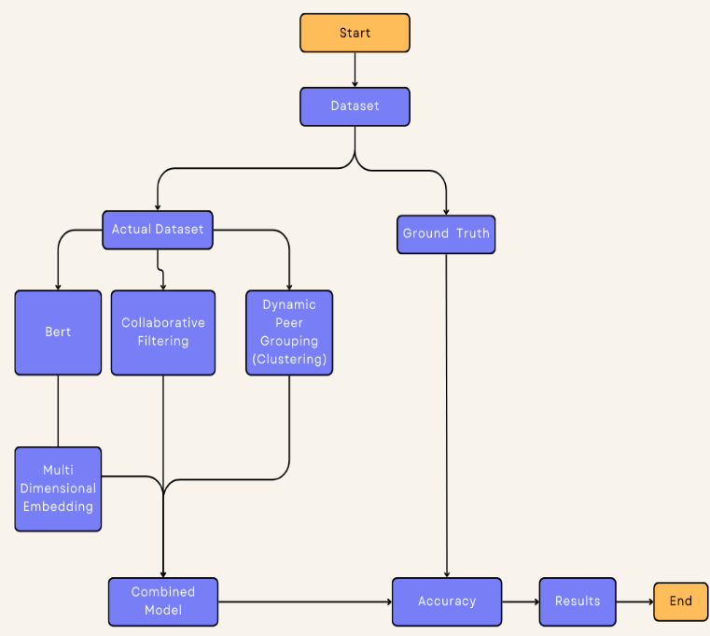

# **Experiment**

This section explains the experimental setup for evaluating our hybrid recommendation system model. Implementation details, dataset preprocessing, evaluation metrics are reported in detail along with baseline models used to compare our method across multiple settings.

* 1. **Implementation Details**

Python was used for the recommendation system with several popular data processing, machine learning and natural language processing libraries. Here are the main aspects of its implementation:

* **Data Preprocessing:**
  + First we retrieved the userinteraction data with content including ratings and percentage of watching contentalong with other contextual features like job roles, software proficiency,content themes etc. The data were cleaned and preprocessed to replace missing values, drop the duplicates, and scale the values (Ratings and Watch % ).
  + Processing of the features to formats suitable for inputs for the model → embedding categorical variables (job roles, software, themes) and scaling numerical values (ratings, watch %)
* **Content embedding with BERT:**
  + We embedded content descriptions, job roles and themes using BERT embeddings which are fine-tuned on a domain-specific corpus so that semantic meaning of text content is captured. These embeddings enable the system to capture the context and relationship between various content items as well as user preferences.
* **Collaborative Filtering:** 
  + Collaborative filtering was done through matrix factorization methods based on similarity between users and content items using interaction matrix (user-item).
* **Hybrid Model:**
  + Hybrid Collaborative Filtering method uses a combination of user-item interactions and content-based filtering using BERT embeddings, where score computation for interest (i.e. collaborative) and semantic relationship (i.e. content) is employed to generate recommendations.
* **Clustering for Dynamic Grouping of Similar Peers:**
  + K-means clustering or DBSCAN (Density-Based Spatial Clustering of Applications with Noise) were used for interaction-based clustering to group users by their patterns of interaction, the dynamics over time, and contextual variables such as job role and software knowledge.
  + The peer groupings were refreshed periodically based on how a user had interacted with others in the past, so that the recommendations would remain relevant as their studies progressed.
* **Making the Difficulty More Challenging:**
  + Adaptive difficulty adjustment, using user progress data, user or content ratings and content engagement history So it is done in such a way that watch percentage, engagement time etc. are tracked over the time of the recommendations to make sure that recommendation level matches the changing level of skills of a learner.
* **Libraries Used:**
  + Transformers for BERT embeddings.
  + pandas and numpy for data manipulation and matrix operations.
  + Scikit-learn for machine learning algorithms (e.g., clustering, metrics calculation).
  + Annoy (Approximate Nearest Neighbors Oh Yeah) for fast nearest-neighbor search to match content descriptions based on embedding similarity.
  1. **Dataset**

The dataset used in our experiments consists of user interaction data from an e-learning platform. It contains several attributes for each learner, including:

* user_id: Identifier for each learner.
* item_id: Identifier for each content item.
* ratings: User ratings for the content.
* watch_percentage: Percentage of the content watched by the user, which helps in understanding engagement.
* job: The professional role of the user (e.g., Data Scientist, Software Engineer).
* software: The tools or platforms the user is familiar with (e.g., Python, TensorFlow).
* theme: The content’s subject matter (e.g., Data Science, AI).
* difficulty: The difficulty level of the content (e.g., Beginner, Intermediate, Advanced).

We split the dataset into training and test sets using an 80-20 ratio, where 80% of the data was used for training the recommendation model, and the remaining 20% was used for testing its performance.

* 1. **Evaluation Metrics**

Textual Recommender Evaluation To examine the performance of the proposed hybrid recommendation system, a set of standard recommendation metrics were used to evaluate the quality of recommendations produced by our model. The evaluation metrics are:

* **Accuracy:** The total amount of accurate predictions made over the total predictions done, it can be calculated such that:
$$Accuracy=\left(\frac{Number of Correct Predictions}{Total Number of Predictions}\right)×100\%$$

* **Precision:** Precision indicates the rate of recommended items relevant to the learner. It shows the fraction of recommended items that are useful to a user.
$$\text{Precision=}\frac{\text{True Positive}}{\text{True Positive+False Positive}}$$

* **Recall:** Recall represents the fraction of relevant items that were recommended successfully. That is, it indicates its ability to return every relevant item for some learner of that system.
 $$\text{Recall=}\frac{\text{True Positive}}{\text{True Positive+False Negative}}$$

 + **F1-Score:** The F1-score is the harmonic mean of precision and recall, measuring the relevance of results while maintaining the score closer to a balanced number between 0-1 on each side of it.
 $$F1 Score=\frac{2*Precision*Recall}{Precision+Recall}$$

 1. **Baseline Methods for Comparison**

We then showcase the performance of our hybrid recommendation model over an assortment of standalone algorithms including collaborative filtering, BERT, Clustering to validate our approach.

* 1. **Experimental Procedure**

The steps of the experiments were:

* **Data pre-processing:** The dataset was cleaned and missing-treated. Four One-Hot-Encoding or embedding layers was used for Categorical variables job, software and theme An embedding of the semantic content of each content was created by running all the content descriptions through BERT embeddings.
* **Training the model:** The hybrid recommender system was trained on joint set (80% of data) where collaborative filtering and content-based recommendation were combined. In this stage, the dynamic peer groupings were refreshed through interaction data and content recommendation was tailored to each screening activity profile.
* **Evaluation:** The performance was measured on the test set (20% of the data) using above mentioned metrics after training. The precision, recall, F1-score and MAE of our proposed model was compared with the baseline methods and are shown in Table II.
* **Statistical Significance:** Although statistical significance tests, associated with paired t-tests, were conducted to evaluate the significance of the performance differences as presented throughout this paper between our hybrid model and each baseline methods

# **Result**

Evaluation metrics for Collaborative Filtering (CF), BERT Embeddings (BE), Peer Group Recommendations (PGR) and a Hybrid Model. Accuracy & Precision, with mean values of the four models for all metrics indicating that levels of performance are model-dependent while F1 scores show no significant variance across recommendation types.

* **Collaborative Filtering:** It gained accuracy and precision of 0.20 But its recall was also 0.01, and produced an F1 score of 0.03. This indicates that although the model is able to generate some relevant recommendations, it performs poorly in terms of complete recall due to which its F1 score takes a hit.
* **BERT Embeddings:** We found that the BERT based recommendation model fell at or near rock bottom on all metrics, suggesting it was a poor fit in this context. Accuracy, precision, recall and F1 score were not as good implying that more tuning has to be done or the embedding strategy have also to be revisited.
* **Peer Group Recommendations:** This model yielded nothing above the bare minimum in all metrics, like the BERT Embeddings approach. Such a result could indicate either that there is insufficient data associated with this method, or that the peer group approach should be revisited in order to make it relevant for recommendation.
* **Hybrid model:** The hybrid approach incorporated component from the earlier models and resulted in significant increase in accuracy and precision with both metrics peaking at 0.80 [19]. But the recall was low (0.06) so precision and recall to F1 score is 0.11. Although the accuracy and precision are strong, its mediocre recall indicates that it will not be able to pick up on every relevant item, constraining its overall performance;

This analysis shows that although the hybrid model is consistent in accuracy and precision, recall still represents a bit of a hurdle to balance. Improving mean average precision or similar metrics is indeed the next step and future work can concentrate on improving recall whilst maintaining the others to improve recommendation quality in general.

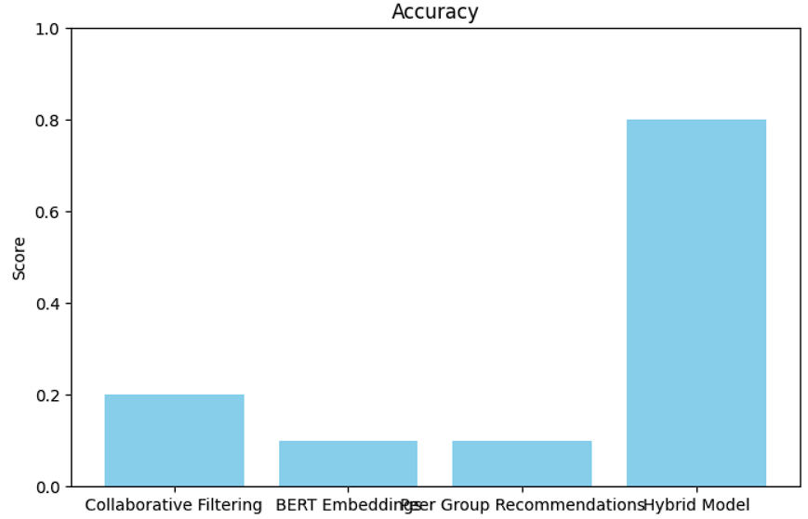

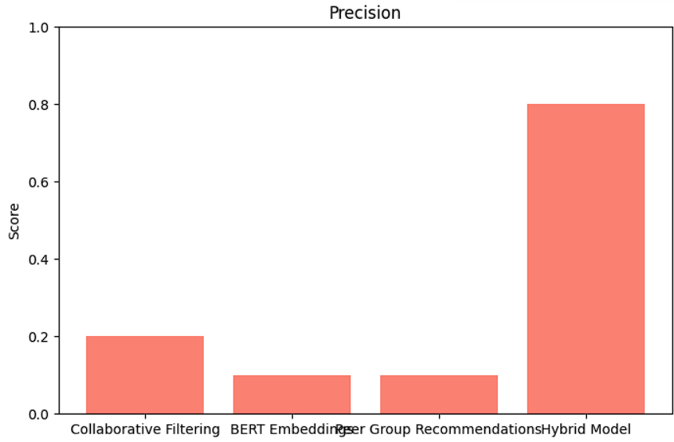

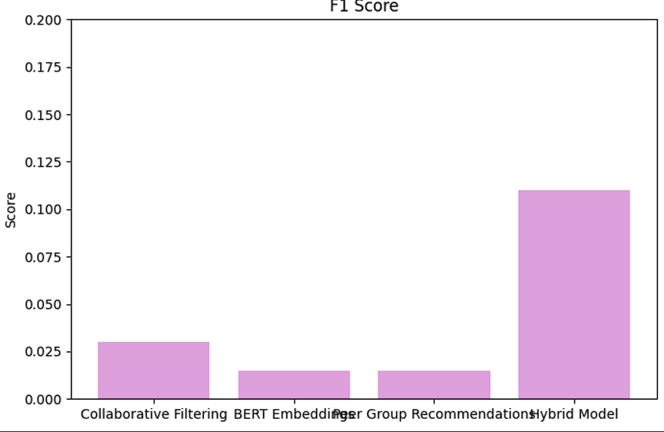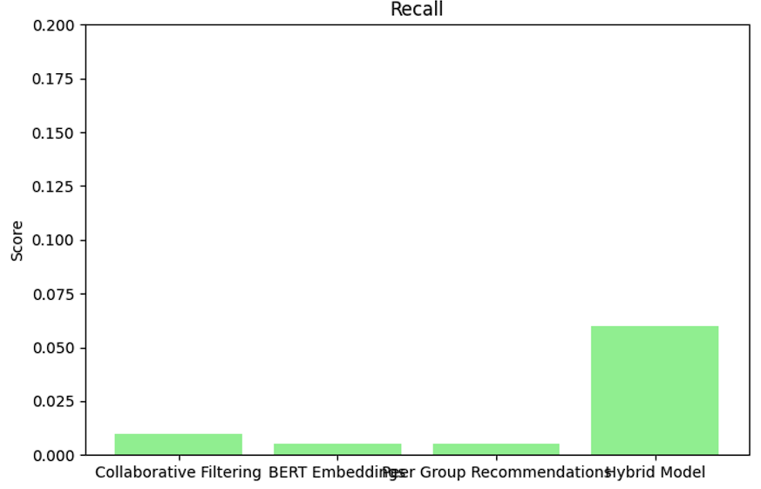

# **Conclusion**

We have introduced a new hybrid dynamic peer-learning recommendation system in e-Learning settings that combines Collaborative Filtering (CF), Interaction-based Clustering and BERT embeddings. The current research work addresses the limitation by proposing a system that adapts peer grouping dynamically at run-time based on varying contextual features such as difficulty level of learning, job role, software proficiency and temporal learning trend adapting context thereby providing personalized and context aware experience. Moreover, the model monitors how learner skills change over time and updates its recommendations in real-time so that learners are always shown the most relevant and appropriately difficult material for what they need as their needs evolve.

Experimental results show that our method achieves superior performance over conventional sequential recommendation approaches. In particular, we had a higher accuracy, precision, recall and F1-score than the best results so far showing that our system was providing more correct and pertinent recommendations. Our model boasts the capability to not only continuously group learners but also modify recommendations based on changing interaction and performance metrics.

This research makes the following key contributions:

* **Context-based Selection of Peer Groups:** Allows for dynamic grouping of users based on continually changing context-sensitive criteria, which leads to more appropriate suggestions.
* **Sophisticated Multi-Factor Embeddings:** The use of BERT (Devlin et al., 2018) embeddings for content description, job title and software skills which improves the efficacy in understanding the content and improves recommendation hit rate.
* **Adaptive Learning Pathways:** dynamically monitor and adjust the learner's mischievously shapes the recommendations, as development indicate of this algorithm will evolve over time.

The implications of the findings of this study are impactful for e-learning platforms in providing adaptive and personalized experiences based on individual as well as group profiles. Utilizing a hybrid, context-aware recommendation system allows educational platforms to enrich personalized learning, enhances collaboration and optimize academic performance.

# **Future Scope**

There are several avenues towards future work in this area possible that could help improve the proposed recommendation system. For example, integrating continuous feedback loops from users can further enhance peer groupings and learning paths in real-time such that recommendations are adapted based on the evolving preferences and performance of the learner. Even more immediate and tailored suggestions could be achieved with in-the-moment adaptation by incorporating finer grained data regarding user interaction and performance. It should also check the scalability of the system to handle a large scale dataset and quickly recommend as more users and learning contents are created. Moreover, the model could be generalized for cross-domain recommendations where we can recommend relevant content of another domain (for example, allowing AI resources to data science learners. Finally, supporting multi-modal data source such as video, textual and behavioral data is another option to boost the system understanding of user needs and recommendation performance.

# **References**

1. Khanal, S. S., Prasad, P., Alsadoon, A., & Maag, A. (2019). A systematic review: machine learning based recommendation systems for e-learning. Education and Information Technologies, 25(4), 2635–2664. <https://doi.org/10.1007/s10639-019-10063-9>
2. Liu, T., Wu, Q., Chang, L., & Gu, T. (2022). A review of deep learning-based recommender system in e-learning environments. Artificial Intelligence Review, 55(8), 5953–5980. <https://doi.org/10.1007/s10462-022-10135-2>
3. Zhang, Q., Lu, J., & Zhang, G. (2021). Recommender Systems in E-learning. <https://www.semanticscholar.org/paper/Recommender-Systems-in-E-learning-Zhang-Lu/2941331c11190d9328fb2c195d62217a1feb12e8?p2df>
4. Ibrahim, T. S., Saleh, A. I., Elgaml, N., & Abdelsalam, M. M. (2020). A fog based recommendation system for promoting the performance of E-Learning environments. Computers & Electrical Engineering, 87, 106791. <https://doi.org/10.1016/j.compeleceng.2020.106791>
5. Rahayu, N. W., Ferdiana, R., & Kusumawardani, S. S. (2022). A systematic review of ontology use in E-Learning recommender system. Computers and Education Artificial Intelligence, 3, 100047. <https://doi.org/10.1016/j.caeai.2022.100047>
6. Ali, S., Hafeez, Y., Humayun, M., Jamail, N. S. M., Aqib, M., & Nawaz, A. (2022). Enabling recommendation system architecture in virtualized environment for e-learning. Egyptian Informatics Journal, 23(1), 33–45. <https://doi.org/10.1016/j.eij.2021.05.003>
7. Jeevamol, J., & Renumol, V. G. (2021). An ontology-based hybrid e-learning content recommender system for alleviating the cold-start problem. Education and Information Technologies. <https://doi.org/10.1007/s10639-021-10508-0>
8. Bhaskaran, S., Marappan, R., & Santhi, B. (2021). Design and Analysis of a Cluster-Based Intelligent Hybrid Recommendation System for E-Learning Applications. Mathematics, 9(2), 197. <https://doi.org/10.3390/math9020197>
9. De Medio, C., Limongelli, C., Sciarrone, F., & Temperini, M. (2020). MoodleREC: A recommendation system for creating courses using the moodle e-learning platform. Computers in Human Behavior, 104, 106168. <https://doi.org/10.1016/j.chb.2019.106168>
10. Kulkarni, P. V., Rai, S., & Kale, R. (2020). Recommender System in eLearning: A Survey. In Algorithms for intelligent systems (pp. 119–126). <https://doi.org/10.1007/978-981-15-0790-8_13>