TFRO-MIS: A WEB MANAGEMENT INFORMATION SYSTEM FOR THE TRICYCLE FRANCHISING AND REGULATORY OFFICE (TFRO)
OF LUCENA CITY

Marriane Joy G. Celzo
Aerol Joshua R. Domirez

Southern Luzon State University
Lucena Campus

Bachelor in Industrial Technology
Major in Computer Technology
May 2026
Chapter I
INTRODUCTION

The Tricycle Franchising and Regulatory Office (TFRO) are responsible for regulating tricycle transport operations as part of the local government’s transportation management functions. The office handles franchise application and renewal processing maintains records of operators and drivers, monitors route compliance, documents violations, and prepares administrative reports to support transport policy implementation. Through these responsibilities, TFRO helps ensure organized and compliant public transport operations, highlighting the importance of strengthening regulatory systems to improve oversight and service delivery in the transportation sector (Guillen et al., 2025).
Despite technological advancements in government operations, some public transportation regulatory offices still rely on manual procedures and fragmented digital tools to manage administrative records and regulatory functions. In offices such as the Tricycle Franchising and Regulatory Office (TFRO), tasks including franchise processing, record management, route monitoring, violation documentation, and report preparation are often handled through paper-based records and separate digital files, which may lead to delays, redundant data entry, and difficulty retrieving accurate information (Perez et al., 2021).
Although digital technologies are increasingly adopted in government operations, many offices still rely on manual and non-integrated information management practices that result in inefficient data processing and delayed report generation. The absence of a centralized management information system limits data accessibility and affects effective administrative decision-making, highlighting the need for an integrated system to improve operational efficiency and service delivery in transport regulatory offices (Padilla, 2025).
The proposed E-TFRO system streamlines the operations of the Tricycle Franchising and Regulatory Office by integrating all essential processes into a single web-based platform. Users can securely log in according to their designated roles, allowing administrators and authorized personnel to access, manage, and update records efficiently. The system automates franchise application and renewal, operator and driver profiling, payment recording, violation monitoring, and report generation, significantly reducing manual paperwork and processing time. Through its centralized database, all information is stored accurately and can be retrieved instantly, enabling faster transactions and informed decision-making. Additionally, the system provides real-time monitoring of franchise records and compliance status, ensuring that TFRO personnel can efficiently oversee operations while delivering faster and more reliable public service. (Pabatang-Hussien, 2023).

Project Context
Information technology is widely used by organizations to improve the management of operations and records. Government offices, in particular, rely on computerized systems to organize data and support administrative activities more efficiently (Gesmundo et al., 2022). In Lucena City, the Tricycle Franchising and Regulatory Office (TFRO) is responsible for regulating and supervising tricycle operations within the city. The office manages various administrative tasks such as franchise applications and renewals, operator and driver registration, route assignments, violation monitoring, and preparation of reports related to transportation regulation.
Traditional manual record-keeping practices can make administrative tasks more time-consuming and difficult to manage, especially when records are stored in different formats and locations. In the TFRO of Lucena City, the use of paper-based documents and separate digital files may result in delays in retrieving information, duplication of records, and challenges in monitoring compliance with transportation regulations. These conditions highlight the need for a more organized and centralized system for managing regulatory data (Touray, 2021).
Due to these challenges, there is a need to develop a system that can improve the efficiency and organization of regulatory processes within the TFRO. This study therefore proposes the design and development of an Integrated Management Information System (IMIS) for the Tricycle Franchising and Regulatory Office of Lucena City. The proposed system will provide a centralized platform for managing franchise records, operator and driver profiles, violation monitoring, and report generation, which can help improve data management and streamline administrative operations (Takain & Katmini, 2021).
From a technical standpoint, the proposed IMIS will be developed using a modular system architecture that separates the user interface, application logic, and database management components. The system will use a relational database structure to ensure efficient storage, retrieval, and management of regulatory data such as franchise records, driver and operator information, and violation logs. Core processes including transaction processing, data validation, and automated reporting support efficient administrative decision‑making (Azuddin et al., 2025).
The proposed E-TFRO is a web-based management information system, meaning it is accessed through a web browser over a local network or the internet without requiring users to install specialized software on their devices. This enables authorized TFRO personnel to securely access the system anytime and from any compatible computer with network connectivity. The system integrates role-based access control to ensure that only authorized users can view, edit, or manage sensitive information based on their assigned responsibilities. It also incorporates search and filtering functions for quick retrieval of franchise, operator, and driver records, while structured digital forms standardize data entry and reduce human errors. As a web-based system, E-TFRO centralizes all records in a single database, allowing real-time updates, improved data consistency, and efficient collaboration among users. Furthermore, its scalable architecture supports future enhancements, including online service integration, mobile accessibility, and advanced analytics, ensuring that the system remains adaptable to the evolving needs of the Tricycle Franchising and Regulatory Office. (Adeoye, 2023; Badjuka, Mozin, & Yacob, 2026).

Table 1
Thematic Analysis of Interview Responses
Problem Themes/ Focus | Statement / Response
Current Process for Franchise Application and Renewal | “It’s still manual like traditional applications with a little bit modernized.” (K.Afable Admin Aide I, 2026)
Problem Themes/ Focus | Statement / Response
Manage and Store Operator and Driver Information | “We use physical folder on safe storage and digital copy like spreadsheet etc.” (M.Recilla, Admin Aide I, 2026)
Record and track a violations and Compliance | “Thru receipt and other releasing slips given by other TFRO sub office.” (M.Recilla, Admin Aide I, 2026)
Payments and Fees Recorded and Monitored | “We have treasurer’s officer to collect fees and manually records on files.” (M.Recilla, Admin Aide I, 2026)
Generate Reports and Documents | “It is generated with the use of print out documents.” (M.Recilla, Admin Aide I, 2026)
Delays or Difficulties in Accessing Records | “Yes, if there was typographical error on the documents of the clients.” (K.Afable, Admin Aide I, 2026)
Experience Issues Such as Data Loss, Duplication, or Errors. | “Absolutely Yes.” (K.Afable, Admin Aide I, 2026)

Purpose and Description
The project will be conducted in order to assist the Tricycle Franchising and Regulatory Office (TFRO) of Lucena City in managing and organizing records related to tricycle franchises, operators, drivers, and regulatory transactions by developing a software system called the Integrated Management Information System (IMIS). Once developed, the IMIS shall automate the processing and monitoring of franchise applications, operator and driver records, and regulatory documentation for use by authorized TFRO office personnel. The system will help TFRO staff and administrators manage information more efficiently, reduce manual paperwork, and provide faster access to important data needed for transportation regulatory services.
The proposed Integrated Management Information System (IMIS) is designed to improve the efficiency, accuracy, and organization of regulatory processes within the Tricycle Franchising and Regulatory Office (TFRO) of Lucena City. The system is intended for internal office use only, accessible exclusively by TFRO staff and administrators. Each user's role is assigned specific access privileges based on their responsibilities within the office. It will replace manual record-keeping with a centralized and automated platform, enabling better data management and more responsive regulatory service delivery.
The system shall have the following capabilities:
- Franchise Application and Renewal Processing. This capability allows TFRO personnel to manage and process franchise applications and renewals efficiently. It enables the encoding, updating, approval, and storage of franchise records in a centralized database, reducing delays and eliminating the need for manual documentation.
- Operator Proof and Information Management. The system will maintain complete and organized profiles of tricycle operators, including personal information, franchise details, and required documents. This ensures that operator records are accurate, updated, and easily accessible for verification and monitoring.
- Driver Proof and Record Management. This feature enables the recording and management of driver information, including identification details, licenses, and supporting documents. It ensures that all drivers are properly registered and compliant with regulatory requirements.
- Monitoring of Violations and Regulatory Compliance. This capability allows TFRO personnel to record violations committed by operators and drivers, track penalties, and document enforcement actions. It supports effective monitoring and ensures adherence to transportation regulations.
- Recording and Tracking of Payments and Fees. The system will record all payments and fees related to franchise applications, renewals, and penalties. It ensures accurate financial tracking, minimizes errors, and promotes transparency in transactions.
- Generation and Management of Reports and Documentation. This feature enables the generation of reports and summaries related to franchises, operators, drivers, violations, and financial transactions. These reports assist in monitoring operations, evaluating performance, and supporting decision-making.
In writing the purpose and description, the features and capabilities highlight the significance of the study by demonstrating how the proposed system can improve efficiency, organization, and accessibility of regulatory records.
Managing transportation regulatory records is an important responsibility of local government offices responsible for overseeing tricycle operations. However, manual record-keeping practices may make administrative tasks more time-consuming and difficult to manage, especially when documents are stored in different formats and locations. Paper-based documentation may also create challenges in retrieving records and monitoring compliance with transportation regulations. Because of these conditions, the development of an automated system for managing regulatory records is considered necessary to support more organized administrative operations.
The use of a computerized information system provides a practical approach for improving the organization of records and supporting faster administrative processing within the TFRO. By replacing manual documentation with a centralized digital platform, the proposed system can help improve the accuracy of stored information, reduce delays in transactions, and strengthen monitoring of regulatory activities. These improvements are expected to support more efficient transportation-related service delivery within the local government unit.
The IMIS addresses specific needs across various sectors, particularly the following:
TFRO Personnel and Administrators. The IMIS system helps personnel efficiently manage franchise records, operator and driver profiles, and regulatory documents through a centralized platform. This reduces manual workload and improves the speed and accuracy of administrative processes. Research indicates that digital systems improve operational efficiency and support faster access to accurate information for better administrative decision-making (Yamoah et al., 2024).
Tricycle Operators and Drivers. Operators and drivers benefit from faster processing of franchise-related transactions and more organized regulatory monitoring. Improved record management promotes transparency and fairness in regulatory processes. Studies have shown that digital governance systems enhance document handling efficiency and improve service delivery in public sector agencies (Nwinyokpugi & Bestman, 2020).
Local Government Unit. The implementation of an integrated management information system supports the modernization of public services by improving transparency, accountability, and efficiency in transportation regulation. Existing research demonstrates that information systems and e-government initiatives enhance administrative efficiency and government transparency in public sector service delivery (Anto et al., 2025).
Researchers and Future Researchers. This project may serve as a reference for future studies related to transportation management systems and information system development. Future researchers may expand the system by integrating advanced technologies such as mobile access, data analytics, or intelligent monitoring tools. Recent studies highlight that digital technologies contribute to the advancement of information system applications and improve public sector service delivery through innovation and system enhancement (Ibrahim et al., 2025).
The Integrated Management Information System (IMIS) study addresses the challenges associated with manual record management and regulatory monitoring within the Tricycle Franchising and Regulatory Office. By utilizing automation and centralized data management, the system streamlines administrative processes, improves data accuracy, and enhances the efficiency of regulatory operations. Through the implementation of this system, the TFRO will be better equipped to manage transportation records, support regulatory enforcement, and provide more efficient services to tricycle operators and the community. Ultimately, the proposed system contributes to improved public service delivery and more effective transportation management.

Objectives of the Study
The primary objective of this study is to design and develop an Integrated Management Information System for the Tricycle Franchising and Regulatory Office (TFRO) of Lucena City to improve the efficiency, accuracy, and management of franchise-related records and regulatory processes.
Specifically, this study aims to:
1. To design and develop an Integrated Management Information System for the Tricycle Franchising and Regulatory Office (TFRO) of Lucena City, particularly in terms of the following system capabilities:
1.1 Franchise Application and Renewal Processing facilitates the submission, evaluation, approval, and renewal of franchise applications digitally.
1.2 Operator Proof and Information Management securely stores and manages operator profiles and identification documents.
1.3 Driver Proof and Record Management maintains organized driver records, including licenses and required documents.
1.4 Monitoring of Violations and Regulatory Compliance tracks violations to ensure compliance with transportation rules.
1.5 Recording and Tracking of Payments and Fees records and monitors all payments, fees, and penalties.
1.6 Generation and Management of Reports and Documentation produces accurate and timely reports for administrative purposes.
2. To evaluate the performance of the developed system using Black Box Testing to ensure that the system performs according to the specified system requirements.
3. To determine the level of acceptability of the web-based system on the software quality characteristics of ISO/IEC 25010, particularly in terms of:
3.1. Functional Suitability
3.2. Performance Efficiency
3.3. Compatibility
3.4. Interaction Capability
3.5. Reliability
3.6. Security
3.7. Maintainability
3.8. Flexibility
3.9. Safety

Scope and Limitations
This study focuses on the design and development of an Integrated Management Information System for the Tricycle Franchising and Regulatory Office (TFRO) of Lucena City. The proposed system aims to improve regulatory operations through a centralized digital platform that handles franchise application and renewal processing, operator and driver record management, violation monitoring, payment and fee recording, and automated report generation. The system is intended to improve the efficiency, accuracy, organization, and accessibility of records for authorized users, specifically the Administrator and TFRO Staff.
From a technical perspective, the implemented TFRO-IMIS uses a browser-based modular architecture. HTML5 and CSS3 provide the structure and responsive interface, while vanilla JavaScript implements validation, role-specific workflows, and asynchronous data operations. Supabase supplies the PostgreSQL relational database, Authentication, Row Level Security, Storage, Realtime updates, and Edge Functions. Supporting libraries include Chart.js for dashboard graphs, PDF-Lib for official TFRO forms, and QRCode.js for driver verification. GitHub is used for version control, GitHub Pages for the live static site, and the repository also contains a Netlify-compatible build configuration.
This study covers the design, development, and evaluation of the TFRO-IMIS for Lucena City. The implemented system supports Administrator, TFRO Staff, Traffic Enforcer, and Tricycle Operator access according to assigned permissions. It includes operator self-service registration, driver submissions, franchise applications and renewals, change-motor requests, violation tickets, payment and receipt recording, official TFRO forms, notifications, audit logs, QR-based driver verification, reports, and bilingual system guidance. It does not directly connect to external LTO or City Treasurer databases and does not process online payments; official records and hardcopy requirements remain subject to TFRO verification.

Definition of Terms
Administrator is the authorized personnel who logs into the system, manages user accounts, updates records, monitors system activities, and ensures proper data handling and security.
Application System is a software program installed on devices that enables data entry, processing, management, storage, and report generation for tricycle operations.
Black Box Testing is a software testing method used to evaluate the functionality of the system by examining outputs based on given inputs without analyzing the internal code structure.
Centralized Database is a single, unified data storage structure where all system records (franchise, drivers, operators, and violations) are stored and managed to ensure consistency and accessibility.
Data Integrity refers the accuracy, consistency, and reliability of data stored in the system, ensuring that information remains correct and unaltered during processing and storage.
Database is an organized and structured electronic repository within the system where driver, operator, franchise, and violation records are stored, accessed, and managed.
Driver is an individual registered in the system who is authorized to operate a tricycle unit for public transportation and has valid franchise documentation.
Franchise is a legal authorization granted to a tricycle, recorded in the system, confirming approval to operate along a designated route.
Franchise Application is the process of submitting necessary documents and information through the system to request approval to operate a tricycle for public transportation.
Information System is a system that collects, processes, stores, and distributes data to support decision-making, management, and regulatory monitoring for tricycle operations.
Integrated Management Information System is a computerized platform that centralizes and manages franchise applications, operator and driver profiling, violation tracking, payment recording, and report generation in a single interface.
Report Generation is the automated process or system feature that produces organized and structured information about drivers, operators, franchises, and violations.
System Interface is the visual layout or user interface of the system that allows users to interact with the application, including forms, dashboards, and navigation components.
User Authentication is a security process within the system that verifies the identity of users through login credentials such as username and password before granting access to system features.

Chapter II
REVIEW OF LITERATURE

This chapter presents the related studies and systems relevant to the Design and Development of an Integrated Management Information System for the Tricycle Franchising and Regulatory Office (TFRO) of Lucena City, using information gathered from various online sources such as articles and websites. These resources served as valuable references that guided the researchers throughout the study, supported the development of the proposed system, and strengthened the theoretical foundation and overall understanding of the research.

Transportation Management Systems in Regulatory Operations
Transportation Management Systems (TMS) are digital platforms designed to manage, monitor, and regulate transportation-related operations such as vehicle registration, licensing, route management, and compliance monitoring. These systems integrate databases, tracking tools, and analytics to ensure accurate and real-time processing of transportation data. According to Zhang et al. (2020), TMS enhances operational efficiency by improving data accuracy, reducing manual errors, and enabling real-time monitoring of transport activities. Additionally, such systems support regulatory agencies in enforcing policies and ensuring compliance through automated tracking and reporting mechanisms.
In the study Design and Development of an Integrated Management Information System for the Tricycle Franchising and Regulatory Office (TFRO) of Lucena City, Transportation Management Systems serve as a conceptual foundation for improving regulatory operations. The TFRO is responsible for managing tricycle franchises, monitoring driver compliance, and recording violations. By adopting principles from TMS, the system can efficiently handle large volumes of transportation data while ensuring transparency and accountability. Zhang et al. (2020) emphasized that digital transportation systems enhance decision-making processes, which is essential for regulatory bodies like TFRO.
In this research, TMS concepts will be applied by integrating features such as digital franchise registration, automated compliance monitoring, and centralized record management. The system will allow administrators to track franchise status, monitor violations, and generate reports in real time. This will improve operational efficiency, reduce manual workload, and support data-driven decision-making within the TFRO.

Management Information Systems (MIS) in Organizational Efficiency
Management Information Systems (MIS) play a vital role in enhancing organizational efficiency by integrating data, processes, and technological resources into a unified platform. MIS enables organizations to automate routine tasks, reduce human errors, and improve the accuracy and accessibility of information. Through real-time data processing and reporting, MIS supports managers in making informed decisions, which leads to improved productivity and operational effectiveness. In government offices, MIS is particularly important because it ensures that large volumes of data are properly managed and easily retrieved when needed (Reddy & Kumar, 2020).
In the context of the Tricycle Franchising and Regulatory Office (TFRO), MIS can significantly improve the handling of franchise applications, driver and operator records, and report generation. By replacing manual processes with an automated system, TFRO can reduce delays, minimize errors, and provide faster services to the public. This supports the development of an integrated system that enhances both efficiency and service quality.

DeLone and McLean Information Systems Success Model
The DeLone and McLean Information Systems Success Model provides a comprehensive framework for evaluating the success and effectiveness of an information system through several interrelated dimensions, including system quality, information quality, service quality, system use, user satisfaction, and net benefits (DeLone & McLean, 2020). System quality refers to the reliability, usability, functionality, performance, and security of the system, ensuring that users can efficiently perform their tasks with minimal errors. Information quality emphasizes the accuracy, completeness, timeliness, and relevance of the information generated by the system, enabling users to make informed decisions. Service quality measures the effectiveness of technical support and maintenance provided to users, while system use and user satisfaction evaluate how frequently the system is utilized and how well it meets users' expectations. Ultimately, these dimensions contribute to the net benefits, which include improved organizational performance, operational efficiency, and better decision-making.
In the context of the proposed E-TFRO: An Integrated Management Information System for the Tricycle Franchising and Regulatory Office of Lucena City, this model serves as a theoretical basis for assessing the system's overall effectiveness. The system is designed to provide a reliable and user-friendly platform for franchise application and renewal, operator and driver record management, payment monitoring, violation tracking, and report generation. By ensuring high system quality and information quality, the proposed web-based system can reduce manual processing, minimize data inconsistencies, and improve the accuracy and accessibility of records. Furthermore, user satisfaction is expected to increase as TFRO personnel experience faster transactions, simplified workflows, and easier access to essential information. The DeLone and McLean Model also emphasizes the need for continuous evaluation and improvement, ensuring that the system remains responsive to the operational needs of the TFRO and continues to deliver long-term organizational benefits through enhanced service delivery, productivity, and decision-making.

Systems Theory in Integrated Information Systems
Systems Theory emphasizes that organizations function as a collection of interconnected components that work together toward a common goal. In information systems, integration ensures that all processes, data, and users are connected within a single platform, enabling seamless communication and coordination (Arnold & Wade, 2020).
In TFRO, integrating different functions such as franchise applications, compliance monitoring, and payment tracking into one system improves workflow efficiency and reduces redundancy. This interconnected approach ensures that data flows smoothly across the system, allowing for faster processing and more accurate reporting.

Web-Based Information Systems in Public Administration
Web-based information systems are digital platforms that allow users to access, process, and manage data through internet-connected devices. These systems provide real-time data processing, remote accessibility, and improved communication between users and service providers. According to Kumar and Singh (2020), web-based systems enhance efficiency in public administration by reducing processing time, improving data accessibility, and enabling seamless interaction between stakeholders. They also support transparency by allowing users to access information and services online.
In the context of the TFRO system, web-based information systems play a crucial role in modernizing service delivery. The traditional manual processes used in many government offices often result in delays and inefficiencies. By implementing a web-based platform, TFRO can provide online access to franchise applications, records, and transactions. Kumar and Singh (2020) highlighted that such systems improve service accessibility and operational efficiency, which aligns with the objectives of the study.
For this research, a web-based system will be developed to allow users—such as tricycle operators and administrative staff—to access services anytime and anywhere. Features such as online application submission, real-time record updates, and digital reporting will be implemented. This will reduce processing time, minimize physical transactions, and improve overall system efficiency.

Digital Transformation in Public Sector Organizations
Digital transformation refers to the integration of digital technologies into organizational processes to improve efficiency, service delivery, and decision-making. In the public sector, it involves shifting from traditional manual systems to automated and data-driven platforms. According to Vial (2020), digital transformation enhances organizational performance by improving transparency, increasing responsiveness, and streamlining workflows. It also enables institutions to adapt to changing technological demands and public expectations.
In relation to the TFRO system, digital transformation is essential in addressing inefficiencies associated with manual record-keeping and fragmented processes. By adopting digital solutions, the TFRO can improve its operational capabilities and provide faster, more reliable services to the public. Vial (2020) emphasized that digital transformation supports better governance through improved data management and service accessibility, which is highly relevant to the study.
In this research, digital transformation will be implemented through the development of an integrated management information system. The system will automate processes such as franchise application, approval, and monitoring, reducing manual intervention. This will enhance efficiency, improve service delivery, and ensure that the TFRO remains responsive to the needs of the public.

Web-Based Information Systems for Local Government Efficiency
Web-based information systems have become essential tools in improving efficiency and service delivery in local government units. These systems enable centralized data storage, faster information retrieval, and improved communication between government offices and the public. According to Albano (2024), the use of open-source web technologies significantly enhances administrative efficiency by reducing processing time, minimizing redundancy, and improving data accessibility. Such systems also reduce human errors and ensure more reliable public service operations.
In the context of the TFRO system, these findings highlight the importance of implementing a centralized and integrated platform for managing transportation-related records. The ability to store and retrieve data efficiently is critical in handling franchise applications, monitoring compliance, and generating reports. Albano (2024) emphasized that integrating system components leads to more efficient workflows, which directly supports the objectives of the TFRO system.
In this study, web-based technologies will be utilized to develop a centralized system that integrates databases, user interfaces, and reporting tools. This will streamline operations, improve record management, and ensure efficient communication between users and administrators. The system will enhance productivity and support faster and more reliable service delivery.

Information Systems in Philippine Public Healthcare
Information systems play a vital role in improving data management and service delivery in public institutions, particularly in healthcare. These systems enable accurate record-keeping, real-time data access, and efficient information sharing among stakeholders. Garcia et al. (2022) found that the implementation of health information systems significantly improves operational efficiency by reducing delays and minimizing data inconsistencies. Additionally, digital systems enhance decision-making by providing timely and accurate information.
In relation to the TFRO system, the use of information systems in healthcare demonstrates the importance of accuracy, accessibility, and usability in managing public records. Similar to healthcare institutions, TFRO requires a reliable system for managing franchise data, operator information, and transaction records. Garcia et al. (2022) emphasized that system usability is a key factor in successful implementation, which is highly relevant to the study.
In this research, principles from healthcare information systems will be applied to ensure that the TFRO system is user-friendly, reliable, and efficient. The system will provide real-time access to data, improve record accuracy, and support informed decision-making. This will enhance overall system performance and user satisfaction.

Digital Systems for Government Response and Coordination
Digital systems have proven to be essential tools for improving government response and coordination, particularly during crisis situations. These systems enable real-time data tracking, efficient resource allocation, and improved communication among agencies. According to Talabis et al. (2021), the use of digital platforms during the COVID-19 pandemic significantly enhanced the ability of local government units to manage data and deliver services effectively. These systems also improved transparency and accountability in government operations.
In the TFRO system, the integration of digital tools is crucial for ensuring efficient coordination and data management. The ability to track franchise records, monitor compliance, and generate reports in real time supports better decision-making and operational efficiency. Talabis et al. (2021) highlighted that centralized systems improve coordination across departments, which is essential for regulatory offices.
For this study, digital system principles will be applied to develop a centralized platform that integrates various TFRO functions. This will improve coordination, enhance transparency, and ensure efficient service delivery. The system will support real-time monitoring and reporting, enabling better management of transportation operations.

Integrated Management Information Systems in Barangay Governance
Integrated Management Information Systems (MIS) are designed to combine multiple organizational processes into a single unified platform. These systems improve data management, enhance efficiency, and support real-time monitoring of operations. According to Padilla (2025), the implementation of MIS in barangay governance significantly improves administrative processes by automating data storage, reducing processing delays, and enhancing decision-making capabilities. These systems also promote transparency and accountability.
In relation to the TFRO system, an integrated MIS is essential for managing various functions such as franchise processing, compliance monitoring, and reporting. The use of a unified system ensures that all data is centralized and easily accessible, improving operational efficiency. Padilla (2025) emphasized that transitioning from manual to digital systems enhances accuracy and reliability, which aligns with the objectives of the study.
In this research, an integrated MIS will be developed to streamline TFRO operations. The system will centralize data, automate workflows, and provide real-time monitoring capabilities. This will improve efficiency, reduce errors, and support effective decision-making within the organization.

Digital Transformation in Philippine Local Governance
Digital transformation in Philippine local governance involves the adoption of digital technologies to improve administrative processes and public service delivery. These initiatives aim to modernize government operations by enhancing efficiency, transparency, and accessibility. According to Calibo-Senit (2026), digital systems significantly improve record management, automate workflows, and increase accessibility of government services. The study also highlighted the importance of collaboration between institutions in successfully implementing digital solutions.
In the TFRO system, digital transformation is a key factor in modernizing operations and improving service delivery. The transition from manual processes to a digital platform will enhance efficiency and reduce delays in processing franchise applications and records. Calibo-Senit (2026) emphasized that integrated systems improve workflow efficiency and reduce reliance on manual processes, which is directly relevant to the study.
In this research, digital transformation will be achieved through the development of a web-based integrated management information system. The system will automate processes, improve data accessibility, and enhance transparency. This will ensure efficient operations and better service delivery for tricycle operators and the public.

Technologies
Web-based technologies play a vital role in developing modern applications that can be accessed through web browsers, eliminating the need for complex installation processes. These technologies allow systems to efficiently retrieve, process, and manage data in a flexible and platform-independent environment. As a result, organizations can provide services that are accessible anytime and anywhere with an internet connection, making web systems highly suitable for applications that require fast and reliable information exchange.
In the developed TFRO-IMIS, HTML5 structures the pages, CSS3 provides responsive and consistent presentation, and vanilla JavaScript supplies interactive behavior and role-based workflows. Supabase replaces the previously proposed Firebase/PHP/MySQL stack by providing a hosted PostgreSQL database, secure authentication, Row Level Security, document storage, real-time synchronization, and server-side Edge Functions. Chart.js generates administrative graphs, PDF-Lib fills official forms, QRCode.js supports driver verification, and a service worker provides Progressive Web Application caching and queued synchronization.

Hypertext Markup Language (HTML)
Hypertext Markup Language (HTML) is a standardized markup language used to structure and organize content on web pages. It uses a system of tags and elements that enable browsers to interpret and display text, images, links, and other multimedia components effectively. Since its development by Tim Berners-Lee, HTML has continuously evolved to support modern web technologies, making it a fundamental component of web development. According to McGrath (2020), HTML provides the structural foundation of web applications, ensuring that content is logically arranged and accessible. Additionally, properly structured HTML using semantic elements enhances readability, accessibility, and searchability of data within web systems (Cutler et al., n.d.).
In relation to the study titled Design and Development of an Integrated Management Information System for the Tricycle Franchising and Regulatory Office (TFRO) of Lucena City, HTML plays a crucial role in structuring system interfaces and organizing large volumes of government-related data. The system requires a well-defined structure to present information such as franchise applications, operator and driver records, and transaction logs. A properly implemented HTML structure ensures that these records are clearly arranged and easily accessible, improving operational efficiency and usability within the system. As emphasized by McGrath (2020), the use of semantic HTML contributes to better data organization, which is essential in management information systems handling structured records.


Figure 1. HTML

Source: https://icons8.com/icons/set/html-logo
In this research, HTML will be used to design and structure the core layout of the TFRO system. It will define key components such as forms for franchise applications, tables for record management, and sections for system navigation. By applying semantic tags and organized layouts, the researchers will ensure that data is presented clearly and systematically. This will improve user interaction, simplify data retrieval, and support efficient system operations for both administrators and end-users.

Cascading Style Sheets (CSS)
Cascading Style Sheets (CSS) is a stylesheet language used to control the visual presentation and layout of web applications. It allows developers to apply design elements such as colors, fonts, spacing, and responsive layouts, enhancing the overall user interface and experience. CSS works alongside HTML to separate content structure from design, making web applications more maintainable and visually appealing. According to Gupta et al. (2022), CSS3 significantly contributes to the development of responsive and optimized web applications, ensuring compatibility across various devices and screen sizes.
In the context of the TFRO Integrated Management Information System, CSS is essential in creating a user-friendly and accessible interface for administrative staff and stakeholders. Since the system will be used by individuals with varying levels of technical expertise, a well-designed interface is necessary to reduce complexity and improve navigation. Gupta et al. (2022) highlighted that responsive design enhances accessibility and ensures a consistent user experience, which is particularly important in public service systems that require efficiency and ease of use.


Figure 2. CSS
Source: https://icons8.com/icons/set/css

For this research, CSS will be applied to design the visual layout of the TFRO system. It will be used to style forms, tables, dashboards, and navigation components, ensuring a clean and organized appearance. Additionally, responsive design techniques will be implemented to allow the system to function properly across desktops, laptops, and mobile devices. This will improve usability, enhance user satisfaction, and support efficient interaction with the system.

JavaScript
JavaScript is a programming language used to create dynamic and interactive features in web applications. It enables client-side functionalities such as form validation, real-time updates, and interactive user interfaces. JavaScript enhances user experience by allowing web pages to respond instantly to user actions without requiring constant page reloads. According to Tulsyan et al. (2024), JavaScript frameworks improve development efficiency by providing reusable components, although excessive use may impact performance. Additionally, modern frameworks such as React and Node.js contribute to building scalable and maintainable applications (Dubey et al., 2024).
In relation to the TFRO system, JavaScript is essential in implementing interactive features that improve workflow and reduce manual processing errors. The system requires dynamic functionalities such as real-time validation of input data, automated fee calculations, and interactive dashboards for monitoring records. As noted by Dubey et al. (2024), JavaScript frameworks support efficient handling of large and dynamic datasets, making them suitable for management information systems like TFRO.

Figure 3. JavaScript
Source: www.logos-world.net

In this study, JavaScript will be used to enhance system functionality and interactivity. It will be applied in validating user inputs in forms, automating calculations for franchise fees, and updating data dynamically without reloading the page. These features will improve efficiency, minimize errors, and provide a smoother user experience for both administrators and clients.

Supabase and PostgreSQL
PostgreSQL is the relational database used by the implemented TFRO-IMIS through Supabase. It stores structured records for profiles, operators, drivers, franchises, applications, renewals, documents, violations, payments, forms, notifications, and audit logs. Primary keys, foreign keys, constraints, indexes, database functions, triggers, and transactions maintain relationships and data accuracy across administrative workflows.
In the TFRO-IMIS, Supabase provides the managed PostgreSQL database and Data API. Row Level Security policies restrict records according to the authenticated user and role, while database functions and triggers synchronize franchise, renewal, violation, payment, notification, and audit information. Supabase Storage keeps protected supporting files and uses time-limited signed links for authorized viewing.


Figure 4. Supabase PostgreSQL
Source: https://www.mysql.com/
For this research, Supabase PostgreSQL serves as the authoritative data repository. It enables centralized storage, validated transactions, secure access policies, real-time updates, and consistent retrieval of TFRO records. The implementation therefore does not use MySQL as its operational database.

Supabase JavaScript Client and Edge Functions
The system uses the Supabase JavaScript client to connect the browser interface to authenticated database, storage, and real-time services. Server-side operations that require protected privileges, including account administration and renewal approval email delivery, are implemented as Supabase Edge Functions and secured PostgreSQL functions rather than PHP scripts.
The TFRO-IMIS application logic is implemented in modular JavaScript files. These modules validate forms, enforce role-based navigation, submit and retrieve records, generate PDFs and QR codes, update dashboards, and coordinate secure Supabase operations. Sensitive business rules are also enforced in PostgreSQL functions, triggers, constraints, and Row Level Security policies so that they cannot be bypassed through the browser interface.



Figure 5. Supabase Client and Edge Functions
Source: https://www.php.net/

For this research, JavaScript is used for client-side application logic and Supabase provides the managed backend. This architecture eliminates the proposed PHP/XAMPP dependency while retaining secure authentication, database transactions, protected file storage, notifications, and server-side functions.

Tools
The development of the Design and Development of an Integrated Management Information System for the Tricycle Franchising and Regulatory Office (TFRO) of Lucena City utilized several essential tools to support the design, development, and evaluation of the system. Visual Studio Code was used as the primary development environment for writing, editing, and managing the system’s source code. Figma was employed for designing and prototyping the user interface, enabling the researchers to visualize and refine the system layout prior to implementation. The World Wide Web served as the platform through which the system is accessed via web browsers, ensuring accessibility and connectivity. Additionally, the Black Box testing method was utilized as a tool to evaluate the system’s functionality by analyzing inputs and expected outputs without examining the internal structure, ensuring that the system meets the required specifications and performs accurately.

Visual Studio Code
Visual Studio Code is a lightweight, yet powerful integrated development environment (IDE) developed by Microsoft. It supports multiple programming languages and provides features such as syntax highlighting, debugging tools, code completion, and version control integration. According to Stack Overflow (2023), Visual Studio Code is one of the most widely used development tools due to its flexibility and strong support for modern web technologies. Del Sole (2023) further emphasized that it supports the entire software development lifecycle, from coding to deployment.

In the TFRO system development, Visual Studio Code plays a significant role in managing and organizing the project efficiently. It allows developers to write, debug, and maintain code effectively, ensuring that the system is developed with minimal errors. The tool’s features enhance productivity and streamline the development process, which is crucial for building a reliable management information system (Del Sole, 2023).

Figure 6. Visual Studio Code
Source: https://icons8.com/icons/set/visual-studio-code
For this research, Visual Studio Code will be used as the primary development environment. It will facilitate coding in HTML, CSS, and JavaScript, as well as debugging and testing system functionalities. Its built-in tools and extensions will help improve code quality, manage project files, and ensure efficient system development.

Cloud Deployment and Development Environment
The implemented project is developed in Visual Studio Code and managed with Git. Node.js and npm run validation and build scripts. The static web application is published through GitHub Pages, while a Netlify configuration is retained as an alternative deployment target. Supabase hosts the PostgreSQL database, Authentication, Storage, Realtime services, and Edge Functions.
The TFRO-IMIS does not require Apache, PHP, MySQL, or XAMPP. Authorized users access the deployed application through a modern web browser. GitHub maintains source history and GitHub Pages distributes the frontend, while Supabase provides the cloud backend. A service worker caches the application shell and queues supported write operations when connectivity is temporarily unavailable.



Figure 7. Cloud Deployment Environment
Source: https://www.apachefriends.org/
For this research, the application is tested using Node.js-based validation and a lightweight local static server, then deployed as a web application. This arrangement matches the actual repository and allows the frontend and managed backend to be maintained independently.

Figma
Figma is a cloud-based interface design and prototyping tool used for creating wireframes, layouts, and interactive user interface designs for web and mobile applications. It allows multiple users to collaborate in real time within a shared workspace, making it highly effective for team-based system development. According to Green and Brandon (2024), Figma supports user-centered interface design through its component-based structure, collaborative editing features, and interactive prototyping capabilities. Huang (2024) further emphasized that Figma enhances interface planning and usability by supporting structured design workflows and improving the efficiency of UI/UX development processes.

In the TFRO system development, Figma plays a significant role in planning and designing the graphical user interface before the actual coding process begins. It allows developers to visualize the structure of the system clearly and organize interface components effectively, ensuring consistency and usability throughout the application. The tool’s collaborative features help streamline communication among developers and improve the overall design workflow, which is essential in developing a reliable management information system (Green & Brandon, 2024).

Figure 8. Figma
Source: https://www.figma.com/
This study utilizes Figma for UI/UX design and prototyping. The tool allows for the efficient creation of wireframes and system interfaces before they are developed using HTML, CSS, and JavaScript. Figma’s robust collaboration features and component libraries are instrumental in managing visual consistency and ensuring that the final system design is intuitive and user-friendly (Huang, 2024).

World Wide Web (WWW)
The World Wide Web (WWW) is a global system of interconnected web pages and resources accessed through the internet. It enables users to access and share information using web browsers and supports various web technologies that power modern applications. According to Paul (2020), the WWW plays a vital role in digital communication and information delivery. Furthermore, integrating the WWW with modern technologies enhances performance, scalability, and accessibility (Kim & Park, 2021; Singh et al., 2022).
In the context of the TFRO system, the WWW enables online accessibility, allowing users to access the system anytime and anywhere. This improves service delivery and operational efficiency, especially in government systems that require continuous access to information. The integration of web technologies ensures that the system is scalable, reliable, and capable of handling multiple users simultaneously (Singh et al., 2022).
For this research, the WWW will serve as the platform for deploying the TFRO system. It will allow users to access the system through web browsers, ensuring convenience and accessibility. This will support efficient service delivery and improve overall system performance.

Performance Testing
Black box testing is a software testing method that evaluates system functionality without examining its internal code structure. It focuses on providing inputs and analyzing outputs to determine whether the system meets expected requirements. According to Platt (2023), this method helps identify usability issues, performance concerns, and system responsiveness.
In relation to the TFRO system, black box testing is used to evaluate the system’s reliability, accuracy, and usability. It ensures that key functionalities such as application processing, record management, and payment tracking work correctly. This approach is particularly useful in assessing how the system responds to user interactions and identifying potential issues (Platt, 2023).
In this study, black box testing will be applied to test various system components. The researchers will input different test cases to evaluate system performance, accuracy, and response time. This will help ensure that the system functions correctly and meets user requirements before deployment.

Acceptability Parameters
To assess the software’s quality, performance, and user satisfaction, this study applied the ISO/IEC 25010 software quality model using the following parameters:

Functional Suitability
Functional suitability refers to the degree to which a system provides functions that meet stated and implied user needs, including functional completeness, correctness, and appropriateness (ISO/IEC 25010, 2011). In the context of the TFRO Integrated Management Information System, this ensures that all required processes such as franchise application, renewal, issuance of permits, violation tracking, and record management are fully implemented and correctly executed.
Puspaningrum et al. (2017) emphasized that functional suitability ensures system features operate completely and accurately based on user requirements, improving data reliability and decision-making. Similarly, Cai et al. (2020) highlighted that systems must correctly execute intended operations to achieve user goals. For the TFRO office, this quality ensures that all regulatory and administrative services are properly automated and aligned with government requirements.

Performance Efficiency
Performance efficiency refers to how well a system performs within time constraints while efficiently utilizing resources such as CPU, memory, and network bandwidth (ISO/IEC 25010, 2011). For the TFRO system, this ensures that multiple users such as staff, drivers, and applicants can access services simultaneously without delays in processing transactions.
Sarwosri et al. (2023) found that performance efficiency is measured through response time and system throughput, which directly affect user satisfaction. MDPI (2022) also emphasized that efficient systems are essential for real-time applications handling large datasets. In TFRO operations, this ensures fast retrieval of records, quick processing of applications, and smooth generation of reports.

Compatibility
Compatibility refers to the ability of a system to operate effectively with other systems and environments without conflict, including interoperability and co-existence (ISO/IEC 25010, 2011). In the TFRO system, compatibility ensures future integration with other government databases such as city hall systems or national transport regulatory platforms.
Han et al. (2021) explained that compatibility allows seamless data exchange between platforms while maintaining system consistency. For TFRO, this is important as transportation regulation often requires coordination with multiple government units, ensuring unified and synchronized data management.

Interaction Capability
Interaction capability refers to how effectively users can interact with a system, including ease of use, learnability, and user satisfaction. In the TFRO system, this ensures that staff and clients can easily navigate functions such as registration, application submission, and payment tracking without technical difficulty.
Speicher (2015) emphasized that usability depends on user context and system interaction, affecting efficiency and error reduction. Huang (2024) further stated that UI/UX design tools improve system accessibility and user-centered design. For TFRO, this ensures that even non-technical users can efficiently access services.

Reliability
Reliability refers to the ability of a system to perform required functions consistently under specified conditions over time (ISO/IEC 25010, 2011). In the TFRO system, reliability ensures continuous availability of services such as record management, application processing, and report generation without system failure.
Haindl et al. (2022) found that reliable systems reduce operational risks and ensure continuous service delivery. For TFRO operations, reliability is crucial because downtime may affect public service delivery, delay applications, and disrupt regulatory processes.

Security
Security refers to the system’s ability to protect data and information from unauthorized access while ensuring confidentiality, integrity, and availability (ISO/IEC 25010, 2011). In the TFRO system, this is critical because it handles sensitive data such as driver records, franchise approvals, and financial transactions.
Han et al. (2021) emphasized that security is essential for systems managing confidential data to prevent breaches and unauthorized access. For TFRO, this ensures that only authorized personnel can access or modify records, maintaining trust and data integrity in government operations.

Maintainability
Maintainability refers to how easily a system can be modified, corrected, or improved after deployment (ISO/IEC 25010, 2011). For the TFRO system, maintainability ensures that future updates such as policy changes, additional features, or system enhancements can be implemented without disrupting operations.
Cai et al. (2020) explained that maintainability allows efficient modification and error correction while maintaining system stability. In TFRO operations, this is important because government systems often evolve due to policy updates and administrative changes.

Flexibility
Flexibility refers to the ability of a system to adapt to changes in environment, requirements, or platforms. For the TFRO system, this ensures that the application can be upgraded or deployed across different devices and platforms such as desktop and mobile.
Singh et al. (2022) emphasized that flexible systems improve scalability and allow easier deployment across multiple environments. In TFRO, flexibility ensures that the system can expand to support additional services or be integrated with future technologies.

Safety
Safety refers to the ability of a system to operate without causing harm to users, data, or operations, especially in critical systems (ISO/IEC 25010, 2011). In the TFRO system, safety ensures that errors do not lead to incorrect issuance of permits, data corruption, or loss of important records.
Haindl et al. (2022) stated that safety is essential in preventing operational risks caused by system failures. For TFRO, this ensures that all transactions and records remain accurate and protected, supporting safe and reliable public service delivery.

Synthesis and Gap Analysis
The synthesis and gap analysis or conceptual framework of the study is based on the Input–Process–Output (IPO) Model, which illustrates the sequence of procedures involved in the design and development of the proposed Integrated Management Information System for the Tricycle Franchising and Regulatory Office (TFRO) of Lucena City. The IPO model presents how the necessary inputs are transformed through systematic processes to produce the desired output of the study. It also shows the relationship between the variables involved in the development of the proposed system and how each stage contributes to improving the existing manual operations of the TFRO office.
OUTPUT
PROCESS
INPUT
- Data Gathering
- Existing TFRO records
- Existing articles and journals

- Planning
- Requirement analysis
- Requirement Documentation
- Software Design
- Development
- Testing
- Evaluation
- Technologies
  - HTML
  - CSS
  - JavaScript
  - SUPABASE EDGE FUNCTIONS
  - PostgreSQL

- Tools
  - Visual Studio
  - Figma
  - GitHub Pages

AN INTEGRATED MANAGEMENT
INFORMATION SYSTEM FOR THE TRICYCLE FRANCHISING
AND REGULATORY OFFICE (TFRO) OF LUCENA CITY

- Unified Modeling Language (UML)

Figure 9. Conceptual Framework of Web-based System

Figure 9 illustrates the conceptual framework of the study using the Input–Process–Output (IPO) model for the development of the Integrated Management Information System for the Tricycle Franchising and Regulatory Office (TFRO) of Lucena City.
The input phase consists of TFRO records, stakeholder requirements, existing official forms, development tools, implemented technologies, and UML models. The tools include Visual Studio Code, Figma, Git, GitHub, Node.js, and npm. The implemented technologies include HTML5, CSS3, JavaScript, Supabase, PostgreSQL, Chart.js, PDF-Lib, QRCode.js, and service-worker APIs. These inputs proceed through iterative design, coding, database migration, validation, role testing, and deployment to produce the integrated TFRO-IMIS.
The process phase represents the stages followed in developing the system, which include planning, requirement analysis, requirement documentation, software design, development, testing, and evaluation. These steps guide the researchers in creating a functional and organized system based on the needs of the TFRO office.
The output phase of the study is an Integrated Management Information System for the Tricycle Franchising and Regulatory Office (TFRO) of Lucena City. The proposed system is expected to improve record management, enhance monitoring of regulatory information, reduce manual processes, and support faster report generation and retrieval of records.

Chapter III
METHODOLOGY

This chapter presents the methods and procedures used by the researchers in the development of the proposed Integrated Management Information System for the Tricycle Franchising and Regulatory Office (TFRO) in Lucena City. It includes the research locale, research design, respondents of the study, research instruments, data gathering procedures, work plan, system development process, testing procedures, evaluation procedures, data analysis plan, implementation plan, and ethical considerations. These procedures served as the guide of the researchers in gathering the necessary data, designing the system, developing the proposed solution, and evaluating its effectiveness and acceptability based on the required software quality standards.

Research Locale
The study will be conducted at the Tricycle Franchising and Regulatory Office (TFRO) of Lucena City, which will serve as the primary regulatory body responsible for managing tricycle operations within the city. The office will handle various administrative processes such as franchise application and renewal, operator and driver registration, monitoring of violations, and preparation of regulatory reports.
Currently, the TFRO performs several of its administrative functions using manual processes and separate digital records, which may result in delays in retrieving information, duplication of data, and difficulties in monitoring compliance. These challenges will make the office an appropriate setting for the development of an integrated management information system designed to improve the efficiency and organization of regulatory operations.
The selection of TFRO as the research locale will allow the researchers to gather relevant data from actual users and personnel involved in regulatory activities. This will ensure that the proposed system will address the specific needs of the office and contribute to improving its administrative services.

Research Design
This study will utilize the Developmental Research Design in the design and development of the proposed Web-Based Integrated Management Information System (IMIS) for the Tricycle Franchising and Regulatory Office (TFRO) of Lucena City. This research design is appropriate because it focuses on the systematic design, development, implementation, and evaluation of an information system that addresses the identified operational challenges and improves the existing manual processes of the office.
The developmental research design will guide the researchers throughout the entire system development process. It will involve gathering and analyzing user requirements, designing the system architecture and database, developing a web-based platform, implementing the system modules, and conducting testing and evaluation to ensure that the system meets the operational needs of the TFRO. The developed system will provide functionalities such as franchise application and renewal processing, operator and driver information management, route and zone monitoring, violation monitoring, payment recording, and report generation.
Through the use of the Developmental Research Design, the researchers will be able to develop a reliable, secure, and user-friendly web-based information system that enhances the efficiency, accuracy, accessibility, and reliability of data management within the Tricycle Franchising and Regulatory Office of Lucena City. Furthermore, the developed system will be evaluated through performance testing and acceptability assessment to determine its effectiveness in supporting the office's daily operations and decision-making processes.
Research Respondents
The respondents of this study will consist of selected individuals who will participate in the performance evaluation and acceptability testing of the developed Integrated Management Information System (IMIS) for the Tricycle Franchising and Regulatory Office (TFRO) of Lucena City.
For the performance evaluation, the respondents will consist of forty (40) actual users of the system. These will include ten (10) registered tricycle operators, twenty (20) registered tricycle drivers, four (4) TFRO administrators, and six (6) TFRO personnel who are directly involved in franchise application processing, records management, monitoring, and regulatory operations. These respondents will evaluate the system based on its functionality, efficiency, responsiveness, accuracy of information, and overall effectiveness in supporting the daily operations of the TFRO.
For the acceptability evaluation, the respondents will consist of twenty (20) evaluators. This group will include ten (10) faculty members from the researchers' institution with expertise in information technology, software engineering, and information systems, four (4) TFRO administrators, and six (6) TFRO personnel. They will evaluate the developed system using the software quality characteristics specified in the ISO/IEC 25010 standard, namely functional suitability, performance efficiency, compatibility, usability, reliability, security, maintainability, and portability. Overall user satisfaction will also be assessed to determine the system's level of acceptance.
The respondents will be selected using purposive sampling, a non-probability sampling technique that enables the researchers to intentionally choose participants who possess the knowledge, experience, and responsibilities relevant to the study. This sampling method ensures that the respondents can provide reliable and meaningful evaluations of the developed system. The participation of both actual users and expert evaluators will provide comprehensive feedback regarding the system's performance, software quality, and overall acceptability, thereby strengthening the reliability and validity of the study's findings.

Research Instruments
To gather the necessary data for the development and evaluation of the Design and Development of an Integrated Management Information System for the Tricycle Franchising and Regulatory Office (TFRO) of Lucena City, the researchers utilized several research instruments.
The primary instrument used in this study was an interview guide questionnaire, which was administered to TFRO personnel. This instrument was designed to collect detailed information regarding the existing processes of franchise application and renewal, operator and driver profiling, violation monitoring, payment recording, and report generation. The information gathered served as the basis for identifying system requirements and addressing the challenges encountered in the current manual and semi-manual operations.
To verify that the developed system functioned correctly, the researchers conducted Black Box Testing before the system evaluation. A Black Box Testing checklist served as the research instrument, allowing technical evaluators to examine the system's functionality by testing its inputs and outputs without considering the internal program structure. This instrument was used to determine whether each system feature operated according to the specified functional requirements.
After confirming that the system met its functional requirements, the researchers conducted Performance Testing using a performance testing questionnaire/checklist. This instrument evaluated the system's responsiveness, processing speed, stability, and overall efficiency while performing various transactions under normal operating conditions. The results provided evidence of the system's capability to perform efficiently and reliably.
Finally, the researchers conducted an Acceptability Evaluation using a questionnaire based on the ISO/IEC 25010 Software Quality Model. The questionnaire measured the respondents' evaluation of the developed system in terms of functional suitability, performance efficiency, compatibility, usability, reliability, security, maintainability, flexibility, and safety. A 4-point Likert scale was used to assess each criterion, with the following interpretation: 4 – Highly Acceptable, 3 – Acceptable, 2 – Unacceptable, and 1 – Highly Unacceptable. The responses gathered were used to determine the overall acceptability and quality of the developed Integrated Management Information System.

Data Gathering Procedures
The researchers will follow a systematic procedure in gathering the data necessary for the conduct of the study and development of the proposed Integrated Management Information System. Prior to the conduct of the study, the researchers will prepare and submit a formal letter of request addressed to the appropriate authorities of the Tricycle Franchising and Regulatory Office (TFRO) of Lucena City seeking permission to conduct the study and gather necessary information related to the existing administrative procedures of the office.
Upon approval of the request, the researchers will conduct interviews with selected TFRO personnel to identify the current processes involved in franchise application and renewal, operator and driver record management, violation monitoring, payment tracking, and report preparation, as well as the challenges encountered in managing regulatory records using manual procedures.
The information that will be gathered during the interviews will serve as the basis for identifying the system requirements needed for the development of the proposed Integrated Management Information System. After identifying the system requirements, the researchers will proceed with the design and development of the system using appropriate programming tools and techniques aligned with the objectives of the study.
Upon completion of the development phase, the system will undergo Black Box Testing to verify whether all system functionalities will perform according to their intended design and specified requirements, and formal permission will also be secured prior to conducting the evaluation of the system by selected respondents.
Finally, the developed system will be evaluated using the ISO/IEC 25010 evaluation questionnaire distributed to the identified respondents in order to determine the level of acceptability of the system in terms of functional suitability, performance efficiency, compatibility, usability, reliability, security, maintainability, flexibility, and safety, and the collected responses will be properly recorded, organized, and analyzed for interpretation.

Work Plan
Table 2 presents the comprehensive work plan of the study, illustrating the systematic progression of the research from its initial planning stage to the completion of the manuscript. The work plan outlines the sequence of activities undertaken by the researchers to ensure that each phase of the study was completed within the designated timeframe. It served as a guide in monitoring the progress of the research and provided a structured schedule for planning, data gathering, proposal submission, revisions, system development, testing, implementation, evaluation, and manuscript preparation.
The study commenced with the planning and conceptualization of the research, followed by data gathering and documentation to identify the system requirements of the Tricycle Franchising and Regulatory Office (TFRO) of Lucena City. After the proposal submission and manuscript revisions, the researchers proceeded with the design, programming, and debugging of the Integrated Management Information System. The developed system then underwent Black Box Testing to verify its functionality, followed by implementation and evaluation using the ISO/IEC 25010 software quality standards. Finally, the researchers completed the statistical analysis, finalized the manuscript, and prepared the study for submission and final defense, ensuring the successful completion of the research within the planned schedule.

Table 2
Schedule of Activities
Activities | April.  2026 |  | May.  2026 |  |  |  |  | Jun. 2026 |  |  |  | Jul. 2026 |  |  |  |  | Aug.  2026 |  | Sept.  2026 |  | Oct.  2026 |  |  | Nov.  2026 |  | Dec.  2026
- Planning and Conceptualizing research for the study proposal
- Data gathering for documentation
- Submission of proposal
- Checking and revising of work
- Designing, programming, and debugging of software application
- Testing of the application
- Implementation and evaluation of application
- Final Evaluation and preparation of manuscript

System Development
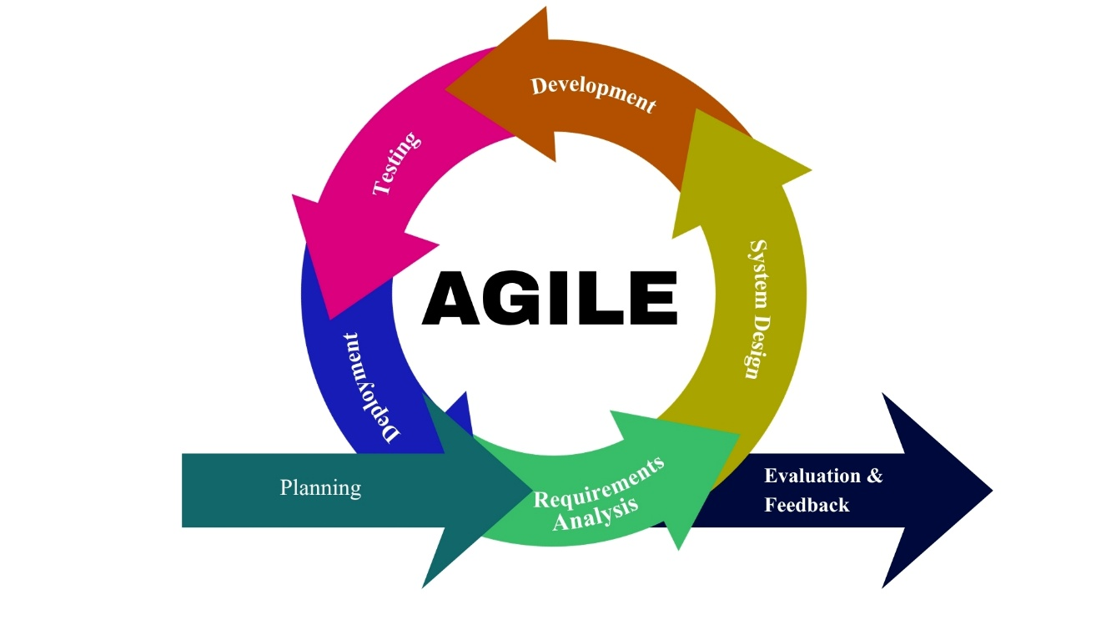
Figure 10. Agile diagram
Figure 10 illustrates the Agile Development Model adopted in the study, which emphasizes an iterative and flexible approach in developing the proposed system. The process begins with Project Planning, where the objectives, scope, and initial ideas of the system are defined. This is followed by Requirements Analysis, where necessary data and user needs are collected from stakeholders to ensure that the system addresses real-world problems encountered by the TFRO. Next is the System Design phase, where the overall architecture, database structure, and interface layout are carefully planned.
After designing, the Development phase takes place, where the actual coding and creation of system features are implemented. The system then undergoes Testing to identify and fix errors, ensuring functionality, accuracy, and reliability. Once the system is verified, it proceeds to Deployment, where it is introduced and used in the actual environment. Finally, Evaluation and Feedback are conducted to assess system performance and gather user insights for further improvements.
The circular flow of the Agile model highlights continuous improvement, allowing each phase to be revisited as needed. This ensures that the developed system remains adaptable, user-centered, and efficient in managing the operations of the Tricycle Franchising and Regulatory Office of Lucena City.

1.Project Planning
The system development planning phase served as the initial stage in the development of the proposed Integrated Management Information System (IMIS) for the Tricycle Franchising and Regulatory Office (TFRO) of Lucena City. During this phase, the researchers identified the objectives of the study and examined the existing procedures used by the TFRO in managing franchise records, operator and driver information, violation monitoring, and report preparation. Interviews and consultations with TFRO personnel were conducted to determine the system requirements and identify the problems encountered in the current process.
The researchers identified the hardware and software requirements of the implemented web system. Client devices require a modern browser and network connection. The interface uses HTML5, CSS3, and JavaScript; Supabase provides PostgreSQL, Authentication, Storage, Realtime, and Edge Functions; Chart.js supports graphs; PDF-Lib generates official forms; QRCode.js supports verification; and the service worker provides application caching and supported offline synchronization.
2. Requirement Analysis
The integrated Management Information System for the Tricycle Franchising and Regulatory Office (TFRO) of Lucena City aim to reduce the manual workload of employees and improve the efficiency of service delivery. By integrating digital technology into daily operations, the system addresses delays, data inconsistencies, and difficulties in managing franchise-related records. Furthermore, the system includes features such as automated report generation, centralized data storage, and real-time updating of records to support faster transactions and decision-making.
This section analyzes the current technical situation and the proposed system, discussing the hardware, software, and user requirements.

Current Technical Situation
The TFRO currently relies on a manual and semi-digital process in managing franchise applications, renewals, operator and driver information, violations, and payments. The office uses physical documents and folders for record-keeping, with some data stored in spreadsheets.
These challenges include:
- Time-consuming processing of franchise applications and renewals due to manual handling of documents
- Difficulty in retrieving records, especially when documents contain typographical errors or are misplaced
- Fragmented tracking of violations and compliance using receipts and release slips from different sub-offices
- Manual recording of payments handled by the treasurer’s office, increasing the risk of human error
- Dependence on printed documents for report generation
- Data duplication, inconsistency, and possible data loss due to lack of centralized storage
These issues result in delays, inefficiency, and increased operational workload for TFRO staff. Additionally, the absence of an integrated system limits the office’s ability to provide fast and reliable public service.
Figure 11 shows the current system workflow in the TFRO office. Issues identified in the current workflow include manual verification of records, lack of automation, and absence of a centralized database system that could enable faster retrieval and processing of information.
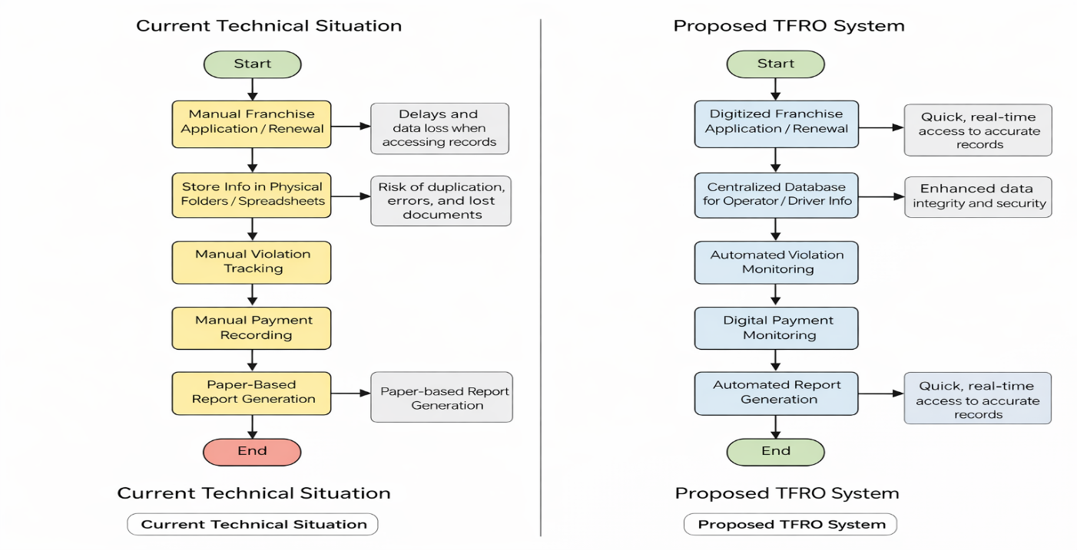
Figure 11. Current technical situation
Proposed TFRO System
The proposed Integrated Management Information System (IMIS) modernizes the current workflow by digitizing all major processes, including application, record management, violation tracking, and payment monitoring. The researchers utilized modern development tools and database systems to ensure efficiency, reliability, and scalability.
The features of the developed system include a user-friendly interface suitable for both computer-literate and non-computer-literate staff, ensuring ease of use and accessibility. The system eliminates slow manual processes by providing a centralized and secure database, reducing reliance on physical documents.
Additionally, the system supports real-time data updates, automated report generation, and improved tracking of franchise status, violations, and payments. It also provides organized data visualization that can assist TFRO in planning and decision-making.
The proposed system workflow is shown in Figure 12. The expected improvements include faster processing of applications, efficient retrieval of records, elimination of misplaced documents, reduced physical storage requirements, and protection of records from physical damage such as fire or natural disasters.
The system represents a significant step toward digital transformation, improving both administrative efficiency and public service delivery in TFRO.
Figure 12. Proposed TFRO system

Technical Requirements
Hardware Requirements
For system deployment and operation, a server or local workstation is required for database storage and processing. A minimum of 4GB RAM, 7000 series AMD Ryzen 5 processor, and standard desktop computers are recommended for smooth system performance. Printers may also be used for generating hard copies of reports when necessary.

Software Requirements
Development requires Visual Studio Code or a comparable editor, Git for version control, Node.js and npm for validation/build tasks, and a modern browser for testing. Operational data is stored in Supabase PostgreSQL rather than MySQL. The deployed system is compatible with current desktop and mobile browsers on Windows, Android, and other platforms with standards-compliant web support.

User Requirements
The system will be primarily used by TFRO personnel. Administrative access will be granted to authorized staff responsible for managing franchise applications, operator and driver records, violations, and payments. The system should be simple and intuitive to ensure usability even for staff with limited technical knowledge. Data input and retrieval should be controlled to maintain consistency, accuracy, and security of information.
The proposed TFRO system provides a structured, reliable, and efficient solution to the current manual processes. By integrating technology into daily operations, the system significantly improves record management, reduces errors, and enhances overall service efficiency. It ensures a faster, more organized, and secure approach to handling franchising and regulatory functions in Lucena City.

Requirement Documentation
The Integrated Management Information System (IMIS) for the Tricycle Franchising and Regulatory Office (TFRO) of Lucena City is a secure, role-based information system designed to automate the management of franchise applications, operator and driver records, violation monitoring, payment tracking, and report generation. The system centralizes regulatory data into a unified database to improve record accuracy, accessibility, and operational efficiency. By replacing manual and fragmented record-keeping practices, the system enhances service delivery, reduces processing delays, minimizes data redundancy, and strengthens monitoring and decision-making processes within the TFRO.

- Functional Requirements
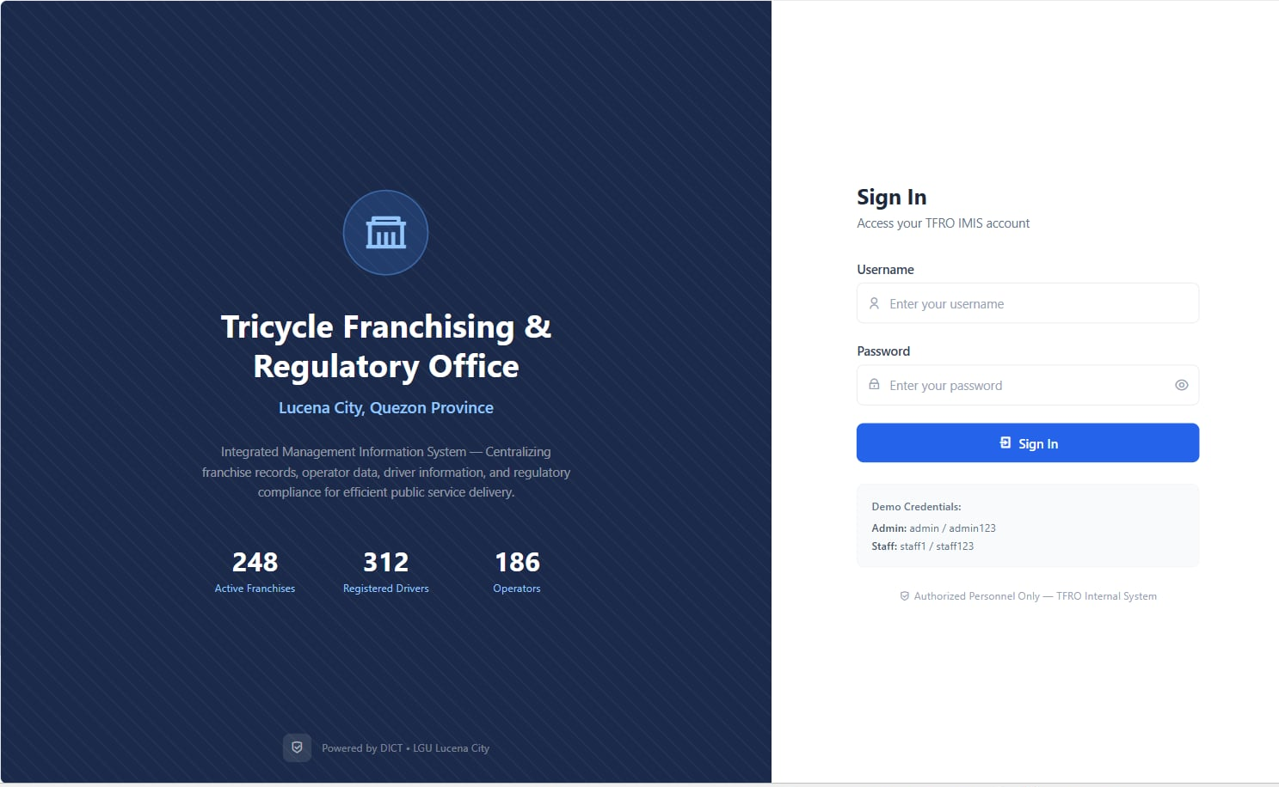
Figure 14. Login page

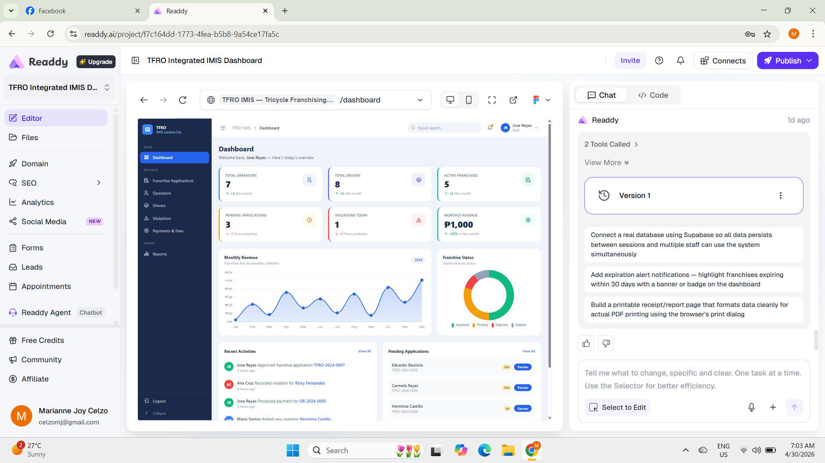
Figure 15. Admin dashboard

A. User Account Management
- Account creation for administrators and authorized TFRO personnel
- Role-based access control depending on user responsibilities
- Secure login and logout functionality
- Password update capability for account security
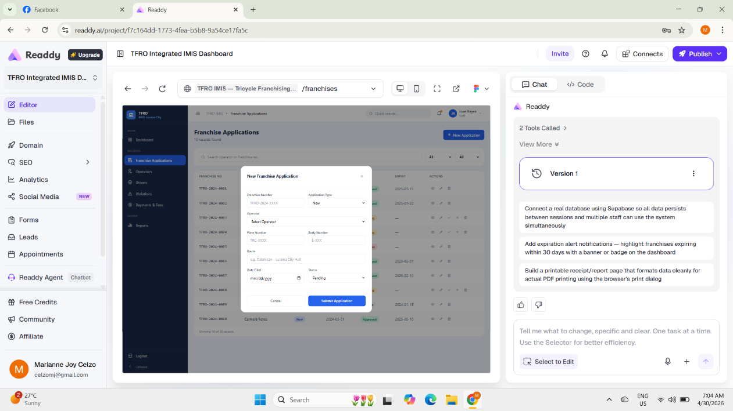
Figure 16. New franchise application

B. Franchise Application and Renewal Management
- Encoding of franchise application details
- Updating and renewal processing of franchise records
- Monitoring of franchise application status
- Verification and approval of submitted franchise records
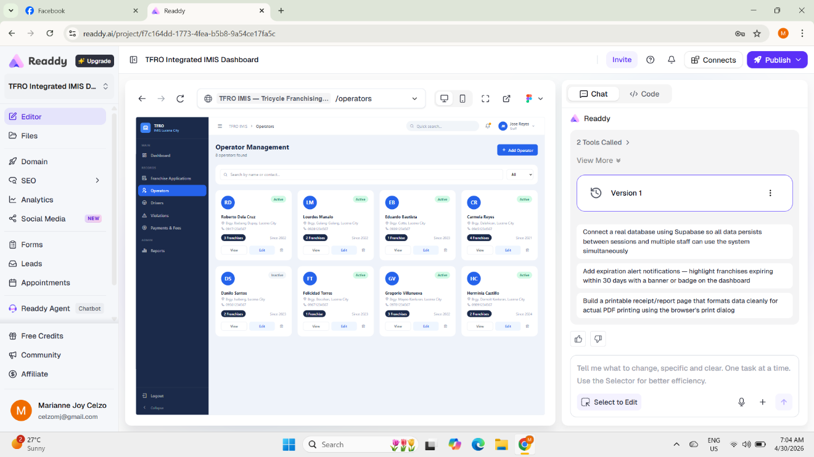
Figure 17. Operator management page

C. Operator Information Management
- Recording of operator personal information
- Updating operator records when necessary
- Searching and retrieval of operator data
- Organized storage of operator regulatory profiles
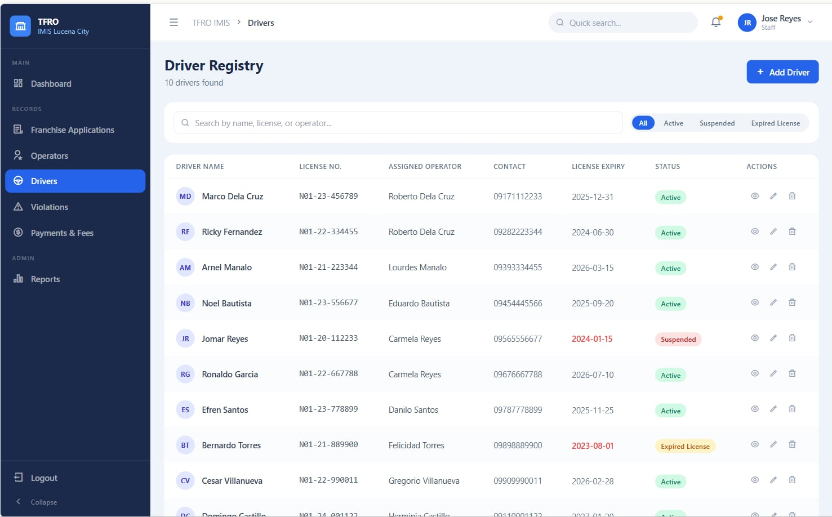
Figure 18. Driver registry
D. Driver Information Management
- Recording of driver personal and license information
- Updating driver records for regulatory compliance
- Searching and retrieval of driver information
- Organized storage of driver related documents
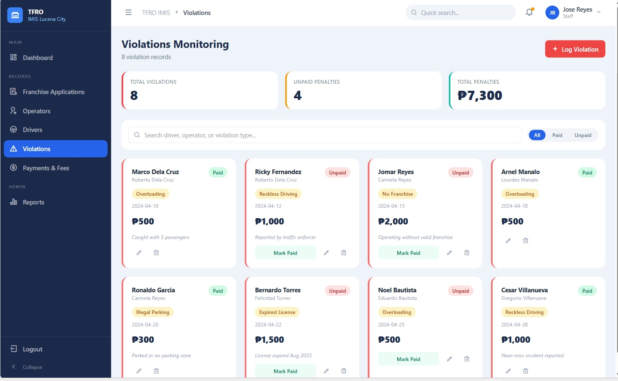
Figure 19. Violations monitoring

E. Violation Monitoring
- Recording of violations committed by operators and drivers
- Monitoring violation history
- Updating violation status and enforcement actions
- Retrieval of violation records for administrative reference
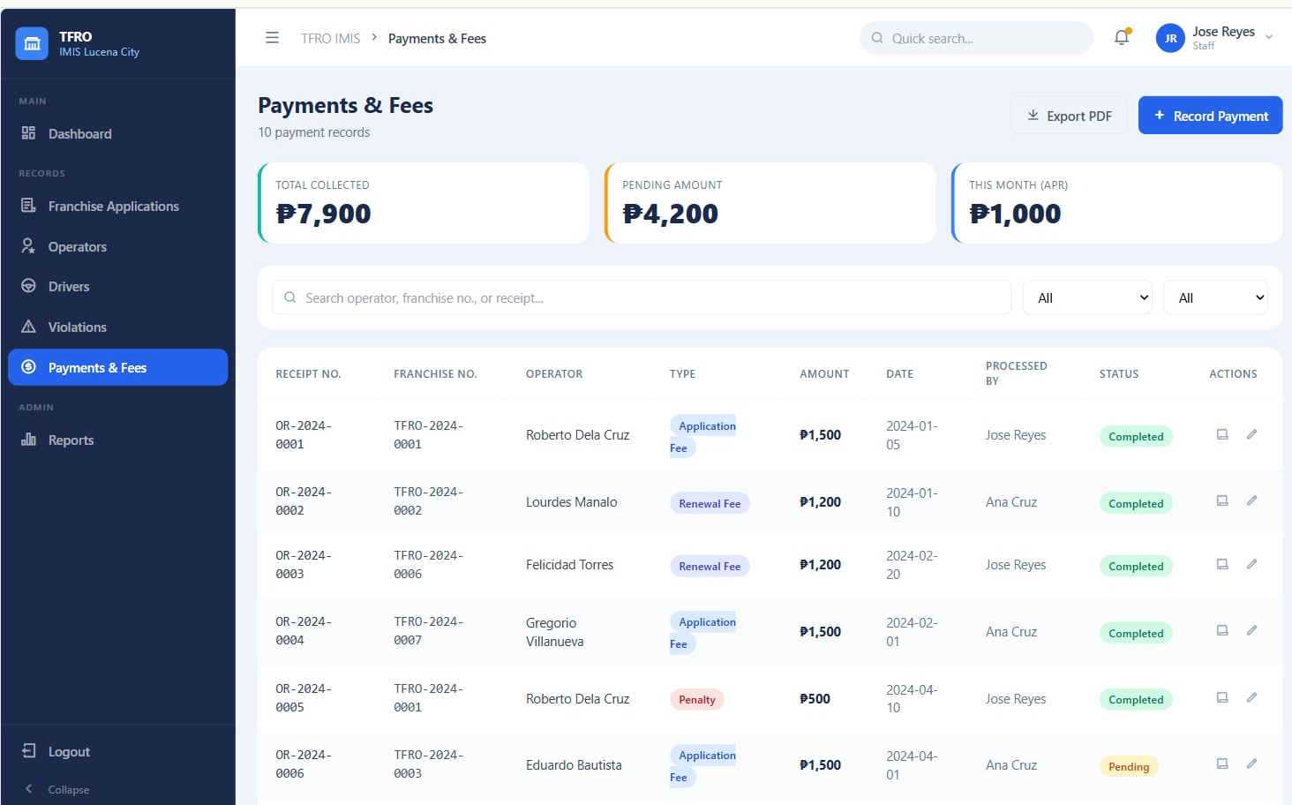
Figure 20. Payments & fees

F. Payment Recording and Tracking
- Recording payments related to franchise applications and renewals
- Tracking penalties and regulatory fees
- Monitoring payment transaction history
- Updating payment records when necessary
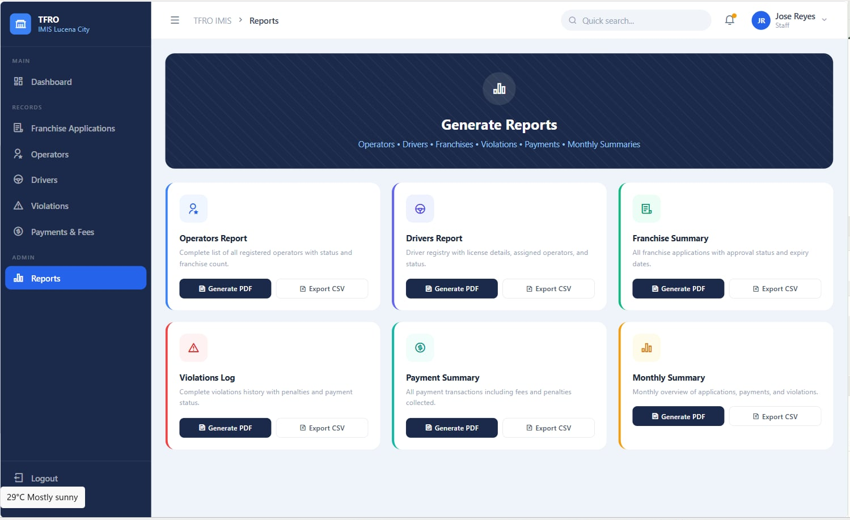
Figure 21. Generate reports
G. Report Generation
- Generation of franchise records reports
- Generation of operator and driver information reports
- Generation of violation monitoring reports
- Generation of payment transaction summaries
- Exporting reports for administrative use

2. Non-Functional Requirements
A. Functional Suitability
- The system shall perform all required functions for franchise application and renewal, operator and driver profiling, violation monitoring, payment recording, and report generation.
- The system shall provide accurate and complete outputs based on user inputs.

B. Performance Efficiency
- The system shall provide fast retrieval of franchise, operator, driver, violation, and payment records.
- The system shall process user requests efficiently to minimize transaction delays.
C. Compatibility
- The system shall operate properly on supported web browsers and devices used by TFRO personnel.
- The system shall maintain consistent functionality across different computing environments.
D. Usability (Interaction Capability)
- The system shall provide a user-friendly interface for TFRO personnel.
- The system shall allow easy navigation between system modules.
- The system shall support efficient data entry, editing, searching, and retrieval operations.
E. Reliability
- The system shall maintain accurate and consistent storage of regulatory information.
- The system shall ensure stable system operation during office hours and recover from minor errors without data loss.
F. Security
- The system shall restrict access through username and password authentication.
- The system shall implement role-based access privileges for administrators and authorized personnel.
- The system shall protect stored data from unauthorized access, modification, or deletion.
G. Maintainability
- The system shall allow updates and modifications without affecting existing data integrity.
- The system shall support future software maintenance, debugging, and feature enhancements.
H. Flexibility
- The system shall allow configuration and modification of system settings to accommodate changes in TFRO policies and procedures.
- The system shall support the addition of new features and regulatory requirements with minimal system disruption.
I. Safety
- The system shall validate user inputs to prevent invalid or duplicate records.
- The system shall minimize the risk of accidental data loss through proper error handling and data backup mechanisms.
3.System Design
Use case diagram represents the functional interactions between the different actors and the proposed system. It illustrates the primary operations performed within the Integrated Management Information System (IMIS) for the Tricycle Franchising and Regulatory Office (TFRO) of Lucena City, showing how users interact with the system to manage tricycle franchise-related records and services.

3.1 Use-case diagram
Figure 22 illustrates interactions among the Administrator, TFRO Staff, Traffic Enforcer, and Tricycle Operator. The Administrator and staff review applications, renewals, documents, payments, violations, forms, reports, accounts, and audit records. Traffic Enforcers submit tickets and manage their profiles, while Operators maintain their profiles, submit franchise and driver requirements, request motor changes and renewals, view recorded official files, and receive status notifications.

Figure 22. Use-case diagram
Figure 22 shows the implemented role-based use cases of TFRO-IMIS. All users authenticate through Supabase Auth and are routed according to their verified profile role. Administrators and TFRO Staff manage regulatory records and approvals; Traffic Enforcers submit violation tickets; and Operators submit and monitor franchise, driver, change-motor, and renewal transactions. Database policies, audit logs, notifications, and synchronized summaries support accountability and consistent information across roles.

3.2 Activity Diagram
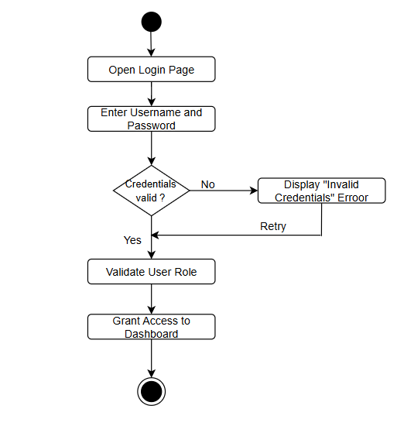
Figure 23. Login activity diagram
Figure 23 depicts the login and authentication process of the system. It starts when the user opens the login page and enters their username and password. The system then checks whether the credentials are valid. If invalid, an error message is displayed, and the user is prompted to retry. If valid, the system proceeds to validate the user’s role, ensuring proper access control. Once verified, access is granted to the appropriate dashboard. This diagram highlights the system’s security features, including credential validation, role-based access control, and user authentication, ensuring that only authorized personnel can access sensitive TFRO data and functionalities.
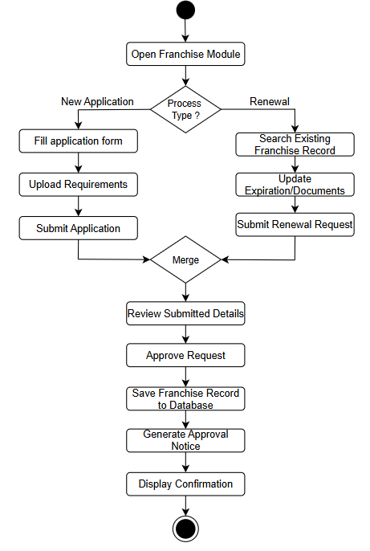
Figure 24. Manage franchise records activity diagram
Figure 24 presents the workflow for handling new franchise applications and renewal requests within the system. The process starts when the user opens the franchise module and selects the process type: new application or renewal. For new applications, the user fills out the application form, uploads requirements, and submits the application. For renewals, the system enables searching for an existing franchise record, updating expiration details and documents, and submitting a renewal request. Both paths merge into a unified review stage where submitted details are evaluated. Once approved, the system saves the franchise record to the database and generates an approval notice, followed by a confirmation display. This diagram emphasizes automation, streamlined processing, and improved service delivery for franchise management in the TFRO.
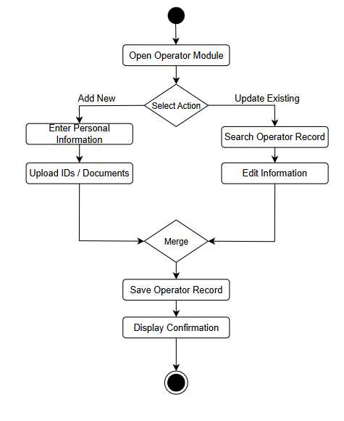
Figure 25. Manage operator information activity diagram
Figure 25 illustrates the process flow of the Operator Module in the developed system. It begins when the user opens the operator module and selects an action, either to add a new operator or update an existing record. In the “Add New” path, the user inputs personal information and uploads required identification or documents. In the “Update Existing” path, the system allows searching for an operator record and editing the stored information. Both processes converge into a merge point, ensuring that whether the record is new or updated, it undergoes a unified saving process. The system then saves the operator record in the database and displays a confirmation message. This diagram highlights the system’s ability to efficiently handle both data entry and updates while maintaining data consistency and integrity within the TFRO database.
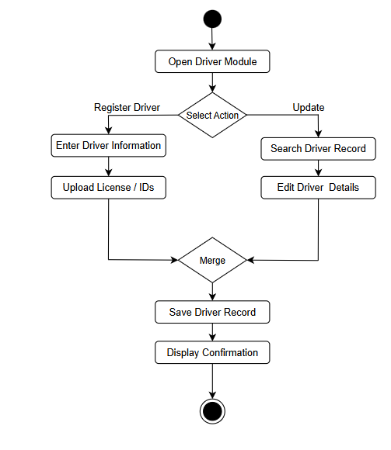
Figure 26. Driver information management activity diagram
Figure 26 shows the workflow for managing driver records, including both registration and updating processes. Upon opening the Driver Module, the user selects an action—either to register a new driver or update an existing record. For registration, the user enters driver information and uploads required documents such as licenses and identification. For updates, the system allows searching for an existing driver record and editing relevant details. Both processes converge into a unified stage where the system saves the driver record and displays a confirmation message. This workflow ensures efficient data management, accurate record-keeping, and proper documentation of drivers within the system.

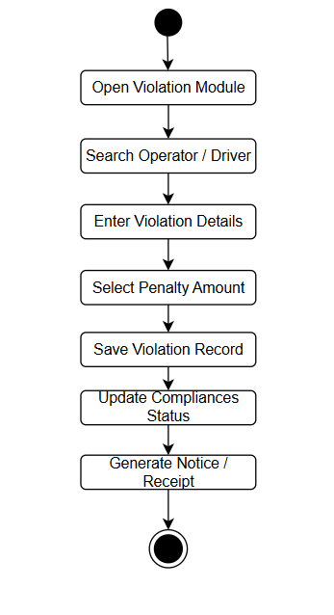
Figure 27. Manage violation records activity diagram
Figure 27 presents the process flow for recording and managing violations. The workflow starts with accessing the Violation Module, followed by searching for the operator or driver involved. The user then inputs the violation details, including the nature and specifics of the offense. Based on the violation, the system determines and assigns the corresponding penalty amount. Once finalized, the violation record is saved, and the compliance status of the operator or driver is updated accordingly. The process concludes with the generation of a notice or receipt, ensuring proper documentation and enforcement. This module enhances monitoring, accountability, and regulatory compliance.
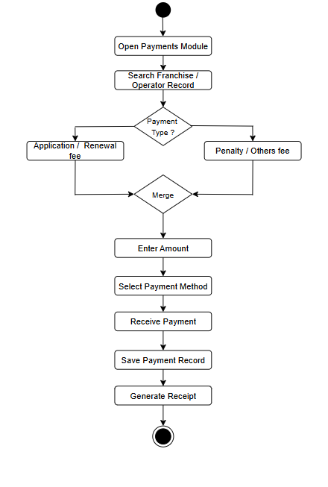
Figure 28. Record payments and fees activity diagram
Figure 28 illustrates the system workflow for handling payment transactions within the platform. The process begins when the user opens the Payments Module and searches for the corresponding franchise or operator record. The system then determines the type of payment, which may either be an application/renewal fee or penalties and other charges. After identifying the payment category, both paths merge into a unified process where the user enters the payment amount and selects the preferred payment method. The system proceeds to receive and validate the payment, securely stores the transaction record, and automatically generates an official receipt. This workflow ensures a streamlined, accurate, and traceable payment process within the system.
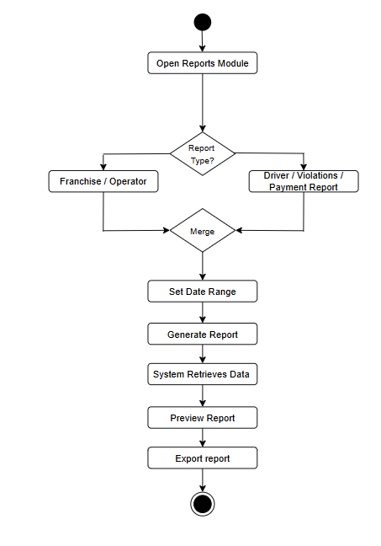
Figure 29. Generate reports activity diagram
Figure 29 The figure presents the workflow of the system’s Reports Module, illustrating how users generate reports in a structured and efficient manner. The process begins when the user opens the Reports Module and selects a report type, either Franchise/Operator or Driver Violations/Payment, after which both options converge into a unified process. The user then sets a specific date range to filter the data, followed by the system generating the report through automated data retrieval. The report is subsequently displayed for preview to allow verification, and once finalized, it can be exported for documentation or further use. This diagram highlights the system’s organized reporting process, emphasizing flexibility in report selection, accuracy in data handling, and user control throughout the report generation cycle.

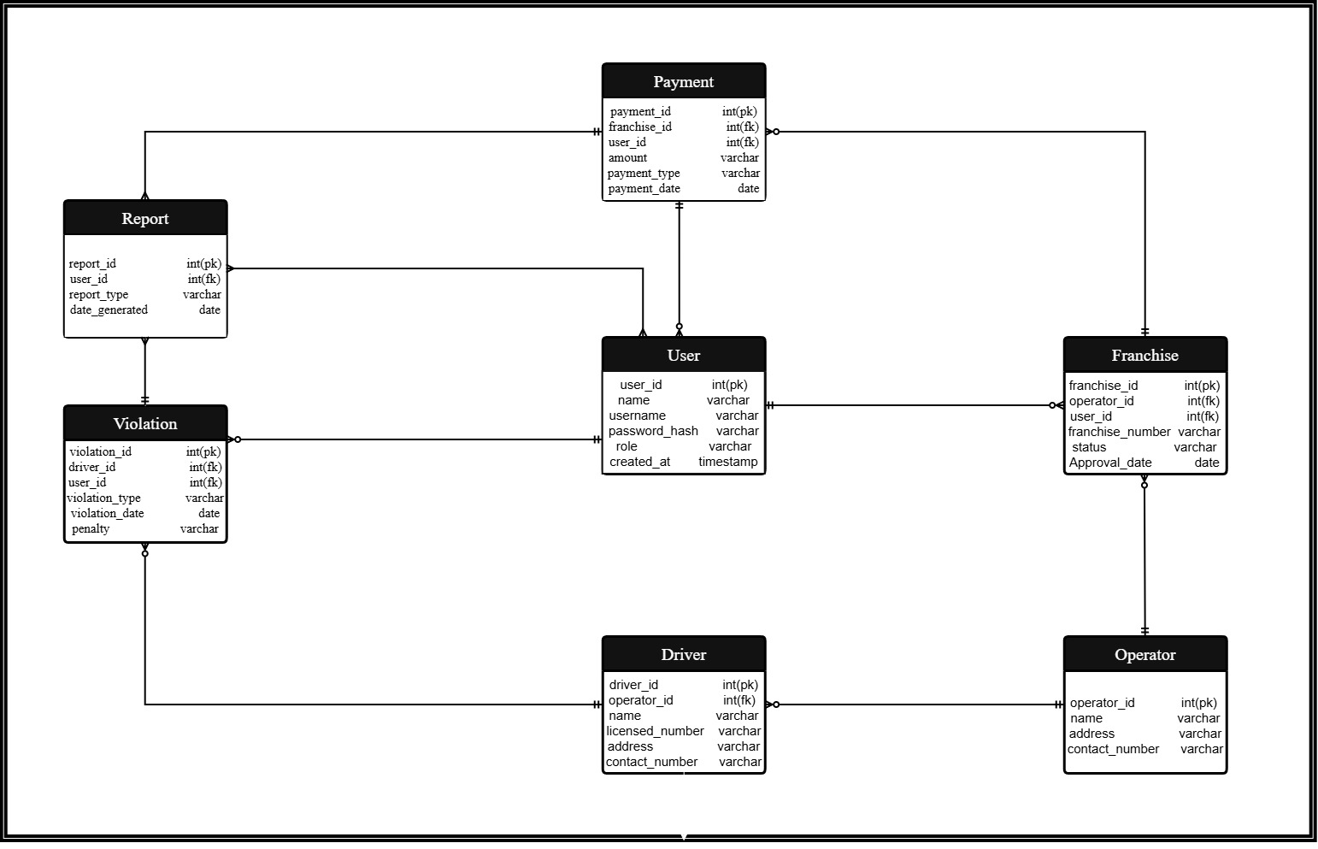
3.3 Data Workflow Diagram

Figure 30. Entity-relationship diagram
Figure 30 presents the implemented relational data model. Supabase Auth users connect to profiles that define the Administrator, Staff, Traffic Enforcer, and Operator roles. Operators link to franchises and drivers; applications and renewals link to their uploaded document records; violations connect drivers, operators, enforcers, payments, and issued forms; change-motor requests update approved franchise vehicle details; and notifications, delivered forms, settings, QR-verification records, and audit logs support communication, traceability, and access control. Foreign keys, constraints, triggers, indexes, and Row Level Security preserve consistency and authorized access.

4.Development
The development phase of the proposed Integrated Management Information System for the Tricycle Franchising and Regulatory Office (TFRO) of Lucena City will focus on translating the approved system design into a functional web-based application that supports franchise processing, operator and driver profiling, violation monitoring, payment recording, and report generation.
The researchers will develop the system using HTML, CSS, and JavaScript as the primary technologies for building the structure, layout, and interactive components of the system interface. The system will be coded and managed using Visual Studio Code (VS Code) as the development environment to ensure organized and efficient program implementation. Prior to actual system development, the interface layout and system prototype design will be created using Figma to visualize system structure and improve usability planning.
For database management and system integration, the implemented system uses Supabase. Its PostgreSQL database stores regulatory records, Supabase Auth manages verified accounts and sessions, Row Level Security enforces role and ownership rules, Storage protects uploaded requirements and profile images, Realtime refreshes selected administrative summaries, and Edge Functions handle protected server-side operations.
The system will include essential modules such as franchise registration and renewal management, operator profiling, driver profiling, violation monitoring, payment tracking, and automated report generation. Validation controls and user-access restrictions will be incorporated throughout the system to ensure accuracy, reliability, and protection of sensitive regulatory data. Continuous refinement will be conducted during development to ensure alignment with the operational workflow of the Tricycle Franchising and Regulatory Office of Lucena City.

5.Testing
The developed Integrated Management Information System will undergo Black Box Testing to verify whether the system performs according to its specified functional requirements. This testing method will evaluate the correctness of system outputs based on user inputs without examining the internal structure of the program.
Each major system module, including franchise processing, operator profiling, driver profiling, violation monitoring, payment recording, and report generation, will be tested individually and collectively to ensure proper functionality and integration. Test cases will be prepared for each module, and testing results will be recorded as either pass or fail based on expected system behavior.
Errors and inconsistencies identified during testing will be documented and corrected immediately to improve system performance and operational reliability. Selected technical evaluators with knowledge in information systems will participate in the testing process to ensure that the system functions effectively prior to deployment for user evaluation.
Through this testing procedure, the researchers will ensure that the developed system meets the functional requirements necessary to support the regulatory services of the Tricycle Franchising and Regulatory Office of Lucena City.

6. Deployment
The deployment phase involves making the Design and Development of an Integrated Management Information System for the Tricycle Franchising and Regulatory Office (TFRO) of Lucena City accessible to its intended users through the World Wide Web. During this stage, the completed system is published online, allowing administrators and staff to access it using standard web browsers without the need for additional installation. The frontend is hosted through GitHub Pages, while Supabase provides PostgreSQL data services, secure authentication, protected storage, realtime updates, and Edge Functions.
Furthermore, deployment includes final system configuration, data setup, and user account creation to ensure smooth operation. The system undergoes final testing to verify performance, security, and accessibility in a live environment. This phase ensures that the system is fully functional, scalable, and ready for actual use by the TFRO office, enabling efficient management of tricycle franchising and regulatory processes.

7. Evaluation
The developed Integrated Management Information System will be assessed to determine its level of acceptability using the ISO/IEC 25010 software quality standards. The evaluation will measure system performance in terms of functional suitability, performance efficiency, compatibility, usability, reliability, security, maintainability, flexibility, and safety.
A structured evaluation questionnaire based on a four-point Likert scale consisting of strongly agree, agree, disagree, and strongly disagree will be distributed to selected respondents composed of TFRO personnel, administrative staff, registered tricycle operators, and technical evaluators.
Prior to the conduct of evaluation activities, orientation sessions will be provided to respondents to familiarize them with the features and functions of the developed system. Respondents will then evaluate the Functional Suitability, Performance Efficiency, Compatibility, Interaction Capability, Reliability, Security, Maintainability, Flexibility and Safety of the system based on their interaction with the application.
The responses gathered during the evaluation process will be tabulated and analyzed using the weighted mean to determine the overall level of system acceptability. The results of the evaluation will serve as the basis for determining whether the proposed system satisfies the operational requirements of the Tricycle Franchising and Regulatory Office of Lucena City and meets recognized software quality standards.

Data Analysis Plan
The researchers will utilize both quantitative and descriptive statistical techniques to evaluate the functional performance and user acceptability of the proposed Integrated Management Information System for the Tricycle Franchising and Regulatory Office (TFRO) of Lucena City. These techniques will ensure that the developed system meets the required operational standards and supports the regulatory functions of the office.
To determine the functional correctness of the developed system, the researchers will conduct Black Box Testing using a Black Box Testing Checklist. This instrument will evaluate whether each module of the Integrated Management Information System performs according to its specified functional requirements without examining the internal program structure. The major modules to be tested include franchise application and renewal, operator profiling, driver profiling, violation monitoring, payment recording, and report generation. Each test case will be evaluated and recorded as Pass or Fail based on the expected system output. The overall functionality of the system will be computed using the following formula:
Formula:
$$\text{Percentage}=\left(\frac{\text{Number of Passed Test Cases}}{\text{Total Number of Test Cases}}\right)×100$$
Where:
Number of Passed Test Cases = Total number of test cases that produced the expected output
Total Number of Test Cases = Total number of test cases conducted
A passing rate of 95% or higher will indicate that the system has successfully met its functional requirements. If the passing rate falls below 95%, the researchers will revise, debug, and retest the system until the required level of functionality is achieved.
Following the successful completion of Black Box Testing, the researchers will conduct Performance Testing using a Performance Testing Questionnaire/Checklist. This instrument will assess the system's response time, processing speed, stability, and efficiency during normal operations. The results will be analyzed using descriptive statistics, particularly frequency counts and percentage, to determine whether the system performs efficiently and consistently under expected operating conditions.
To evaluate the overall quality and user acceptance of the developed system, the researchers will administer an ISO/IEC 25010 Acceptability Evaluation Questionnaire to the intended respondents. The questionnaire will assess the system based on the nine software quality characteristics: Functional Suitability, Performance Efficiency, Compatibility, Interaction Capability, Reliability, Security, Maintainability, Flexibility, and Safety. Each criterion will be rated using a 4-point Likert scale, interpreted as follows:

Numerical Equivalent | Range | Scale Description
4 | 3.26 – 4.00 | Highly Acceptable
3 | 2.51 – 3.25 | Acceptable
2 | 1.76 – 2.50 | Unacceptable
1 | 1.00 – 1.75 | Highly Unacceptable
The responses gathered from the acceptability questionnaire will be analyzed using the Weighted Mean, Average Weighted Mean (AWM), Median, and Mode. The Weighted Mean and Average Weighted Mean will determine the level of acceptability for each indicator and software quality characteristic, while the Median and Mode will describe the central tendency of the respondents' evaluations.
Formula:
$$\text{AWM}=\frac{∑(f×w)}{N}$$
Where:
f = Frequency of responses
w = Weight assigned to each response
N = Total number of respondents
The results obtained from these statistical treatments will serve as the basis for determining the system's functional correctness, performance efficiency, and overall acceptability in terms of Functional Suitability, Performance Efficiency, Compatibility, Interaction Capability, Reliability, Security, Maintainability, Flexibility, and Safety, ensuring that the proposed Integrated Management Information System effectively supports the operational requirements of the Tricycle Franchising and Regulatory Office (TFRO) of Lucena City.

Implementation plan
Table 4.
Implementation Plan Strategies of the System
Strategy | Activities | Persons Involved | Duration
Approval from City Offices | Secure endorsement and approval from TFRO Head, City Government Officials, and IT personnel | Proponents, TFRO Head, City Officials | 2 days
System Deployment | Installation of the system on authorized computers, database setup, and configuration | Proponents, TFRO Staff, IT Personnel | 2 days
Data Migration | Encoding and transfer of existing records (operators, drivers, franchises, violations, payments) into the system | Proponents, TFRO Staff | 3–5 days
System Testing | Conduct testing for system functionality, bug fixing, and validation of outputs | Proponents, Selected TFRO Staff | 2 days
Documentation Turnover | Provide system documentation including user manuals, technical guides, and maintenance plan | Proponents, TFRO Officials | 1 day
User Orientation | Conduct training and orientation for TFRO personnel, demonstration of system features and usage | Proponents, TFRO Staff | 1 day
System Implementation | Official launch and full utilization of the system in daily TFRO operations | TFRO Office, City Officials | 1 day

The system will be officially deployed at the Tricycle Franchising and Regulatory Office (TFRO) of Lucena City once all necessary revisions and testing have been completed. The proponents will turn over the final version of the Integrated Management Information System, along with complete documentation.
This documentation includes user manuals, installation guides, and maintenance procedures to ensure proper system usage and sustainability. Prior to full implementation, approval from the concerned city officials and TFRO management will be secured. Once approved, the outlined strategies in Table 4 will be carried out accordingly. The implementation of the system is expected to improve operational efficiency, reduce manual workload, and enhance the overall management of franchise records, violations, and payments within the TFRO.

Ethical Considerations
This study ensured adherence to ethical principles to protect respondents’ rights, maintain integrity, and uphold research standards. The following ethical considerations were observed in conducting the capstone project:
All participants involved in the study were provided with a clear explanation of the research objectives, procedures, and their respective roles in the development of the system. Informed consent was obtained prior to their participation, ensuring that their involvement was voluntary and based on a full understanding of the study. The identities of respondents, including TFRO personnel, operators, and drivers, were safeguarded to prevent unauthorized access or disclosure of information. All collected data were handled with strict confidentiality and used solely for academic and system development purposes. The study also ensured that participants were not exposed to any form of physical, emotional, or professional harm during interviews, data gathering, and system evaluation.
Moreover, selected respondents, including office personnel and system users, were carefully chosen based on their relevance and involvement in the Tricycle Franchising and Regulatory Office (TFRO) operations to ensure fair and accurate evaluation of the system. The researchers ensured that all findings, methodologies, and system performance results were presented truthfully, without bias, fabrication, or manipulation. All references, software tools, and related studies used in the development of the Integrated Management Information System were properly cited to uphold academic integrity and avoid plagiarism.
Furthermore, the study adhered to the research policies and guidelines of Southern Luzon State University and complied with applicable national standards on ethical research practices, including data privacy and protection principles. These ethical considerations ensured the responsible conduct of the study and supported the development of a secure, reliable, and user-centered Integrated Management Information System for the Tricycle Franchising and Regulatory Office (TFRO) of Lucena City, while maintaining professionalism and integrity throughout the research process.

REFERENCES CITED
Adeoye, M. A. (2023). Management information system: Tools for achieving administrative effectiveness in private universities. Indonesian Journal of Multidisciplinary Research, 3(1). https://doi.org/10.17509/ijomr.v3i1.48429
Albano, H. (2024). Empowering local government units with open-source tools: Building a dynamic web-based information system. Journal of Engineering, Computing and Technology. https://www.isujournals.ph/index.php/ject/article/view/19
Anto, A., Mappasere, F. A., Abdi, A., & Alyas, A. (2025). The role of e-government in improving efficiency and transparency in public services in Indonesia. KnE Social Sciences, 10(16), 92–106. https://doi.org/10.18502/kss.v10i16.19157
Azuddin, M., Yusup, M., Setiyowati, H., Wibowo, S., Suwita, J., Basuki, S., & Astuti, E. D. (2025). Design and implementation of a relational database for an academic information system. International Transactions on Artificial Intelligence (ITALIC), 3(2), 171–180. https://doi.org/10.33050/italic.v3i2.801
Bansal, D. (2025). Developing Dynamic Web Applications with PHP and MySQL. International Journal of Inventions in Engineering & Science Technology, 11(1), 10–15. https://doi.org/10.37648/ijiest.v11i01.002
Cai, C.-H., Sun, J., & Dobbie, G. (2020). Measuring the quality of B abstract machines with ISO/IEC 25010. arXiv. https://arxiv.org/abs/2003.02619
Calibo-Senit, D. I. (2026). An academic extension-driven solution for enhancing local governance. ASEAN Journal of Scientific and Technological Reports, 29(3). https://doi.org/10.55164/ajstr.v29i3.261914
Chen, H., Chiang, R. H. L., & Storey, V. C. (2021). Business intelligence and analytics: From big data to big impact. IEEE Access, 9, 3051234. https://doi.org/10.1109/ACCESS.2021.3051234
Choina, M., & Skublewska-Paszkowska, M. (2022). Performance analysis of relational databases MySQL, PostgreSQL and Oracle using Doctrine libraries. Journal of Computer Sciences Institute, 24, 250–257. https://doi.org/10.35784/jcsi.3000
Chougale, A., et al. (2022). Firebase and real-time database management for scalable applications. International Journal of Computer Applications. https://www.ijcaonline.org/
Del Sole, A. (2023). Visual Studio Code and modern software development workflows. Microsoft Learn. https://learn.microsoft.com/en-us/training/
DeLone, W. H., & McLean, E. R. (2020). The DeLone and McLean model of information systems success: A ten-year update and extension. International Journal of Information Management, 52, 102205. https://doi.org/10.1016/j.ijinfomgt.2020.102205
Dubey, R., et al. (2024). JavaScript frameworks and their impact on web application performance. Journal of Software Engineering and Applications. https://www.scirp.org/journal/jsea/
Dwivedi, Y. K., Rana, N. P., Chen, H., & others. (2020). Technology adoption research: A review of theories, frameworks and future directions. Telecommunications Policy, 44(10), 101447. https://doi.org/10.1016/j.tele.2020.101447
Garcia, A. P., De La Vega, S. F., & Mercado, S. P. (2022). Health information systems for older persons in select government tertiary hospitals and health centers in the Philippines: Cross-sectional study. Journal of Medical Internet Research, 24(2), e29541. https://www.jmir.org/2022/2/e29541
Gesmundo, J. L., Glorioso, R. R. B., Raviz, K. J., & Apat, E. J. C. (2022). Records management strategies and professional performance of administrative staff. International Journal of Academe and Industry Research, 3(1), 70–92. https://doi.org/10.53378/352858
Green, T., & Brandon, K. (2024). UX Design with Figma. In Design Thinking. https://doi.org/10.1007/979-8-8688-0324-6
Guillen, M. D. V., Gaspay, S. M., Mateo-Babiano, I., & Schneck, J. a. T. (2025). Formalizing the informal in public transportation: The case of motorcycle taxis transport network service in the Philippines. Research in Transportation Economics, 115, 101681. https://doi.org/10.1016/j.retrec.2025.101681
Gupta, K. P., Singh, S., & Bhaskar, P. (2020). E-government adoption and impact on public service delivery: A systematic literature review. Government Information Quarterly, 37(4), 101571. https://doi.org/10.1016/j.giq.2020.101571
Gupta, P., et al. (2022). HTML5 and CSS3 in modern responsive web design. International Journal of Advanced Computer Science and Applications. https://thesai.org/Publications/IJACSA
Haindl, P., Hoch, T., Dominguez, J., Aperribai, J., Ure, N. K., & Tunçel, M. (2022). Quality characteristics of a software platform for human-AI teaming in smart manufacturing. arXiv. https://arxiv.org/abs/2205.15767
Han, S., Sinha, R., & Lowe, A. (2021). Assessing support for industry standards in reference medical software architectures. arXiv. https://arxiv.org/abs/2107.08185
Huang, L. (2024). Enhancing UI/UX design through Figma in modern development workflows. Journal of Digital Design and Interaction. https://www.figma.com/resources/
Ibrahim, M., Emmanuel, C., Yeboah, D., & Kumah, A. (2025). The influence of digital technologies on quality service delivery in the public sector: The mediating role of service expectation. Future Business Journal, 11, 158. https://link.springer.com/article/10.1186/s43093-025-00579-7
ISO/IEC. (2011). Systems and software engineering — Systems and software quality requirements and evaluation (SQuaRE) — System and software quality models (ISO/IEC 25010). International Organization for Standardization. https://www.iso.org/standard/35733.html
Kim, J., & Park, S. (2021). Progressive Web Applications and modern web performance optimization. Journal of Internet Technologies. https://www.sciencedirect.com/
McGrath, M. (2020). HTML fundamentals and web structure development. Web Development Journal. https://developer.mozilla.org/en-US/docs/Web/HTML
Nwinyokpugi, P. N., & Bestman, N. (2020). The E-Governance application: Improving the administrative efficiency of public sector in Rivers State, Nigeria. GPH-International Journal of Computer Science and Engineering, 3(02), 06–18. https://gphjournal.org/index.php/cse/article/view/268
Pabatang-Hussien, E. (2023). Service delivery through e-governance: The case of highly urbanized cities in northern Mindanao, Philippines. E3S Web of Conferences, 440, 01012. https://doi.org/10.1051/e3sconf/202344001012
Padilla, A. T. (2025). Enhancing local governance in Surigao del Norte through Barangay Connect: A total management information system for Barangays. Journal of Information Systems Engineering & Management, 10(27s), 260–279. https://doi.org/10.52783/jisem.v10i27s.4405
Paul, S. (2020). The evolution and importance of the World Wide Web in modern systems. International Journal of Information Systems. https://www.sciencedirect.com/
Perez, R. E., Ng, A. C. L., & Tiglao, N. C. C. (2021). Enhancing policy capacity through co-design: The case of local public transportation in the Philippines. Policy Design and Practice, 5(1), 103–121. https://doi.org/10.1080/25741292.2021.1930689
Puspaningrum, A. S., Rochimah, S., & Akbar, R. J. (2017). Functional suitability measurement using goal-oriented approach based on ISO/IEC 25010 for academic information system. Journal of Information Systems Engineering and Business Intelligence, 3(2), 68–74. https://doi.org/10.20473/jisebi.3.2.68-74
Sarwosri, S., Rochimah, S., Yuhana, U. L., & Hidayat, S. B. (2023). Software quality measurement using ISO 25010. Journal of Software Engineering Research. https://www.researchgate.net/
Singh, A., et al. (2022). Web scalability and backend integration for modern applications. Journal of Cloud Computing and Web Services. https://link.springer.com/
Singh, J., & Goraya, M. S. (2023). An Autonomous Multi-Agent Framework using Quality of Service to prevent Service Level Agreement Violations in Cloud Environment. International Journal of Advanced Computer Science and Applications, 14(3). https://doi.org/10.14569/ijacsa.2023.0140325
Speicher, M. (2015). What is usability? A characterization based on ISO 9241-11 and ISO/IEC 25010. arXiv. https://arxiv.org/abs/1502.06792
Stack Overflow. (2023). Developer survey 2023. https://survey.stackoverflow.co/2023/
Talabis, D. A. S., Babierra, A. L., Buhat, C. A. H., Lutero, D. S., Quindala, K. M., & Rabajante, J. F. (2021). Local government responses for COVID-19 management in the Philippines. BMC Public Health, 21, 1711. https://doi.org/10.1186/s12889-021-11746-0
Takain, I., & Katmini, K. (2021). The implementation of computer based administrative information systems to improve the performance of services quality in hospitals. Journal for Quality in Public Health, 5(1), 203–216. https://doi.org/10.30994/jqph.v5i1.275
Touray, R. (2021). A review of records management in organisations. OALib, 08(12), 1–23. https://doi.org/10.4236/oalib.1108107
Tulsyan, V., et al. (2024). JavaScript frameworks and efficient web development practices. Journal of Computing and Information Technology. https://www.sciencedirect.com/
Vial, G. (2020). Understanding digital transformation: A review and a research agenda. Journal of Strategic Information Systems, 29(2), 101640. https://doi.org/10.1016/j.jsis.2020.101640
Yamoah, L. E., Attafuah, E. D., & Nketia, M. O. (2024). The impact of management information systems on organizational performance. International Journal of Research and Scientific Innovation (IJRSI), 11(9), 872–885. https://doi.org/10.51244/IJRSI.2024.1109074

APPENDICES

Appendix A
RESEARCH INSTRUMENTS
PERFORMANCE TESTING

“E-TFRO: AN INTEGRATED MANAGEMENT INFORMATION SYSTEM FOR THE TRYCICLE FRANCHISING AND REGULATORY OFFICE (TFRO) OF LUCENA CITY”

Name: __________________________________________ Date: ___________________

Platform: Visual Studio Code Website Title: E-TFRO
Version: 1.0 Developers: Marianne Joy G. Celzo
Aerol Joshua R. Domirez

General Information
The E-TFRO: An Integrated Management Information System for the Tricycle Franchising and Regulatory Office (TFRO) of Lucena City is designed to modernize and digitalize the operations of the TFRO. The system provides an integrated and automated platform that supports franchise application and renewal processing, operator and driver records management, violation monitoring, payment tracking, and report generation.
The system serves three (3) types of users: (1) TFRO Administrators and Staff, who manage and oversee all franchise-related transactions; (2) Tricycle Operators, who can submit franchise applications, monitor application status, and view their franchise details; and (3) Drivers, who can access their driver records, monitor their compliance status, and view relevant franchise information.

Instructions
This questionnaire aims to evaluate the effectiveness and efficiency of the E-TFRO system based on its specific system capabilities. Please indicate your level of agreement by placing a check mark (✓) in the appropriate column. All responses will be kept strictly confidential.

Test | Features | Result
Test | Features | Passed | Failed
Login & User Access | Verifies user credentials and ensures that administrators, operators, and drivers are directed to their respective dashboards with secure access.
Admin and Staff Dashboard | Provides administrators and staff with system control, including processing franchise applications, managing user records, monitoring violations, tracking payments, and generating reports.
Operator Dashboard | Allows operators to monitor application status, and view franchise details and requirements.
Driver Dashboard | Enables drivers to access their records, monitor compliance status, and view franchise-related information.
Franchise Application & Renewal Module | Facilitates the digital submission, evaluation, approval, and renewal of franchise applications.
Operator Information Management | Securely stores and manages operator profiles, identification documents, and related records.
Driver Record Management | Maintains organized driver records, including licenses and other required documents for verification.
Violation & Compliance Monitoring | Tracks violations and monitors compliance with transportation rules and regulations.
Payment & Fee Tracling | Records and monitors all payments, fees, penalties, and transaction history within the system.
Report Generation | Generates accurate and timely reports for administrative and regulatory purposes.
Appendix B
ACCEPTABILITY EVALUATION

Name: __________________________________________ Date: ___________________
(Optional)

General Description:
This evaluation form is designed to gather feedback on the developed Integrated Management Information System (IMIS) for the Tricycle Franchising and Regulatory Office (TFRO) of Lucena City. It aims to identify strengths and areas for improvement to ensure that the system is efficient, user-friendly, secure, and adaptable to the operational needs of the office.
INSTRUCTION: Please evaluate the system using the given scale by checking the corresponding numerical rating indicated below:
4 – Highly Acceptable (HA)
3 – Acceptable (A)
2 – Unacceptable (U)
1 – Highly Unacceptable (HU)

System Requirements | Specification System Features | HA  (4) | A  (3) | U  (2) | HU  (1)
Functional Suitability | 1. Functional Completeness  The system provides all necessary features such as user login, franchise application and renewal processing, operator and driver registration, violation monitoring, payment tracking, and report generation required by the TFRO.  (Naibibigay ng sistema ang lahat ng kinakailangang feature tulad ng login, pagproseso ng prangkisa, rehistrasyon ng operator at driver, monitoring ng paglabag, at paggawa ng ulat.)
Functional Suitability | 2. Functional Correctness  The system ensures that all stored and displayed data such as franchise records, operator information, and violation details are accurate, consistent, and free from errors.  (Tinitiyak ng sistema na ang lahat ng datos tulad ng franchise records at impormasyon ng operator ay tama, pare-pareho, at walang mali.)
Functional Suitability | 3.Functional Appropriateness  The system performs tasks efficiently by simplifying processes and eliminating unnecessary manual steps in record management and reporting.  (Ginagawa ng sistema ang mga gawain sa mas mabilis at maayos na paraan sa pamamagitan ng pagbawas ng manu-manong proseso.)

Performance Efficiency | 1.Time Behavior  The system responds quickly when retrieving  records, processing transactions, and  generating reports, minimizing delays in office  operations.  (Mabilis tumugon ang sistema sa pagkuha ng  records at paggawa ng ulat kaya  nababawasan ang pagkaantala sa trabaho.)
Performance Efficiency | 2. Resource Utilization  The system uses system resources efficiently and does not slow down devices during operation.  (Hindi mabigat sa memory at processing ang sistema kaya maayos itong gumagana.)
Performance Efficiency | 3. Capacity  The system can support multiple users and large  volumes of data without affecting performance.  (Kaya ng sistema ang maraming gumagamit at  datos nang hindi bumabagal ang performance.)

Compatibility | 1.Co-existence  The system operates smoothly alongside other office software without conflicts or interruptions.  (Maayos na gumagana ang sistema kahit may kasabay na ibang software.)
Compatibility | 2. Interoperability  The system effectively shares and integrates data across modules such as franchise records, violations, and reports.  (Maayos ang palitan at paggamit ng datos sa iba’t ibang bahagi ng sistema.)

Interaction Capability | 1. Appropriateness Recognizability  Users can easily understand that the system is designed for TFRO operations and regulatory management.  (Madaling maintindihan na ang sistema ay para sa pamamahala ng TFRO.)
Interaction Capability | 2.Learnability  Users can quickly learn how to use the system with minimal training.  (Mabilis matutunan ng gumagamit ang paggamit ng sistema.)
Interaction Capability | 3.Operability  The system interface is user-friendly and easy to navigate.  (Madaling gamitin at i-navigate ang sistema.)
Interaction Capability | 4. User Error Protection  The system prevents incorrect data entry through validation and error messages.  (Pinipigilan ng sistema ang maling input gamit ang validation at error messages.)
Interaction Capability | 5. User Engagement  The system has an organized and visually appealing interface that enhances user experience.  (Maayos at kaaya-aya ang disenyo ng sistema.)
6. Inclusivity
The system can be used by individuals with different levels of technical knowledge.
(Magagamit ang sistema kahit ng mga may iba’t ibang antas ng kaalaman sa teknolohiya.)

7. User Assistance
The system provides guides, prompts, or help features for users.
(May gabay o tulong ang sistema para sa mga gumagamit.)

8. Self-Descriptiveness
Each function is clearly labeled and easy to understand without additional explanation.
(Malinaw ang bawat function ng sistema kahit walang paliwanag.)

Reliability | 1.Faultlessness  The system operates without errors during normal usage.  (Walang error ang sistema habang ginagamit.)
Reliability | 2.Availability  The system is accessible whenever needed by authorized users.  (Magagamit ang sistema anumang oras.)
Reliability | 3.Fault Tolerance  The system continues to function despite minor errors.  (Patuloy na gumagana kahit may maliit na error.)
Reliability | 4. Recoverability  The system can restore lost data after interruptions or failures.  (Kayang maibalik ang datos kapag nagkaroon ng aberya.)

Security | 1.Confidentiality  The system protects sensitive data such as personal and franchise records from unauthorized users.  (Pinoprotektahan ang sensitibong impormasyon laban sa hindi awtorisadong access.)
Security | 2.Integrity  Data cannot be altered without proper authorization.  (Hindi mababago ang datos nang walang pahintulot.)
Security | 3.Accountability  User activities are recorded for monitoring and auditing purposes.  (Naitatala ang aktibidad ng gumagamit para sa monitoring.)
Security | 4. Authenticity  User identities are verified through secure login credentials.  (Tinitiyak ang pagkakakilanlan ng gumagamit sa pamamagitan ng login.)
Security | 5. Resistance  The system can resist cyber threats and unauthorized access attempts.  (Kayang labanan ng sistema ang mga banta sa seguridad.)

Maintainability | 1.Modularity  System components are organized and can be updated independently.  (Maaaring i-update ang bawat bahagi ng sistema nang hiwalay.)
Maintainability | 2.Reusability  Some system components can be reused in future development.  (Maaaring magamit muli ang ilang bahagi ng sistema.)
Maintainability | 3.Analysability  System issues can be easily identified and resolved.  (Madaling matukoy at ayusin ang problema.)
4. Modifiability
The system can be modified without affecting other features.
(Madaling baguhin ang sistema nang hindi naaapektuhan ang ibang bahagi.)

5. Testability
System updates can be tested efficiently.
(Madaling subukan ang mga update ng sistema.)

Flexibility | 1. Adaptability  The system can adjust to different devices and user needs.  (Nakakaangkop ang sistema sa iba’t ibang device at pangangailangan.)
Flexibility | 2. Scalability  The system can handle increasing users and data over time.  (Kayang suportahan ang pagdami ng users at data.)
3. Installability
The system can be installed and deployed easily.

(Madaling i-install ang sistema.)
4. Replaceability
The system can be updated or replaced without losing data.

(Maaaring palitan o i-update ang sistema nang hindi nawawala ang datos.)

Safety | 1. Operational Constraint  The system operates within safe limits and avoids system misuse.  (Ligtas ang operasyon ng sistema at iwas sa maling paggamit.)
Safety | 2. Risk Identification  The system can identify possible risks such as data loss or errors.  (Natutukoy ang mga posibleng panganib tulad ng pagkawala ng datos.)
Safety | 3. Fail Safe  The system ensures safe operation during failures.  (May proteksyon ang sistema kapag nagka-error.)
Safety | 4. Hazard Warning  The system provides alerts for errors and issues.  (Nagbibigay ng babala ang sistema kapag may problema.)
Safety | 5. Safe Integration  The system remains stable when integrated with updates or other systems.  (Nananatiling ligtas kahit may integration o update.)

Comments and Recommendations:
________________________________________________________________________________________________________________________________________________________________________________________________________________________________________________________________________________________________________________________________________________________________________

Signature

UPDATED SYSTEM DIAGRAMS
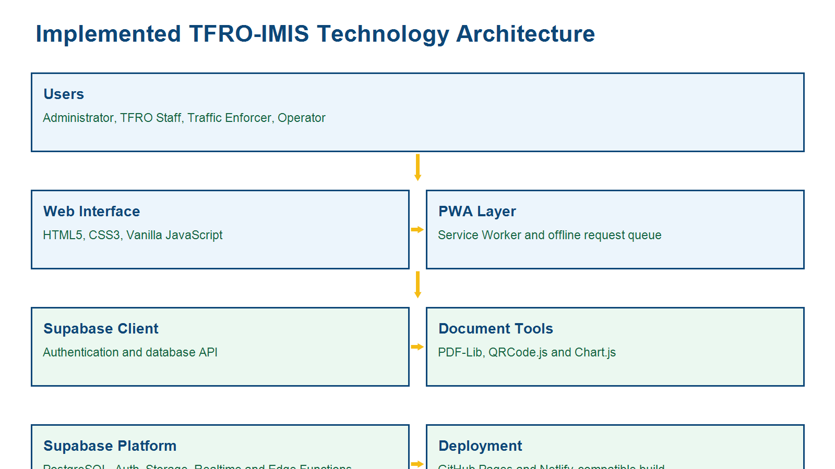
Figure A. Implemented TFRO-IMIS Technology Architecture
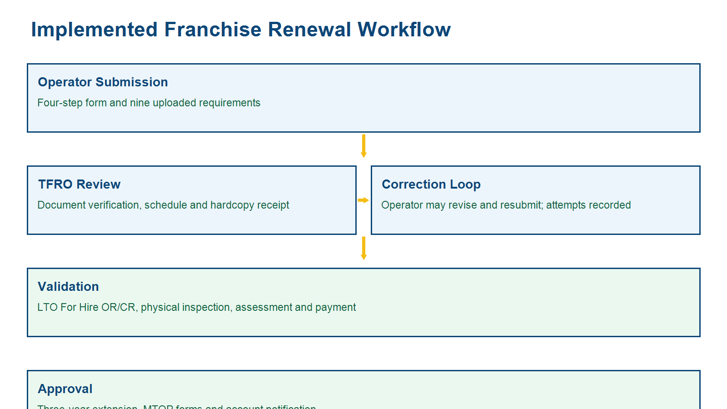
Figure B. Implemented Franchise Renewal Workflow

