Task 2: Eyelid Gestures for people with Motor Impairments

Scribing by Aryan Gaurav 2020CS10327 Presentation by Atharva Dabli and Shreyansh Singh

# Introduction

The presentation starts with the results of a census held in 2011, which stated that there are nearly 26.8 million people with disabilities in India, making up to a total of somewhat 2.21 percent of the total population. Some of these disabilities pose major difficulties in communication and controlling the day-to- day activities. And so, the major problem to solve here is to improve the human- computer and human-human interaction for people with motor impairments.

The presentation then moves on to talk about the existing technologies like eye-trackers, brain- computer interfaces, mechanical devices like joysticks, heavy, intrusive and expensive supports like *text entry* etc. and how there is a need to bring in simple and cheap installations to make improvements in the inter- actions. That’s where the main *theme* of the paper is introduced, i.e., **eyelids** and their movements and how these movements can be used to make a variety of *gestures*, which in turn, can be combined in a number of ways, creating a whole new system of interaction. The presentation talks about the eyelid ges- ture design, algorithm to detect these gestures and how they are applicable in real life scenarios.

# Eyelid Gesture Design

The Design consists of **4 Eyelid States** namely:

* + both eyelids open (O)
  + both eyelids closed (B)
  + only right eyelid closed (R)
  + only left eyelid closed (L)

Along with states, the *duration* of the states is also taken into account, both

*short* and *long* which can be adjusted according to the user. *’Both eyelids*

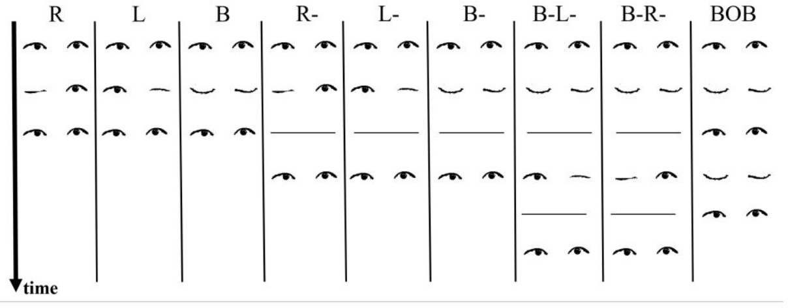

Figure 1: Eyelid Gesture Design

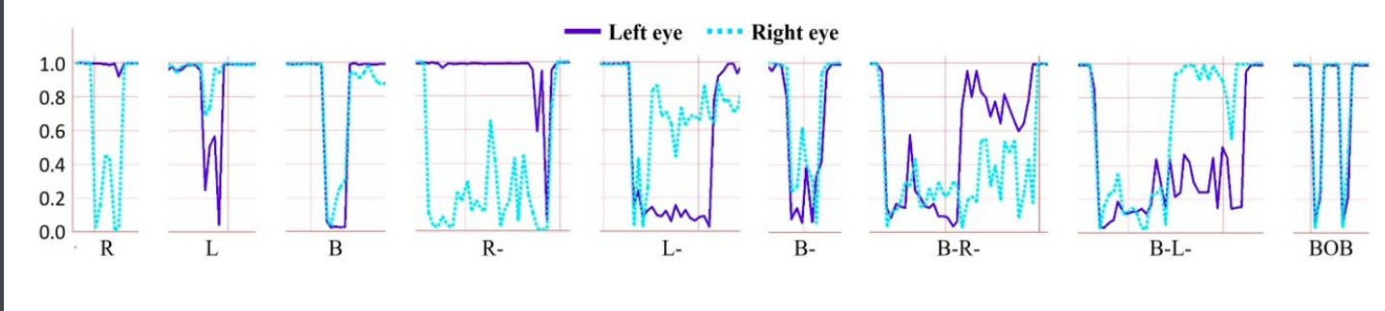

Figure 2: Probabilities and Noises

*open’(O)* is used as a gesture delimiter, to mark the start and end of a gesture (works like a full stop at the end of a sentence).

After this, we take a look at the **9 eyelid gestures** that the algorithm detects. These are: *R, L, B, R-, L-, B-, B-L-, B-R-, BOB*. The letters have the meanings as stated above. *′ ′* means long duration else, short duration. (Figure 1)

*−*

# Algorithm: Recognizing the Eye Gesture

Now, to recognize these eye gestures, images are collected from the front cam- era of the phone and stream of **probability pairs** (for each gesture) of each eye being open are generated, in the form of a tuple **(***PL, PR***)** with time, using Google Mobile Vision *API*. Noises/ irregularities are observed in the proba- bility streams, mainly when one eye is open and the other one is closed. It is observed that when one eye is closed, the probability of other eye being open also decreases.

(*PL, PR*) is continuously generated with time and hence, we get a continuous time series of probabilities for eye states. Now, this continuous time series is segmented into durations, based on the threshold of *”Both eyes open”(O)*. We make use of **SVM** classifiers to classify (*PL, PR*) into ”*Both − Open*”(*O*) or ”*Any − close*”. We also use a different SVM classifier to classify samples into *long − duration* and *short − duration*. Resampling of the data is done into

say, 100 samples of (*PL, PR*) pairs in case of long duration and 50 samples of (*PL, PR*) pairs, in case of short duration. Further classification of *long duration and short duration* gestures is done using different SVM classifiers.

**NOTE:** SVM (Support Vector Machine) is a popular supervised machine learning classification algorithm.

# Testing our Algorithm

Now for testing the algorithm, the first thing needed were **training data**, which were collected for each of the **4 eyelid states** and **9 eyelid gestures**. The participants were made to sit on a wheelchair with a smartphone camera placed in front of them. They had to perform the eyelid gesture as shown on the app screen and the app randomly displayed 10 instances of each eyelid gesture. Some variations in the training data were introduced such as changing rooms, sitting positions etc. and this data was used to train and test the model. Two types of tests were performed: one with 12 healthy individuals and the other with 4 severely motor impaired individuals. These tests were further broken down into user-dependent and user-independent eyelid gesture evaluation.

For the *healthy individuals*, in the case of *user-dependent eyelid gesture* eval- uation, where some samples were used to train while others were used to test the classifier, an accuracy of 76 *percent* was observed and in case of *user-independent eyelid gesture* evaluation, where the data of one user is used for testing and that of remaining users is used for training, an overall accuracy of 68 *percent* was observed.

As for the *severely motor impaired individuals*, the *same* overall *accuracy*

was observed in both the cases.

# Interaction with Smartphone using Eyelid Ges- tures

These eyelid gestures could be used to interact with smartphones in a number of ways. Navigation in a smartphone is possible at 3 different levels: *between apps*, *between tabs/screens of an app* and *between containers in a tab/screen of an app*. Different actions were assigned different eyelid gestures like: *R* and *L* for going to the next and previous tab/screen respectively, *R* for going to the next container within a tab/screen, complex eyelid gestures like *B R* and *B L* for switching between apps (because these would be less frequent actions). In addition to navigation, gesture *BOB* is included to select an item.

*— −*

*— −*

*−*

*−*

This type of smartphone navigation using eyelid gestures aren’t only helpful for the impaired but, can also be put to use by normal people when their hands are busy and they need to get certain tasks done like: sending a message, searching a recipe, entering a password etc.

# Future Goals

Even after being this useful and handy, the application has a lot of scope for improvement in the future like *half closed* eyelids could be introduced in the design space resulting in a widened eyelid gesture space; other reasonably dis- tinguishable levels of *duration* could be introduced, again, widening the eyelid gesture space. Other advancements like user-customizability of *(eyelid gesture, action)* pair could be introduced and the field of electronic devices where it could be put to use, could also be widened from smartphones to TVs, ACs, e-watches etc.

*−*

On a *conclusive* note, this application is a great non-bulky and non-expensive approach towards improvement in the human-computer level of interaction for both, the able-bodied and the physically challenged people.