COQ 302

Eyelid Gestures for people with Motor Impairments

Scribing by Atul Jeph 2020CS10329

Presentation by Shreyansh Singh and Atharva Dabli

# Introduction

The potential use of eyelid motions to operate smartphones is discussed in this essay. For those with motor limitations, this is very beneficial. Eye-trackers, brain-computer interfaces, and mechanical devices (such as joysticks and trackballs) are currently available to help people with motor impairments, but these technologies are intrusive, expensive for the average person, and have limited functionality. In contrast, a smartphone is readily available to the majority of people and is capable of a much wider range of tasks.

There are certain technologies in use today that interact with the eyelids, however they mostly focus on blinking and ocular movement. This study paper highlights the utilisation of various eyelid states that are simple to recognise.

# Eyelid Gesture Design

The Design has 4 eyelid states, including:

* + both eyelids open (O)
  + both eyelids closed (B)
  + only right eyelid closed (R)
  + only left eyelid closed (L)

Along with the states, the duration of the states—both short and long—which can be altered by the user—is also taken into consideration.

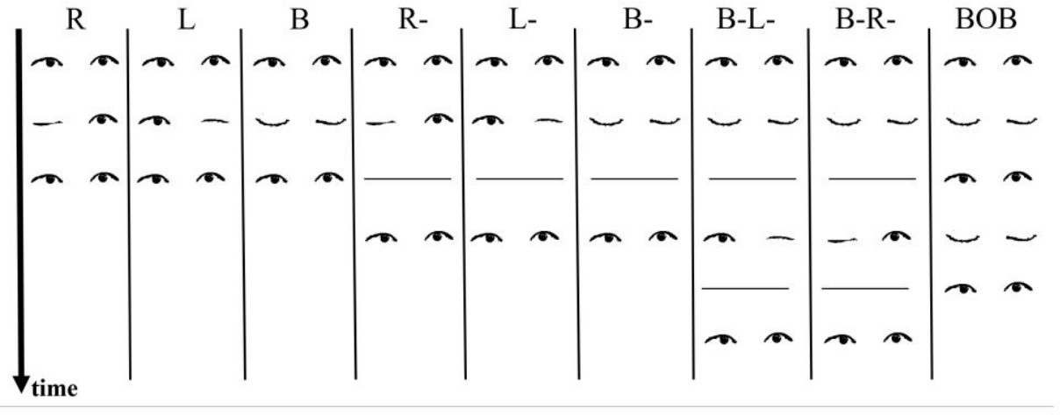

Figure 1: Eyelid Gesture Design

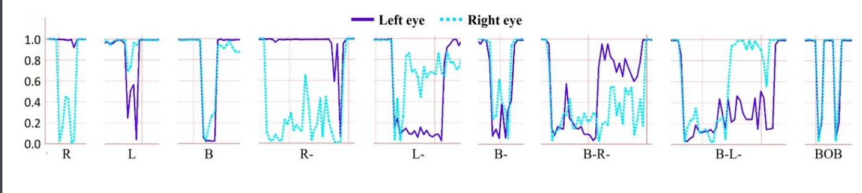

Figure 2: Probabilities and Noises

The gesture delimiter "Both eyelids open" (O) is used to indicate the beginning and finish of a gesture (works like a full stop at the end of a sentence).

Next, we examine the nine eyelid motions that the computer picked up. The following are these: R, L, B, R-, L, B, B, B-L, B, R, BOB. The above-mentioned meanings apply to each letter. “___”Means long duration otherwise, denotes a short duration. In (Figure 1)

# Algorithm: Recognizing the Eye Gesture

Images from the phone's front camera are now gathered in order to recognise these eye gestures, and then, using Google Mobile Vision API, a stream of probability pairs (for each gesture) of each eye being open is generated, taking the form of a tuple (PL, PR) with time. In the probability streams, noises and anomalies are mostly noticed while one eye is open while the other is closed. It has been noted that the likelihood of the second eye opening similarly lowers when one eye is closed.

We acquire a continuous time series of probability for ocular states because (PL, PR) is continually created over time. This continuous time series is now divided into durations based on the "Both eyes open" threshold (O). SVM classifiers are used to categorise (PL, PR) as "Both Open" (O) or "Any close." To categorise samples into long- and short-duration samples, we additionally employ a separate SVM classifier. The data is resampled into, let's say, 50 samples of (PL, PR) pairs for short duration and 100 samples of (PL, PR) pairs for long duration. Various SVM classifiers are used to further classify gestures of long and short duration.

A well-known supervised machine learning classification approach is SVM (Support Vector Machine).

# Testing our Algorithm

Now that training data had been gathered for all 4 eyelid states and 9 eyelid movements, it was time to test the algorithm. A smartphone camera was held up in front of each participant as they were made to sit in a wheelchair. They had to make the eyelid gesture exactly as it appeared on the app screen, which presented 10 different examples of each eyelid action at random. Change rooms, sitting positions, and other variables were added to the training data, and this data was utilised to train and test the model. The first test involved 12 healthy participants, and the second involved 4 people who had severe motor impairments. The user-dependent and user-independent evaluation of eyelid gestures was done for these tests.

For the healthy individuals, an accuracy of 76 percent was observed for user-dependent eyelid gesture evaluation, where some samples were used to train the classifier while others were used to test it, and an accuracy of 68 percent was observed for user-independent eyelid gesture evaluation, where the data of one user is used for testing while that of the remaining users is used for training.

The same overall accuracy was seen in both scenarios for people with significant motor impairment.

# Interacting with mobile apps

There are three forms of navigation on a smartphone. The first is app switching, which is a difficult problem to assign the eyelid gestures (B-L-, B-R-). The eyelid gesture allocated to navigating between an app's displays is R-, L-, followed by the most often task of navigating between an app's containers, which is R, L. BOB is employed for both navigation and item selection.

*−*

*−*

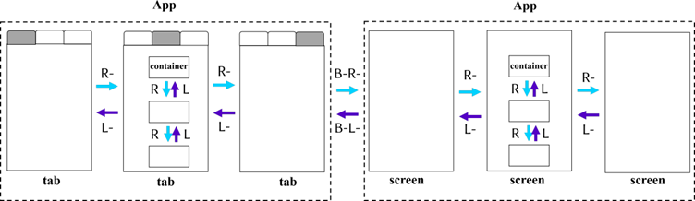

# Future Goals

Even after being this helpful and practical, the application still has a lot of room for improvement. For example, half-closed eyelids could be added to the design space, widening the eyelid gesture space. Additionally, other reasonably distinct levels of duration could be added, further widening the eyelid gesture space. Other improvements might include the option for users to customise the (eyelid gesture, action) pair, and the range of electronic devices that could use it could be expanded from smartphones to TVs, air conditioners, e-watches, and other gadgets.

*−*

In conclusion, this programme is a fantastic non-obtrusive and inexpensive solution towards improving the human-computer level of connection for both physically able-bodied and challenged individuals.