Microprocessors & Embedded Systems Design Project **Report**

Dr. Belal Sababha Fall 2022/2023



**Pet Food Dispenser**

# Members:

* Tawfiq Morrar (20180352) - NIS Engineering
  + [taw20180352@std.psut.edu.jo](mailto:moh20180187@std.psut.edu.jo)
* Omar AlAbdallah (20170022) - NIS Engineering
  + [oma20170022@std.psut.edu.jo](mailto:was20180071@std.psut.edu.jo)
* Abdallah Abu Ghali (20190051) - NIS Engineering

[abd20190051@std.psut.edu.jo](mailto:abd20190051@std.psut.edu.jo)

# Abstract:

Having a pet is awesome and fun but the pet has to be taken care of in which pet owners have to feed them every day. So, our projects aim to make life easier for pet owners in which we developed a device that can keep track of the pet food schedule where the device fills the pets according to the amount we want.

# Introduction and Background:

This project’s purpose is to help people travel or leave their house without worrying about feeding their pets. It’s a pet feeding device that fills the bowl using a timer that you can set beforehand. The device will automatically open the door of the tank above the bowl, and drop the exact amount of food you selected using ultrasonic sensor. The ultrasonic sensor measures the distance between the top of the device and the gate that the food will be dropped from, if there is no food or is about to finish inside the tank then the ultrasonic will give us the distance between the top of the device and the gate, therefore that means the device is empty and a buzzer will ring indicating that we need to fill the tank with food.

# Mechanical Design:

**The Tank –** Firstly we used a large box made of wood in which the upper part of the box is the tank where the food will be filled.

The tank is 15cm wide and 25cm long, at the top of the tank from the inside, an ultrasonic sensor is attached which will give us an indicator if the tank needs to be filled. Inside the tank at the base there is a hole which will be covered by a gate, and this gate will open only if there is low or no food, allowing the food to drop from the tank to lower part of the design. Outside the tank at the sides, we place a wood surface where we will place an LCD to make it user friendly, where the LCD will have messages such as welcome, opening, and closing.

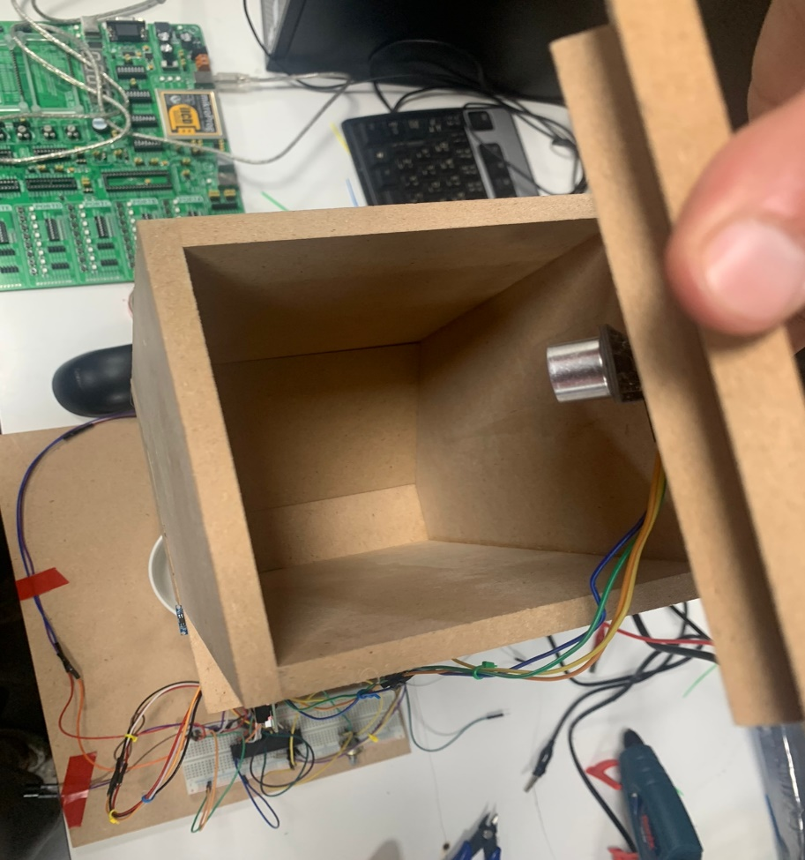

**Lower Part –** The lower part of the design is an empty area where the bowl will be placed. At the top of the lower part, we placed an ultrasonic sensor that will measure if the bowl is full or need to be filled more with food. 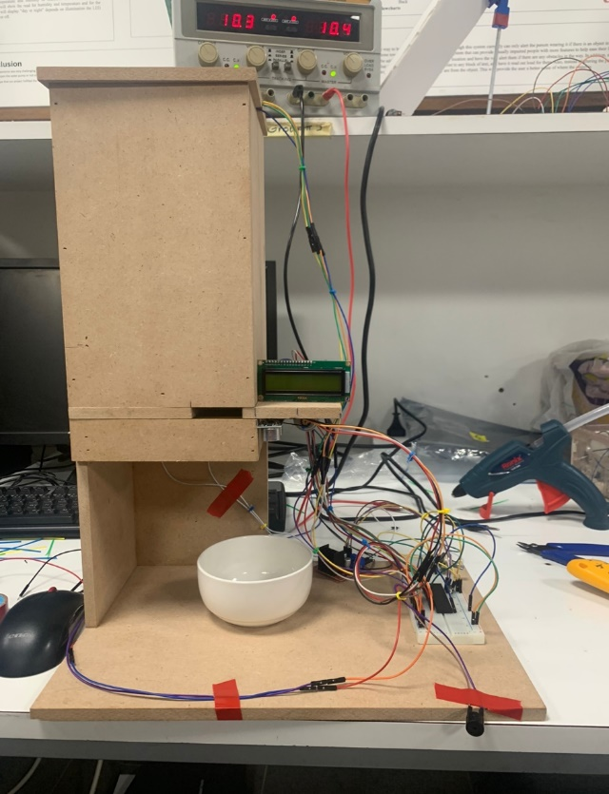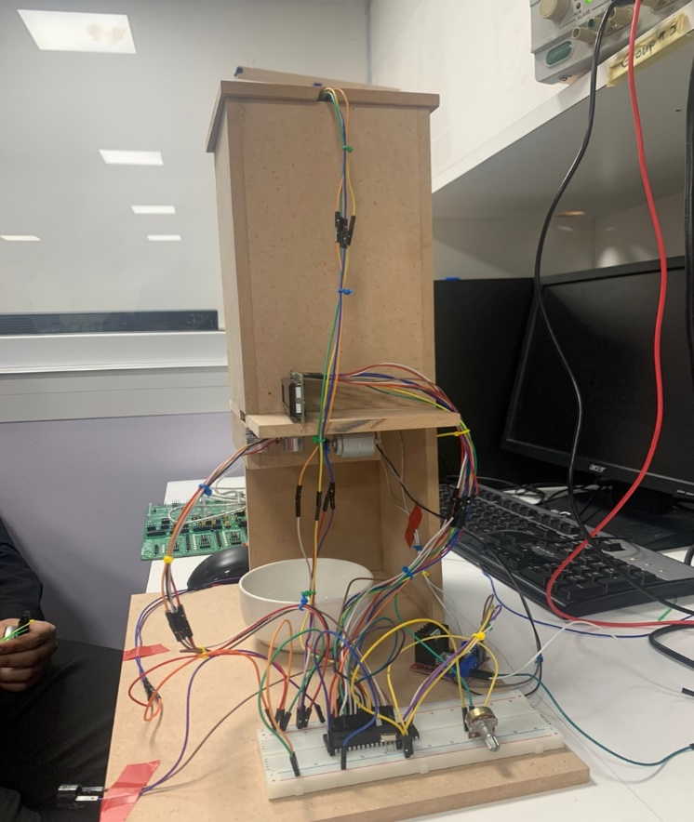

# Electrical Design:

We used 2 different power supplies, one to power the H-Bridge and one to power up the pic. We connected 2 motors to the H-Bridge on a high voltage to power up the H-Bridge, one motor is to open the door of the tank and the other motor is to close the door. The pic was connected to a 5V power supply not to burn the pic. In our project we have 2 ultra-sonic sensors both connected to the pic. The one in the tank we used cable extensions, so it can reach the bread board. The Lcd is connected directly to the pic, vcc, ground, and potentiometer, while the potentoimeter has two more cables, one connected to the ground and the other to vcc. The buzzer has 2 cables, the positive side is connected to the pic and the negative is connected to the ground.

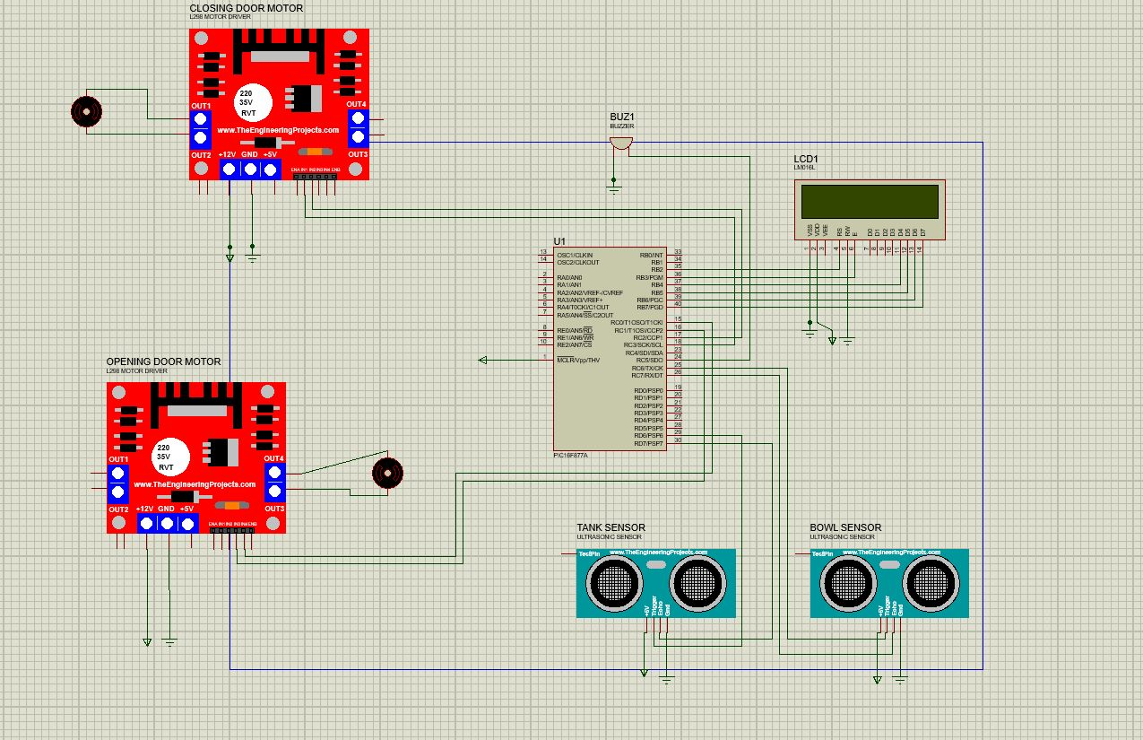

# Software Design:

We used the microC pro for PIC to write our code using C language. We wrote two delay functions, one is a timer0 interrupt that when it’s done it automatically calculate the bowl’s level and if it needs to be filled, it will open the door using opendoor function. The other delay is NoTDelay used to give the doors enough time to open and close the door before turning the motors off. Calcdist is a function we wrote to calculate the level of the bowl and make sure its either full or needs to be filled. If it needs to be filled it will call the opendoor function in order to fill the bowl. Calcdisttank function calculates the tank level of food, in which if the tank is low on food or empty it calls the Buzzer function to notify us that the tank needs to be filled. Closedoor function turns on the dcmotor to close the door placed under the tank.

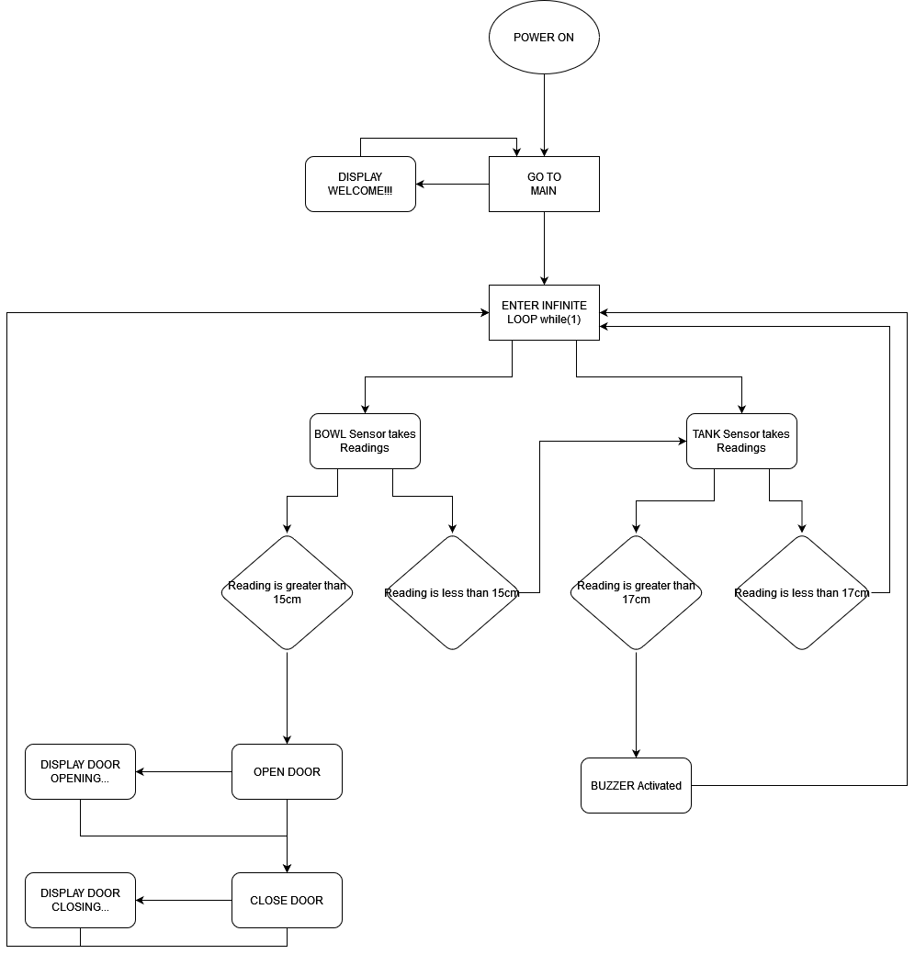

**Conclusion:**

At the end of our project, we achieved our goal of designing an automated pet feeder. It’s concept what based on making it as simple as possible with no complicity. After many trials and errors, we had to make some changes on initial mechanical design where we have replaced the load cell sensor with Ultrasonic sensors, on the physical design side we used AutoCAD which helped us with visioning on what we wanted to have and made it easy for the dimensions. As for the software, our program had many changes until we have achieved what we needed in a way which we tried to keep the code as simple as possible and away from complicity, so after facing many challenges and many errors and after many trials, we reached our goal and ended up with a working pet feeder dispenser.