## Yogurt Recipe

This is how I make 'bulk' sized portions of yogurt that can be served by scooping into bowls with fruit, granola, vanilla, coconut cream, or honey. Individual serving size containers may also be used for making yogurt.

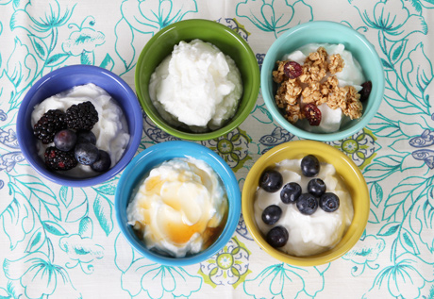

Ingredients

* 2 qt 2% milk
* 1/2 c powdered non-fat milk (optional)
* 2 T plain yogurt, with live cultures. (Commercial yogurt to start. After wards, use current batch to start the next batch.)

Equipment

* 2 qt Pyrex measuring container.
* Thermometer. (I use an instant read barbeque thermometer.)
* Cold water bath (Sink or pot of ice water, large enough to hold Pyrex measuring container.)
* 8x 8-oz or larger clean canning jars or similar container to hold finished yogurt.
* Insulated box with 40 Watt appliance bulb as heat source. Optional temperature controller yields consistent results throughout the year. (See *Yogurt Culture Controller.pdf*)

Procedure

1. Combine milk with optional powdered milk in clean Pyrex container.
2. Heat milk in microwave to reach 180 deg F. (19 minutes on High, milk may begin to foam)
3. Cool the milk by placing the Pyrex container into the cold water bath. (18-20 min)
4. When milk reaches 110 deg F, in a clean bowl, make starter by stirring 2 T of cooled milk into the yogurt.
5. Stir starter into remaining milk in Pyrex container. ( If making individual servings, pour the mix into clean canning jars.) Cover, and place in a warm location maintaining 105- 110 deg F.
6. Let mixture incubate 8 hours (overnight) , undisturbed.
7. Cool in refrigerator.
8. Add fruit or other ingredients just before serving.

Variations of this recipe can be sought out on the web. See these for example:

* <http://www.makeyourownyogurt.com/>
* <http://www.food.com/recipe/homemade-yogurt-32460>