Maven Market Retail Analytics

BY:

AJIGBOTOSHO HAMMED OLAITAN

Ajigbotoshoshohammed2020@gmail.com Abstract

This project leverages SQL to analyze sales, returns and operational efficiency for Maven Market, a retail chain. By exploring relationships between products, stores and regions, the analysis identifies trends, predicts risks and provides actionable recommendations to optimize profitability and customer satisfaction.

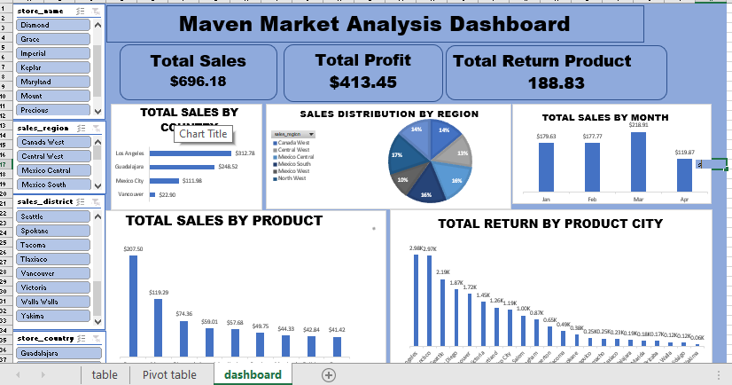

Table of Contents

Title Page

Abstract

Chapter 1: INTRODUCTION

1.1 Background

1.2 Objectives

1.3 Key Deliverable

1.4 Problem Statement

Chapter 2: METHODOLOGY

2.1 Data Characteristics

2.2 Data Cleaning and Transformation

2.3 Data Analysis

2.4 Dashboard Development

Chapter 3: KEY INSIGHTS & RECOMMENDATION

3.1 Insights

3.2 Predictive

3.3 Recommendation

Chapter 4: ANALYSIS AND RESULT

4.1 Insights

4.2 Predictive patterns 4.3 Key findings

4.4 Dashboard Outputs

Chapter 5: DISCUSSION & CONCLUSION

5.1 Implications

5.2 Limitations

5.3 Future Work

5.4 Summary

5.5 Recommendations

5.6 Impact

Figure 1:Total Revenue by store_country 7

Figure 2: list of product columns 8

Figure 3: Data cleaning in SQL 9

Figure 4: Analysis by product name and returns 9

Figure 5; Key Parameter insights 10

Figure 6: Revenue generated in Dec 10

Figure 7: Sales by region 11

Figure 8: Analysis for higher units sold 11

Figure 9:Comparision of low fat quantity 12

Figure 10: Top 5 higher profit 13

Figure 11: Analysis of return risk model 13

Figure 12: Recyclable product analysis 13

Chapter 1: INTRODUCTION

1.1 Background

Maven Market operates across multiple regions with diverse products offerings. The project addresses challenges in:

* Tracking sales performance
* Reducing product return rates
* Improving store efficiency

1.2 Objectives

1. Identify top-performing products and regions (e.g., Southwest region)
2. Analyze return patterns and root causes
3. Provide data-driven recommendations for operational improvements

1.3 Key Deliverable

* SQL scripts for data cleaning and analysis
* Interactive Excel dashboard for KPIs tracking
* Report summarizing insights and recommendations

1.4 Problem Statement

* Maven Market lacks visibility into:
* Profit margins by product category
* Regional return rate disparities
* Store efficiency metrics (e.g., sales/ sqft)

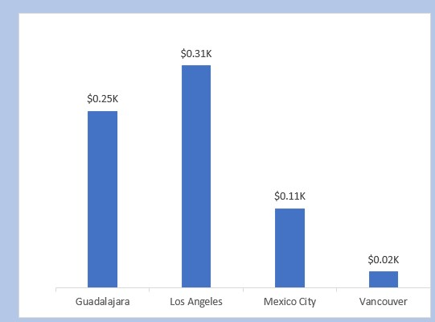

# Figure 1:Total Revenue by store_country

Revenue by store_country

CHAPTER 2: METHODOLOGY

2.1 Data Characteristics Table Analyzed:

* Product (product_id, brand, retail_price, cost)
* Transaction (transaction-date, store_id, quantity)
* Return (return_date, product_id, quantity)
* Store (store_id, store_type,region_id, total_sqft)
* Region (sales_district, sales_region)

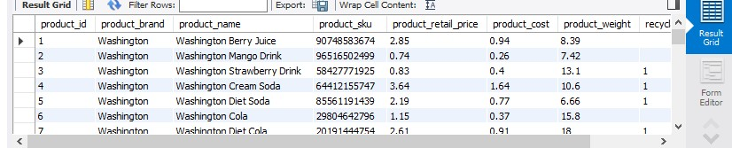

# Figure 2: list of product columns

Relationships:

Transaction.product_id -> Product.product_id

Store.region_id -> Region.region_id

2.2 Data Cleaning and Transformation

1. Handling Missing Data:

Sql DELETE FROM Transaction WHERE product_id NOT IN (SELECT product_id FROM Prodcut);

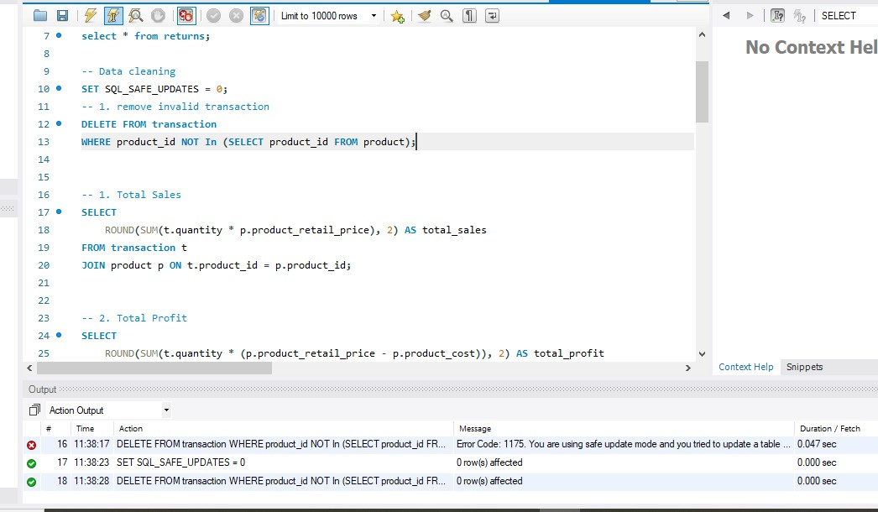

# Figure 3: Data cleaning in SQL

2.3 Data Analysis

* Techniques Applied:
* Joins. Aggregations, CASE statements, and CTEs
* Example Query

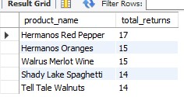

# Figure 4: Analysis by product name and returns

2.4 Dashboard Development

* Tools: Excel (PivotTables, Charts, Slicers) • KPIS Tracked:
* Total Sales, Profit Margin, Return Rates, Highest Units sold
* Interactive Filters: Stores Type, Sales Region



# Figure 5; Key Parameter insights

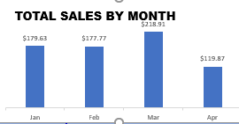

# Figure 6: Revenue generated in Dec

Chapter 3: KEY INSIGHTS & RECOMMENDATION

3.1 Insights

1. Product Performance:

Healthy Life brand contributes 28% of total profit

1. Regional Returns:

Northwest has a 22% rate (national average: 12%)

1. Store Efficiency:
2. Supermarkets generate 40% higher sales/sqft than Express store

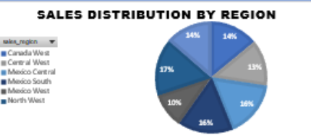

# Figure 7: Sales by region



# Figure 8: Analysis for higher units sold

3.2 Predictive Patterns

Low-fat products have a 15% higher return rate

Stores remolded in 2023 saw a 10% sales growth post-renovation



# Figure 9:Comparision of low fat quantity

3.3 Recommendation

1. Product strategy: Discontinue low-fat products with >20% returns
2. Store Operations: Prioritize remodels for stores with sales/sqft < $100
3. Sustainability: Promote recyclable products to reduce returns

Chapter 4: ANALYSIS AND RESULT

4.1 Insights

Top 5 product by profit



# Figure 10: Top 5 higher profit

4.2 Predictive Patterns

Return Risk Model:



# Figure 11: Analysis of return risk model

4.3 Key Findings

* Recyclable products have 15% lower return rates
* Post-remodel sales growth correlates with reduced returns

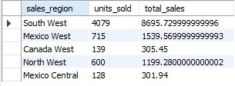

# Figure 12: Recyclable product analysis

Chapter 5: Discussion & Conclusion

5.1 Implications

Data-driven strategies can reduce returns by 20% and boost profits by 15%

5.2 Limitations

Lack of customer demographics limited segmentation analysis

5.3 Future Work

Integrate inventory data to analyze stock turnover

5.4 Summary

SQL analysis uncovered actionable insights into product performance and store efficiently

5.5 Recommendations

* Focus on Descent store and North West regions to generate higher sales
* Target March for high revenue
* Launch recyclable product campaigns to prevent retuned product
* Implement a real-time dashboard for ongoing monitoring

5.6 Impact

Potential annual savings: $500k from reduced returns and optimized store layouts.