**Hottest Year**

from mrjob.job import MRJob

from mrjob.step import MRStep

class Max_temp(MRJob):

def mapper(self, _, line):

# Extract year and temperature from the line

year, temp = line.split(',')

yield year, float(temp)

def reducer_find_max_temp(self, year, temps):

max_temp = max(temps)

yield None, (year, max_temp)

def reducer_find_year_with_max_temp(self, _, year_temp_pairs):

year_with_max_temp = max(year_temp_pairs, key=lambda x: x[1])

yield year_with_max_temp

def steps(self):

return [

MRStep(mapper=self.mapper, reducer=self.reducer_find_max_temp),

MRStep(reducer=self.reducer_find_year_with_max_temp)

]

if __name__ == "__main__":

Max_temp.run()

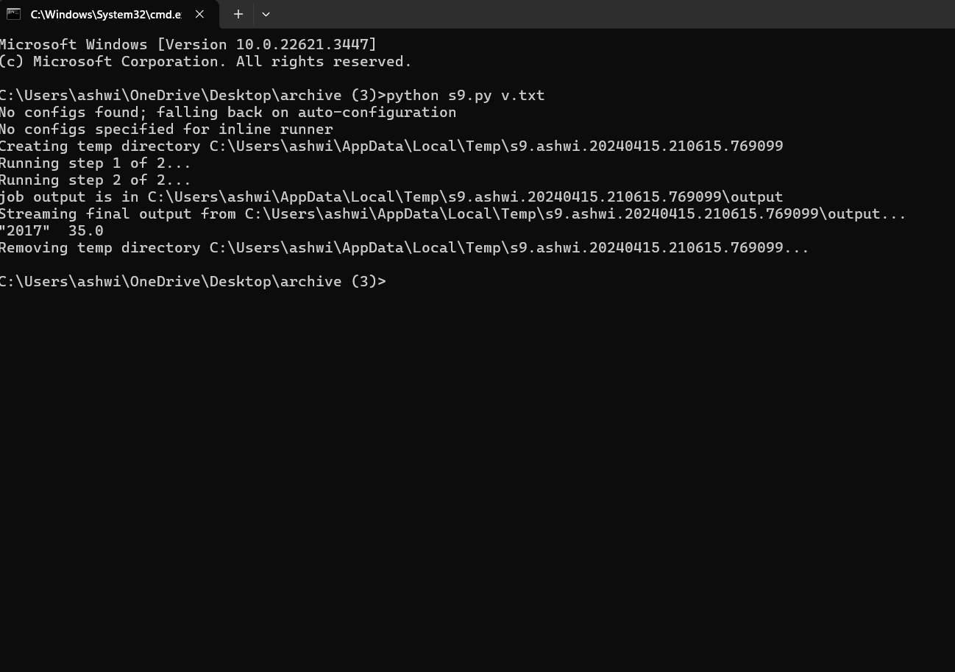

**Coolest Year**

from mrjob.job import MRJob

from mrjob.step import MRStep

class Min_temp(MRJob):

def mapper(self, _, line):

# Extract year and temperature from the line

year, temp = line.strip().split(',')

yield year, float(temp)

def reducer_find_min_temp(self, year, temps):

min_temp = min(temps)

yield None, (year, min_temp)

def reducer_find_year_with_min_temp(self, _, year_temp_pairs):

year_with_min_temp = min(year_temp_pairs, key=lambda x: x[1])

yield year_with_min_temp

def steps(self):

return [

MRStep(mapper=self.mapper, reducer=self.reducer_find_min_temp),

MRStep(reducer=self.reducer_find_year_with_min_temp)

]

if __name__ == "__main__":

Min_temp.run()

