**LOCKERS PVT LTD**

**Company Lockers Pvt. Ltd.. aim to digitise their products and chose LockedMe.com as their first project to start with.**

**AGILE SCRUM FRAMEWORK:**

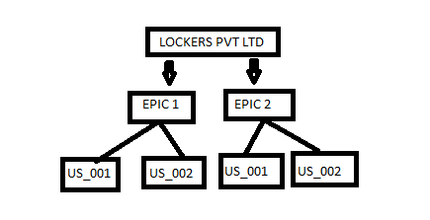

**Number of sprints required to make this product are 2.**

**Each sprint has a duration of 2 weeks.**

**EPIC 01**

**For a new E-commerce website,the seller wants to sell the products**

Estimated story points are 2**.**

Sprint time period = 2 weeks (8 days for developing and 2 days for testing)

***Us_001:***

* **As a seller ,**
* **I want to enter my details,**
* **So that I can enter the website.**

**Us_002:**

* **As a seller,**
* **I want to enter the product details,**
* **So that I can sell them.**

**EPIC 02**

**The customer wants to buy the product from the website.**

**Us_001:**

* **As a customer,**
* **I want to view the list of products**
* **So that I can choose my product.**

**Us_002:**

* **As a customer,**
* **I want to enter my address details,**
* **So that I can place my order.**

Flow of the application:

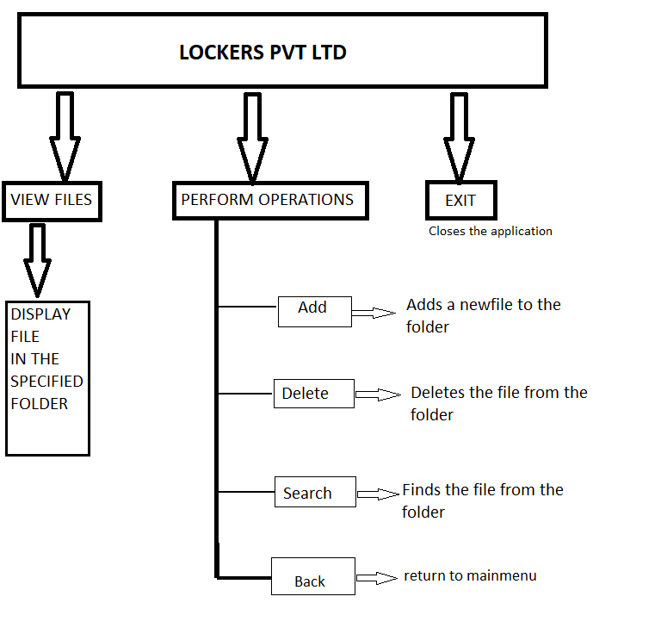

**CORE CONCEPTS,DATA STRUCTURES AND ALGORITHMS**

**ECLIPSE IDE-JAVA SE 1.8**

* **Scanner object**

To get the input from the user.

* **Data types**

1. Integers
2. string

* **Arrays**

To display the list of files .

* **Loops**

While loop to perform operations continuously until the user exits.

* **Conditional statements**

**If else** condition to print the results of the operations upon user input.

* **Switch Expressions**

Switch cases to perform a particular operation that the user needs.

In this case we have used the **nested switch statements.**

* **Searching and sorting techniques used**

**Sorting**

Collections.sort() to display the list of files in the ascending order.

**Search**

Arrays is used to search file in directory

**GIT AND GITHUB**

Git hub repository link:

**<https://github.com/AJITH1036/Phase1-Project.git>**

Go to the directory of the file you want to push to the github repository.

Execute the following steps

* Git init
* Git status

To check the status if files whether staged or unstaged

* Git add .

To bring the file to the staging area

* Git config –global user.email “ “

Git config –global user.name “ “

To get details of the developer

* Git commit -m “ “

Type the changes you have committed

* Git log

To see the changes made to the file

* Git remote add origin “ code link”

To add your github repository code link with the file

* Git push origin master

To push the file to your github repository.

**CONCLUSION**

As a developer ,I have created the report for the new company “LOCKERS PVT LTD” and executed a java program for performing operations. I have pushed my documents to the github repository and attached the source code where you can find the project details .