Automating Summary of Surveys with RMarkdown

Pete Mohanty

This guide is shows how to automate the summary of surveys with R and RMarkdown using RStudio. The motivation is twofold: *efficiency* (minimize copy and pasting, maximize the number of data sets that any given code can analyze) and *reproducibility* (minimize the effort to recreate scientific results, maximize the number of people and computers that can recreate the findings).

The basic setup is to write an Rmd file that will serve as a template and then a short script that (using library(knitr)) loops over each data file. This is great for portions of the document that don’t change (e.g., “the survey shows substantial partisan polarization”). The render function then turns the Rmd into a PDF (or HTML or docx as desired), taking additional metadata about the data set as a “parameter” ([RStudio guide](http://rmarkdown.rstudio.com/developer_parameterized_reports.html)). There are countless ways to summarize a survey in R. This guide will show a few basics with ggplot and questionr but focus on the overall workflow (file management, etc.).

Following the instructions here, you should be able to reproduce all four reports (and in principle, many more) despite only writing code to clean one survey. Almost all of the code that you need is found in this file, though some additional data cleaning code is found only in pewpoliticaltemplate.Rmd. The file that then loops over the available data sets is pew_report_generator.R. All code and resulting documents can be found in this [Github folder](https://github.com/rdrr1990/datascience101/edit/master/automating/).

# Software

RStudio’s interface with rmarkdown is evolving rapidly. Installing the current RStudio is highly recommended, particularly for the previews of the R markdown code (this doc was created with 1.1.83). (Here is my [install guide](stats101.stanford.edu), which includes links to tutorials and cheat sheets. For somewhat more advanced survey data cleaning, click [here](stats101.stanford.edu/R_skill_dRill.html).) Note that this document has been created with Pandoc 1.19.2.4, not the brand new 2.0, which seems to have a few minor compability issues with rmarkdown.

Even if you’ve knit R Markdowns in the past, your libraries may not be new enough to create parameterized reports. Install pacman, which has a convenience function p_load that smoothes package installation, loading, and maintenance.

install.packages("pacman")  
p_load(rmarkdown, knitr, foreign, questionr, tidyverse, update = TRUE)

# The Data

Download the four “political surveys” from Pew Research available [here](http://www.people-press.org/datasets/2016/) (i.e., January, March, August, and October 2016). You may recall, some politics happened in 2016.

* If need be, decompress each zip folder.

Three of my folders have intuitive names (Jan16, Mar16, and Oct16) but one of my folders picked up a lengthy name, http___www.people-press.org_files_datasets_Aug16. Don’t worry about that.

* Create a new folder, call it say pewpolitical
* Move all four folders into pewpolitical

Please note I have no affiliation (past or present) with Pew Research. I simply think that they do great work and they make it relatively hassle free to get started with meaningful data sets.

# The R Notebook (R Markdown) Template

In RStudio, create a new RNoteook and save it as pewpoliticaltemplate.Rmd in the pewpolitical folder you just created. This document will likely knit to HTML by default; hold down the knit button to change it to PDF. Add fields to the header as desired. Below find a sample header that automatically puts today’s date on the document. (Remember PDF requires LaTeX [(install links)](stats101.stanford.edu). By contrast, knitting to docx or HTML does not require LaTeX. Creating pptx is possible with R with library(ReporteRs).)

Next add an R code chunk to pewpoliticaltemplate.Rmd to take care of background stuff like formatting. Though setting a working directory would not be needed just to knit the Rmd, it must be set by knit::opts_knits$set(root.dir = '/path/to/pewpolitical/') to automate document prep. (setwd isn’t needed in the Rmd but setting the working directory separately in Console is recommended if you’re still editing.)

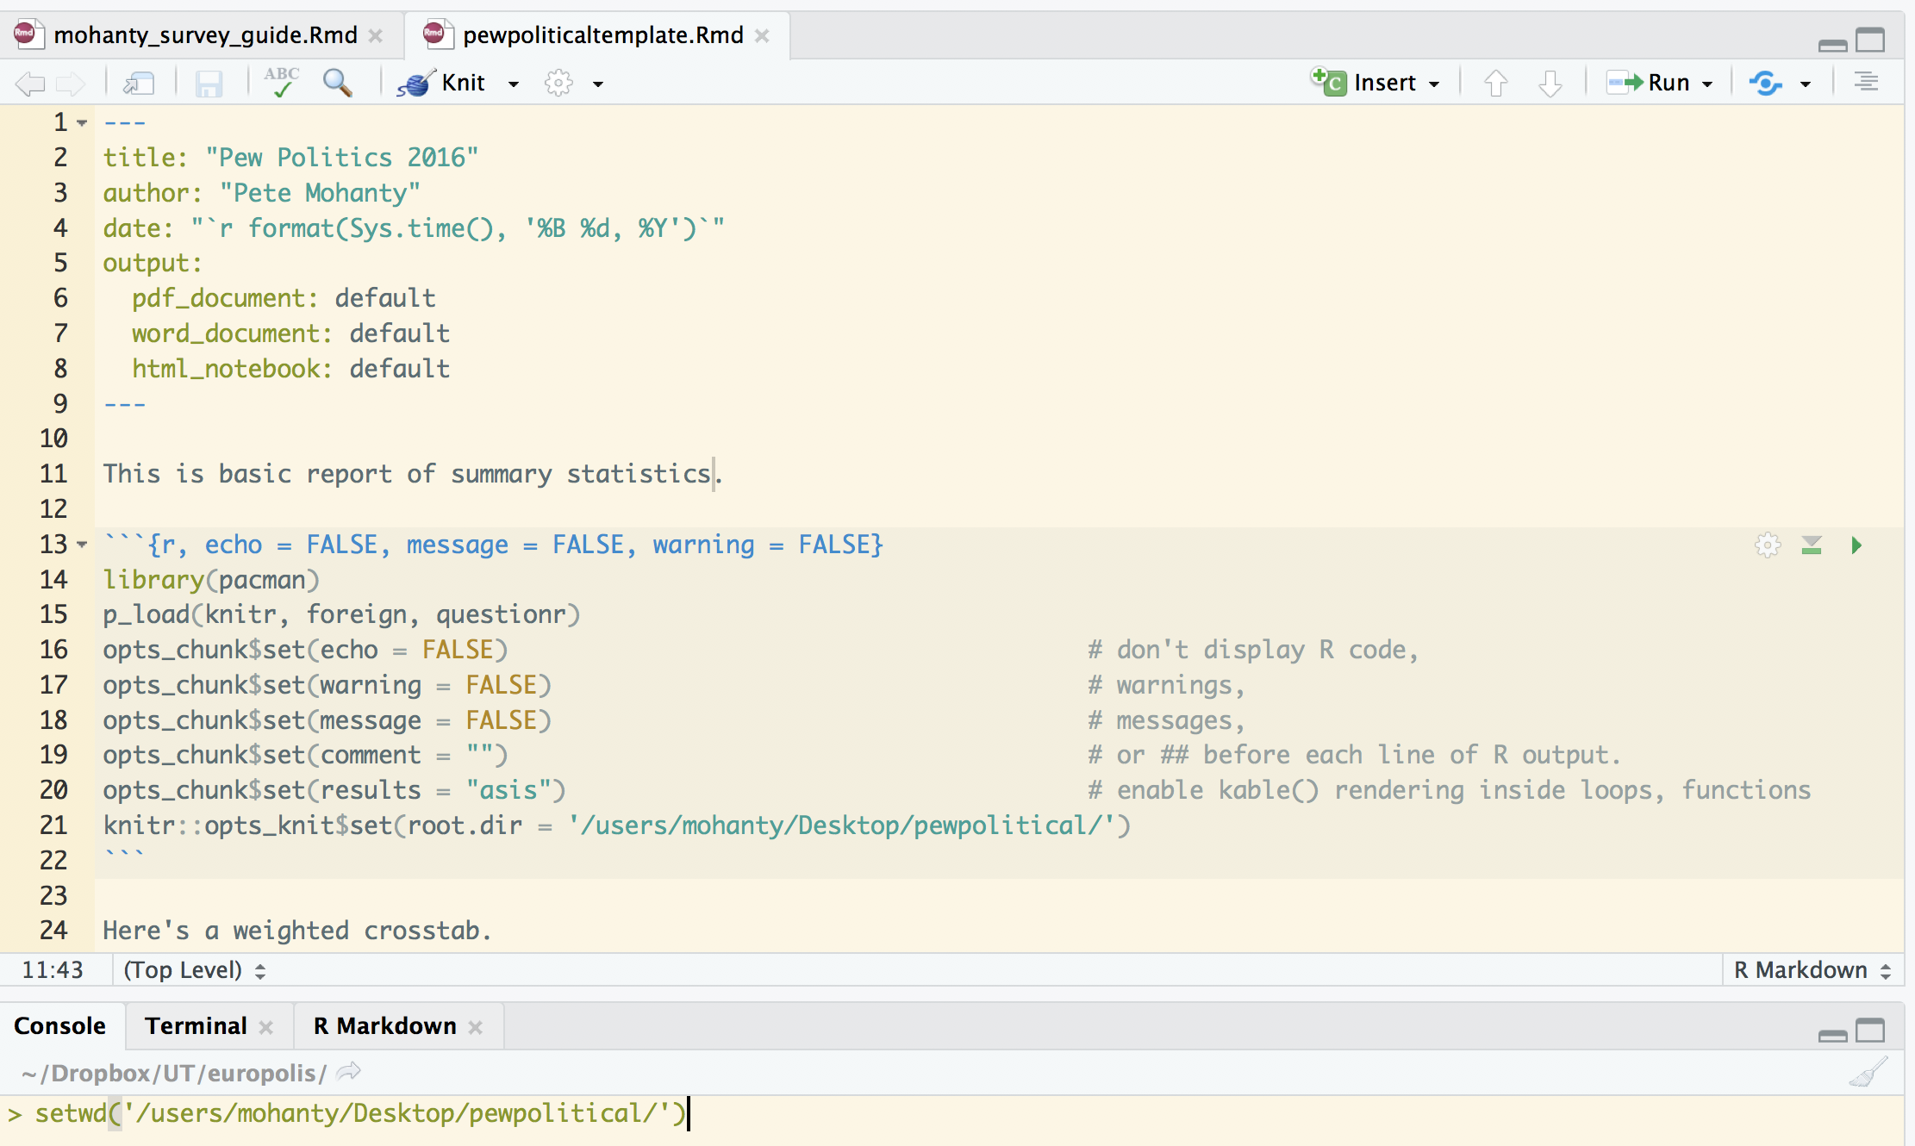

Initial Configuration

Now the default settings have been set and you don’t need to worry about suppressing warnings and so on with each code chunk. You can of course change them case-by-case as you like.

– Unlike in R, when setting the format options for individual code chunks (as shown above to suppress warnings before the defaults kick in), you do need to type out the words TRUE and FALSE in full.

– In this document, by constrast, I’ve set the defaults to echo = TRUE and tidy = TRUE to display the R code more pleasingly.

– The setting asis = TRUE is very useful for professionally formatted tables (show below) but is not recommendable for raw R output of matrix and tables.

### The Template

I find it easiest to write a fully working example and then make little changes as needed so that knitr::render() can loop over the data sets. First things first.

survey <- read.spss("Jan16/Jan16 public.sav", to.data.frame = TRUE)

Here is a basic plot we might want, which reflects the survey weights. facet_grid() is used to create analogous plots for each party identification. The plot uses the slightly wonky syntax y = (..count..)/sum(..count..) to display the results as percentages rather than counts. Note some code that cleans the data (mostly shortening labels) is omitted for brevity but can be found [here](https://github.com/rdrr1990/datascience101/blob/master/automating/pewpoliticaltemplate.Rmd).

PA <- ggplot(survey) + theme_minimal()  
PA <- PA + geom_bar(aes(q1, y = (..count..)/sum(..count..), weight = weight,   
 fill = q1))  
PA <- PA + facet_grid(party.clean ~ .) + theme(strip.text.y = element_text(angle = 45))  
PA <- PA + xlab("") + ylab("Percent of Country")  
PA <- PA + ggtitle("Presidential Approval: January 2016")  
PA <- PA + scale_y_continuous(labels = scales::percent)  
PA

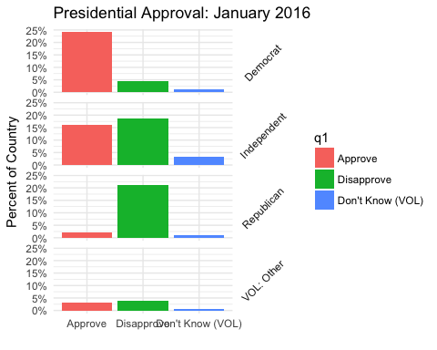

Here is an example of a weighted crosstab. knitr::kable will create a table that’s professional in appearance (when knit as PDF, kable takes the style of an academic journal).

kable(wtd.table(survey$ideo, survey$sex, survey$weight)/nrow(survey), digits = 2)

|  |  |  |
| --- | --- | --- |
|  | Male | Female |
| Very conservative | 0.04 | 0.03 |
| Conservative | 0.14 | 0.13 |
| Moderate | 0.20 | 0.20 |
| Liberal | 0.08 | 0.09 |
| Very liberal | 0.03 | 0.03 |
| DK* | 0.02 | 0.03 |

Suppose we want to do many crosstabs. The syntax survey$ideo is widely used for convenience but survey[["ideo"]] will serve us better since it allow to work with vectors of variable names ([details from win-vector](http://www.win-vector.com/blog/2017/06/non-standard-evaluation-and-function-composition-in-r/)). Below, the first two calls to comparisons are identical but the final one is not because there is no variable “x” in the data frame survey.

identical(survey$ideo, survey[["ideo"]])

[1] TRUE

x <- "ideo"  
identical(survey[[x]], survey[["ideo"]])

[1] TRUE

identical(survey[[x]], survey$x)

[1] FALSE

So suppose we want weighted crosstabs for ideology and party id crossed by all question 20, 21, 22.. 30. Here is some code that will do that.

x <- names(survey)[grep("q2[[:digit:]]", names(survey))]  
x

[1] "q20" "q21" "q22a" "q22b" "q22c" "q22d" "q22e" "q22f" "q22g" "q22h"  
[11] "q22i" "q25" "q26" "q27" "q28"

y <- c("ideo", "party")

for (i in x) {  
 for (j in y) {  
 cat("\nWeighted proportions for", i, "broken down by", j, "\n")  
 print(kable(wtd.table(survey[[i]], survey[[j]], survey$weight)/nrow(survey),   
 digits = 2))  
 cat("\n") # break out of table formatting  
 }  
 cat("\\newpage")  
}

A few notes:

– This code will only work with the asis setting (shown above) that lets knitr interpret the output of print(kable()) as something to render (rather just Markdown code to display that could be copy and pastied elsewhere).

– Ideally one would have a csv or data.frame of the questions and display the as loop switched questions. In this case, the questionnaire is in a docx and so library(docxtrackr) may help.

– Rather than a nested loop, one would likely prefer to pick a question, loop over the demographic and ideological categories for the crosstabs, and then insert commentary and overview.

– The outer loops makes a new page each time it is done with the inner loop with cat("\\newpage")), which is specific to making PDFs. Extra line breaks \n are needed to break out of the table formatting and keep code and text separate. A different approach to page breaks is needed [for docx](https://stackoverflow.com/questions/24672111/how-to-add-a-page-break-in-word-document-generated-by-rstudio-markdown).

# Adapting the Template with Parameters

The next step is to add a [parameter](http://rmarkdown.rstudio.com/developer_parameterized_reports.html) with any variables you need. The parameters will be controlled by the R script discussed below. There is of course quite a bit of choice as to what is controlled by which file. Add the following to the end of the header of pewpoliticaltemplate.Rmd:

params:  
 spssfile: !r 1  
 surveywave: !r 2016

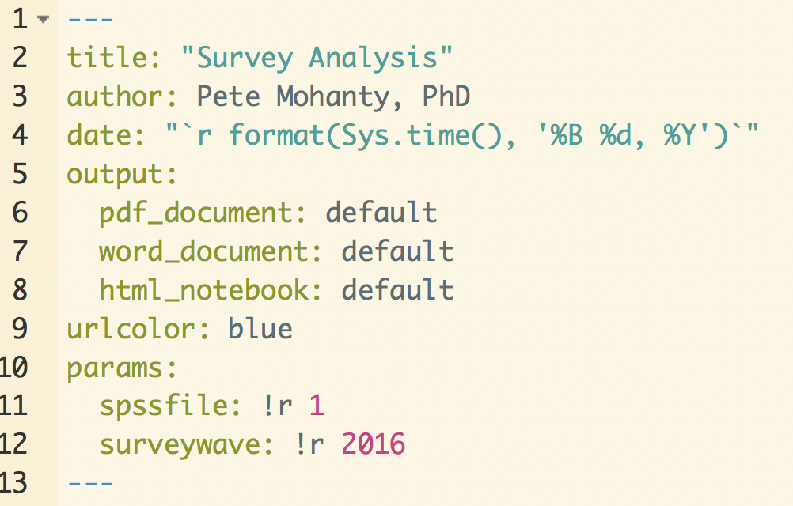

RMarkdown Header with Parameters

That creates variables params$spssfile and params$surveywave that can be controlled externally from other R sessions and gives them default values of 1 and 2016. Setting default values smooths debugging by allowing you to continue knitting the Rmd on its own (as opposed to from the R script we will create in a moment… You can also click on knit and choose knit with parameters to specify particular values).

Now make any changes to Rmd template. For example, in the ggplot code…

PA <- PA + ggtitle(paste("Presidential Approval:", params$surveywave))

Notice we can get a list of all the spss files like so:

dir(pattern = "sav", recursive = TRUE)

[1] "http___www.people-press.org_files_datasets_Aug16/Aug16 public.sav"  
[2] "Jan16/Jan16 public.sav"   
[3] "March16/March16 public.sav"   
[4] "Oct16/Oct16 public.sav"

or in this case

dir(pattern = "public.sav", recursive = TRUE)

[1] "http___www.people-press.org_files_datasets_Aug16/Aug16 public.sav"  
[2] "Jan16/Jan16 public.sav"   
[3] "March16/March16 public.sav"   
[4] "Oct16/Oct16 public.sav"

I recommend making the pattern as specific as possible in case you or your collaborators add other spss files with similar names. To use regular expressions to specify more complicated patterns, see [here](https://rstudio-pubs-static.s3.amazonaws.com/74603_76cd14d5983f47408fdf0b323550b846.html).

Now back to editing pewpoliticaltemplate.Rmd…

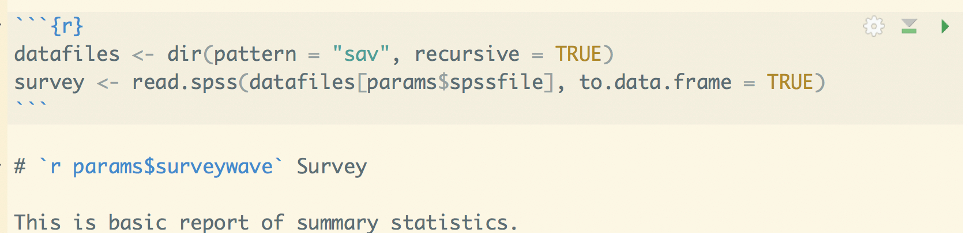

Reading Data given Parameters

Knit the file to see how it looks with these default settings; that's it for this portion.

# Automating with knitr

Now create a new R script; mine's called pew_report_generator.R. It's just a simple loop that tells which data set to grab as well as the label to pass to the Rmd. Note that the labels appear in alphabetical rather than chronological order as a function of the way that the Rmd happens to find the files.

library(pacman)  
p_load(knitr, rmarkdown, sessioninfo)  
  
setwd("/users/mohanty/Desktop/pewpolitical/")  
  
waves <- c("August 2016", "January 2016", "March 2016", "October 2016")  
  
for (i in 1:length(waves)) {  
 render("pewpoliticaltemplate.Rmd", params = list(spssfile = i, surveywave = waves[i]),   
 output_file = paste0("Survey Analysis ", waves[i], ".pdf"))  
}  
  
session <- session_info()  
save(session, file = paste0("session", format(Sys.time(), "%m%d%Y"), ".Rdata"))

The last bit of code is not necessary but is a convenient way to store which versions of which libraries were actually used. If something works now but not in the future install_version (found in library(devtools)) can be used to install the older version of particular packages.

That's it. Of course, in practice you might write some code on the first survey that doesn't work for all of them. Pew, for example, seems to have formatted the survey date differently in the last two surveys which made me change the way displayed which survey we are looking at. But if the data are formatted consistently, a one time investment in modifying your Rmd and creating an extra R file can save massive amounts of time lost to error prone copying and pasting.

s <- session_info()  
s$platform

setting value   
 version R version 3.4.2 (2017-09-28)  
 os macOS Sierra 10.12.6   
 system x86_64, darwin15.6.0   
 ui X11   
 language (EN)   
 collate en_US.UTF-8   
 tz America/Los_Angeles   
 date 2017-10-31

s$packages

package * version date source   
 assertthat 0.2.0 2017-04-11 CRAN (R 3.4.0)   
 backports 1.1.1 2017-09-25 CRAN (R 3.4.2)   
 bindr 0.1 2016-11-13 CRAN (R 3.4.0)   
 bindrcpp 0.2 2017-06-17 CRAN (R 3.4.0)   
 broom 0.4.2 2017-02-13 CRAN (R 3.4.0)   
 cellranger 1.1.0 2016-07-27 CRAN (R 3.4.0)   
 clisymbols 1.2.0 2017-05-21 cran (@1.2.0)   
 colorspace 1.3-2 2016-12-14 CRAN (R 3.4.0)   
 digest 0.6.12 2017-01-27 CRAN (R 3.4.0)   
 dplyr * 0.7.4 2017-09-28 cran (@0.7.4)   
 evaluate 0.10.1 2017-06-24 CRAN (R 3.4.1)   
 forcats 0.2.0 2017-01-23 CRAN (R 3.4.0)   
 foreign * 0.8-69 2017-06-22 CRAN (R 3.4.2)   
 formatR 1.5 2017-04-25 CRAN (R 3.4.0)   
 ggplot2 * 2.2.1 2016-12-30 CRAN (R 3.4.0)   
 glue 1.2.0 2017-10-29 CRAN (R 3.4.2)   
 gtable 0.2.0 2016-02-26 CRAN (R 3.4.0)   
 haven 1.1.0 2017-07-09 CRAN (R 3.4.1)   
 highr 0.6 2016-05-09 CRAN (R 3.4.0)   
 hms 0.3 2016-11-22 CRAN (R 3.4.0)   
 htmltools 0.3.6 2017-04-28 CRAN (R 3.4.0)   
 httpuv 1.3.5 2017-07-04 CRAN (R 3.4.1)   
 httr 1.3.1 2017-08-20 cran (@1.3.1)   
 jsonlite 1.5 2017-06-01 CRAN (R 3.4.0)   
 knitr * 1.17 2017-08-10 CRAN (R 3.4.1)   
 labeling 0.3 2014-08-23 CRAN (R 3.4.0)   
 lattice 0.20-35 2017-03-25 CRAN (R 3.4.2)   
 lazyeval 0.2.1 2017-10-29 CRAN (R 3.4.2)   
 lubridate 1.7.0 2017-10-29 CRAN (R 3.4.2)   
 magrittr 1.5 2014-11-22 CRAN (R 3.4.0)   
 mime 0.5 2016-07-07 CRAN (R 3.4.0)   
 miniUI 0.1.1 2016-01-15 CRAN (R 3.4.0)   
 mnormt 1.5-5 2016-10-15 CRAN (R 3.4.0)   
 modelr 0.1.1 2017-07-24 CRAN (R 3.4.1)   
 munsell 0.4.3 2016-02-13 CRAN (R 3.4.0)   
 nlme 3.1-131 2017-02-06 CRAN (R 3.4.2)   
 pacman * 0.4.6 2017-05-14 CRAN (R 3.4.0)   
 pkgconfig 2.0.1 2017-03-21 CRAN (R 3.4.0)   
 plyr 1.8.4 2016-06-08 CRAN (R 3.4.0)   
 psych 1.7.8 2017-09-09 CRAN (R 3.4.1)   
 purrr * 0.2.4 2017-10-18 CRAN (R 3.4.2)   
 questionr * 0.6.1 2017-06-20 CRAN (R 3.4.1)   
 R6 2.2.2 2017-06-17 CRAN (R 3.4.0)   
 Rcpp 0.12.13 2017-09-28 cran (@0.12.13)   
 readr * 1.1.1 2017-05-16 CRAN (R 3.4.0)   
 readxl 1.0.0 2017-04-18 CRAN (R 3.4.0)   
 reshape2 1.4.2 2016-10-22 CRAN (R 3.4.0)   
 rlang 0.1.2 2017-08-09 CRAN (R 3.4.1)   
 rmarkdown 1.6.0.9009 2017-10-31 Github (rstudio/rmarkdown@b839aae)  
 rprojroot 1.2 2017-01-16 CRAN (R 3.4.0)   
 rstudioapi 0.7 2017-09-07 cran (@0.7)   
 rvest 0.3.2 2016-06-17 CRAN (R 3.4.0)   
 scales 0.5.0 2017-08-24 cran (@0.5.0)   
 sessioninfo * 1.0.0 2017-06-21 CRAN (R 3.4.1)   
 shiny 1.0.5 2017-08-23 cran (@1.0.5)   
 stringi 1.1.5 2017-04-07 CRAN (R 3.4.0)   
 stringr 1.2.0 2017-02-18 CRAN (R 3.4.0)   
 tibble * 1.3.4 2017-08-22 cran (@1.3.4)   
 tidyr * 0.7.2 2017-10-16 CRAN (R 3.4.2)   
 tidyverse * 1.1.1 2017-01-27 CRAN (R 3.4.0)   
 withr 2.0.0 2017-10-25 Github (jimhester/withr@a43df66)   
 xml2 1.1.1 2017-01-24 CRAN (R 3.4.0)   
 xtable 1.8-2 2016-02-05 CRAN (R 3.4.0)   
 yaml 2.1.14 2016-11-12 CRAN (R 3.4.0)