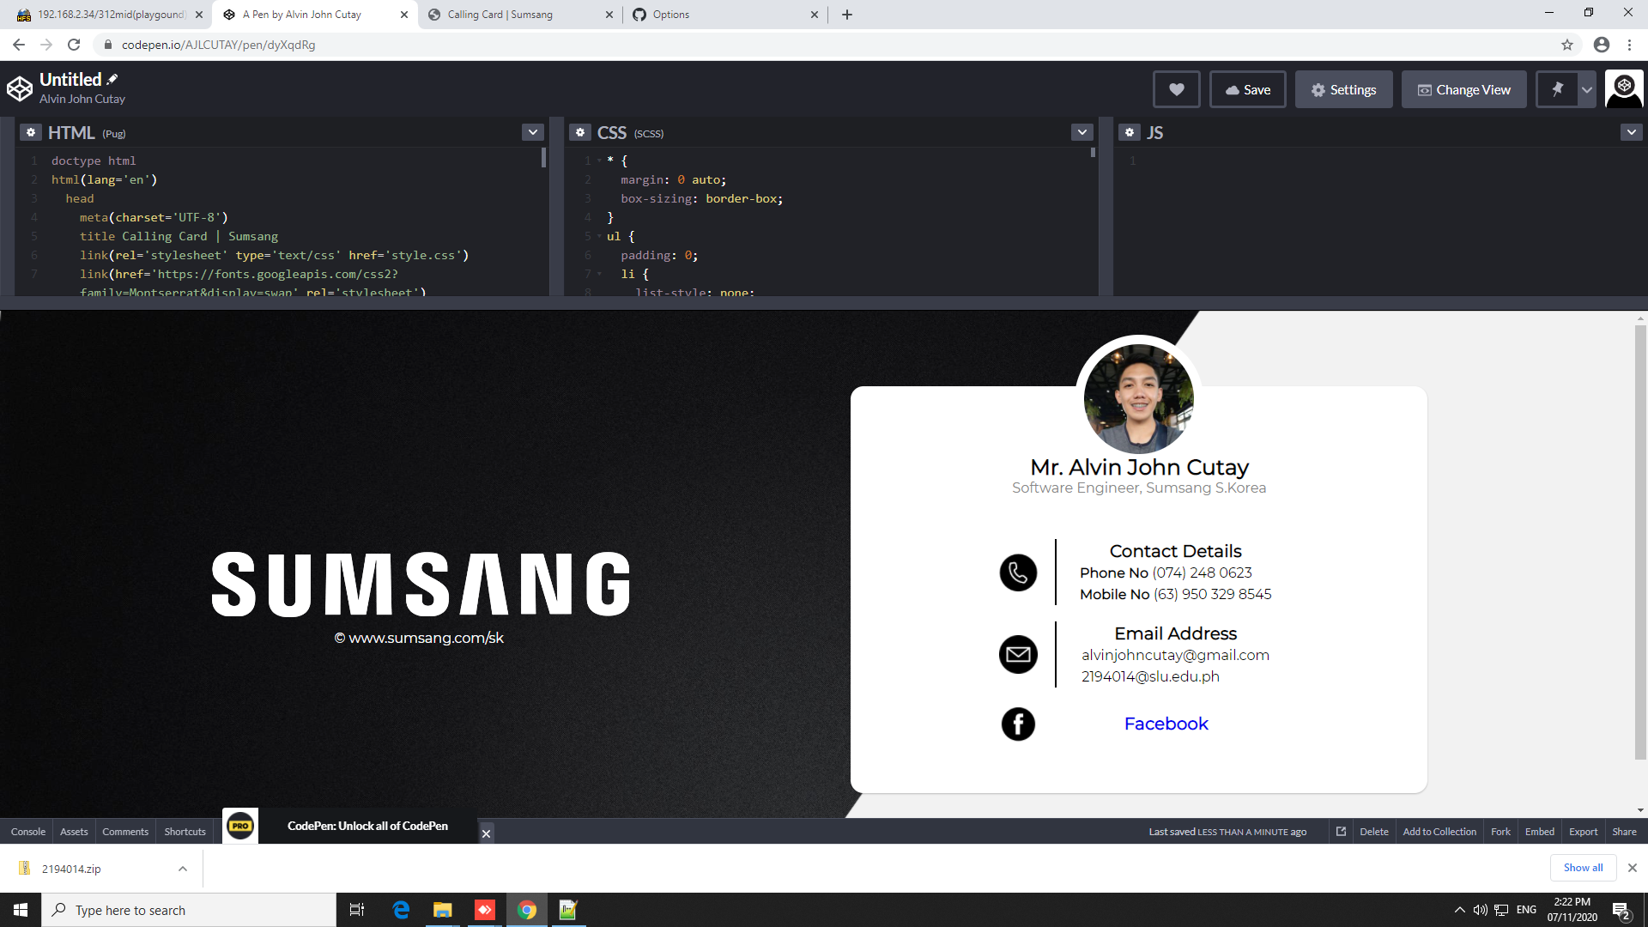
Accomplished pug, scss, and images integration.
Responsive design has not been implemented.

