DIYino Prime v1.0 User Manual

# Introduction

DIYino Prime is an Arduino compatible integrated circuit board for all projects implementing **Light**/**Sound**/**Motion**. Its main field of application is to control lightsaber electronics. It is compatible to Arduino, i.e. it can be programmed using Arduino compatible IDE’s (Arduino IDE, Eclipse etc.)

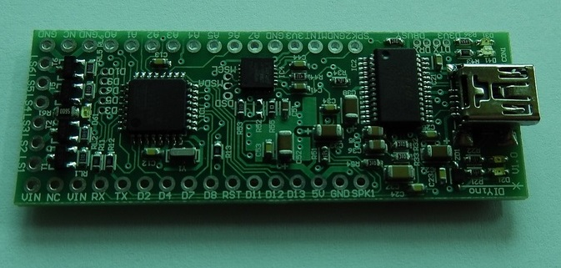

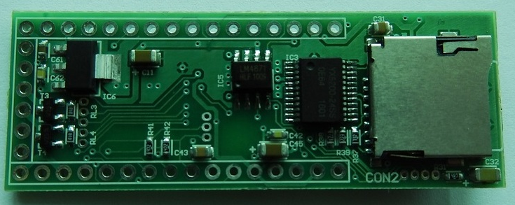

# General Product Characteristics

## Circuit overview (size, short feature overview)

* Very compact size, dimensions: **22** mm(W)x **60** mm(L)x **8** mm(H)
* Arduino Compatible
* Gapless Wav-audio playback
* 3W audio amplifier (supports 8Ω/4Ω speakers up to 3W)
* Built in high-end gesture detection sensor (6-axis accelerometer and gyro)
* Includes FTDI USB2Serial chipset for plug-and-play programming using Arduino IDE or similar
* 6 PWM controlled build-in low-side drivers as power extenders with up to 1.1A current capability each
* Input voltage range 3.3V-5V or 6V-20V

## Circuit Pinout



|  |  |  |
| --- | --- | --- |
| Pin | Functionality | Comment |
| VIN | Voltage-in pin. Connect to Battery(+)/power source(+). Input to 5V LDO. | Input voltage must stay between 6V and 20V for correct operation. |
| NC | Non-connected pin. Can be used on the PCB for signal routing. |  |
| VIN | Voltage-in pin. Connect to Battery(+)/power source(+). Input to 5V LDO. | Input voltage must stay between 6V and 20V for correct operation. |
| RX | D0 digital I/0 of Atmega328P. RX pin of Serial UART. |  |
| TX | D1 digital I/0 of Atmega328P. TX pin of Serial UART. |  |
| D2 | D2 digital I/O of Atmega328P. INT capable pin. |  |
| D4 | D4 digital I/O of Atmega328P. |  |
| D7 | D7 digital I/O of Atmega328P. | Connected to YX5200-24SS TX pin. Used for communication between Atmega328P and wav-decoder. |
| D8 | D8 digital I/O of Atmega328P. | Connected to YX5200-24SS RX pin. Used for communication between Atmega328P and wav-decoder. |
| RST | Reset pin of the Atmega328P, with pull-up to 5V. |  |
| D11 | D11 digital I/O of Atmega328P, PWM capable, connected to Gate of LS6 Low-Side driver, with 100kΩ pull-down to GND. MOSI pin for ICP. |  |
| D12 | D12 digital I/O of Atmega328P. MISO pin for ICP. |  |
| D13 | D13 digital I/O of Atmega328P. SCK pin for ICP. |  |
| 5V | Output of the 5V LDO (type 7805). Supply pin for Atmega328P, FTDI, YX5200-24SS chipsets. |  |
| GND | Board(-) or GND. Connected to GND plane of the PCB. |  |
| SPK1 | Speaker terminal 1. Connect to speaker directly. Other speaker terminal to SPK2. |  |
| GND | Board(-) or GND. Connected to GND plane of the PCB. |  |
| NC | Non-connected pin. Can be used on the PCB for signal routing. |  |
| GND | Board(-) or GND. Connected to GND plane of the PCB. |  |
| A0 | A0 digital I/O of Atmega328P with input 10-bit ADC. |  |
| A1 | A1 digital I/O of Atmega328P with input 10-bit ADC. |  |
| A2 | A2 digital I/O of Atmega328P with input 10-bit ADC. |  |
| A3 | A3 digital I/O of Atmega328P with input 10-bit ADC. |  |
| A4 | A4 digital I/O of Atmega328P with input 10-bit ADC. | SDA I2C signal for communication with MPU6050. Connected to auxiliary signal MSDA. |
| A5 | A5 digital I/O of Atmega328P with input 10-bit ADC. | SCL I2C signal for communication with MPU6050. Connected to auxiliary signal MSCL. |
| A6 | A6 analog input pin with 10-bit ADC. | Only analog input, cannot be used as digital I/O. |
| A7 | A7 analog input pin with 10-bit ADC. | Only analog input, cannot be used as digital I/O. |
| GND | Board(-) or GND. Connected to GND plane of the PCB. |  |
| 3V3 | Output of the 3.3V LDO of the FTDI (FT232RL) chip. |  |
| MINT | INT output pin of the MPU6050. |  |
| GND | Board(-) or GND. Connected to GND plane of the PCB. |  |
| SPK2 | Speaker terminal 2. Connect to speaker directly. Other speaker terminal to SPK1. |  |
| LS1 | Drain of the Low-Side switch 1 |  |
| LS2 | Drain of the Low-Side switch 2 |  |
| LS3 | Drain of the Low-Side switch 3 |  |
| LS4 | Drain of the Low-Side switch 4 |  |
| LS5 | Drain of the Low-Side switch 5 |  |
| LS6 | Drain of the Low-Side switch 6 |  |
| D3 | D3 digital I/O of Atmega328P, PWM capable, INT capable, connected to Gate of LS1 Low-Side driver, with 100kΩ pull-down to GND | Auxiliary signals, see Chapter 5.4 |
| D5 | D5 digital I/O of Atmega328P, PWM capable, connected to Gate of LS2 Low-Side driver, with 100kΩ pull-down to GND | Auxiliary signals, see Chapter 5.4 |
| D6 | D6 digital I/O of Atmega328P, PWM capable, connected to Gate of LS3 Low-Side driver, with 100kΩ pull-down to GND | Auxiliary signals, see Chapter 5.4 |
| D9 | D9 digital I/O of Atmega328P, PWM capable, connected to Gate of LS4 Low-Side driver, with 100kΩ pull-down to GND | Auxiliary signals, see Chapter 5.4 |
| D10 | D10 digital I/O of Atmega328P, PWM capable, connected to Gate of LS5 Low-Side driver, with 100kΩ pull-down to GND | Auxiliary signals, see Chapter 5.4 |
| SDS | Shut-down pin of the LM4871 3W audio-amplifier. | Auxiliary signals, see Chapter 5.4 |
| MSDA | SDA I2C signal of MPU6050 | Auxiliary signals, see Chapter 5.4 |
| MSCL | SCL I2C signal of MPU6050 | Auxiliary signals, see Chapter 5.4 |
| DBUSY | Busy signal of the YX5200-24SS wav decoder. | Auxiliary signals, see Chapter 5.4 |
| DRX | RX line of the YX5200-24SS wav decoder, connected to D8. | Auxiliary signals, see Chapter 5.4 |
| DTX | RX line of the YX5200-24SS wav decoder, connected to D7. | Auxiliary signals, see Chapter 5.4 |
| D3V3 | Output of the 3.3V LDO of the YX5200-24SS chip. | Auxiliary signals, see Chapter 5.4 |

## Module description

### uController: Atmega328

### Sound module: DFPlayer

### USB2Serial: FTDI

### Low-side drivers

In order to control High-Power LEDs or LED strings consisting or multiple LEDs, the DIYino Prime board implements so called Low-Side drivers to connect the negative side of loads (i.e. cathode of LEDs) to the GND. A Low-Side driver consists of an n-channel type MOS transistor with its source connected to GND of the board, the drain is connected to an LS terminals (LS1 to LS6), and the gate is controlled via PWM by PWM capable pins of the Atmega328 uController.

Therefore code-wise still the PWM capable pins have to be addressed; the mapping is shown in the next table:

|  |  |
| --- | --- |
| LS pin on DIYino Prime | Corresponding PWM capable pin |
| LS1 | D3 |
| LS2 | D5 |
| LS3 | D6 |
| LS4 | D9 |
| LS5 | D10 |
| LS6 | D11 |

Table : mapping of PWM capable Atmega328 pins to the Low-Side driver pins

Wiring of loads via the LS pins is depicted in Figure 1, using as example a RGB(W) HP-LED setup., but the concept is the same using LED strings or serially connected LEDs in general.

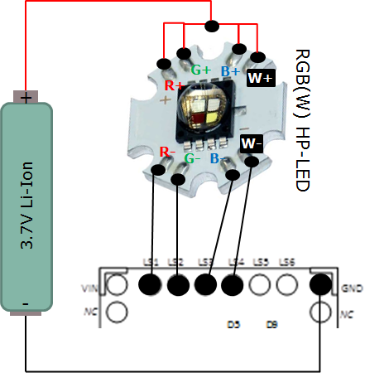

Figure : connection of the load to the Low-Side driver pins (LS1…LS6). Example shows wiring of an RGB(W) High-Power LED module on Star PCB. Current limiting resistors are not shown for simplicity’s sake.

### Gesture detection: MPU6050

# Getting started…

**Warning**: DIYino Prime is an electronic board containing parts sensitive to ESD. Final wiring & assembly is under the responsibility of the user with the appropriate tools and ESD protection. If you’re not familiar with ESD, please visit : [http://en.wikipedia.org/wiki/Electrostatic_discharge](http://en.wikipedia.org/wiki/Electrostatic_discharge%20)

The manufacturer cannot be held responsible for improper use or assembly of the DIYino Prime board.

# Board Supply Concepts

**Warning**: Please note that the DIYino Prime board does not implement a reverse polarity protection. Reversing the polarity of the supply might lead to board damage!

## Standard supply scheme

The DIYino Prime board shall be supplied from the VIN pin (similar to the Arduino Nano on which the DIYino design is based on). Due to the fact that the DIYino Prime board implements an 5V LDO between VIN and 5V pins, the voltage of the VIN pin has to be between 6V(min) and 20V(max).

Figure 2 shows wiring of the voltage source used to supply the board. This wiring scheme can be used if the voltage source has an output voltage between 6V(min) and 20V(max). The integrated LDO will regulate the input voltage on VIN to 5V and supply the rest of the components on the board. Please note that any VIN pin can be used to connect the voltage source to. The two VIN pins are connected together on the board.

If the USB cable is plugged in, i.e. as during sketch upload, the circuit will auto-select the higher voltage between the one supplied by the USB and the on board 5V LDO.

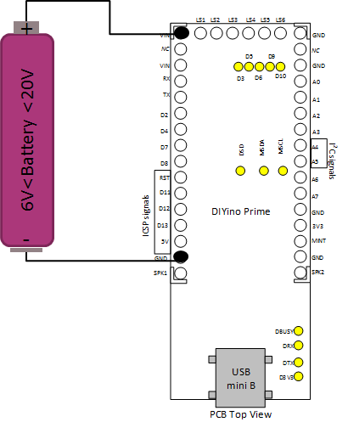

Figure : Standard supply wiring

## Alternate supply concepts

The standard supply scheme is explained in Chapter 4 The supply schemes introduced in the current Chapter are considered technically feasible to supply the DIYino Prime board, but due to the nominal supply requirements of certain circuit components and the uncertainty arising from static/dynamic behavior of the used external components (for instance DC/DC supply, battery etc.), the manufacturer does not take any liability nor does he guarantee performance of the board if the below described supply schemes are used. What does it mean in simpler terms?

1. In both cases the on-board LDO is bypassed and external components are directly wired to the supply node of sensitive IC’s (5V pin), without the LDO regulating this voltage to 5V. Glitches/transients on the external components might cause irreversible damage to the circuit components.
2. Some of the components are nominally rated for supply voltages close to 5V. Supplying them with a voltage below 5V might degrade their performance.
3. The board is not fully characterized for operation with less than 5V. Early results indicate the board works down to 3.1V, but it strongly depends on factors like contact resistances, IR-drop, parasitic effects etc.

### Sub-5V supply

Due to the

* limited space in the application builds: i.e. prop lightsaber hilts
* the capacity requirements of used batteries: typically >3000mAh, otherwise the saber migth shut-off prematurely during a show/presentation
* supply requirements of LEDs: except for serially connected LED-strings, other type of lightsaber light sources require a voltage source between 2V (Vth_typ of red LEDs) and 4V (Vth_max of Blue/Green LEDs).

Li-Ion batteries with a nominal voltage of 3.7V are the most commonly used voltage sources. They can be used to fully supply the DIYino Prime board, the wiring is shown in Figure 3. Instead of connecting the voltage source to VIN, it has to be connected directly to the 5V pin, which is the output of the 5V LDO. All parts directly supplied by the LDO (Atmega328 and FTDI chips) will be supplied now from the external voltage source. VIN can be left unconnected or if necessary it can be connected to the voltage source as well.

**Warning:** in case this supply scheme is implemented, please ensure to disconnect the power source from the DIYino Prime board before connecting the board via the USB cable to PC. Reason is, that the USB in this case will overforce the voltage of the power source, thus acting as a battery charger, which – based on the battery type and electrical characteristics, such as charging curve – can lead to battery damage.

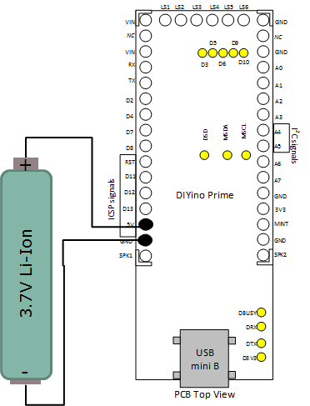

Figure : Supply of the DIYino board with a voltage source below 5V

### Supply using 5V DC/DC boost

As mentioned at the beginning of Chapter 4.2, supplying the DIYino Prime circuitry with less than 5V on the 5V pin/node might lead to performance and/or premature undervoltage reset condition. For this reason, a hybrid supply scheme is introduced here, which used a voltage source with a nominal voltage below 5V but still can supply the board circuitry with 5V. This scheme uses a so called DC/DC boost converter. A boost converter regulates (“boosts”) the voltage from a lower input voltage to a higher input voltage. Please use a DC/DC boost converter with a 5V output.

**Warning**: DC/DC boost modules which are not specially rated at 5V output voltage usually have an adjustable voltage output, which can far exceed 5V. Using such a DC/DC boost module could cause board damage if the output voltage is not set to 5V (or below)!

The clear advantage of this supply scheme is that the board is supplied with the required 5V for best performance, while the lower source voltage can be used to power the LEDs/other external circuits with nominal voltages below 5V.

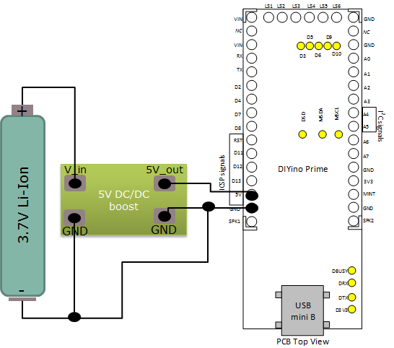

Figure : Supply scheme using 5V DC/DC boost converter

# Basic Wirings of external components

## Wiring buttons and speaker

Figure 5 shows wiring of the switches and that of the speaker.

The speaker has to be connected between the SPK1 and SPK2 terminals/pins of the board. 4Ω/8Ω speaker can be used, up to 3W output power. It does not matter which terminal of the speaker you connect to which pin.

Switches – latching or momentary, although mostly momentary switches are supported by Arduino libraries – are connected with one terminal connected to GND and the other terminal to a digital I/O. Please note that although in the Figure 5 the Main and Aux. switches are connected to D12 and D4 respectively, any digital I/O of the DIYino Prime board can be used from D2 to D13 and A0 to A5. Please note that certain pins have pre-defined functionality, please refer to the DIYino Prime schematics (A4 and A5, as well as D7 and D8 are used for communication between Atmega328 and the YX5200/MPU6050; A6 and A7 are analog inputs only. D2 is interrupt capable)

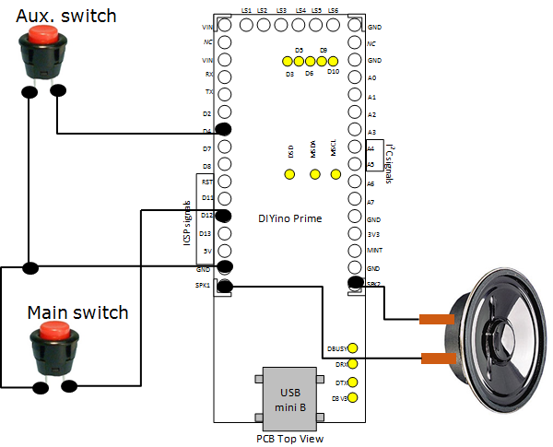

Figure : wiring switches and the speaker

## In-hilt recharge

It is very convenient if the battery does not have to be removed from the hilt every time it needs recharging. Therefore so called in-hilt recharge ports found a wide-spread use in saber hilts together with rechargeable batteries (most common type being the 3.7V type 18650). The wiring of the recharge port is depicted on Figure 6, showing the wiring only for the Standard Supply Scheme introduced in Chapter 4.1. The commonly used 2.1mm DC sockets have 3 terminals, one is wired to the rechargeable voltage source (~battery) negative labelled ***Battery(-),*** one to the Board GND labelled ***Board(-),*** and the third one labelled ***Battery(+) and Board(+)*** to both the rechargeable voltage source positive lead and to the Board. The exact connection of ***Battery(+) and Board(+)*** to the Board depends on the supply scheme used, described in the Chapter 4.

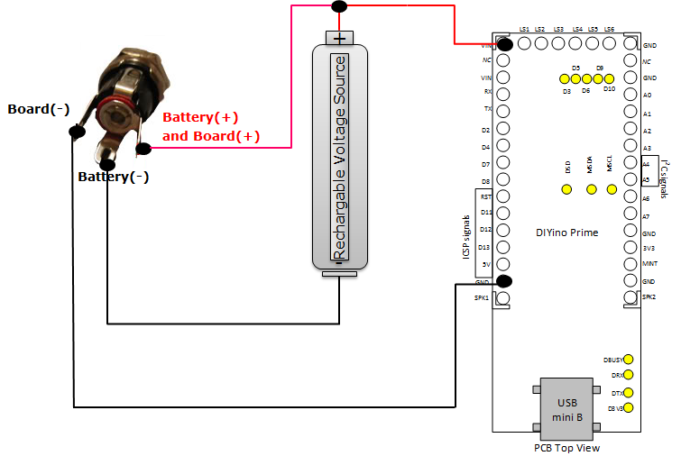

Figure : in-hilt recharge using a 2.1mm DC socket

## Audio controlled flicker

## Auxiliary signal wiring

## SD-Card preparation and Sound Font adjustment

## Upload software using Arduino IDE

# Electrical Characteristics

# Application Examples

**Warning** : High-power LEDs (such as the Luxeon, Cree atc. brand LED) and strings/stripes of LEDs (such as LED strings composed of many single LEDs or neopixel LED moduls such as WS2812B) are extremely bright. Especially High-power LEDs are considered "class 2 lasers"! You should neither look directly to the beam nor point someone with it when the light source is not diffused/blocked, just like a powerful lamp or flashlight. Manufacturer of the DIYino Prime board could not be held responsible for any bad use of high-power or other type of LEDs/LED modules. To avoid injuries and retina damage due to the high brightness of LEDs, always use protective googles or other means to avoid looking directly into the light source and also take care to protect others (like children) from being able to look directly into the light source.

In this Chapter the most common lighting options of saber designs will be discussed with application notes and wiring diagrams showing how these options can be interfaced to the DIYino Prime board.

**Caution:** in case of a High-Power LED or LED-string setups, you can use the LS pins to adjust the current flowing through the LEDs using PWM control (Pulse Width Modulation) of the transistor gates. The transistors connecting the cathode (-) of the LEDs to the GND can act as voltage controlled variable resistors, thus limiting the current through the LED. For those LEDs having a Vth above the battery voltage, this intrinsic current limiting is sufficient to ensure no overvoltage/overcurrent to the LED, while still offering the full dynamic range of brightness control. But in case the LED has a Vth below (or even far below) the nominal battery voltage (i.e. for red/amber/yellow LEDs), depending on the electrical characteristic of the LED, this intrinsic limiting might not be enough to ensure no overvoltage to the LED, which in turn can lead to damage or degradation of the life time of the LED. Even if the limiting through the transistors is deemed sufficient, during debug the PWM level can be set accidentally to a level which causes overvoltage. Last but not least, if only a small portion of the available PWM range can be used to control the brightness, it can lead to less smooth color transitions. Therefore in doubt please include a limiting series resistor, which can be calculated using the following formula:

Example: suppose you use a Red LED with Vth_LED=2V and you want the current to be I_LED=700mA, you use a Vbattery=3.7V, type 18650 battery. The value of the resistor you need to wire in series to the LED is:

Please check the power rating of the resistor you intend to use.

## High-Power RGB(W) LED setup

Figure 1 depicts connection of a High-Power LED module to the DIYino Prime. It depicts a 4-color LED module consisting of 4 LED dies in colors Red, Green, Blue and White. The same wiring can be extended to all different variants of HP-LEDs, like RGB, in which case only 3 of the available 6 Low-side drivers are used, or even for a single die HP-LED which can be controlled with a single Low-side driver.

Please note that that maximum DC current which can be switched by the LS pins is 1.1A. If the HP-LED used in the design involves LED dies with a max current above this rating, you must connect the cathode of the LED die to multiple of these LS pins to avoid violating the maximum rating of the transistors.

**Suitable supply schemes:**

* Sub-5V supply
* Supply using 5V DC/DC boost
* Standard supply scheme

## LED-String setup

## Neopixels setup

 “NeoPixel” is Adafruit’s brand for individually-addressable RGB color pixels and strips based on the **WS2812**, **WS2811** and **SK6812** LED/drivers, using a single-wire control protocol. Commonly used neopixels stripes are composed of individual LED segments connected together to form a ladder similar to LED-strings. The stripes can be cut at any joint and multiple striped can be connected together at these joints as well.

Neopixel LED modules integrate RGB LEDs and a control circuit which uses PWM (Pulse Width Modulation) to control the brightness of each individually. For that purpose each LED module has a shift register composed of 24-bits, 8-bits belonging to each color Red, Green and Blue. The shift registers are connected between the DI (Data-In) and DO (Data-Out) pins of the individual segments. In a stripe configuration one segment shift register is connected serially to the shift register of the next segment. If a blade has a stripe with 100LEDs, it means during programming 100x24=240bits of data have to be transmitted to the stripe using neopixels own serial protocol to fill up all PWM registers, which in turn determine the brightness of the LEDs. This takes only a few us, so programming can happen so fast, that transitions seem smooth to the eye.

A neopixel stripe has only 3+1 signals:

**5V**: supply of the stripe

**DI**: Data-In for the single-line serial protocol

**GND**: Ground or negative of the stripe

**DO**: Data-out, this signal has to be used only of you want to connect several stripes together which are not continuous (back-to-back stripes or think about the cross guard of a Kylo Ren style saber)

The specification of the neopixel LED segments defines 5V as nominal voltage for the stripes, however the module can work with a much lower voltage as well. A lower voltage is even necessary to minimize power loss during operation, because any excess voltage above the voltage threshold of the used LEDs (Red ~2V, Green and Blue ~3.5V) is “wasted” over protection circuits in the control logic. Therefore a voltage source around the LED Vth is ideal to power neopixel strings.

Neopixel striped can be wired to the DIYino Prime board in two different ways, illustrated in the following two Chapters.

### Basic neopixels wiring

The simplest way to connect neopixel stripe to the DIYino is to connect the Battery(+) of a 3.7V supply to the 5V terminal of the first segment of the stripe, the Battery(-) to the GND terminal of the first segment and a digital I/O (in this example D13 is used, as depicted on Figure 7) to the DI (Digital-In) terminal of the first segment.

Connection of the GND signal can be realized over the DIYino Prime GND pins as well. Please note that if you use in-hilt recharge, you connect the recharge port to the GND of the board and the stripe as in Figure 6.

**Suitable supply schemes:**

* Sub-5V supply
* Supply using 5V DC/DC boost

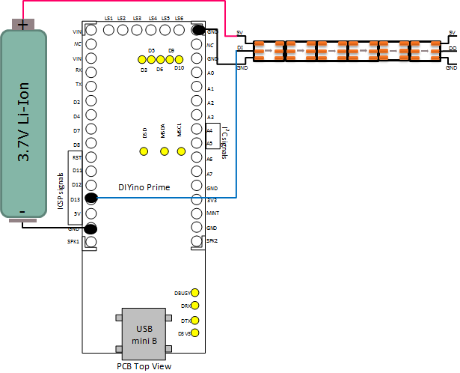

Figure : wiring of a neopixels stripe using 3.7V voltage source

### Neopixels wiring with programmable kill key

Neopixels chips consume power even when all the LEDs are switched off (all 0’s). This static current consumption amounts to 1mA per LED. You can quickly calculate what this means to your battery charge if you use – let’s say – 60LED/m type of neopixels, back to back, in a 80cm blade. There will be 100 LEDs in your blade, drawing 100mA even if all LEDs are switched off. It will even discharge the best battery in less than one day. It is not hard to predict, that with the introduction of the 144LED/m type neopixel striped, some blades will include much more than 100 LEDs, which will lead to an even quicker discharging of the battery. Killing power to the circuitry using a kill-key is a good method to lengthen the shelf life of your saber, but quite annoying during a show if you have to keep plugging in/out the kill key. Therefore I invented a unique method using the existing DIYino Prime architecture. If the GND pin of the neopixels stripe is connected to the LS pins instead of the GND of the battery/DIYino Prime, the transistors of the LS pins can be used to cut power to the neopixels stripe. If the blade is activated, the transistors have to be fully switched on (using the digitalWrite function) to connect the GND of the neopixels to the Battery(-), therefore powering the stripe. If the blade is retracted/switched off, the transistors have to be fully switched off in order to avoid the static current consumption of the stripes discharging the battery.

Connection of the GND signal can be realized over the DIYino Prime GND pins as well. Please note that if you use in-hilt recharge, you connect the recharge port to the GND of the board and the stripe as in Figure 6.

**Suitable supply schemes:**

* Sub-5V supply
* Supply using 5V DC/DC boost

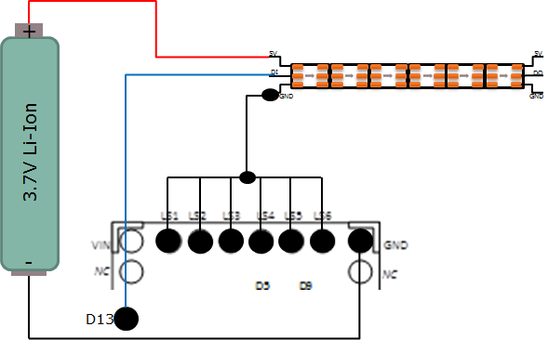

Figure : neopixels wiring using 3.7V voltage source, “kill-key” of LEDs thru LS pins

# Full wiring examples

## 7.4V supply LED-String setup with Serial-II or Serial-III technique

## RGBW High-Power LED setup with 3.7V supply and 5V DC/DC

## Neopixels setup with programmable kill-key and 3.7V supply

On Figure 9 the full saber wiring diagram can be seen. It includes

* an in-hilt recharge port
* 3.7V Li-Ion battery as voltage source (for instance 18650)
* A neopixels LED-stripe of (theoretically ☺ ) any length
* Programmable neopixels stripe kill-key setup
* A main and and aux. switches
* Speaker
* Connections for Audio controlled flicker

When connecting the programmable neopixels stripe kill-key, you have to calculate max. current consumption of your LED stripe and connect the LSx pins accordingly, i.e. if you anticipate 2A-3A’s, connect 3 of the LS pins to the GND terminal of the stripe. Up to max. 6A !!!

All considerations in the Chapters describing the individual parts of this circuit diagram apply here as well. Please read them carefully. These are:

Chapter 4.2.1

Chapter 5.1

Chapter 5.2

Chapter 5.3

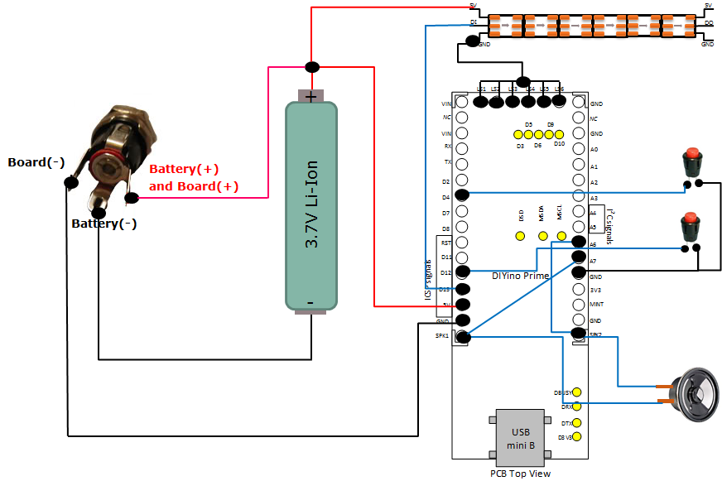

Figure : full wiring diagram of a neopixel stripe based saber

# Circuit schematics

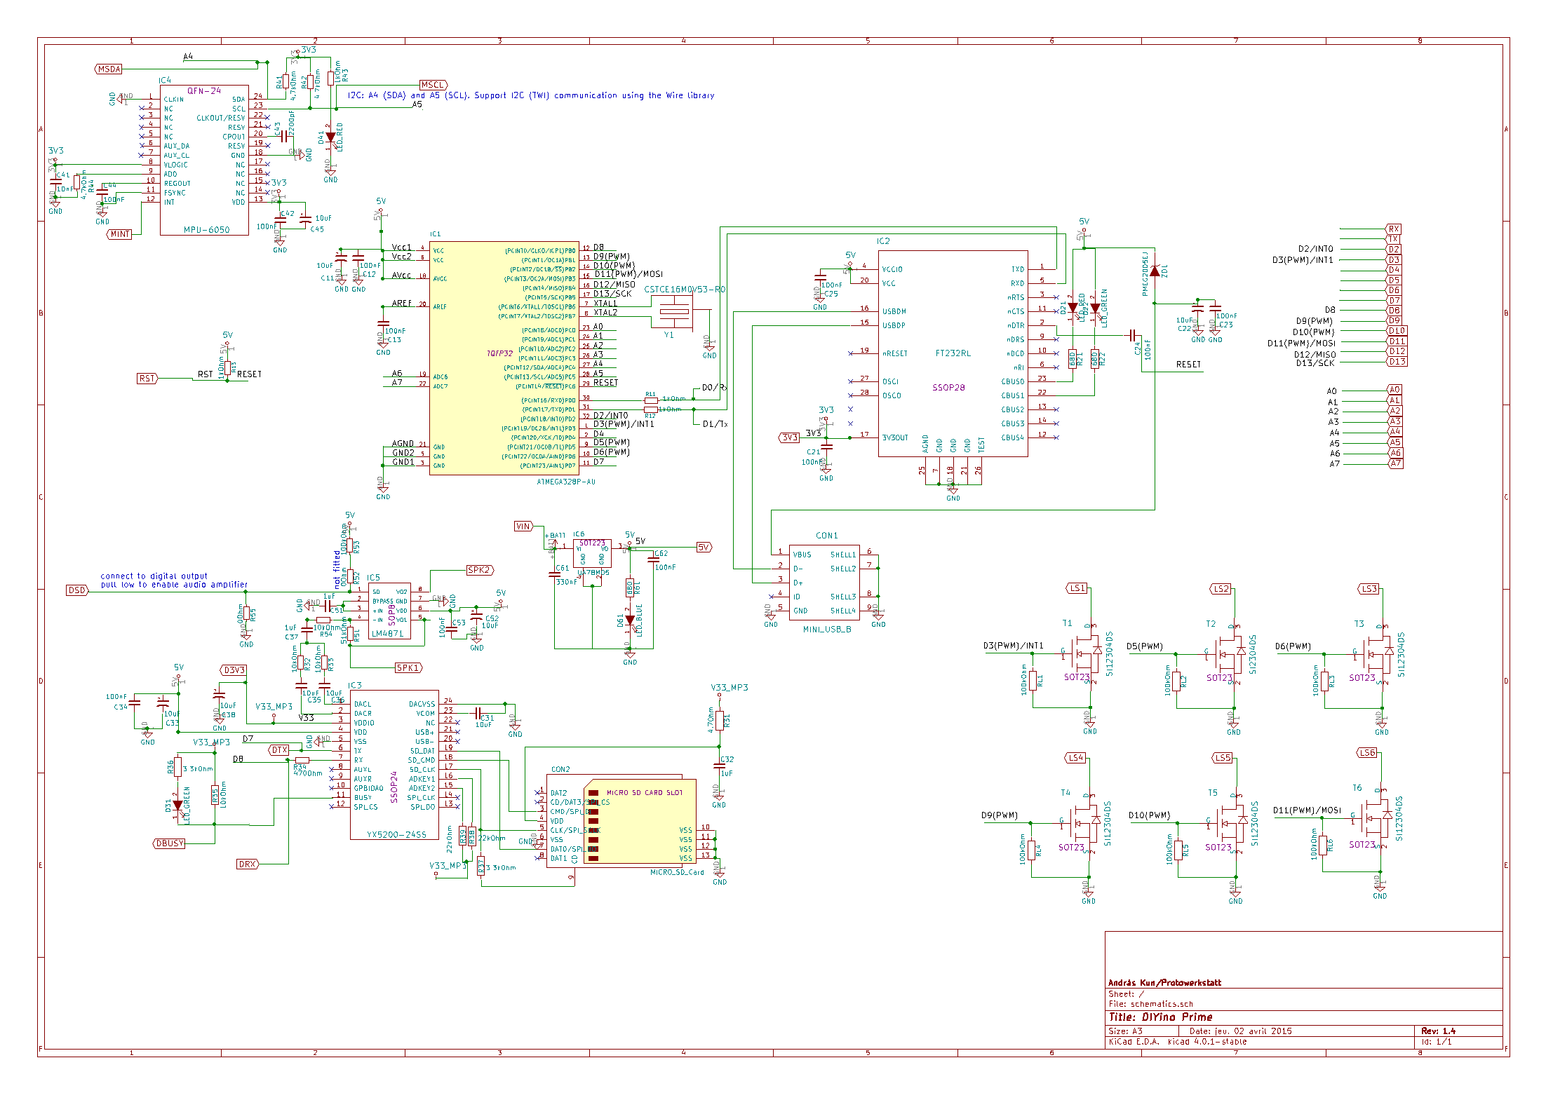

# Related links

LSOS: <https://github.com/neskweek/LightSaberOS>

USaber: <https://github.com/JakeS0ft/USaber>

LED-string wiring

Demo videos