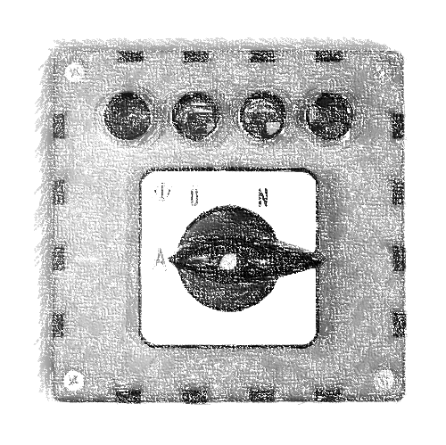**DefuseMe-Manual Style Guide**

Lorem ipsum dolor sit amet

**Rules for the Manual:**

* **One** **page** per DefuseMe-module
* Page must include a **picture/drawing/sketch/symbol** to identify the module (see top right)
* Each page should have its **own style**, layout and wording to look like from different authors, offices and centuries
* It should look like **used and Xeroxed** many times (coffee cup prints, dust, dirt, Xerox stipes…)
* The page footer must include **“defuseme.org”**, the module ID, manual file name. It can include the author and makers home page.
* Text should be **ANSI text** (not images) to support translations
* Manual page must be under a **Creative Common license**

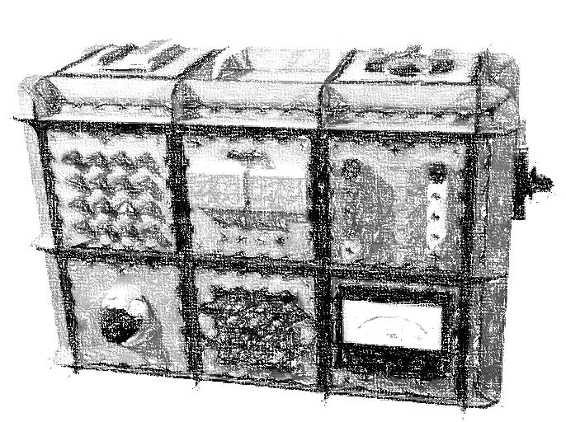

**Technical Details:**

* Page size is DIN A4 with left margin of min. 3.5cm (for punched holes) and rest margins of min. 1cm (printer limits)
* Type writer or matrix printer font (e.g. Gabriele, Fuckin Gwenhwyfar, McGarey) with size 12pt. Headlines should not be scaled to keep authenticity. Font must be free of license fees
* Final page is saved as printable PDF file with embedded fonts and images. PDF version ???
* Source of page should be in a format that can be opened/modified with free software (OpenOffice, Inkscape)

Lorem ipsum dolor sit amet