## CHAPTER 5

**RESULTS**

**5.1 Snapshots**

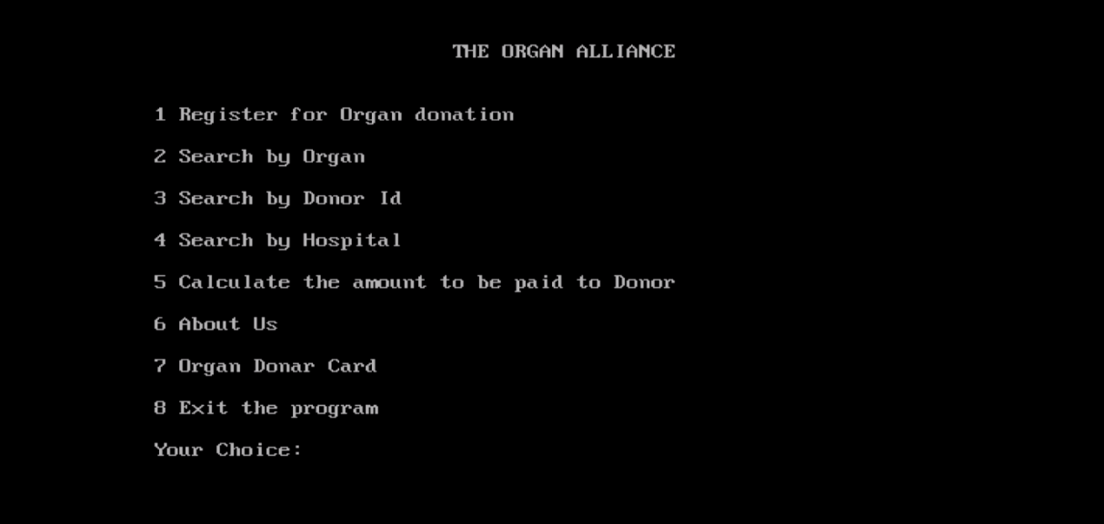

Figure 5.1

The Organ Alliance gateway will be displayed here when the application is run. Options are provided in the menu bar.

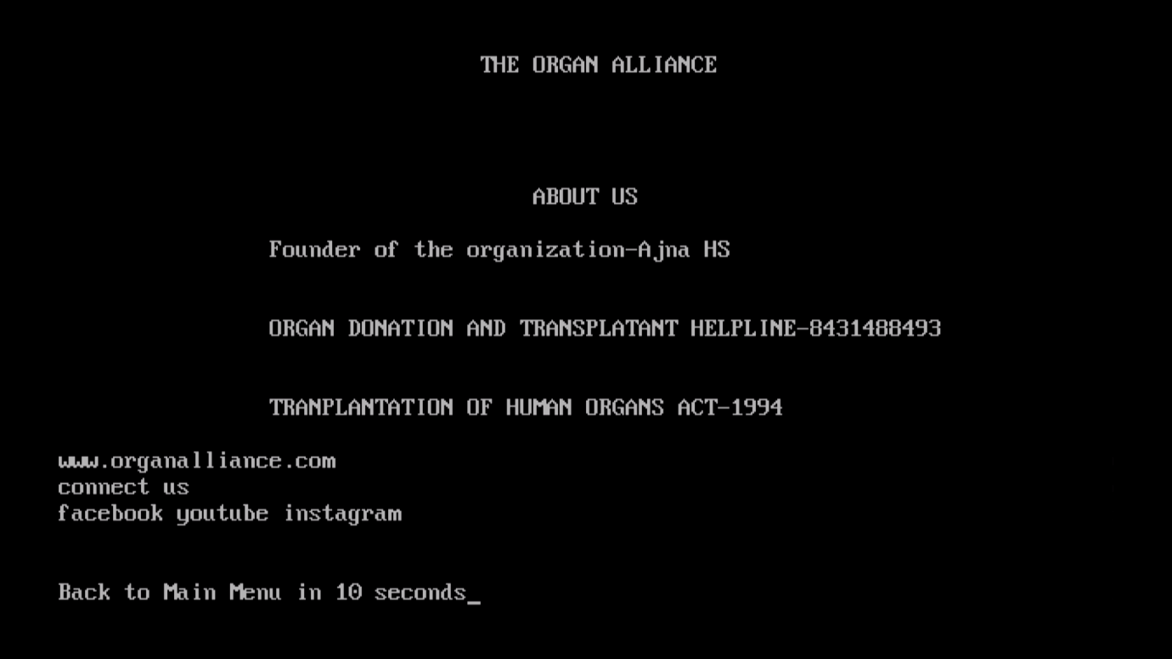

Figure 5.2

The rules and regulations are given here, along with contact information.

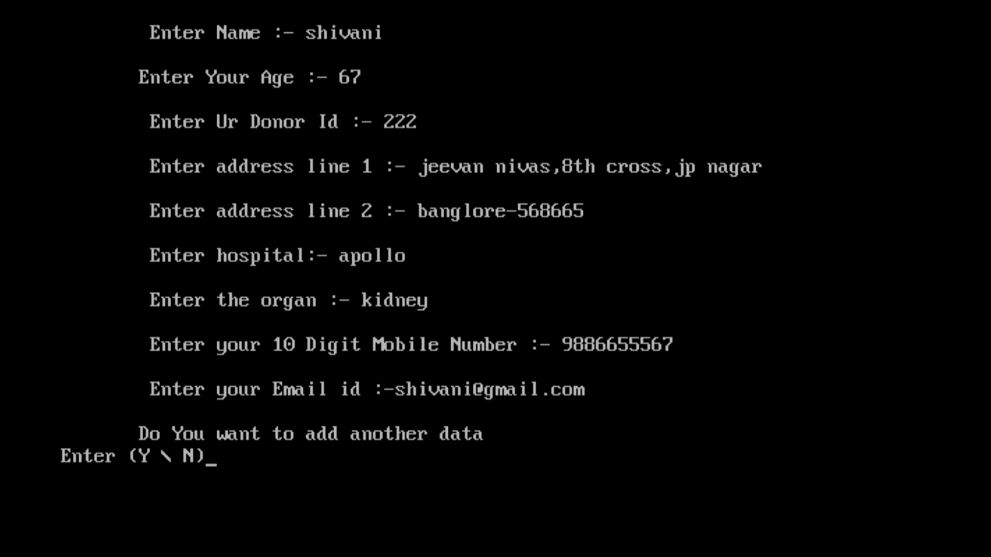

Figure 5.3

We can sign up to donate organs here. The name, address, hospital, email address, organ, and phone number must be filled out in order to register.

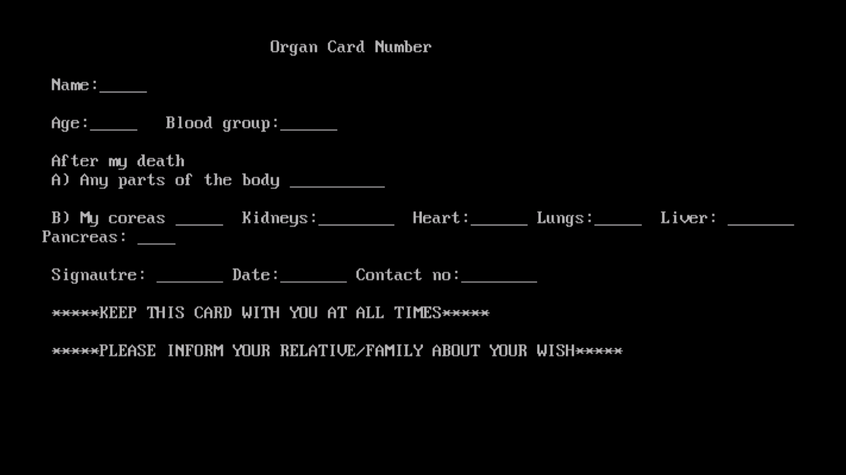

Figure 5.4

After registering for organ donation, a donor card is produced as proof, and the donor can give the card to a member of his or her family.

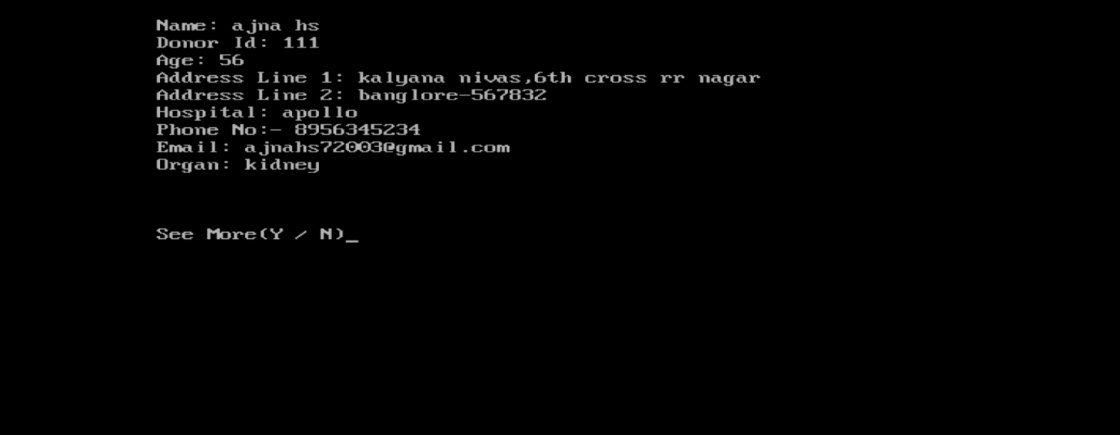

Figure 5.5

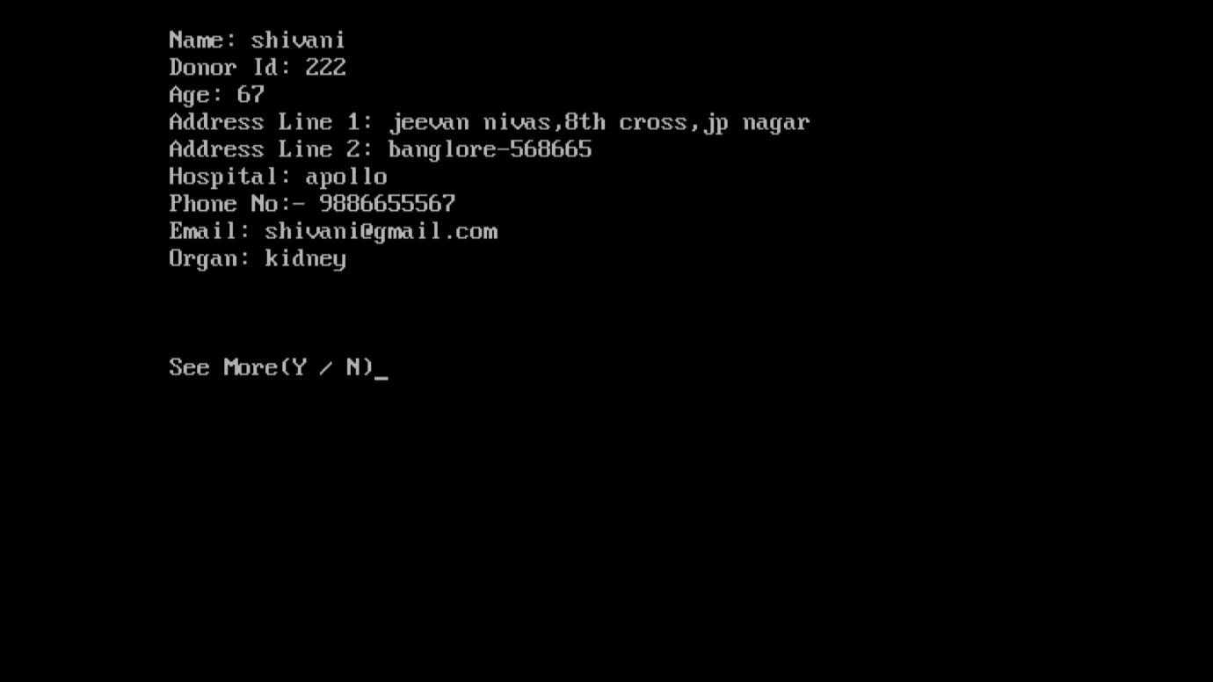

Figure 5.6

Here we can search the organ by search by organ option.All the list will be diaplayed one by one.

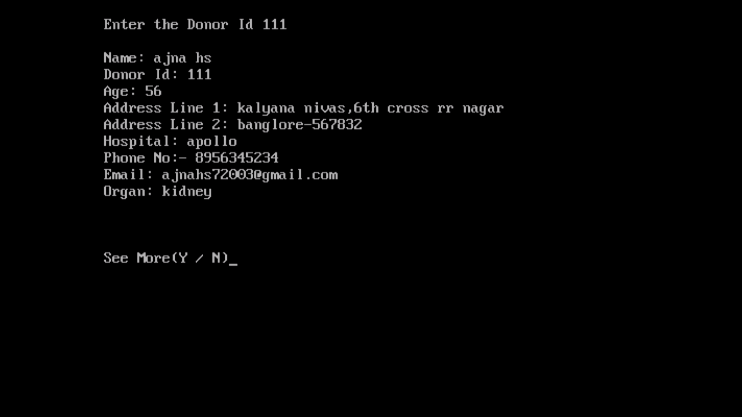

Figure 5.7

Here we can search the organ by search by donor id option.All the list will be diaplayed one by one.

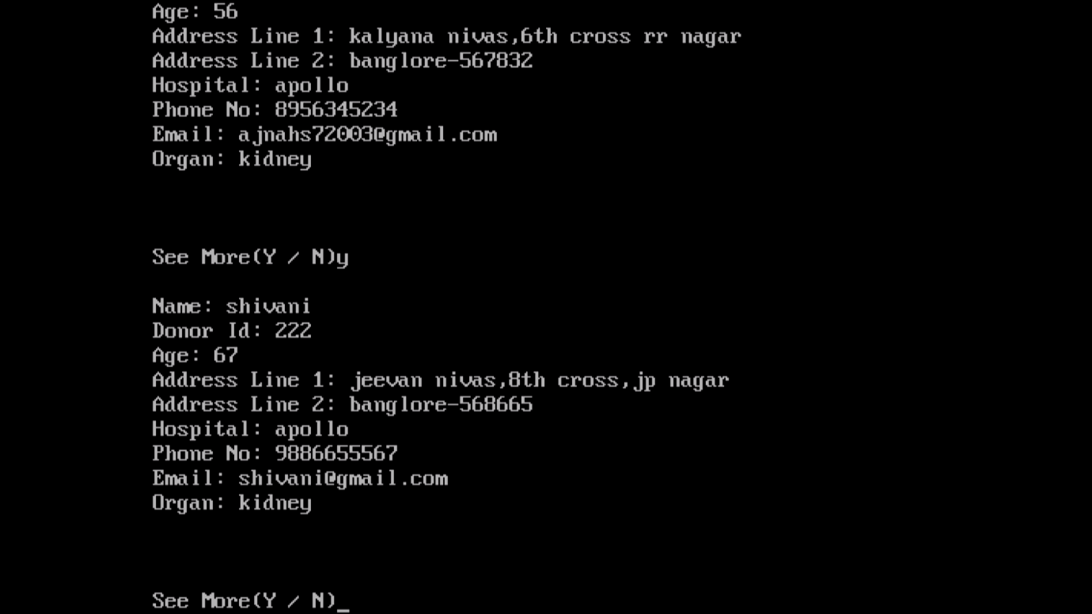

Figure 5.8

Here we can search the organ by search by hospital option.All the list will be diaplayed one by one.