PERSONAL PROJECT REPORT
VK DSA Sheet
Master Patterns. Solve Problems. Level Up.
A free, open-source, pattern-based DSA practice platform unifying LeetCode, GeeksforGeeks, TakeUForward and Codeforces — with built-in progress tracking, revision management, and a personal knowledge base.

Ajnabh Koushik Baruah
Creator & Developer
Email: ajnabhb.ug24.cs@nitp.ac.in
GitHub: github.com/AJNABH-KOUSHIK
Contact: +91 89782 10477
Live Demo: vk-dsa-sheet-vz9q.vercel.app
Submitted: July 2026

Table of Contents

1. Introduction & Problem Statement 3
2. The Idea Behind VK DSA Sheet 4
3. Core Features 5
4. Progress Tracking System 6
5. Practice Calendar & Knowledge Base 7
6. Technology Stack 8
7. System Architecture & User Flow 9
8. DSA Patterns Covered 10
9. Comparative Analysis 11
10. Product Walkthrough 12
11. Design Philosophy & Roadmap 13
12. Conclusion 13

1. Introduction & Problem Statement
Every coding platform promotes its own problem set — LeetCode, TakeUForward, GeeksforGeeks and Codeforces each have strengths, but none give students one unified, pattern-based place to practice, track, and revise.
Platform | What They Offer | What's Missing
LeetCode | Huge question bank | No pattern roadmap, no cross-platform tracking
TakeUForward | Striver's SDE Sheet | Limited to their own curated list
GeeksforGeeks | Topic-wise problems | No unified progress tracking across platforms
Codeforces | Competitive problems | No structured DSA sheet

The Real Issue
- Students jump between four or five platforms with no single place to track everything
- Sheets exist, but they are just lists — no pattern-based learning
- No way to mark revision status separately from completion
- No personal bookshelf, link storage, or notes alongside practice
- No calendar view to visualize coding consistency
- No difficulty-wise breakdown (Easy / Medium / Hard) with progress

There is no completely free website that combines LeetCode + GFG + TUF + Codeforces + Pattern Names + Progress Tracker all in one place — until now.

2. The Idea Behind VK DSA Sheet
The frustration was simple: every creator and every platform promotes their own sheet. As a student, the goal was one place to see all patterns — not just topics like "Arrays," but actual patterns like Sliding Window, Two Pointers, and Kadane's Algorithm — pull questions from every major platform, and track progress, revision, and personal notes together.

What the Platform Set Out to Deliver
- See ALL patterns, not just broad topics
- Pull questions from LeetCode, GFG, TUF and Codeforces — all in one place
- Track what has been COMPLETED
- Track what needs to be REVISED, separately from completion
- Store favourite BOOKS
- Save important LINKS
- Write personal NOTES
- See practice history on a CALENDAR
- See a difficulty breakdown — Easy, Medium, Hard
- Have all of this PERSIST with a secure login

"No such website existed. So I built one."

3. Core Features

Pattern-Based Learning
Instead of solving questions at random, learners work through the way interviewers actually think — by recognizing patterns, not memorizing individual problems.
- 16 pattern categories: Arrays, Binary Search, Strings, Bit Manipulation, Linked List, Two Pointers, Sliding Window, Stacks & Queues, Greedy Algorithms, Heaps, Binary Trees, BST, Graphs, Tries, Dynamic Programming and more
- Sub-pattern breakdown for each category — e.g. Arrays splits into Array Traversal, Rotate Array, Brute Force Subarray, Kadane's Algorithm, and Dutch National Flag
- Every pattern sources problems from LeetCode, TakeUForward, GeeksforGeeks and Codeforces

Personal Knowledge Base
Feature | Description
Search | Quickly find any pattern or question
Books | Store favourite DSA books plus recommended titles
Links | Save important links — YouTube videos, articles, editorials
Notes | Write personal notes for any topic or question

User Authentication
- Secure Login / Sign-Up powered by Firebase Authentication
- Persistent data — progress, books, links, and notes all saved to the account
- Cross-device sync — log in from anywhere and pick up where you left off

4. Progress Tracking System
Every question can be marked complete AND separately flagged for revision — a dual-tracking feature missing from almost every existing DSA sheet.
Element | Description
Completion Tick | Mark a question as done
Revision Tick | Separately mark a question for a second pass
Progress Bars | Visual progress for each sub-pattern, e.g. 5 / 16
Circular Progress Ring | Overall completion indicator, e.g. 11 / 65
Difficulty Counter | Tracks Easy, Medium and Hard problems solved
Beats Percentage | Shows how a learner compares against others, e.g. "Beats 2.5%"

Example — Dashboard Snapshot
Metric | Value
Total Solved | 12 Problems
Easy / Medium / Hard | 5 / 7 / 0
Overall Completion | 11 / 65 patterns
Beats Percentage | 2.5%

5. Practice Calendar & Knowledge Base

GitHub-Style Practice Calendar
- A GitHub-style calendar shows which days a learner practiced
- Daily streak tracking highlights active days
- Monthly view lets learners navigate through their history
- A detailed practice log records questions solved per day

Personal Knowledge Base (Sidebar)
Beyond the sheet itself, the platform doubles as a coding-journey companion — not just a problem list.
Feature | Purpose
Books | Recommended DSA books plus user-added favourites
Links | Saved YouTube videos, blog posts and editorials
Notes | Personal notes written for any topic or problem
Search | Instant lookup across every pattern and question

6. Technology Stack
Layer | Technology
Frontend | React, JavaScript, HTML5, CSS3
Backend / Database | Firebase Authentication + Cloud Firestore
Deployment | Vercel
Version Control | Git & GitHub

Libraries & Tools Used
Library / Tool | Purpose
React | Component-based UI framework
Firebase Auth | User authentication (Login / Sign-Up)
Cloud Firestore | Real-time database for storing user progress
React Router | Client-side routing and navigation
CSS3 / Custom CSS | Styling with dark theme and animations
Vercel | Production deployment and hosting
Git & GitHub | Version control and collaboration

7. System Architecture & User Flow
The application takes a visitor from an anonymous browse session all the way to a synced, cross-device practice habit.
Step | What Happens
1. Visit & Browse | Explore all DSA patterns — no login required
2. Login / Sign Up | Secured via Firebase Authentication
3. Pick a Pattern | Pattern -> Sub-pattern -> Question
4. Solve & Mark | Mark complete, or flag for revision
5. Sync in Real Time | Progress saved instantly to Cloud Firestore
6. Track Consistency | Calendar, stats, notes and links — available on every device

Flow Summary
User Visits -> Browses Patterns -> Login / Sign Up -> Selects Pattern -> Solves Question -> Marks Complete or Revision -> Progress Saved to Firebase -> Views Calendar & Stats -> Stores Books / Links / Notes -> Continues from Any Device

8. DSA Patterns Covered
Sixteen pattern categories give a complete, interview-ready roadmap across every major data structure and algorithm family.
# | Pattern | Sub-Patterns
01 | Arrays | Traversal, Rotate, Kadane's, Dutch National Flag
02 | Binary Search | Standard, on Answers, on Rotated Arrays
03 | Strings | Matching, Palindromes, Anagrams
04 | Bit Manipulation | XOR Tricks, Bit Masking, Power of Two
05 | Linked List | Reversal, Fast & Slow Pointer, Merge
06 | Two Pointers | Opposite / Same Direction, Three Pointers
07 | Sliding Window | Fixed, Variable, Shrinkable
08 | Stacks & Queues | Monotonic Stack, Next Greater Element
09 | Greedy Algorithms | Activity Selection, Fractional Knapsack
10 | Heaps | Top-K Elements, Merge K Sorted, Median
11 | Binary Trees | Traversals, Views, Diameter, LCA
12 | BST | Search, Insert, Delete, Validate
13 | Graphs | BFS, DFS, Dijkstra, Topological Sort
14 | Tries | Insert, Search, Prefix Matching
15 | Dynamic Programming | 1D / 2D DP, Knapsack, LIS, LCS
16 | More… | Additional patterns added regularly

9. Comparative Analysis
VK DSA Sheet is the only platform in this comparison that combines a pattern-wise roadmap, multi-platform questions, dual progress tracking, a practice calendar, and a personal knowledge base — while remaining completely free.
Feature | LeetCode | TUF Sheet | GFG Sheet | NeetCode | VK DSA Sheet
Pattern-wise Roadmap | – | ~ | – | ~ | ✓
Multi-Platform Questions | – | – | – | – | ✓
Progress Tracking | ~ | ✓ | – | ✓ | ✓
Revision Tracking | – | – | – | – | ✓
Practice Calendar | ✓ | – | – | – | ✓
Personal Notes / Books / Links | – | – | – | – | ✓
Completely Free | – | ✓ | ✓ | – | ✓

Legend: ✓ = fully supported ~ = partially supported – = not supported

10. Product Walkthrough
The dashboard is the first thing a learner sees after logging in — pattern categories, a live progress ring, difficulty breakdown, and a GitHub-style calendar, all visible at a glance.
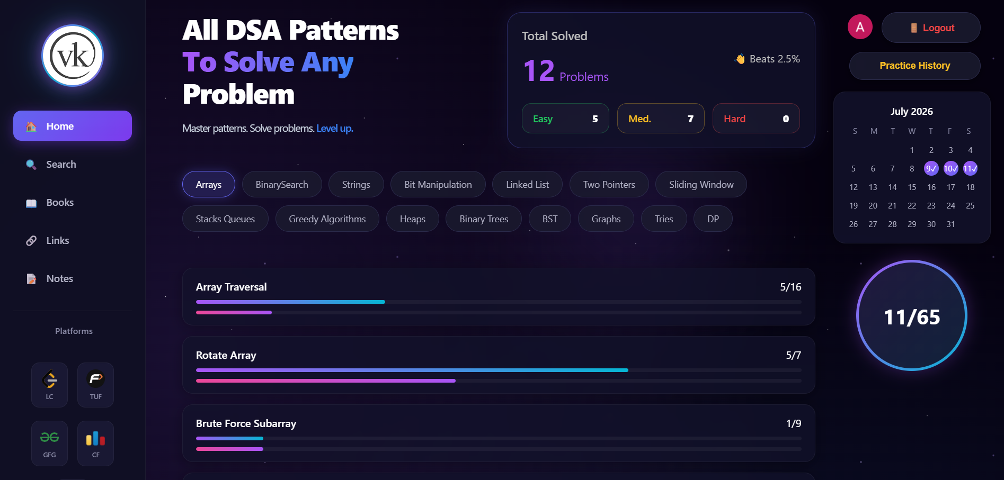
Fig. 1 — All DSA Patterns dashboard, showing live progress and calendar tracking

11. Design Philosophy & Roadmap

Design Principles
- Dark theme — easy on the eyes for late-night coding sessions
- Purple & cyan gradient — a modern, developer-friendly identity
- Fully responsive — works cleanly across desktop, tablet and mobile
- Real-time sync — Firebase keeps every device instantly up to date

Roadmap Ahead
- Expand beyond 16 patterns with community-suggested additions
- Add contest / company-wise question tags (FAANG, product-based)
- Introduce streak rewards and a leaderboard for friendly competition
- Build a mobile app version for on-the-go revision

12. Conclusion
VK DSA Sheet was built to solve a problem every DSA learner faces: too many platforms, no single place to track patterns, progress, and revision. By unifying LeetCode, GeeksforGeeks, TakeUForward and Codeforces into one pattern-based roadmap — with real-time tracking, a practice calendar, and a personal knowledge vault — it gives learners one home for their entire coding-interview journey, completely free.

Try it now: vk-dsa-sheet-vz9q.vercel.app

