Die Fledermaus (Iris Theatre)
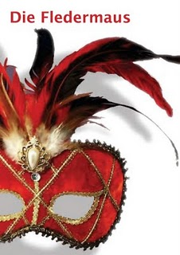
After their gobsmackingly brilliant "A Midsummer Night's Dream", I came dashing back for Iris Theatre's "Die Fledermaus". Despite many of the cast's best efforts I came away rather disappointed. With little ingenuity, this production ended up looking threadbare, a deficit of good ideas compounding budgetary constraints.
Their "AMND" took the setting as the very basis of the evening, they use the setting here as merely a space in which to perform the operetta. The end result is a spartan production in an uncomfortable building. All this would be fine of course, if the staging worked, but it really doesn't. Languishing in cod-farce, slapstick moments mixing with gauche dialogue, it might have worked with actors but it doesn't with singers. The highlight of the evening came from the only actor in the cast, an un-credited performer playing Frosch absolutely bringing the house down with perfect timing and physicality. Much looked scrappy and under-rehearsed, the glorious dance of Act II a real mess.
The quality of the singing is impressive. An extremely young cast who gave it their all. Andrew Dickinson's "Gap Yahh" Eisenstein didn't really work, but he delivered the notes with a bright winning tone. Felicity Hayward never quite convinced at the top but brought a likeable persona to bare. Amy J Payne sold the hijinks better than any of the other singers and mustered some warm singing. Sarah Gabriel sounded a touch breathy and, like most the cast, dramatically switched accents when moving between speech and sung material. Whilst it made the words a good deal clearer, dramatically it made little sense for the lower class servant to suddenly burst out in pure received pronunciation.
There wasn't anything particularly wrong with this production but without a spark of originality, the end result looked what it was, rather than rising above: a low budget effort in an awkward space. A pity, if they'd brought a tenth of the imagination they applied to "AMND", using this cast and space, they could have made something excellent.

