meet Amy J. Payne, young British mezzo
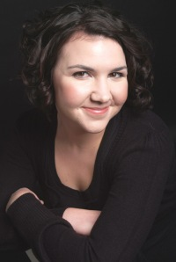
Mezzo Amy J. Payne
Amy J. Payne is a vivacious British mezzo-soprano who is amassing an interesting collection: glittering reviews. She’s being singled out for her performances, as in the comic opera Spinalba:
“Particularly successful in both facets was Amy J. Payne as Dianora.”
–Nick Breckenfield
And in Dialogues des Carmelites at theGuildhall School of Music and Drama:
“Amy J Payne gave a truly remarkable performance as Mere Marie. Payne conveyed a strength and depth of experience in her performance which is rare, she gave Mere Marie a real feeling of solidity.”
–Robert Hugill
She graduated with a Masters in Performance with Distinction in November 2010 from the Guildhall School of Music and Drama, where she was taught by Theresa Goble. She also holds an Honors degree in French and German fromKing’s College, London.
At conservatoire, she has been directed in projects by Graham Johnson MBE (Vaughan Williams concert series, Nov 2008), Iain Burnside (Lads in their Hundreds, Jan 2009) and Sarah Walker CBE (Messiah, March 2009). In 2009 she was recipient of The School’s English Song Prize and won The Susan Longfield Competition. Last year she made her Barbican Hall debut with The Guildhall New Music Ensemble in Voices (Henze). Amy’s studies on the Opera Course at GSMD are very generously supported by Serena Fenwick.
As well as developing a career on the classical concert platform and on the operatic stage, Amy is a founder member of The Bombshellettes, the UK’s only 15-piece all-female swing orchestra.
Welcome to “Operatoonity,” Amy. It’s a pleasure to feature you this month–our first mezzo soprano.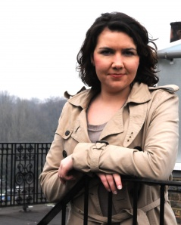
Where did you grow up, what was your home life like, and how did it affect your life choices?
I grew up in a town called Newton Abbot in South Devon, UK., so I was exposed to a good mix of rural and urban living. I was blessed with a very happy childhood with one younger sister and parents and grandparents who provided every opportunity for us within their means. In terms of my life choices, I have have always felt that I have been ‘allowed’ to follow whichever path I choose and I felt that my upbringing gave me many choices as to which direction to take. My decision to follow a musical path was met with some concern by my family at first, but to their absolute credit they have always supported my determination to succeed.
When did you make the decision to pursue classical vocal performance as a career?
In some ways I think I had always wanted to sing, but then I guess almost every six-year old girl wants to be a pop star! I remember singing constantly; making up songs and singing them to myself in the garden or in the school playground. I used to pretend to be Ariel the mermaid for Disney’s A Little Mermaid a lot! I enjoyed mimicking other voices. But the big moment came when I went to London with my mum and granny to see The Phantom of the Opera. I must have been about eight and became absolutely obsessed with the show. It made a huge impression on me, and I quickly learnt the whole piece by ear, with the aid of my double cassette original London cast recording and a libretto. Of course I wanted to be Christine, and I think probably then the first real seeds of an idea to sing for a living were planted then. Yet despite my mum encouraging me to join the local church choir, I didn’t really have the confidence, although later on I attended Newton Abbot Amateur Dramatic Society for a time. It wasn’t until I was fifteen that I had my first singing lesson (originally as a bit of a joke with my best friend!) and the teacher, Carolyn Harries, in her own words ‘got her claws into me’ and that was it, I was going to be a classical singer and no-one was going to stop me!
How would you describe your voice? When critics say ‘quirky,’ what do they mean?
This is a very difficult question! My voice is my voice and I can’t imagine having another. I feel lucky that when I sing I am recognisable as me and I guess that must be what critics mean by ‘quirky’. I stick out from the crowd a bit, which I like to think is a good thing! One thing I will say though is that I like my voice, I don’t mean to sound arrogant, but I think it is important to love your own sound, not least because you’re stuck with it, and it is surprising how many singers you meet, who confess to not being fond of their own sound! I don’t think I would singing if I didn’t think I had something worth hearing.
How is the UK as a location to launch a professional singing career?
I suppose I have to answer ‘great’ to this question, as so far so good for me! Although I want to see the world through my singing, and am a very definite Europhile, having lived in France, Germany and Austria, I hope that my career stays rooted in the UK. I certainly intend to start my career here. Of course if opportunities dry up, I may have to look elsewhere and that would probably be Germany, but for now I am giving it my best shot here and hope it eventually takes me to other shores.
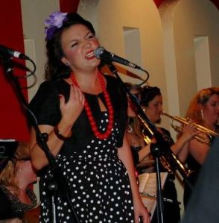
Singing with the Bombshellettes
You also sing in a swing band. What is your role with the Bombshellettes? (I watched a YouTube video of you singing “Apple Blossom Time”–Andrews Sisters style. In a word–fab!)
I’ve always been interested in keeping my vocal activities as broad as possible. Having sung in musicals, chamber choirs, operas and big bands, I feel lucky that I can use my voice in different ways and don”t see why I should stop doing that so long as one technique doesn’t interfere with another. When the opportunity to sing with The Bombshellettes (the only UK all-female swing orchestra) came up about two years ago, I jumped at the chance and was delighted when they were happy to take on an opera singer! Having sung and played saxes with the big band at Exeter College, where I studied A-Levels in Music, English, French & German, I really missed the ‘swing thing’ and the opportunity to be part of this new ’1940′s girl band’, came just after I had returned to Exeter to sing with a band made up of college alumni and I well and truly caught the bug again. I don’t really play much anymore, so I just sing with the band – and it is so much fun! It’s lovely to perform when your sole purpose is to make people smile and dance – quite a nice antidote to the constant critical ears one is performing to in the classical world!
You’ve done opera performance, oratorio and recitals? Do you prefer one over the others?
Opera is without a doubt my favourite genre, although I do enjoy recital very much also, and hope my careers takes me in a direction where I can do both. I find oratorio the most nerve-wracking of the three, but when a performance goes well, it is often the most rewarding, as things are often rehearsed only on the day with all performers and can be a bit of an unknown quantity. However my real passion is for getting inside a character and finding their physicality and their voice. I am never happier than when getting to grips with a new operatic acquaintance in the rehearsal room. I feel the most creative freedom on the operatic stage and despite, portraying somebody else, I probably expose most of myself in an operatic performance than in recital or oratario.
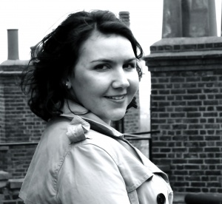What would you like to be doing in five years? Ten years?
In five years, as in ten years, I would love to be enjoying a busy and varied career of opera and concert work, and hopefully with a bit of swing and musical theatre thrown in for good measure. I am very at home in London, so I’d hope to be even more settled here, with maybe a place elsewhere where I could walk my dogs!
To what extent have you embraced social media and how has it impacted your career or visibility?
I’ve had a website now for about a year, and until recently I really hadn’t noticed it had made any difference, but I felt it was important that I was in control of what people would see if they ‘googled’ me. In fact, you are the first person to contact me through it! But I hope people do go onto it and have a clearer idea of what I am about! I have been using Facebook for many years and some months ago joined Twitter in order to keep Facebook more for social purposes. Twitter so far has proved very useful for professional purposes. Keeping up with the latest developments in the opera world is fairly easy to as most houses and companies have Twitter accounts and jobs are also occasionally advertised. So overall, certainly useful. I have been booked for several gigs now through Facebook or found audition notices, and Twitter has raised exposure for my website and brought about my first interview!
What is something most people don’t know about you, something not on your resume?
I am a huge fan of Robbie Williams, born of being a Take That teeny-bopper! It is an ambition to sing with him one day – I’d kill to be a backing singer on tour!
Where can we expect to see/hear you in 2011?
This year I am making my summer opera festival debut at Garsington Opera. I am covering the role of the Second Lady in The Magic Flute and singing in the chorus. Later on in the summer I shall be at the St. Endellion summer festival, singing Schwertleite in Die Walkuere. I know I am a bit young for Wagner, but it was an opportunity to share a stage with some of the UK’s greatest living Wagnerians (Susan Bullock and Robert Hayward to name a couple!), and I couldn’t turn it down! It should be a wonderful fortnight-long masterclass! Yet before all that there is a recital of Handel and Purcell here in London.
* * *

To learn more about Amy and her promising career, visit her website, follow her on Twitter @AmyJPayne or friend her on Facebook.

