**Landing Page:** This is the page where the user can Sign up/Sign in to Connect\o The Social Networking Site.

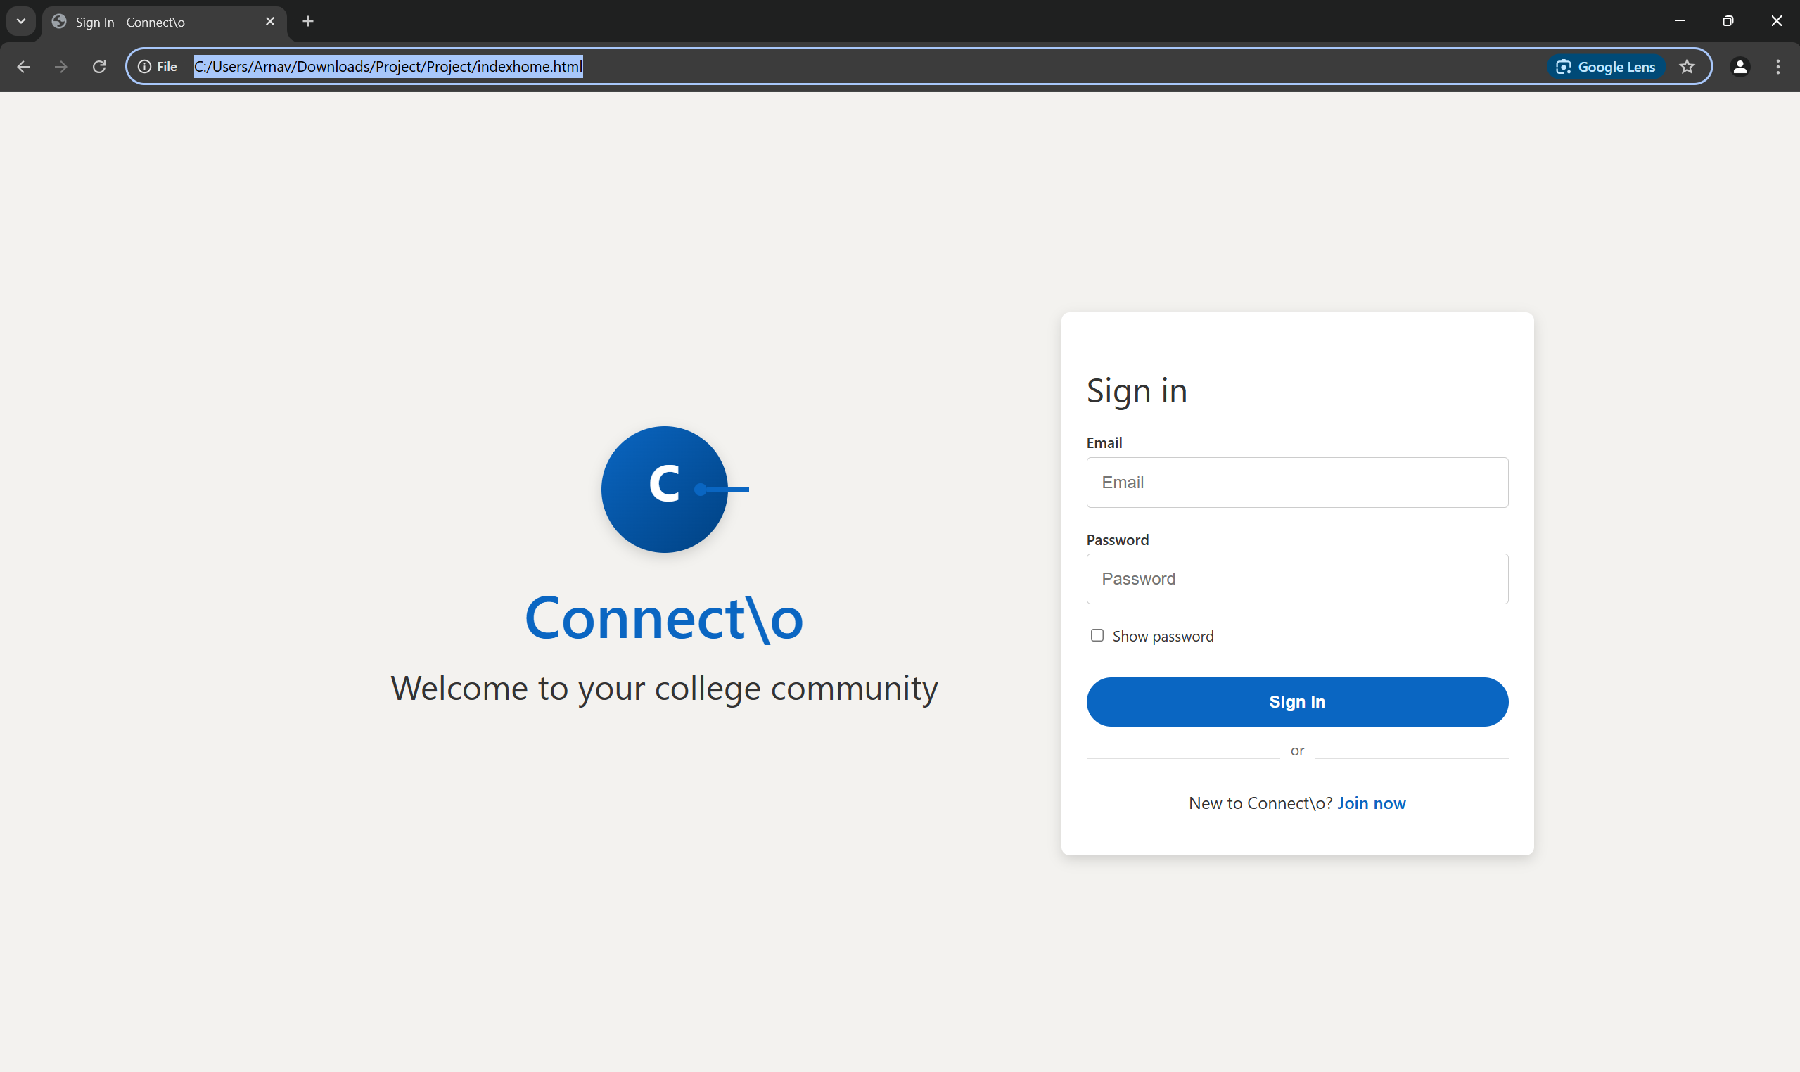

**Home Page:** The hub to navigate to other pages(tabs) and allows the user to post, like post of user and other people, comment and share the posts.

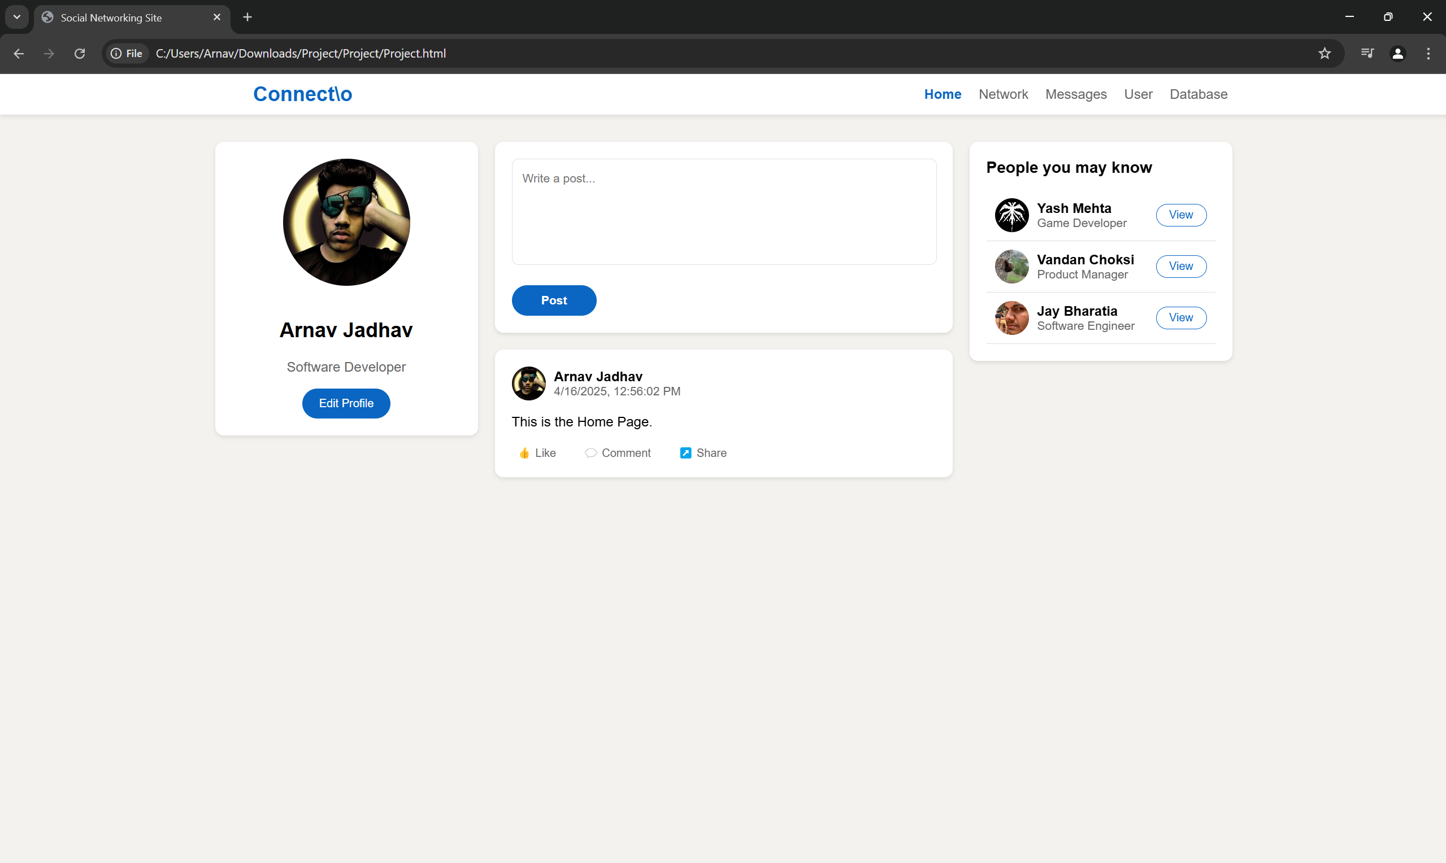

**Network Page:** Allows the user to view groups and people you(the user) may know.

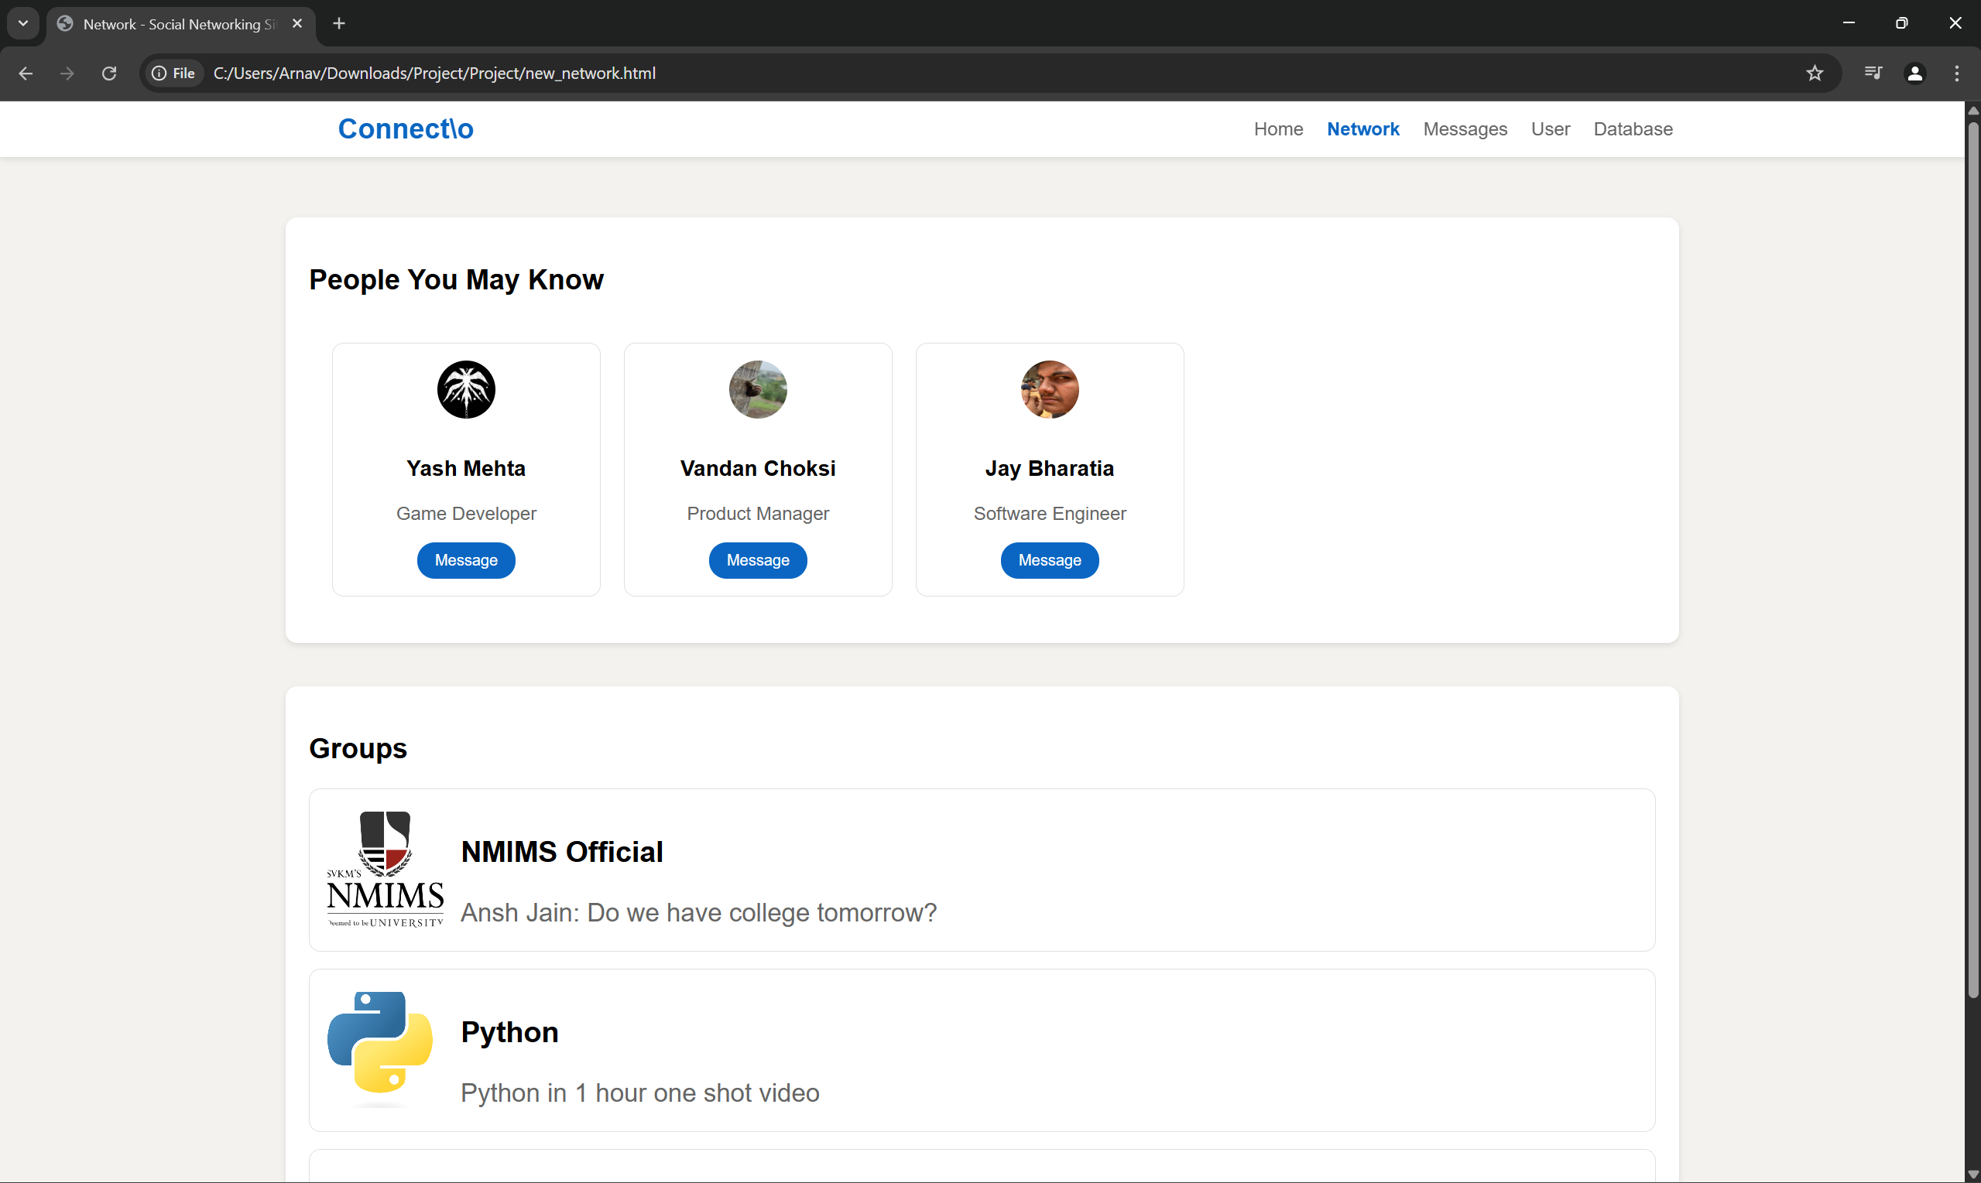

**Messages Page:** This is the page where you can message people directly or in a group.

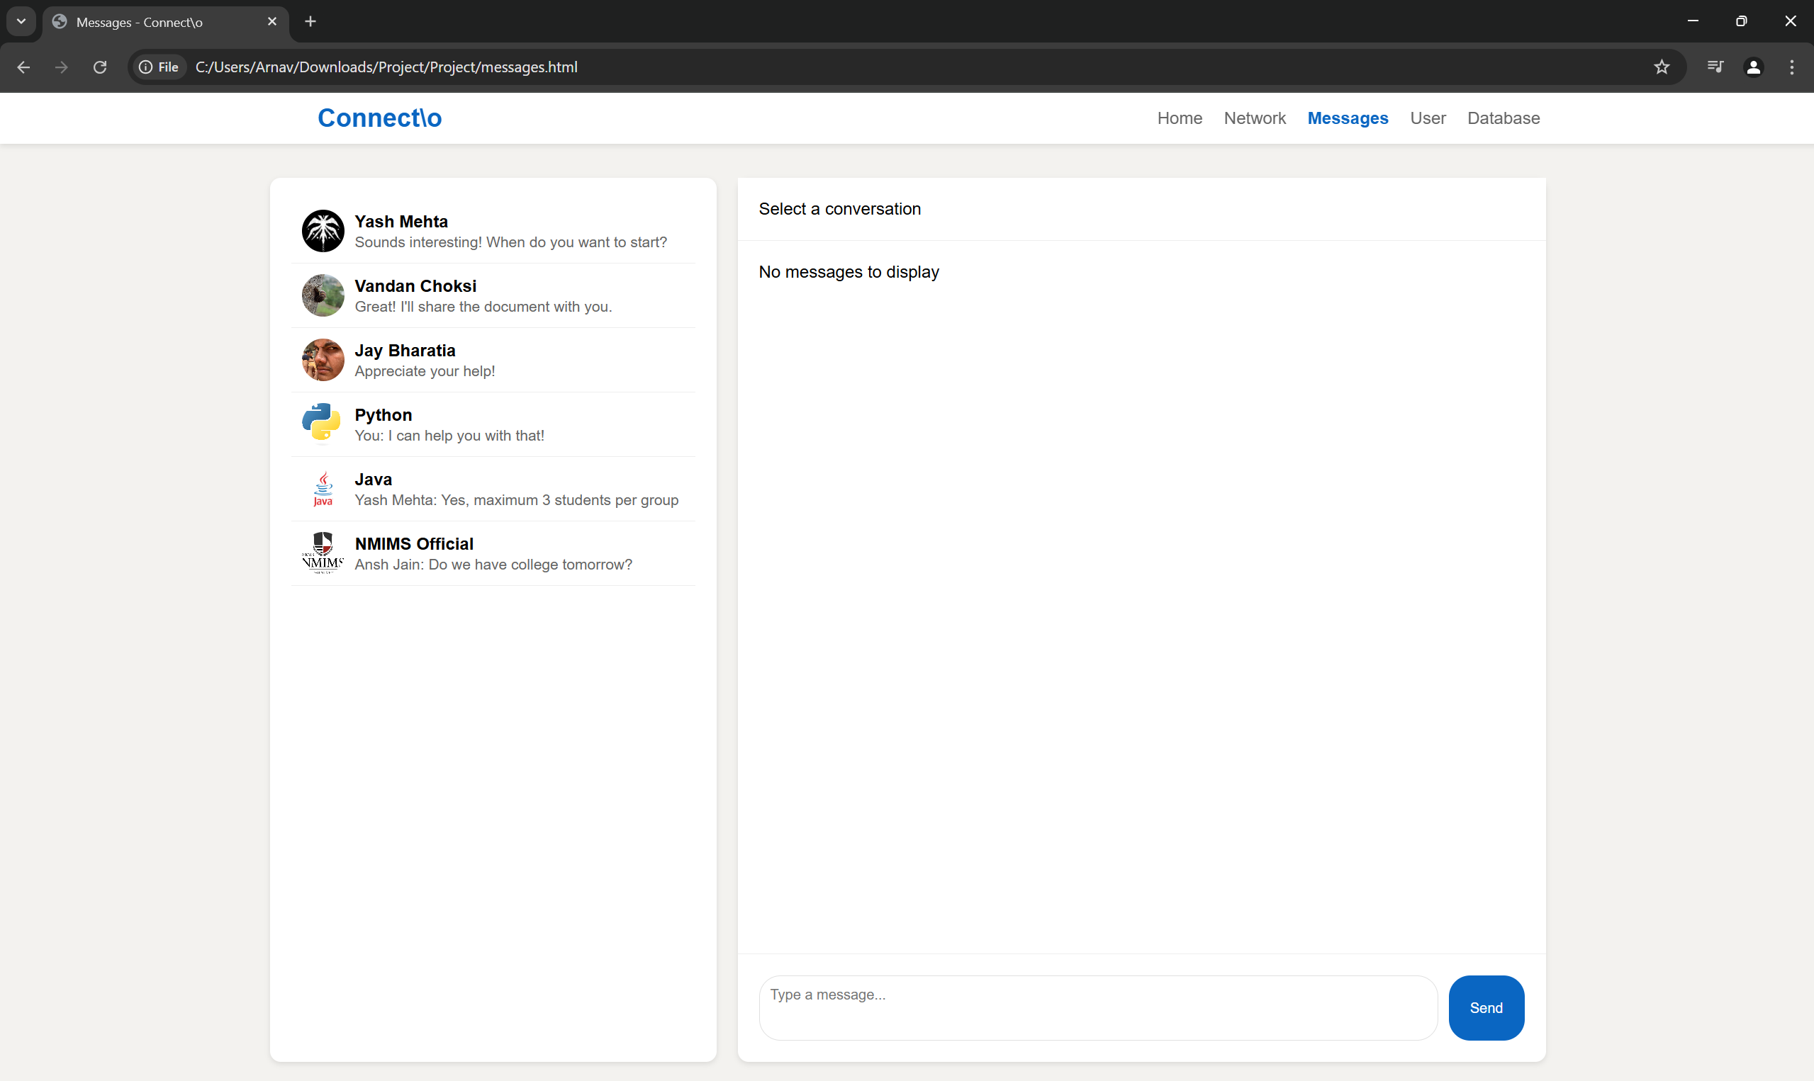

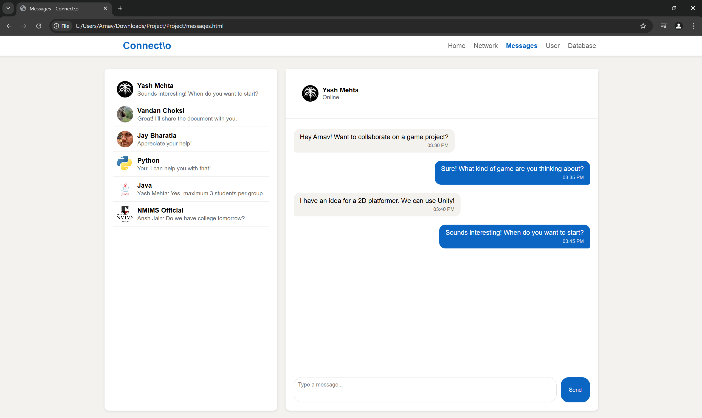

**User Page:** User can sign out, edit their profile and delete posts and comments they have posted.

