# Connect\o - Social Networking Platform

**A Project Report**

***Submitted by***

## Arnav Jadhav

## Vandan Choksi

## Yash Mehta

***Under the Guidance of***

Prof. Vijayetha Thoday/Prof. Rojal Tuscano

for the course “Web Programming”

***in partial fulfillment for the award of the degree of***

**BTECH** /**MBATECH**

At



**Department of Computer Engineering,**

**MPSTME, NMIMS.**

**APRIL,2025**

## DECLARATION

We, **Arnav Jadhav, Vandan Choksi, and Yash Mehta**, Roll No.: **N029, N014, and N050** respectively of MBA TECH CE, IV semester understand that plagiarism is defined as anyone or combination of the following:

1. Un-credited verbatim copying of individual sentences, paragraphs or illustration (such as graphs, diagrams, etc.) from any source, published or unpublished, including the internet.
2. Un-credited improper paraphrasing of pages paragraphs (changing a few words phrases, or rearranging the original sentence order)
3. Credited verbatim copying of a major portion of a paper (or thesis chapter) without clear delineation of who did wrote what. (Source: IEEE, The institute, Dec. 2004)
4. We have made sure that all the ideas, expressions, graphs, diagrams, etc., that are not a result of my work, are properly credited. Long phrases or sentences that had to be used verbatim from published literature have been clearly identified using quotation marks.
5. We affirm that no portion of my work can be considered as plagiarism and I take full responsibility if such a complaint occurs. I understand fully well that the guide of the seminar/ project report may not be in a position to check for the possibility of such incidences of plagiarism in this body of work.

Names: Arnav Jadhav, Vandan Choksi, and Yash Mehta

Roll Nos.: N029, N014, and N050

Place: Mumbai

Date: April 15, 2025

## CERTIFICATE

This is to certify that the project entitled “**Social Networking Site**” is the Bonafide work carried out by **Arnav Jadhav, Vandan Choksi and Yash Mehta** of MBATECH, MPSTME (NMIMS), Mumbai, during the VI semester of the academic year 2024-25, in partial fulfillment of the requirements for the Course Web Programming

___________________

Prof. Vijayetha Thoday/Prof. Rojal Tuscano

Internal Mentor

_______________________ ________________________

Examiner 1 Examiner 2

## Table of contents

|  |  |  |
| --- | --- | --- |
| **CHAPTER NO.** | **TITLE** | **PAGE NO.** |
| 1. | Introduction, Scope and Purpose | 5 and 6 |
| 2. | Description of Modules | 6 and 7 |
| 3. | Software/API’s/Database used with description |  |
| 4. | Methods Implemented |  |
| 5. | Code Snippets |  |
| 6. | GUI/Database Screenshots |  |
| 7. | Conclusion and Future Scope |  |
| 8. | Applications |  |

**1. Introduction, Scope & Purpose**

**1.1 Project Overview**

Connect\o is a comprehensive professional networking platform designed to bridge the gap between professionals across various industries. The platform combines modern web technologies with user-centric design to create a seamless networking experience.

**1.2 Project Scope**

* **User Profile Management**
  + Profile creation and customization
  + Professional information management
  + Profile visibility settings
  + Activity history tracking
* **Content Management**
  + Post creation and editing
  + Media attachment support
  + Content categorization
  + Post privacy controls
* **Communication System**
  + Real-time messaging
  + Group chat functionality
  + Message history
  + Notification system
* **Network Management**
  + Connection requests
  + Network visualization
  + Connection recommendations
  + Network analytics
* **Database Operations**
  + User data management
  + Content storage
  + Message archiving
  + Activity logging

**1.3 Project Purpose**

The primary objectives of Connect\o are to:

* Facilitate professional networking and collaboration
* Enable knowledge sharing and professional development
* Provide a secure and efficient communication platform
* Support career growth and opportunities
* Create a professional community ecosystem

**2. Description of Modules**

|  |  |  |  |
| --- | --- | --- | --- |
| **Module** | **Description** | **Features** | **Technical Implementation** |
| Home | Central hub for content interaction | * Post creation and editing * Feed display with infinite scroll * Like/comment/share functionality * Content filtering and sorting | * localStorage for post storage * DOM manipulation for feed updates * Event listeners for interactions |
| Network | Professional connection management | * Connection requests * Network visualization * Professional recommendations * Connection analytics | * Graph-based data structure * Recommendation algorithms * Connection status tracking |
| Messages | Real-time communication system | * Private messaging * Group chat rooms * Message history * File sharing | * localStorage for message storage * Real-time updates * Message threading |
| User Profile | Personal information management | * Profile customization * Activity tracking * Privacy settings * Professional portfolio | * Form validation * Image handling * Data persistence |
| Database | Data management system | * CRUD operations * Data validation * Record management * Data export/import | * localStorage API * JSON data handling * Data synchronization |

**3. Technologies Used**

**3.1 Frontend Technologies**

**HTML5**

* Semantic markup for structure
* Form validation
* Media elements
* Local storage API

**CSS3**

* Flexbox and Grid layouts
* Responsive design
* Animations and transitions
* Media queries

**JavaScript**

* ES6+ features
* DOM manipulation
* Event handling
* Asynchronous programming

**3.2 Data Storage**

**localStorage API**

* Client-side data persistence
* Session management
* Data synchronization
* Storage limits handling

**JSON**

* Data serialization
* Data transfer format
* Schema validation
* Data parsing

**3.3 Development Tools**

**Visual Studio Code**

* Code editing
* Debugging
* Extensions
* Version control integration

**Git**

* Version control
* Branch management
* Collaboration
* Code review

**Chrome DevTools**

* Debugging
* Performance analysis
* Network monitoring
* Memory profiling

**4. Methods Implemented**

**User Authentication**

* Login/Registration
* Session management
* Password handling
* User validation

**Post Management**

* Post creation
* Content editing
* Post deletion
* Content moderation

**Message Handling**

* Message sending
* Message receiving
* Message threading
* Message archiving

**Profile Management**

* Profile editing
* Privacy settings
* Activity tracking
* Profile customization

**Database Operations**

* Data creation
* Data retrieval
* Data updating
* Data deletion

## 6. GUI/Database Screenshots

### **6.1 User Interface**

#### **Login/Registration Page**

#### Modern, responsive design with form validation and error handling

#### **Home Feed**

#### Dynamic post feed with infinite scroll and interaction options

#### **Network Page**

#### Connection management interface with recommendations

#### **Messages Interface**

#### Real-time chat interface with message history

#### **User Profile**

#### Customizable profile page with activity feed

### **6.2 Database Management**

#### **Data Tables**

#### Structured data representation with CRUD operations

#### **Record Management**

#### User-friendly interface for data manipulation

#### **Data Visualization**

#### Graphical representation of stored data

**7. Conclusion & Future Scope**

**7.1 Project Achievements**

* Successfully implemented core networking features
* Created a responsive and user-friendly interface
* Established efficient data management system
* Implemented secure user authentication
* Developed scalable architecture

**7.2 Future Enhancements**

* **Technical Improvements**
  + Backend integration with Node.js
  + Real-time updates using WebSocket
  + Advanced search algorithms
  + Machine learning for recommendations
* **Feature Additions**
  + Video conferencing
  + Professional portfolio builder
  + Job posting and application system
  + Analytics dashboard
* **Security Enhancements**
  + Two-factor authentication
  + End-to-end encryption
  + Advanced privacy controls
  + Data backup system
* **Mobile Development**
  + Native mobile applications
  + Offline functionality
  + Push notifications
  + Mobile-optimized features

**8. Applications**

**8.1 Professional Use Cases**

* **Career Development**
  + Professional networking
  + Job opportunities
  + Skill development
  + Mentorship programs
* **Business Communication**
  + Team collaboration
  + Project management
  + Client communication
  + Business networking
* **Industry Communities**
  + Specialized groups
  + Knowledge sharing
  + Industry updates
  + Professional events
* **Recruitment**
  + Talent acquisition
  + Candidate screening
  + Job matching
  + Professional verification

**8.2 Business Benefits**

* Enhanced professional visibility
* Improved networking opportunities
* Streamlined communication
* Access to industry insights
* Career growth potential

**Screenshot of Landing Page:**

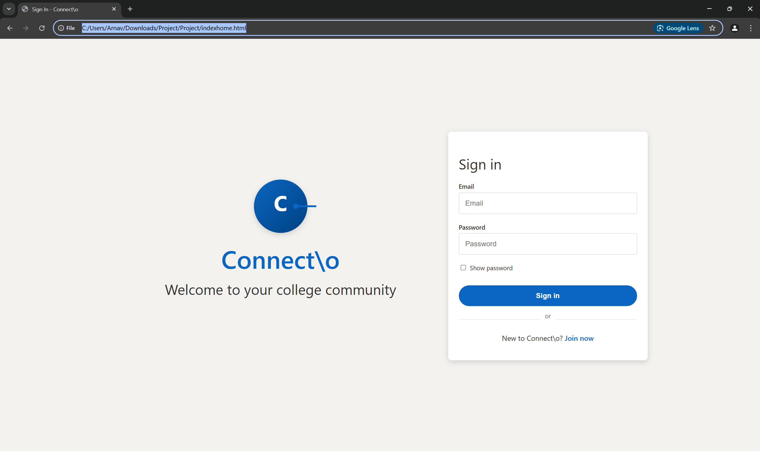

**GitHub Link:**